Table of Contents
UNITED STATES
SECURITIES AND EXCHANGE COMMISSION
Washington, D.C. 20549

 |  |  | FORM |  |  | 10-K

☒ |  |  | ANNUAL REPORT PURSUANT TO SECTION 13 OR 15(d) OF THE SECURITIES EXCHANGE ACT OF 1934
For the fiscal year ended December 31, 2024
OR
☐ |  |  | TRANSITION REPORT PURSUANT TO SECTION 13 OR 15(d) OF THE SECURITIES EXCHANGE ACT OF 1934
For the transition period from to .
Commission file number:
001-36042
PRECIGEN, INC.
(Exact name of registrant as specified in its charter)

 |  |  | Virginia |  |  |  |  |  |  |  |  | 26-0084895
 |  |  | (State or other jurisdiction of  incorporation or organization) |  |  |  |  |  |  |  |  | (I.R.S. Employer  Identification Number)
 |  |  | 20374 Seneca Meadows Parkway
 |  |  | Germantown, |  |  | Maryland |  |  |  |  |  | 20876
 |  |  | (Address of principal executive offices) |  |  |  |  |  |  |  |  | (Zip Code)

Registrant's telephone number, including area code: (301) 556-9900
Securities registered pursuant to Section 12(b) of the Act:
Title of each class |  |  |  |  |  | Trading Symbol(s) |  |  |  |  |  | Name of each exchange on which registered
Common Stock, No Par Value |  |  |  |  |  | PGEN |  |  |  |  |  | Nasdaq Global Select Market

Securities registered pursuant to Section 12(g) of the Act: None

Table of Contents

Indicate by check mark if the registrant is a well-known seasoned issuer, as defined in Rule 405 of the Securities Act. Yes ☐ No ☒
Indicate by check mark if the registrant is not required to file reports pursuant to Section 13 or Section 15(d) of the Act. Yes ☐ No ☒
Indicate by check mark whether the registrant (1) has filed all reports required to be filed by Section 13 or 15(d) of the Securities Exchange Act of 1934 during the preceding 12 months (or for such shorter period that the registrant was required to file such reports), and (2) has been subject to such filing requirements for the past 90 days. Yes ☒ No ☐
Indicate by check mark whether the registrant has submitted electronically every Interactive Data File required to be submitted pursuant to Rule 405 of Regulation S-T (§232.405 of this chapter) during the preceding 12 months (or for such shorter period that the registrant was required to submit such files). Yes ☒ No ☐
Indicate by check mark whether the registrant is a large accelerated filer, an accelerated filer, a non-accelerated filer, a smaller reporting company, or an emerging growth company. See the definitions of "large accelerated filer," "accelerated filer," "smaller reporting company," and "emerging growth company" in Rule 12b-2 of the Exchange Act.

Large accelerated filer |  |  |  |  |  | ☐ |  |  |  |  |  | Accelerated filer |  |  |  |  |  | ☐
Non-accelerated filer |  |  |  |  |  | ☒ |  |  |  |  |  | Smaller reporting company |  |  |  |  |  | ☒
 |  |  |  |  |  |  |  |  |  |  |  | Emerging growth company |  |  |  |  |  | ☐

If an emerging growth company, indicate by check mark if the registrant has elected not to use the extended transition period for complying with any new or revised financial accounting standards provided pursuant to Section 13(a) of the Exchange Act. ☐
Indicate by check mark whether the registrant has filed a report on and attestation to its management's assessment of the effectiveness of its internal control over financial reporting under Section 404(b) of the Sarbanes-Oxley Act (15 U.S.C. 7262(b)) by the registered public accounting firm that prepared or issued its audit report. ☐
Indicate by check mark whether the registrant is a shell company (as defined in Rule 12b-2 of the Act). Yes ☐ No ☒
If securities are registered pursuant to Section 12(b) of the Act, indicate by check mark whether the financial statements of the registrant included in the filing reflect the correction of an error to previously issued financial statements. Yes ☐ No ☒
Indicate by check mark whether any of those error corrections are restatements that required a recovery analysis of incentive-based compensation received by any of the registrant’s executive officers during the relevant recovery period pursuant to §240.10D-1(b). Yes ☐ No ☒
As of June 30, 2024, the last business day of the registrant's most recently completed second fiscal quarter, the aggregate market value of the registrant's common stock held by non-affiliates based upon the closing price of such shares on the Nasdaq Global Select Market on such date was approximately $239.8 million.
As of February 15, 2025, 294,042,973 shares of common stock, no par value per share, were issued and outstanding.
DOCUMENTS INCORPORATED BY REFERENCE: Portions of the registrant's Definitive Proxy Statement for its 2025 Annual Meeting of Shareholders are incorporated by reference in Part III of this Annual Report on Form 10-K where indicated. Such proxy statement will be filed with the Securities and Exchange Commission within 120 days of the registrant's fiscal year ended December 31, 2024.

Table of Contents
TABLE OF CONTENTS
 |  |  |  |  |  | Page
 |  |  | PART I
Item 1. |  |  | Business |  |  | 9
Item 1A. |  |  | Risk Factors |  |  | 36
Item 1B. |  |  | Unresolved Staff Comments |  |  | 66
Item 1C. |  |  | Cybersecurity Risk Management |  |  | 66
Item 2. |  |  | Properties |  |  | 67
Item 3. |  |  | Legal Proceedings |  |  | 67
Item 4. |  |  | Mine Safety Disclosures |  |  | 67
 |  |  | PART II
Item 5. |  |  | Market for Registrant's Common Equity, Related Stockholder Matters and Issuer Purchases of Equity Securities |  |  | 68
Item 6. |  |  | [Reserved] |  |  | 70
Item 7. |  |  | Management's Discussion and Analysis of Financial Condition and Results of Operations |  |  | 70
Item 7A. |  |  | Quantitative and Qualitative Disclosures About Market Risk |  |  | 81
Item 8. |  |  | Financial Statements and Supplementary Data |  |  | 81
Item 9. |  |  | Changes in and Disagreements with Accountants on Accounting and Financial Disclosure |  |  | 82
Item 9A. |  |  | Controls and Procedures |  |  | 82
Item 9B. |  |  | Other Information |  |  | 82
Item 9C. |  |  | Disclosure Regarding Foreign Jurisdictions that Prevent Inspections |  |  | 83
 |  |  | PART III
Item 10. |  |  | Directors, Executive Officers and Corporate Governance |  |  | 84
Item 11. |  |  | Executive Compensation |  |  | 84
Item 12. |  |  | Security Ownership of Certain Beneficial Owners and Management and Related Stockholder Matters |  |  | 84
Item 13. |  |  | Certain Relationships and Related Transactions, and Director Independence |  |  | 84
Item 14. |  |  | Principal Accounting Fees and Services |  |  | 84
 |  |  | PART IV
Item 15. |  |  | Exhibits, Financial Statement Schedules |  |  | 85
Item 16. |  |  | Form 10-K Summary |  |  | 88
________________________
Precigen®, AdenoVerse®, UltraCAR-T®, RheoSwitch®, UltraVector®, RTS®, UltraPorator®, ActoBiotics®, Advancing Medicine With Precision®, RRP Awareness Day ® and RheoSwitch Therapeutic System® are our and/or our affiliates' registered trademarks in the United States and GenVec™, Giving Voice to Inspire Change™, Imwayka™, Inkalvo™, Papzimeos™, Recurrent Respiratory Papillomatosis Awareness Giving Voice to Inspire Change™, RRP Awareness & Design™, RRP Awareness Day Giving Voice to Inspire Change™, and Rygnar™ are our and/or our affiliates' common law trademarks in the United States. This Annual Report on Form 10-K, or Annual Report, and the information incorporated herein by reference contain references to trademarks, service marks, and trade names owned by us or other companies. Solely for convenience, trademarks, service marks, and trade names referred to in this Annual Report and the information incorporated herein, including logos, artwork, and other visual displays, may appear without the ® or ™ symbols, but such references are not intended to indicate, in any way, that we will not assert, to the fullest extent under applicable law, our rights or the rights of the applicable licensor to these trademarks, service marks, and trade names. We do not intend our use or display of other companies' trade names, service marks, or trademarks to imply a relationship with, or endorsement or sponsorship of us by, any other companies.
3
Table of Contents
Other trademarks, trade names, and service marks appearing in this Annual Report are the property of their respective owners. Unless the context requires otherwise, references in this Annual Report to "Precigen", "Company","we", "us", and "our" refer to Precigen, Inc.
Special Note Regarding Forward-Looking Statements
This Annual Report contains forward-looking statements within the meaning of the Private Securities Litigation Reform Act of 1995, which statements involve substantial risks and uncertainties. All statements, other than statements of historical facts, included in this Annual Report, including statements regarding our strategy; future events, including their outcome or timing; future operations; future financial position; future revenue; projected costs; prospects; plans; objectives of management; and expected market growth, are forward-looking statements. The words "aim", "anticipate", "assume", "believe", "continue", "could", "due", "estimate", "expect", "intend", "may", "objective", "plan", "positioned", "potential", "predict", "project", "seek", "should", "target", "will", "would", and the negatives of these terms or similar expressions are intended to identify forward-looking statements, although not all forward-looking statements contain these identifying words. These statements may relate to, among other things: (i) the timeliness of regulatory approvals; (ii) our strategy and overall approach to our business model, our efforts to realign our business, and our ability to exercise more control and ownership over the development process and commercialization path; (iii) our ability to successfully enter new markets or develop additional product candidates, including the expected timing and results of investigational studies and preclinical and clinical trials, whether with our collaborators or independently; (iv) our ability to consistently manufacture our product candidates or, our products, if approved, on a timely basis or to establish agreements with third-party manufacturers; (v) our ability to successfully enter into optimal strategic relationships directly or with our subsidiaries and operating companies that we may form in the future; (vi) actual or anticipated variations in our operating results; (vii) actual or anticipated fluctuations in competitors' or collaborators' operating results or changes in their respective growth rates; (viii) our cash position; (ix) market conditions in our industry; (x) our expectations regarding the size of the patient populations amenable to treatment with our product candidates; (xi) the volatility of our stock price; (xii) the ability, and the ability of our collaborators, to protect our intellectual property and other proprietary rights and technologies; (xiii) outcomes of pending and future litigation; (xiv) the rate and degree of market acceptance of any products developed by us, our subsidiaries, or our potential collaborators, and competition from existing technologies and products or new technologies and products that may emerge; (xv) our ability to retain and recruit key personnel; (xvi) expectations related to the use of proceeds from public offerings and other financing efforts; (xvii) estimates regarding expenses, future revenue, capital requirements, and needs for additional financing; (xviii) our substantial doubt about our ability to continue as a going concern; and (xix) our timeline to commercialization of our product candidates.
Forward-looking statements are based on our beliefs, assumptions, and expectations of our future performance, and may also concern our expectations relating to our subsidiaries and other affiliates. We caution you that the foregoing list may not contain all of the forward-looking statements made in this Annual Report.
We may not actually achieve the plans, intentions, or expectations disclosed in our forward-looking statements, and you should not place undue reliance on our forward-looking statements. Actual results or events could differ materially from the plans, intentions, and expectations disclosed in the forward-looking statements we make. We have included important factors in the cautionary statements included in this Annual Report, particularly in "Summary of Risk Factors" set forth below and Item 1A, "Risk Factors," that could cause actual results or events to differ materially from the forward-looking statements that we make. Our forward-looking statements do not reflect the potential impact of any future acquisitions, mergers, dispositions, JVs, or investments that we may make.
You should read this Annual Report, the documents that we reference in this Annual Report, the audited consolidated financial statements and related notes thereto included in this Annual Report, the other reports we have filed with the Securities and Exchange Commission, or SEC, and the documents that we have filed as exhibits to our filings with the SEC completely and with the understanding that our actual future results may be materially different from what we expect. We do not assume any obligation to update any forward-looking statements, whether as a result of new information, future events or otherwise, except as required by law.
4
Table of Contents
Market and Industry Data

This Annual Report contains industry and market data that are based on general and industry publications, surveys and studies commissioned or conducted by third parties, some of which may not be publicly available, and our own internal estimates and research. Third-party publications, surveys and studies generally state that they have obtained information from sources believed to be reliable, but do not guarantee the accuracy and completeness of such information. These data involve a number of assumptions and limitations and contain projections and estimates of the future performance of the industries in which we operate that are subject to a high degree of uncertainty. We caution you not to give undue weight to such projections, assumptions and estimates.

5
Table of Contents
Summary of Risk Factors
We are subject to a variety of risks and uncertainties, including risks that could have a material adverse effect on our business, financial condition, results of operations, and cash flows. The following summary of the principal factors that make an investment in our securities speculative or risky should not be relied upon as an exhaustive summary of the material risks facing us. You should read the following summary together with the more detailed description of the risks that we deem material described under "Risk Factors" in Item 1A of this Annual Report and the other information contained in this Annual Report before investing in our securities.
Risks Related to Our Financial Position and Capital Needs
•We will need substantial additional capital in the future in order to fund our business and have identified conditions that raise substantial doubt about our ability to continue as a going concern.
•We have a limited number of shares of common stock available for future issuance which could adversely affect our ability to raise capital or consummate strategic transactions.
•We have a history of net losses, and we may not achieve or maintain profitability.
•Our strategic prioritization and streamlining of resources undertaken to extend our cash runway and focus more of our capital resources on PRGN-2012 might not achieve our intended outcome. Zopapogene imadenovec is the nonproprietary name for the investigational therapeutic known as PRGN-2012. Zopapogene imadenovec has not been approved by any health authority in any country for any indication.
•We expect our future capital requirements will be substantial and will depend on many factors.
Risks Related to the Discovery and Development of Our Product Candidates
•Our business is dependent on our ability to advance our current and future product candidates through clinical trials, obtain marketing approval, and ultimately commercialize them.
•The market opportunities for our product candidates may be smaller than we estimate.
•The regulatory process of the United States Food and Drug Administration, or FDA, and comparable foreign authorities are lengthy, time-consuming, and inherently unpredictable, and we may be unable to obtain FDA approval of our product candidates. The denial or delay of any such approval would prevent or delay commercialization of our product candidates and adversely impact our potential to generate revenue, our business, and our results of operations.
•Clinical development involves a lengthy and expensive process with uncertain outcomes. We may incur additional costs and experience delays in developing and commercializing or be unable to develop or commercialize our current and future product candidates.
•As an organization, we have limited experience designing and implementing clinical trials and failure to adequately design a trial, conduct a trial in accordance with regulatory requirements, or enroll patients in clinical trials, could result in adverse effects, including but not limited to increased or unexpected costs and delayed timelines.
•Cell and gene therapies are novel, complex, and difficult to manufacture.
•Interim and preliminary results from our clinical trials that we announce or publish from time to time may change, which could result in material changes in the final data.
•We have chosen to prioritize certain of our product candidates and, as a result, may expend our limited resources on product candidates that do not yield a successful product, or fail to capitalize on opportunities that may be more profitable.
Risks Related to the Commercialization of Product Candidates and Other Legal Compliance Matters
•Even if a product candidate receives marketing approval, it may fail to achieve the degree of market acceptance necessary for commercial success.
6
Table of Contents
•Delays in obtaining regulatory approval of manufacturing processes and facilities or disruptions in manufacturing processes may delay or disrupt our commercialization efforts.
•Even if we receive marketing approval of a product candidate, we will be subject to ongoing regulatory obligations and continued regulatory review, which may result in significant additional expense.
•As a company, we have never commercialized a product, we currently have no active sales force and we may lack the necessary expertise, personnel and resources to successfully commercialize our product candidates.
•The successful commercialization of our product candidates will depend in part on the extent to which third-party payers provide coverage and adequate reimbursement levels.
•We are subject to certain United States and foreign anti-corruption, anti-money laundering, export control, sanctions and other trade laws and regulations.
•Failure to comply with current or future federal, state and foreign laws and regulations and industry standards relating to privacy and data protection laws could lead to governmental enforcement actions (which could include civil or criminal penalties), private litigation, and/or adverse publicity.
Risks Related to Our Business Operations and Strategy
•We may rely on third parties to develop and commercialize some of our product candidates, and we may fail to successfully manage, or disputes may arise from, any such collaborations.
•If we fail to maintain an effective system of internal control over financial reporting, we may not be able to accurately report our financial results or prevent fraud.
•We may be sued for product liability.
•Our insurance policies are expensive and protect only from some business risks, which leaves us exposed to significant uninsured liabilities.
•Competitors and potential competitors may develop products and technologies that make ours obsolete or garner greater market share than ours.
•If we lose key personnel, including key management personnel, or are unable to attract and retain additional personnel, it could delay our product development programs, harm our research and development efforts, and we may be unable to continue to commercialize our product candidates.
•If we experience a significant breach of data security or disruption in our information systems, our business could be adversely affected.
•We may pursue strategic acquisitions and investments that could have an adverse impact on our business.
Risks Related to Our Intellectual Property
•Our ability to compete may decline if we do not adequately protect our proprietary technologies or intellectual property rights.
•Litigation or other proceedings or third-party claims of intellectual property infringement, misappropriation or other violation could require us to spend significant time and money and could prevent us from commercializing our technologies or impact our stock price.
Risks Related to Our Common Stock
•We have failed in the past and may fail in the future to meet all applicable continued listing requirements of the Nasdaq Global Select Market, which could result in a delisting of our common stock.
•Our quarterly and annual operating results may fluctuate in the future. As a result, we may fail to meet or exceed the
7
Table of Contents
expectations of research analysts or investors, which could cause our stock price to decline.
•Our stock price is volatile, and purchasers of our common stock could incur substantial losses.
•We do not anticipate paying cash dividends, and accordingly, shareholders will have to rely on any stock appreciation for return on their investment.
•As of February 15, 2025, Randal J. Kirk controlled approximately 40 percent of our common stock and may be able to control or significantly influence shareholder votes and other corporate actions.
•Sales of a substantial number of shares of our common stock in the public market could occur at any time. This could cause the market price of our common stock to drop significantly, even if our business is doing well.
•Our articles of incorporation authorize us to issue preferred stock with terms that are preferential to those of our common stock.
•We are subject to anti-takeover provisions in our articles of incorporation and bylaws and under Virginia law that could delay or prevent an acquisition of our Company, even if the acquisition would be beneficial to our shareholders.

8
Table of Contents
PART I

Item 1. Business
Overview
We are a dedicated discovery and clinical-stage biopharmaceutical company advancing the next generation of gene and cell therapies with the overall goal of improving outcomes for patients with significant unmet medical needs. We are leveraging our proprietary technology platforms to develop product candidates designed to target urgent and intractable diseases in our core therapeutic areas of immuno-oncology, autoimmune disorders, and infectious diseases. We have developed an extensive pipeline of therapies across multiple indications.
We believe that our array of technology platforms uniquely positions us among other biotechnology companies to advance precision medicine. Precision medicine is the practice of therapeutic product development that takes into account specific genetic variations within populations impacted by a disease to design targeted therapies to improve outcomes for a disease or patient population. Our proprietary and complementary technology platforms provide a strong foundation to realize the core promise of precision medicine by supporting our efforts to construct powerful gene programs to drive efficacy, deliver these programs through viral, non-viral, and microbe-based approaches to drive lower costs, and control gene expression to drive safety. Our therapeutic platforms, including UltraCAR-T, AdenoVerse immunotherapy, and ActoBiotics, are designed to allow us to precisely control the level and physiological location of gene expression and modify biological molecules to control the function and output of living cells to treat underlying disease conditions. We have developed a proprietary electroporation device, UltraPorator, designed to further streamline and ensure the rapid and cost-effective manufacturing of UltraCAR-T therapies. UltraPorator has received FDA clearance for manufacturing UltraCAR-T cells in clinical trials, and we have been dosing patients with UltraCAR-T cells manufactured with UltraPorator in our clinical trials.
Our clinical pipeline includes PRGN-2012 and PRGN-2009, which are based on our AdenoVerse immunotherapy platform; and PRGN-3005, PRGN-3006 and PRGN-3007, which are built on our UltraCAR-T platform. We have completed enrollment in the Phase 1b clinical trial of PRGN-3006. As part of the strategic prioritization of our pipeline, we have paused enrollment in the PRGN-3005 and PRGN-3007 clinical trials. In addition, we have completed a Phase 1b/2a study of AG019, which is built on our ActoBiotics platform, which we have completed the shut-down of, as discussed below under our Biopharmaceuticals segment (Precigen ActoBio, Inc.). We have reduced our focus on preclinical programs, while continuing select projects that we believe could provide further near-term validation of our technology platforms.
In August 2024, we announced strategic prioritization of our pipeline to focus on development of our lead program, PRGN-2012. We plan to minimize UltraCAR-T spending and focus on strategic partnerships to further advance UltraCAR-T programs. As part of this restructuring, we have paused enrollment in PRGN-3005 and PRGN-3007 UltraCAR-T clinical trials. In addition, we plan to continue PRGN-2009 Phase 2 clinical trials under a cooperative research and development agreement ("CRADA") with the National Cancer Institute ("NCI") in recurrent/metastatic cervical cancer and in newly diagnosed HPV-associated oropharyngeal cancer. We have reduced our focus on preclinical programs, while continuing select projects that we believe could provide further near-term validation of our technology platforms. We have completed the shutdown of our ActoBio subsidiary operations, including the elimination of all ActoBio personnel. In conjunction with this shutdown, ActoBio's portfolio of intellectual property is available for prospective transactions.
These strategic changes are designed to enable us to focus on the pre-commercialization efforts on PRGN-2012, including supporting regulatory approval, conducting the confirmatory clinical trial, and manufacturing of commercial products. Additionally, we will continue acceleration of commercial readiness efforts for a potential launch. We have completed submission of a Biologics License Application ("BLA") for PRGN-2012 for the treatment of adults with Recurrent Respiratory Papillomatosis ("RRP") and the FDA has granted priority review with a Prescription Drug User Fee Act ("PDUFA") target action date set for August 27, 2025.
We exercise discipline in our portfolio management by systematically evaluating data from our preclinical programs in order to make rapid "go" and "no go" decisions. Through this process, we believe we can more effectively allocate resources to programs that we believe show the most promise and advance such programs to clinical trials.
To guide our decision-making and operations, we have adopted the following tenets, which form the core of our operating ideology:
•Financial Discipline. Responsibly allocate capital in an effort to ensure maximum value creation.
•Active Portfolio Management. Continuously evaluate our portfolio and strictly adhere to data-driven "go" and "no go" decisions to advance programs with the highest probability of success.
9
Table of Contents
•Rapid Execution. Advance priority programs quickly to value inflection points.
•Strategic Partnerships. Seek strategic partnerships to maximize value generation.
Our Strategy
Our strategy is to use our discovery and clinical development infrastructure to continue advancement of our clinical programs with the goal of improving outcomes for patients with significant unmet medical needs. The key elements of our strategy include:
•Advancing our lead clinical stage programs and seeking opportunities to maximize their value. We are actively advancing our lead programs that we believe have significant potential value. We intend to efficiently pursue these programs toward clinical proof-of-concept and commercialization, whether independently or with collaborators.
•Strategically pursuing our preclinical programs. We are strategically focusing on selecting preclinical programs to create long-term value. We exercise discipline in our portfolio management by systematically evaluating data from our preclinical programs in order to make rapid "go" and "no go" decisions. Through this process, we believe we can more effectively allocate resources to programs that we believe show the most promise and advance such programs to clinical trials.
•Leveraging our technology and therapeutic platforms across indications. Through the application of our suite of proprietary and complementary synthetic biology technologies, we believe we can create optimized biological processes and overcome the limitations of traditional techniques, leading to precision medicines that are manufactured more efficiently and cost-effectively with superior performance. We continually assess the application of these technologies across therapeutic areas to determine where we can develop and provide unique solutions to challenges facing existing therapies.
We have strategically focused our efforts on developing an innovative pipeline of therapies based on our transformative UltraCAR-T and AdenoVerse immunotherapy therapeutic platforms. A core focus of our research and development programs has been an effort to address the drawbacks associated with conventional cell and gene therapy manufacturing approaches. To this end, we are developing therapeutic candidates that reduce manufacturing risk by eliminating the need for centralized cell therapy manufacturing and have invested in internal manufacturing capabilities to de-risk our clinical and, in certain cases, commercial production.
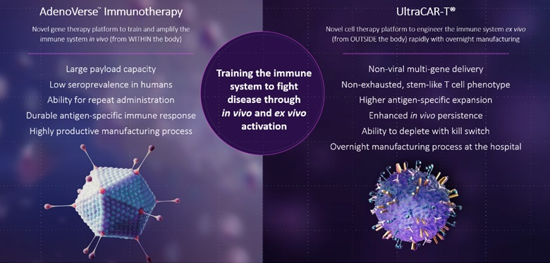
Our Clinical Pipeline
10
Table of Contents
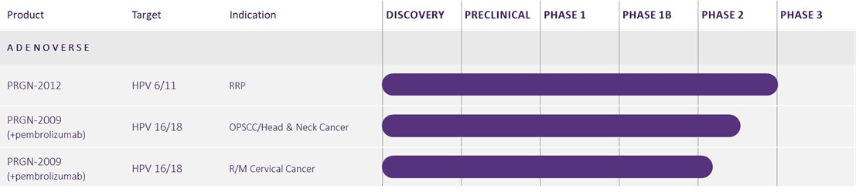
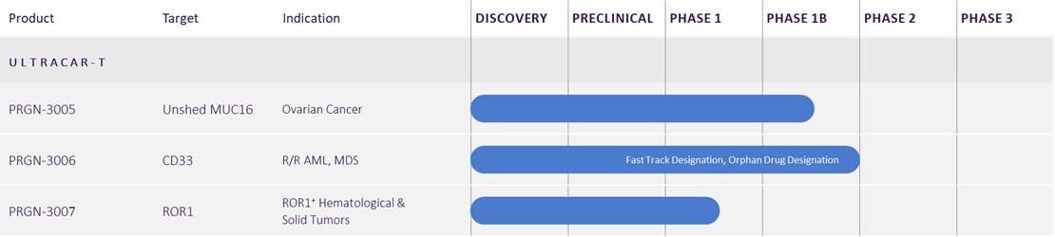
Our Healthcare Business
Our Biopharmaceuticals reportable segment is primarily comprised of the Company's legal entities of Precigen and ActoBio, as well as royalty interests in therapeutics and therapeutic platforms from companies not controlled by us. Our Exemplar reportable segment is comprised of Exemplar Genetics LLC, doing business as Precigen Exemplar, or Exemplar, our wholly owned subsidiary focused on developing research models and services for healthcare research applications.
Biopharmaceuticals
Precigen is a dedicated discovery and clinical stage biopharmaceutical company advancing the next generation of gene and cell therapies using precision technology to target urgent and intractable diseases in immuno-oncology, autoimmune disorders and infectious diseases.
Precigen's Technology Platforms
We leverage a diverse portfolio of proprietary technology platforms to accelerate research and development efforts to deliver the promise of precision medicine. Precigen's innovative technology platforms enable us to construct powerful, multigenic programs that we believe will drive efficacy, deliver multigenic constructs using viral and non-viral approaches that we believe will drive lower costs, and control expression of genes and performance of therapeutics in vivo for precise targeting of complex malignancies. The following discussion describes the technology platforms that we use for our approach to precision medicine.
11
Table of Contents
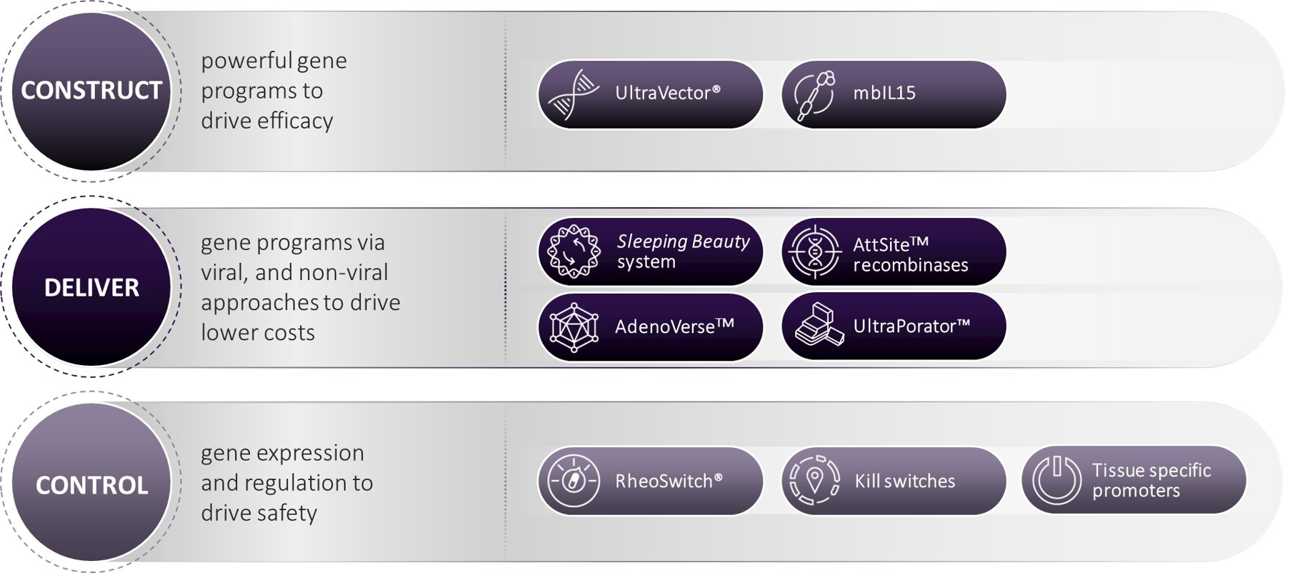
We believe that the development of innovative biological products requires a deep understanding of the complexity of cellular processes and the construction of improved gene programs developed in conditions reflective of the natural environment. We accomplish the design of optimized gene programs for our therapeutic approaches via our UltraVector platform that incorporates advanced DNA construction technologies and computational models to design and assemble genetic components into complex gene expression programs. UltraVector-enabled matrices facilitate rapid identification of components that yield desired gene expression. Our library of characterized genetic components and associated functional characterization data enables construction of gene programs for optimized expression of multiple effector genes. Expression of our membrane-bound interleukin-15, or mbIL15, gene improves functional characteristics of certain immune cells, including T-cells, by enhancing their potential for expansion and persistence.
We deliver gene programs via viral, non-viral, and microbe-based approaches, including Sleeping Beauty, AttSite recombinases, and gorilla adenoviral vectors, from our AdenoVerse library. Sleeping Beauty is a non-viral transposon/transposase system licensed from the University of Texas MD Anderson Cancer Center that stably reprograms immune cells by inserting specific DNA sequences into their genome. The Sleeping Beauty system has been shown to promote random integration in the genome without insertion bias, which contrasts with the predilection of other viral and non-viral methods such as lentiviral vectors and the PiggyBac transposon system for integration at transcriptionally active sites. We believe that our non-viral system may confer benefits including a reduction of the risk of genotoxicity. Precigen has made significant improvements to the Sleeping Beauty system by optimizing gene elements, genetic payload capacity, and efficiency of delivery, which provides a system tailored to our multigenic UltraCAR-T platform. Our AttSite recombinases, which break and rejoin DNA at specific sequences in unidirectional, irreversible fashion to direct integration of a transgene into the host cell genome, allow for stable, site-specific gene integration. The UltraPorator system includes proprietary hardware and software solutions and potentially represents major advancements over current electroporation devices by significantly reducing the processing time and contamination risk. UltraPorator is designed for rapid and cost-effective manufacturing of UltraCAR-T therapies and has the potential to enable rapid manufacturing of a range of gene and cell therapies beyond UltraCAR-T.
Genetically engineered adenoviruses (a common group of viruses) called adenovectors that are designed to insert genes into cells are an important part of our technology platforms. Our AdenoVerse technology platform is composed of a library of engineered adenovector serotypes that yield greater tissue specificity and target selection as compared to known human Ad5 adenovectors. This includes our gorilla adenovectors, which provide a potential competitive advantage with their large payload capacity, ability for repeat administrations and generation of robust antigen-specific immune responses.
The final component of our approach to precision medicine is our ability to control gene expression and regulation using the RheoSwitch, kill switches, and tissue-specific promoters. The RheoSwitch Therapeutic System, our inducible gene switch system, provides quantitative dose-proportionate regulation of the amount and timing of target protein expression in response to an orally available activator ligand. We have developed kill switches, which allow us to selectively eliminate cell therapies in vivo after their administration, to improve their safety profile. We are developing tissue-specific promoters to only induce gene expression locally in cells or tissues of therapeutic interest.
We have leveraged our proprietary and complementary technology platforms discussed above and our expertise in immunology to develop key therapeutic platforms, including UltraCAR-T and AdenoVerse, to address multiple pathways of complex disorders with significant unmet medical needs and to realize our core promise of precision medicine.
12
Table of Contents
Precigen's Therapeutic Platforms
AdenoVerse
Our AdenoVerse platform utilizes a library of proprietary adenovectors for the efficient gene delivery of therapeutic effectors, immunomodulators, and vaccine antigens. We have established proprietary manufacturing cell lines and production methodologies from our AdenoVerse platform, which we believe are scalable for commercial supply. We believe that our proprietary gorilla adenovectors, part of the AdenoVerse technology, have superior performance characteristics as compared to current competition, including standard human adenovirus serotype 5, or Ad5, rare human adenovirus types and other non-human primate adenovirus types.
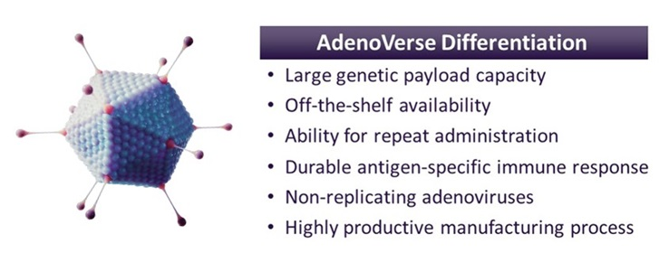
The key advantages of AdenoVerse platform include:
Large genetic payload capacity
Our gorilla adenovectors have a larger genetic payload capacity than other viral vectors that currently dominate the gene therapy field, allowing us to engineer multigenic therapeutic candidates to treat complex diseases. Currently, we are able to engineer up to a 12kb genetic payload using our gorilla adenovectors, providing us with an advantage to express multiple genes in a controlled manner.
Repeat administration
Unlike most competing approaches, our gorilla adenovectors are suitable for repeat administration, which can lead to boosted antibody and T-cell responses. This suitability for repeat administration stems from the very low to non-existent seroprevalence of and limited immunity to gorilla adenoviruses in the human population. For example, our gorilla adenovector variant GC46 has been shown to have a seroprevalence of less than 6 percent in the United States, with low seropositive titers. In comparison, the seroprevalence of Ad5 in the United States is estimated to be 58 percent, with most of seropositive individuals having high titers. This high Ad5 seroprevalence limits the effectiveness of Ad5-based adenovectors in clinical studies. The rare and weak pre-existing immunity against gorilla adenovectors may therefore provide an advantage in clinical applications as compared to existing competition.
Replication incompetence
Our gorilla adenovectors are engineered and manufactured using a process that ensures the production of replication incompetent adenoviral therapeutic candidates with no cytopathic or cytotoxic effect in normal human cells. This has been achieved by engineering deletions of two regions essential for replication of the adenoviral genome. The use of a proprietary complementing cell line provides the necessary genetic elements for manufacture of AdenoVerse immunotherapy candidates. We believe our AdenoVerse immunotherapy candidates have reduced regulatory and commercialization risk due to their design, which renders them incapable of replicating and therefore less susceptible to manufacturing failures. Furthermore, our gorilla adenovector manufacturing process has yielded therapeutic candidates at a very high titer and has reduced the complexity of manufacturing.
Durable antigen-specific immune response
Gorilla adenovectors have been shown in preclinical studies to generate high-level and durable antigen-specific neutralizing antibodies and effector T-cell immune responses, as well as an ability to boost these antibody and T-cell responses via repeat administration.
13
Table of Contents
cGMP Manufacturing Facility
We have built internal cGMP manufacturing capabilities for our Adenoverse-based therapeutics in Germantown, Maryland, with the aim to reduce the risks associated with technology transfer and timing when outsourcing to contract manufacturing organizations. We are able to execute drug substance manufacturing at this facility in an expedited manner at reduced cost compared to contract manufacturing organizations. We have expanded our drug substance cGMP manufacturing capabilities at this facility with an aim to support the possible commercial launch of our PRGN-2012 asset. We will continue to evaluate internal and external strategies to support cGMP manufacturing needs of our AdenoVerse-based therapeutics.
Precigen's most advanced programs based on the AdenoVerse immunotherapy platform include: (i) PRGN-2012, a first-in-class, investigational "off-the-shelf" AdenoVerse gene therapy designed to elicit immune responses directed against cells infected with HPV type 6, or HPV6, or HPV type 11, or HPV11, for which BLA is submitted to the FDA for adults with recurrent respiratory papillomatosis, or RRP; and (ii) PRGN-2009, a first-in-class, investigational "off-the-shelf" treatment utilizing the AdenoVerse platform, is designed to activate the immune system to recognize and target human papillomavirus-positive, or HPV+, solid tumors, which is in two Phase 2 clinical trials for patients with HPV-associated cancers.
PRGN-2012
PRGN-2012 is an investigational "off-the-shelf" AdenoVerse gene therapy for the treatment of RRP. PRGN-2012 is engineered with an optimized antigen design and uses our gorilla adenovector technology, part of our proprietary AdenoVerse platform, to elicit immune responses directed against cells infected with HPV6 and HPV11. Gorilla adenovectors have numerous advantages, including the ability for repeat administration, the inability to replicate in vivo, which may improve safety, and the ability to deliver large payload capacity.
RRP is a rare, difficult-to-treat and sometimes fatal neoplastic disease of the upper and lower respiratory tracts that is caused by infection with HPV6 or HPV11. RRP is classified based on age of onset as juvenile or adult. RRP prevalence is estimated to be approximately 27,000 adult patients in the U.S and more than 125,000 patients outside the U.S., based on our commissioned research. There is no approved therapeutic treatment for RRP and the current standard-of-care is repeated endoscopic debulking with ablation or excision of papillomatous lesions. Surgeries are not curative and recurrence of papilloma after surgical removal is very common and repeated procedures are required to debulk and monitor the disease, which exposes patients to anesthetic and surgical risks, and emotional distress. Patients with aggressive RRP can undergo hundreds of lifetime surgeries to control their disease. RRP morbidity and mortality results from the effects of papilloma mass on the vocal cords, trachea, and lungs, which may cause voice changes, stridor, airway occlusion, loss of lung volume, and/or post-obstructive pneumonia. Although rare, RRP has the potential for malignant transformation in three to seven percent of adult patients. In addition, more than 90 percent of genital warts are related to HPV6 and HPV11 infection.
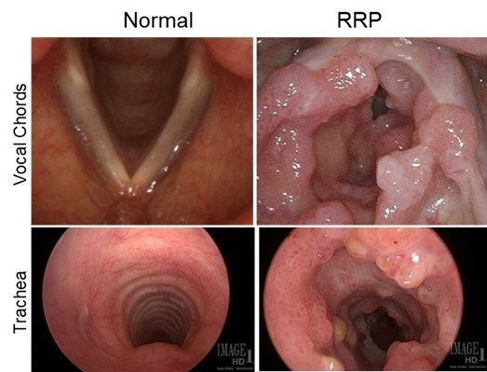
In preclinical models, PRGN-2012 has demonstrated strong HPV6 and HPV11-specific T-cell response in RRP patient samples in vitro.
14
Table of Contents
We have completed Phase 1/2 pivotal clinical trial of PRGN-2012 in adults with RRP. Phase 1/2 pivotal study met the primary safety and efficacy endpoints.

The Phase 1/2 clinical trial (clinical trial identifier: NCT04724980) evaluated safety and efficacy of PRGN-2012. The study design included an initial 3+3 dose escalation cohort to identify the recommended Phase 2 dose (RP2D). Adult RRP patients who had three or more surgeries in the prior 12 months were eligible for the study. The Phase 1/2 study enrolled a total of 38 patients. Of these, 3 patients received four administrations of PRGN-2012 at 1x 1011 particle units (PU)/dose and 35 patients received four administrations of PRGN-2012 at RP2D (5 x 1011 PU/dose) over a 12-week treatment period via subcutaneous injection.

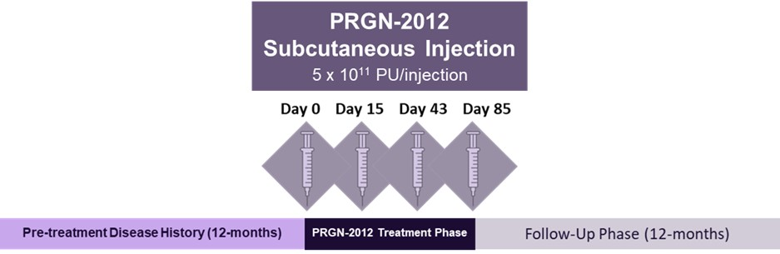

Primary endpoints included safety and Complete Response rate defined as the percentage of patients who require no RRP surgeries in the 12-month period after PRGN-2012 treatment completion. Key secondary endpoints included HPV-specific immune responses, extent of papilloma growth as measured by Derkay scoring, and quality of life measurement as measured by Vocal Handicap Index-10 (VHI-10).

Baseline patient characteristics of the 35 adult patients included a median age of 49 years (range: 20-88); 20 of the patients were male and 15 were female. Patients had a median of 4 surgeries (range: 3-10) in the 12 months before PRGN-2012 treatment initiation. Average years since RRP diagnosis was 20 (range: 1-65) with 12 and 23 patients with juvenile and adult onset RRP, respectively.

PRGN-2012 treatment was well-tolerated with no dose-limiting toxicities and no treatment-related adverse events, or TRAEs, greater than Grade 2. All patients received four administrations of PRGN-2012 at the intended dose levels. TRAEs were mostly mild with no treatment-related serious adverse events reported. The most common TRAE was injection site reaction. Other common TRAEs occurring in more than one subject were fatigue, chills, and fever. There was no meaningful anti-drug antibody response with repeat administrations of PRGN-2012.
Primary efficacy endpoint analysis demonstrated that 51% (18 out of 35) (95% CI: 34-69) patients treated at RP2D achieved Complete Response. The Complete Response rate was 50% (6 out of 12) and 52% (12 out of 23) in the Phase 1 and Phase 2 portions of the study, respectively. Complete Responses were durable with median durability of response yet to be reached. PRGN-2012 treatment significantly (p < 0.0001) reduced the need for surgeries in RRP patients compared to pre-treatment history. PRGN-2012 treatment reduced the need for RRP surgeries in 86% (30 out of 35) of patients compared to their pre-treatment history. RRP surgeries were reduced from a median of 4 (range: 3-10) in the 12 months pre-treatment to 0 (range: 0-7) in the 12 months post PRGN-2012 treatment completion.

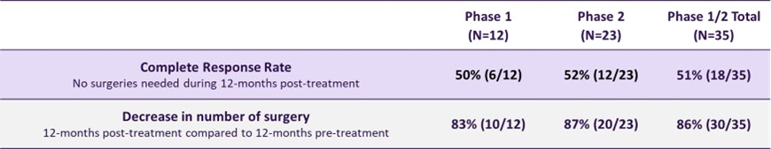
15
Table of Contents
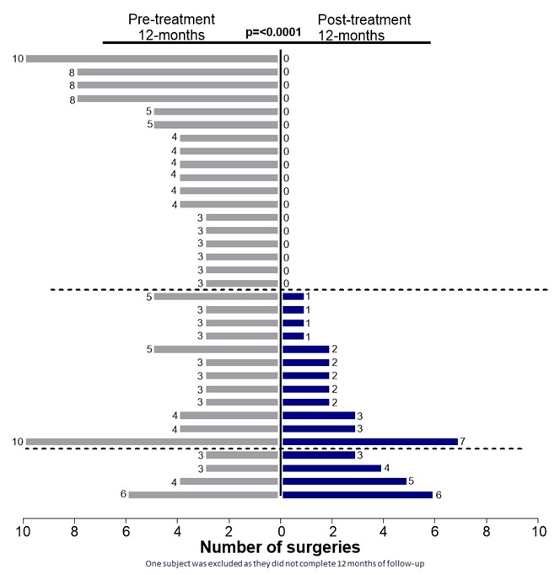
PRGN-2012 treatment showed a significant (p < 0.0001) improvement in anatomical Derkay scores, a tool used for research purposes to quantify RRP severity based on involvement of laryngeal structures, with mean Derkay scores reducing from 9 (range: 5-19) at baseline to 1 (range: 0-5) at 24 weeks post-treatment in patients with Complete Response. Quality of life, as evaluated using the validated VHI-10, significantly (p < 0.0001) improved from a mean of 25 (range: 12-38) at baseline to 7 (range: 0-30) at 24 weeks post PRGN-2012 treatment in patients with Complete Response. PRGN-2012 treatment induced HPV 6/11-specific T cell responses in RRP patients with a significantly greater expansion of peripheral HPV-specific T cells observed in responders compared with non-responders.
PRGN-2012 has been granted Breakthrough Therapy Designation and Orphan Drug designation for the treatment of RRP by the FDA. PRGN-2012 has received Orphan Drug Designation for the Treatment of RRP from the European Commission as well. We have completed the submission of, and received priority review for Precigen's BLA for PRGN-2012, which is intended for treating adults with RRP. The PDUFA target action date is set for August 27, 2025.
PRGN-2009
PRGN-2009, an "off-the-shelf" investigational AdenoVerse gene therapy, is designed to activate the immune system to recognize and target HPV+ solid tumors. PRGN-2009 leverages our UltraVector and AdenoVerse platforms to optimize HPV type 16, or HPV16, and HPV type 18, or HPV18, antigen design for delivery via a proprietary gorilla adenovector with a large genetic payload capacity and the ability for repeat administrations. Guided by our bioinformatics analysis and in silico protein engineering, PRGN-2009 encodes for a novel, multi-epitope antigen design to target HPV16 and HPV18 infected cells and potentially differentiates from the competition. PRGN-2009 has been engineered using our AdenoVerse platform to be replication deficient in vivo.
HPV infections account for 5 percent of all cancers globally, and 690,000 new cancer cases are attributable to HPV infections per year. HPV infects the squamous cell carcinoma. Some cervical cancers come from HPV infection of gland cells in the cervix and are referred to as adenocarcinomas. HPV-related cancers include cervical, oropharyngeal, anal, penile, vaginal, and vulvar. Nearly 44,000 HPV-associated cancers occur in the United States each year. Of these, approximately 25,000 occur in women and 19,000 occur in men. HPV is considered responsible for more than 90 percent of anal and cervical cancers, about 70 percent of vaginal and vulvar cancers, and more than 60 percent of penile cancers. Recent studies indicate that about 70 percent of cancers of the oropharynx also may be related to HPV.

16
Table of Contents
We have completed a Phase 1 clinical trial of PRGN-2009 as a monotherapy or in combination with bintrafusp alfa, or M7824, an investigational bifunctional fusion protein, for patients with HPV-associated cancers in collaboration with the National Cancer Institute, or NCI, pursuant to a cooperative research and development arrangement, or CRADA.
PRGN-2009 is being evaluated in two Phase 2 clinical trials in combination with anti-PD1 monoclonal antibody, pembrolizumab, for patients with HPV-associated cancers in collaboration with NCI pursuant to a CRADA.

The first Phase 2 clinical trial is designed to evaluate PRGN-2009 in combination with anti-PD1 antibody, pembrolizumab, in adult patients with newly-diagnosed HPV-associated oropharyngeal cancer is ongoing in collaboration with NCI pursuant to a CRADA. The primary objective of the study is to determine if there is an increase in CD3+ tumor infiltrating T cells post treatment compared with pre-treatment. Secondary objectives include safety and overall survival (OS).
The second Phase 2 clinical trial is randomized, open-label clinical trial of PRGN-2009 in combination with pembrolizumab to treat patients with recurrent or metastatic, or R/M, cervical cancer. Patients in the Phase 2 trial will be randomized 1:1 to the combination of PRGN-2009 and pembrolizumab (cohort 1) or pembrolizumab monotherapy (cohort 2). Patients randomized to the PRGN-2009 plus pembrolizumab cohort will receive PRGN-2009 via subcutaneous (SC) injection (5 x 1011 PU every 3 weeks for three administrations followed by administration each 6 weeks thereafter). Patients in the PRGN-2009 plus pembrolizumab cohort and pembrolizumab monotherapy cohort will receive pembrolizumab via intravenous (IV) infusion (400 mg every 6 weeks). Patients randomized to the pembrolizumab monotherapy cohort will be offered the option to crossover to the PRGN-2009 plus pembrolizumab cohort if certain conditions are met.
The primary objective of the Phase 2 trial in R/M cervical cancer is to assess the objective response rate (ORR) per RECIST v1.1 following treatment with PRGN-2009 in combination with pembrolizumab or pembrolizumab monotherapy. Secondary objectives include the evaluation of safety and tolerability, progression-free survival (PFS), overall survival (OS), best overall responses (BOR), Disease Control Rate (DCR), time to response and duration of response. The Phase 2 trial in R/M cervical cancer is enrolling patients. As part of the strategic prioritization of our pipeline announced in August 2024, we plan to enroll patients in the PRGN-2009 clinical trials only at NCI under a CRADA.
UltraCAR-T
Recent technological advances have revolutionized the field of immunotherapy for the treatment of cancer. Of the many immunotherapy approaches, chimeric antigen receptor T, or CAR-T, cell therapies in particular have shown remarkable responses in cancer patients with hematological malignancies. These therapies rely on the genetic modification of T-cells to express chimeric antigen receptors and enable these modified T-cells to bind to specific antigens on the patient's tumor cells and kill the tumor cells. Concerns remain, however, regarding complex and lengthy manufacturing processes and the safety profile of CAR-T cell therapies. Furthermore, current autologous and allogeneic CAR-T cell therapies face challenges in the treatment of solid tumors due to rapid exhaustion and limited in vivo persistence of CAR-T cells. Current approaches to CAR-T manufacturing require extensive ex vivo expansion following viral vector transduction to achieve clinically relevant cell numbers. We believe such an ex vivo expansion process can result in the exhaustion of CAR-T cells prior to their administration, limiting their potential for persistence in patients after administration. Furthermore, the lengthy and complex manufacturing of current CAR-T approaches results in high manufacturing costs and long delays in providing the CAR-T treatment to cancer patients. Time is of the essence for advanced cancer patients and even modest delays in treatment can adversely affect outcomes.
Our UltraCAR-T platform is differentiated from the competition, and we believe it has the potential to address the shortcomings of current technologies and disrupt the CAR-T treatment landscape by increasing patient access through shortening manufacturing time from weeks to days, decreasing manufacturing-related costs, and improving outcomes. We advanced the UltraCAR-T platform to address the inhibitory tumor microenvironment by incorporating intrinsic checkpoint blockade without the need for complex and expensive gene editing techniques. The next generation of UltraCAR-T utilizes a single multicistronic transposon DNA and our overnight, decentralized manufacturing process of UltraCAR-T.
17
Table of Contents
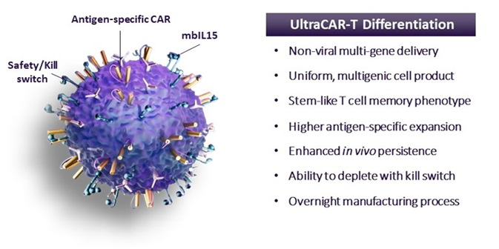
We have introduced our vision for a new UltraCAR-T library approach, which is intended to transform the personalized cell therapy landscape for cancer patients. Our goal is to develop and validate a library of non-viral plasmids to target tumor-associated antigens. Enabled by what we believe to be design and manufacturing advantages of UltraCAR-T, coupled with the capabilities of the UltraPorator system, we are working to empower cancer centers to deliver personalized, autologous UltraCAR-T treatment with overnight manufacturing to any cancer patient. If our goal is realized, one or more non-viral plasmids could be selected based on the patient's cancer indication and biomarker profile from the library to build a personalized UltraCAR-T treatment. After initial treatment, this approach has the potential to allow for redosing of UltraCAR-T targeting the same or new tumor-associated antigens based on the treatment response and the changes in antigen expression of the patient's tumor.

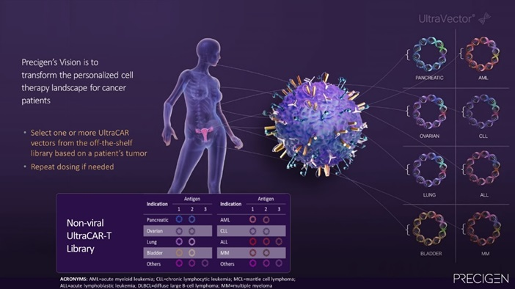
The key advantages of UltraCAR-T versus the traditional CAR-T approaches include:
Advanced non-viral multigenic delivery system
We have optimized and advanced the Sleeping Beauty system using our UltraVector DNA construction platform to produce multigenic UltraCAR-T cells. As a result of this optimization, our UltraCAR-T cells are precision-engineered to produce a homogeneous cell product that simultaneously co-expresses antigen-specific CAR, kill switch, and mbIL15 genes in any genetically modified UltraCAR-T cell. We recently introduced the next generation UltraCAR-T platform that addresses the inhibitory tumor microenvironment by incorporating a novel mechanism for intrinsic downregulation of one or more checkpoint inhibitor, or CPI, genes. This design achieves intrinsic CPI blockade without gene editing and is aimed at avoiding systemic toxicity and the high cost of combining CPI antibodies. The next generation UltraCAR-T cells simultaneously express CAR, mbIL15, and a kill switch, and incorporate intrinsic CPI blockade using a single multicistronic non-viral transposon. This design differentiates our UltraCAR-T platform from the approaches used by our competitors and, we believe, reduces the developmental risk as compared to those approaches because product homogeneity is a critical consideration for later stages of clinical development and subsequent commercialization. We utilize our protein engineering and immunology expertise to
18
Table of Contents
optimize antigen binding, hinge, and signaling domains of each CAR based on the target antigen expression profile and cancer indication. We have also included our proprietary kill switch technology in our UltraCAR-T cells to improve the safety profile.
Enhanced persistence and elimination of ex vivo expansion step due to expression of mbIL15
A key driver of improved UltraCAR-T cell performance is mbIL15. The expression of mbIL15 has been shown to enhance in vivo expansion of UltraCAR-T cells in the presence of tumor antigens and prevent T-cell exhaustion to maintain a less differentiated, stem-cell like memory phenotype leading to longer persistence of UltraCAR-T cells. This yields an enduring anti-tumor response that has been shown to outlast conventional CAR-T cells in preclinical studies, which we believe is essential to successfully targeting solid tumors. This design allows us to eliminate the need for ex vivo expansion prior to administration, a requirement that is a major limitation of current CAR-T treatments.
Scalable, rapid, decentralized manufacturing process
Another key differentiator of the UltraCAR-T therapeutic platform is our rapid and decentralized proprietary manufacturing process, which allows us to manufacture UltraCAR-T cells overnight at a medical center's current good manufacturing practices, or cGMP, facility and reinfuse the patient the following day after gene transfer. This process improves upon current approaches to CAR-T manufacturing, which require extensive ex vivo expansion following viral vector transduction that we believe can result in the exhaustion of CAR-T cells prior to their administration, limiting their potential for persistence in patients. The decentralized nature of the manufacturing process allows us to scale beyond the confines of a dedicated facility. We believe we are the first company to validate non-viral, rapid, decentralized manufacturing of CAR-T cells in the clinic by infusing patients one day after gene transfer at two different sites in our ongoing clinical trials. We believe UltraCAR-T is the only autologous CAR-T platform with manufacturing, quality control release and infusion back to the patient, occurring in one day.
We have developed a proprietary electroporation device, UltraPorator, designed to further streamline and ensure the rapid and cost-effective manufacturing of UltraCAR-T therapies. The UltraPorator system, intended to be a viable scale-up and commercialization solution for decentralized UltraCAR-T manufacturing, includes proprietary hardware and software solutions and potentially represents major advancements over current electroporation devices by significantly reducing processing time and contamination risk. The FDA has cleared UltraPorator as a manufacturing device for clinical trials of our UltraCAR-T investigational therapies.
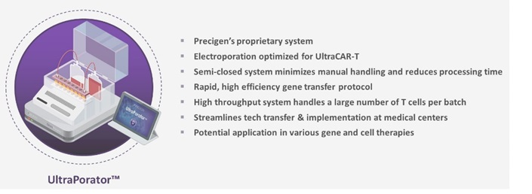
We believe our UltraCAR-T manufacturing process will provide a significant potential competitive advantage in the timeline and cost required to manufacture and deliver CAR-T therapies to patients as compared to current treatment approaches that require large, centralized facilities to support manufacturing of a relatively small number of treatments. We believe development of rapid and successful overnight manufacturing of UltraCAR-T therapies at medical centers signifies a paradigm shift in CAR-T therapy by eliminating manufacturing and timing risks associated with conventional CAR-T therapies, and our intent is for it to take place directly in numerous treatment centers, which can improve the accessibility of our therapies for patients.
Precigen's most advanced programs based on the UltraCAR-T platform include PRGN-3006, which has completed enrollment in a Phase 1b clinical trial for patients with relapsed or refractory acute myeloid leukemia, or AML, and high-risk myelodysplastic syndromes, or MDS; PRGN-3005, which is in a Phase 1b clinical trial for patients with advanced ovarian, fallopian tube, or primary peritoneal cancer; and PRGN-3007, based on the next generation UltraCAR-T, which is in a Phase 1/1b clinical trial for patients with advanced receptor tyrosine kinase-like orphan receptor 1-positive, or ROR1+, hematological and solid tumors.

19
Table of Contents
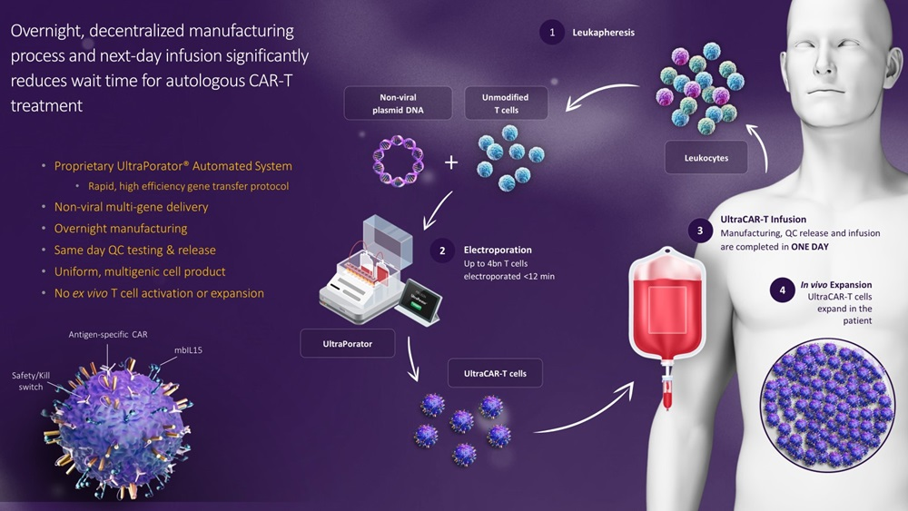
PRGN-3005
PRGN-3005 is an investigational autologous CAR-T therapy that utilizes our UltraCAR-T platform to simultaneously express a CAR targeting the unshed portion of the Mucin 16 antigen, or MUC16, mbIL15, and kill switch genes.
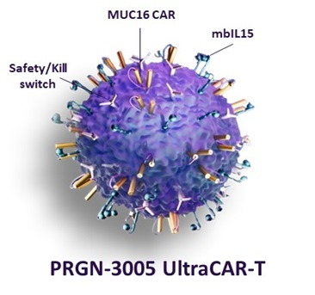
MUC16 is an extremely large, type I transmembrane cell surface glycoprotein that plays a key role in the pathogenesis of ovarian cancer by promoting an increase in cell proliferation, metastasis, resistance to chemotherapy and immune system evasion by cancer cells. MUC16 is overexpressed on more than 80 percent of ovarian tumors but has limited expression in healthy tissues, making it an attractive CAR-T target for ovarian cancer. Other cancers with known overexpression of MUC16 include pancreatic, breast, endometrial, lung, and bladder cancers. MUC16 undergoes proteolytic cleavage in the extracellular domain resulting in shedding of a large portion of extracellular domain, termed CA125, from the cell surface and leaving only a short, unshed extracellular domain tethered to the cell surface. Therapies that target the region of MUC16 that is shed from the cell surface may have limited effectiveness due to their binding to CA125 in circulation which is not associated with tumor cells. In order to eliminate binding to circulating CA125, we have designed our MUC16 CAR using an antigen binding domain that specifically binds the unshed portion of MUC16 and optimized its affinity to preferentially target PRGN-3005 to tumor cells.
20
Table of Contents
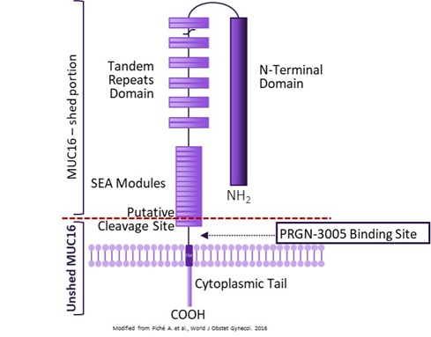
Advanced ovarian cancer is often fatal, with Stage IV survival rates as low as 20 percent, and has limited treatment options. Patients with ovarian cancer represent a large population, with approximately 300,000 patients diagnosed worldwide annually, including 22,000 in the United States alone.
In preclinical in vitro studies, PRGN-3005 UltraCAR-T has shown robust MUC16-specific cytotoxicity of ovarian cancer cell lines, a stem-cell like memory phenotype and significant improvement in their longevity even in the absence of exogenous cytokines as compared to conventional CAR-T cells. PRGN-3005 UltraCAR-T cells have shown significantly superior anti-tumor response in mouse models of ovarian cancer compared to mice treated with a saline solution or conventional MUC16 CAR-T cells lacking mbIL15 expression. These data demonstrated the potential of UltraCAR-T cells to persist long-term in vivo, prevent CAR-T cell exhaustion, and mount a durable anti-tumor response with the ability to continue to respond upon tumor rechallenge.
PRGN-3005 is in a 1/1b clinical trial designed to enroll in two phases, an initial dose escalation phase (Phase 1) followed by a dose expansion phase (Phase 1b). We have completed the Phase 1 dose escalation portion of the PRGN-3005 Phase 1/1b study. The Phase 1 portion of the study is a dual-arm, non-randomized, open-label clinical trial in patients with advanced, recurrent platinum-resistant ovarian, fallopian tube or primary peritoneal cancer. Patients in the Phase 1 dose escalation trial received either intraperitoneal, or IP (Arm 1), or intravenous, or IV (Arm 2), administration of PRGN-3005 without prior lymphodepletion. After receiving FDA clearance, we also incorporated a cohort with lymphodepletion at Dose Level 3 of the IV arm in the Phase 1 study. The primary objectives of the Phase 1 trial included assessment of safety and maximum tolerated dose, or MTD, of PRGN-3005.

The Phase 1 study enrolled a total of 27 patients (N=12 IP; N=6 IV; and N=9 IV with lymphodepletion). Patients were heavily pretreated with a median of greater than or equal to 8 prior lines of therapy across all arms. Patients had significantly advanced stage disease with a high baseline tumor burden with most patients having distant metastases, including liver, spleen, bladder and lung.
PRGN-3005 treatment was well-tolerated with low incidence of treatment related adverse events (TRAEs), no dose limiting toxicities (DLTs), and no neurotoxicity. The most common side effects for the IV and IP arms without lymphodepletion were abdominal pain, fever and decreased absolute lymphocyte count (ALC). Serious Adverse Events included five incidences of Cytokine Release Syndrome (CRS), with no incidence of CRS greater than Grade 2. One patient with CRS required specific intervention which was resolved following standard CRS management after 24 hours. There was no use of tocilizumab or dexamethasone or kill switch.
PRGN-3005 administered via either IP or IV infusion resulted in a dose-dependent expansion and encouraging persistence in peripheral blood. Best responses in patients treated without lymphodepletion were stable disease with complete responses
21
Table of Contents
observed in certain individual target lesions. Incorporating lymphodepletion prior to IV infusion led to an encouraging anti-tumor activity with a decrease in tumor burden in 67% (6/9) of patients and stable or partial response in 90% of the individual target lesions in these patients.
Subsequently, we initiated the Phase 1b dose expansion study of PRGN-3005 UltraCAR-T at Dose Level 3 with lymphodepletion prior to IV infusion. As part of the strategic prioritization of our pipeline announced in August 2024, we have paused enrollment in the Phase 1b clinical trial of PRGN-3005.
PRGN-3006
PRGN-3006 is an investigational autologous CAR-T therapy that utilizes our UltraCAR-T platform to express a CAR to target CD33, mbIL15 and a kill switch for better precision and control.

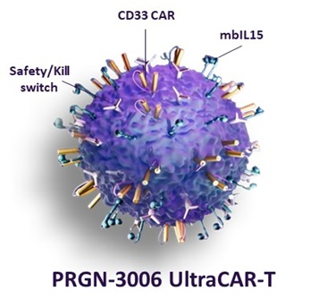
CD33, also known as Siglec-3, is a single pass transmembrane glycoprotein and a member of the sialic acid-binding immunoglobulin-like lectin super-family. CD33 is an attractive target for immunotherapy because it is over-expressed on AML blasts and leukemic stem cells, or LSCs, but is not expressed on normal blood stem cells, also known as hematopoietic stem cells. Approximately 85-90 percent of AML patients express CD33 on their tumor cells. In addition to broad expression on AML blasts, CD33 is expressed on LSCs underlying AML. LSCs are thought to be more resistant to chemotherapy treatment and to be capable of reinitiating the disease resulting in high relapse rates for AML. In healthy subjects, CD33 is primarily expressed on normal myeloid precursors, colony-forming cells, monocytes, and maturing granulocytes. Because CD33 is not expressed outside the hematopoietic system or on normal hematopoietic stem cells, it is an attractive target for treatment of AML.
AML is among the most common types of leukemia in adults with approximately 20,000 AML patients diagnosed in the United States annually. AML is a heterogeneous disease with 50-70 percent relapse rates and rapid progression. The prognosis for patients with AML is poor, with an average five-year survival rate of approximately 25 percent overall, and less than a 5 percent five‐year survival rate for patients older than 65. More than 10,000 cases of higher-risk MDS are diagnosed annually in the United States. Due to the aggressive nature of AML progression, rapid availability of treatment is of even greater importance in this patient population, and our non-viral UltraCAR-T manufacturing process would represent a significant potential advantage over current approaches that require long lead times for manufacturing.
In preclinical studies, PRGN-3006 demonstrated robust expansion in the presence of CD33 antigen, lack of autonomous expansion in the absence of CD33 and prolonged persistence in the absence of exogenous cytokines. PRGN-3006 exhibited target-specific killing of CD33+ tumor cells as well as a significant release of inflammatory cytokines such as IFNγ, upon co-culture with AML tumor cells. PRGN-3006 cells were specifically eliminated by kill switch activator treatment, displaying functionality of the kill switch, which is intended to improve the safety profile of PRGN-3006. In vivo, a single administration of PRGN-3006 UltraCAR-T cells only one day after gene transfer effectively eliminated the tumor burden and significantly improved overall survival of tumor bearing mice compared to CAR-T cells lacking mbIL15 expression (conventional CAR-T) in an aggressive xenograft model of AML. PRGN-3006 demonstrated engraftment and significantly higher expansion and persistence in mice compared to conventional CAR-T cells, which lack mbIL15 expression.
PRGN-3006 is in a Phase 1/1b clinical trial designed to enroll in two phases, an initial dose escalation phase (Phase 1) followed by a dose expansion phase (Phase 1b). We have completed Phase 1 dose escalation portion and completed enrollment in Phase
22
Table of Contents
1b portion of the trial. The Phase 1 portion of this study is a dual-arm, non-randomized, dose-escalation clinical trial where PRGN-3006 is delivered via intravenous infusion. The patient population included patients with relapsed or refractory AML, or r/r AML, higher-risk MDS, and CMML. In the Phase 1 3+3 dose escalation portion, patients are treated in one of the two arms: patients in Cohort 1, or No Lymphodepletion arm, receive UltraCAR-T cell infusion without prior lymphodepletion, and patients in Cohort 2, or Lymphodepletion arm, receive lymphodepleting chemotherapy prior to UltraCAR-T infusion. The primary objective included assessment of safety of PRGN-3006 and determination of the MTD.
The Phase 1 study enrolled a total of 26 patients (N=10 non-lymphodepletion; N=16 with lymphodepletion) and included 21 patients with r/r AML, 2 patients with chronic myelomonocytic leukemia (CMML), and 3 patients with MDS. The median age was 60.5 years (range: 32-77). Patients were heavily pre-treated with a median of 3.5 prior regimens (range: 1-9) and 58% of patients (N=15) had prior allogeneic hematopoietic stem cell transplantation (allo-HSCT). Patients treated in the non-lymphodepletion cohort and lymphodepletion cohort received a single administration of 1.8 to 50 x 106 and 4.4 to 83 x 106 UltraCAR-T cells via IV infusion, respectively.
In both the non-lymphodepletion (Cohort 1) and the lymphodepletion (Cohort 2) cohorts, PRGN-3006 was well-tolerated with no dose-limiting toxicities (DLTs) reported. The majority of treatment emergent adverse events (TEAEs) were either Grade 1 or 2. There was only one transient Grade 3 CRS reported in each cohort with the Cohort 2 event subsequently downgraded to Grade 1 by the investigator. Incidence of immune effector cell-associated neurotoxicity syndrome (ICANS) was rare with one Grade 1 event and one Grade 2 event in Cohort 1 and Cohort 2, respectively.
Excellent dose-dependent expansion and persistence of PRGN-3006 in peripheral blood and bone marrow was observed following a single infusion in both the non-lymphodepletion and lymphodepletion cohorts highlighting the ability of UltraCAR-T cells to engraft and survive even in the absence of lymphodepletion. Higher peak expansion (> 10 fold) in peripheral blood was observed in the lymphodepletion cohort compared to non-lymphodepletion cohort at the same dose level.
In the lymphodepletion cohort (Cohort 2), an objective response rate (ORR) of 27% (3 out of 11) was reported for heavily pre-treated r/r AML patients with poor prognosis (median prior treatments: 4; range: 1-9). A disease control rate (DCR) of 45% (5 out of 11) was reported at day 28 for r/r AML patients and 100% of MDS patients, respectively. Additionally, of the 15 evaluable patients in the lymphodepletion cohort (Cohort 2), 60% (9 out of 15) heavily pre-treated patients had a reduction in bone marrow blasts following a single PRGN-3006 infusion, with 4 patients experiencing a substantial decrease to ≤5%.
Analysis of peripheral blood samples post PRGN-3006 infusion showed gene expression changes consistent with improvement in the immune compartment function for anti-tumor effect in responders. There was an increase in cytotoxicity, costimulatory signaling, and lymphoid compartment and decreased apoptosis pathway scores in the lymphodepletion cohort on Days 14 and 28 post PRGN-3006 treatment compared to baseline. Based on the results of correlative studies of the patient samples from the Phase 1/1b study, we have identified clinical biomarkers that correlate to objective responses after PRGN-3006 treatment in r/r AML patients. This advancement may further enable patient stratification and positively impact efficacy.

We have completed enrollment in the Phase 1b dose expansion study. We are preparing for an end of Phase 1b meeting with the FDA to discuss the results and next steps. We plan to focus on strategic partnership opportunities to advance PRGN-3006 UltraCAR-T program in AML. PRGN-3006 has been granted Orphan Drug designation in patients with AML and Fast Track Designation in patients with r/r AML by the FDA.
PRGN-3007
PRGN-3007 is an investigational autologous CAR-T therapy that utilizes the next generation UltraCAR-T platform to express a CAR to target ROR1, mbIL15, kill switch, and a novel mechanism for the intrinsic blockade of the programmed death 1, or PD-1, gene expression.
23
Table of Contents
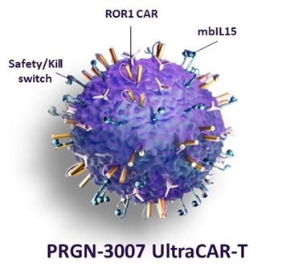
ROR1 is a type I orphan-receptor that is expressed during embryogenesis and by certain hematological and solid tumors but is undetectable on normal adult tissues. ROR1 in malignancies is aberrantly expressed in B-cell malignancies such as B-cell acute lymphoblastic leukemia, or B-ALL, diffuse large cell B-cell lymphoma, or DLBCL, chronic lymphocytic leukemia, or CLL, and mantle cell lymphoma, or MCL. Furthermore, upregulated expression has been detected in various solid tumors, including ovarian cancer, breast adenocarcinomas encompassing triple negative breast cancer, or TNBC, pancreatic cancer, Ewing's sarcoma and lung adenocarcinoma. The increased expression of ROR1 in hematological and solid tumor malignancies has been associated with tumor proliferation, metastasis and poor clinical outcomes.
The PD-1/programmed death ligand 1, or PD-L1, pathway plays a vital role in how tumor cells evade immune response. While the blockade of the PD-1/PD-L1 pathway has demonstrated considerable benefit for treating various cancers, the use of systemic CPI can lead to side effects associated with autoimmune response. The innovative design of PRGN-3007, where the blockade of PD-1 expression is intrinsic and localized to UltraCAR-T cells, is aimed at avoiding systemic toxicity and the high cost of CPI by eliminating the need for combination treatment.
In preclinical in vitro studies, PRGN-3007 showed significant reduction in PD-1 expression on UltraCAR-T cells compared to control ROR1 CAR-T cells lacking PD-1 blockade. The downregulation of PD-1 expression on PRGN-3007 resulted in enhanced ROR1-specific cytotoxicity and release of inflammatory cytokines upon co-culture with various ROR1-positive, or ROR1+, PD-L1+ hematological and solid tumor cells compared to Control ROR1 CAR-T, especially at low effector to target cell ratios. Single-cell cytokine proteomics showed that the downregulation of PD-1 expression on PRGN-3007 resulted in a significantly higher number of polyfunctional CAR-T cells compared to Control ROR1 CAR-T. PRGN-3007 showed robust expansion in presence of ROR1 antigen, lack of autonomous expansion in absence of ROR1, and durable persistence even in absence of exogenous cytokines in vitro. PRGN-3007 was selectively and effectively eliminated by the kill switch activator treatment demonstrating functionality of the kill switch, which is intended to improve the safety profile of PRGN-3007. In preclinical in vivo testing, a single administration of PRGN-3007, only one day after gene transfer, effectively reduced tumor burden and significantly improved overall survival of tumor bearing mice compared to Control ROR1 CAR-T in an aggressive xenograft model of mantle cell lymphoma. Blood analyses demonstrated sustained downregulation of PD-1 expression, rapid expansion, long-term persistence, and a predominant central memory phenotype of PRGN-3007 in tumor bearing mice.
The Phase 1/1b clinical trial is designed as an open-label study designed to evaluate the safety and efficacy of PRGN-3007 in patients with advanced ROR1+ hematological (Arm 1) and solid (Arm 2) tumors. The target patient population for Arm 1 includes relapsed or refractory CLL, relapsed or refractory MCL, relapsed or refractory B-ALL, and relapsed or refractory DLBCL. The target patient population for Arm 2 includes locally advanced unresectable or metastatic histologically confirmed TNBC. The study will enroll in two parts: an initial 3+3 dose escalation in each arm followed by a dose expansion at the maximum tolerated dose. As part of the strategic prioritization of our pipeline announced in August 2024, we have paused enrollment in the Phase 1 clinical trial of PRGN-3007.

Preclinical Programs
We have a robust pipeline of preclinical programs in order to drive long-term value creation. Our pipeline includes product candidates based on UltraCAR-T and "off-the-shelf" AdenoVerse immunotherapy therapeutic platforms. We expect to continue development of a number of potential product candidates in our preclinical pipeline and, consistent with our commitment to actively manage our portfolio programs, we exercise discipline in our portfolio management by systematically evaluating data from our preclinical programs in order to make rapid "go" and "no go" decisions. Through this process, we believe we can more effectively allocate resources to programs that we believe show the most promise and advance such programs to clinical trials.
24
Table of Contents
Precigen ActoBio (ActoBio)
ActoBio has developed a proprietary class of microbe-based biopharmaceuticals that enable expression and local delivery of disease-modifying therapeutics. We refer to these microbe-based biopharmaceuticals as ActoBiotics.ActoBio’s lead asset is AG019, a disease modifying antigen-specific, investigational immunotherapy for the prevention, delay, or reversal of type 1 diabetes mellitus, or T1D. We have completed a Phase 1b/2a clinical trial of AG019 for the treatment of early-onset T1D. As part of our strategic prioritization, we have completed the shutdown of our ActoBio subsidiary operations, including the elimination of all ActoBio personnel. In conjunction with this shutdown, ActoBio's portfolio of intellectual property is available for prospective transactions.
Precigen Exemplar
Exemplar is committed to enabling the study of life-threatening human diseases through the development of MiniSwine Yucatan miniature pig research models and services. Historically, researchers have lacked animal models that faithfully represent human diseases. As a result, a sizeable barrier has blocked progress in the discovery of human disease mechanisms; novel diagnostics, procedures, devices, prevention strategies and therapeutics; and the ability to predict in humans the efficacy of those next-generation procedures, devices, and therapeutics. Exemplar's MiniSwine models are genetically engineered to exhibit a wide variety of human disease states, which provides a more accurate platform to test the efficacy of new medications and devices.

As of December 31, 2024, Exemplar had 25 employees. Exemplar's primary domestic production facilities are located in Sioux County and Johnson County, Iowa, and include approximately 57,960 square feet of production, lab, and office facilities.
Competition: Healthcare Business
While we believe that our novel approach to developing the next generation of gene and cell therapies utilizing our AdenoVerse and UltraCAR-T platforms to target the most urgent and intractable challenges in immuno-oncology, autoimmune disorders, and infectious diseases provides us with competitive advantages, our industry is highly competitive and subject to rapid and significant technological change. Many of our competitors have significantly greater financial, technical, and human resource capabilities than we do, and certain of our competitors may also benefit from local government subsidies and other incentives that are not available to us. In addition, mergers and acquisitions in the pharmaceutical and biotechnology industries may result in even more resources being concentrated among a smaller number of our competitors. As a result of the resources available to our competitors, our competitors may be able to develop competing and/or superior technologies and processes, and compete more aggressively and sustain that competition over a longer period of time than we can.
Product candidates that we successfully develop and commercialize will compete with a range of therapies that are currently approved and any new therapies that may become available in the future. Our ability to compete successfully will depend on our ability to develop proprietary technologies that can be used to produce products that reach the market in a timely manner and are technologically superior to and/or are less expensive than other products on the market. The availability of reimbursement from government and other third-party payers will also significantly affect the pricing and competitiveness of our products. Our competitors may also obtain FDA or other regulatory approval for their products more rapidly than we may obtain approval for ours, which could result in our competitors establishing a strong market position before we are able to enter the market. Key product features that would affect our ability to effectively compete with other therapeutics include the efficacy, safety and convenience of our products, as well as the availability of intellectual property protection.
25
Table of Contents
AdenoVerse Immunotherapy
For our product candidate PRGN-2012 for the treatment of RRP, while we believe our approach for PRGN-2012 is novel based on the design of antigen targeting HPV6 and HPV11 and use of our gorilla adenovector, we face competition in the treatment of RRP. We believe our main competitor in the field is INOVIO Pharmaceuticals with their investigational DNA vaccine INO-3107 targeting HPV6 and HPV11 antigens.
For our PRGN-2009 candidate in HPV-associated cancers, we believe that INOVIO Pharmaceuticals, BioNTech SE, PDS Biotechnology, Hookipa Pharma, Transgene S.A. and Nykode Therapeutics are developing immunotherapies that are in clinical testing. TG4001 is an investigational therapeutic cancer vaccine candidate using an attenuated and modified poxvirus, or MVA, as a vector expressing the HPV16 E6 and E7 proteins and interleukin-2. We believe TG4001 is in a clinical trial in combination with anti-PD-L1 antibody avelumab for anogenital HPV+ cancers. INOVIO's lead investigational candidate VGX-3100 is a plasmid DNA based vaccine designed to increase T cell immune responses against the E6 and E7 antigens of HPV16 and HPV18. VGX-3100 is in clinical trials for precancerous cervical dysplasia, vulvar dysplasia, and anal dysplasia. INOVIO is also developing INO-3112, a DNA medicine candidate targeting HPV 16/18, combined with a DNA plasmid for IL-12 in combination with an anti-PD1 monoclonal antibody for locoregionally advanced, high-risk, HPV16/18 positive oropharyngeal squamous cell carcinoma. We believe BioNTech is developing BNT113, an investigational HPV16 E6/7 mRNA vaccine. We believe BNT113 in combination with an anti-PD1 monoclonal antibody is in a clinical trial for HPV16+PD1+ Head and Neck squamous cell carcinoma. We believe PDS Biotechnology is developing Versamune® HPV (previously PDS0101), an investigational HPV16 peptide vaccine for various HPV-associated cancers. We believe Versamune HPV is in clinical trials as monotherapy and combination therapy for recurrent/metastatic HPV16+ head and neck cancer, pre-metastatic HPV-associated oropharyngeal cancer, and HPV+ anal, cervical, head and neck, penile, vaginal, vulvar cancers. We believe Hookipa is developing Eseba-vec (HB-200), based on two single-vector compounds with arenaviral backbones based on lymphocytic choriomeningitis virus and pichinde virus expressing the same transgene encoding an HPV16 E7E6 fusion protein, which is in a clinical trial for HPV16+ head and neck cancers. Cellid is developing BVAC-C, which is based on CeliVax technology that uses patient-derived B cells and monocytes transfected with E6/E7 recombination gene of HPV16 and HPV18 and loaded with an adjuvant for HPV-associated cancers. Nykode Therapeutics is developing VB10.16, a DNA-based therapeutic vaccine targeting malignancies caused by HPV16, which is being evaluated in multiple clinical trials.
In addition to our direct competitors developing vaccines for treatment of HPV-associated cancers, various development-stage companies are involved in different vaccine and immunotherapy technologies, including Bavarian Nordic. We also face competition from non-vaccine based approaches being developed by companies such as Kite, Iovance, Bristol-Myers Squibb, and Merck.
UltraCAR-T
Our lead product candidates include PRGN-3005, PRGN-3006, and PRGN-3007, each of which are built on our UltraCAR-T platform. While we are employing a novel approach, there are a number of competitors pursuing CAR-T cell therapies for the treatment of cancer. We believe that, among others, Bristol-Myers Squibb, and Anixa Biosciences are developing CAR-T based treatments for ovarian cancer and Adaptimmune is developing TCR-T based treatment for ovarian cancer. We believe that Kite, Amgen, Cellectis S.A., Autolus and Allogene Therapeutics are also using CAR-T technology to develop product candidates for the treatment of AML. We believe that Lyell Immunopharma, and Oncternal Therapeutics are developing ROR1 CAR-T cells for treatment of ROR1-positive cancers.
Anixa Biosciences is developing an autologous CAR-T treatment targeting follicle stimulating hormone receptor (FSHR) for ovarian cancer, which we believe is in a clinical trial. Arsenal Biosciences is developing AB-1015 CAR-T, which we believe is in a clinical trial for platinum resistant ovarian cancer. Adaptimmune is developing ADP-A2M4CD8 TCR T-cell therapy that coepxresses CD8α co-receptor alongside the engineered TCR targeting MAGE-A4 which we believe is in a clinical trial.
Regeneron and 2seventy bio are developing bbT4015, an engineered CAR T-cell therapy targeting MUC16, which we believe is in preclinical development.
For the treatment of AML using cell therapies, we believe that Kite, 2seventy bio and Nkarta have product candidates in the most advanced clinical trials. Nkarta is developing NKX101, an investigational allogeneic NK cell therapy expressing a CAR target NKG2D ligands and mbIL-15. We believe NKX101 is in a clinical trial for AML and MDS. Vor Biopharma is developing Trem-cel (VOR33), an investigational hematopoietic stem cell (HSC) therapy with elimination of CD33 expression via gene-editing, in combination with MylotargTM, an anti-CD33 antibody drug conjugate (ADC). Vor Biopharma is also developing VCAR33, an autologous anti-CD33 CAR-T as a monotherapy and in combination with Trem-cel. We believe Autolus is developing AUTO09, an autologous CAR-T targeting CD33, CD123 and CLL-1, is in preclinical development. We believe Arcellx is developing ACLX-002, CAR-T targeting CD123 based on ARC-SparX platform. We believe Allogene Therapeutics' allogeneic CAR-T therapy ALLO, targeting CD70 is manufactured using healthy donor T-cells that are
26
Table of Contents
engineered using lentiviral transduction to express CAR followed by gene editing to eliminate expression of TCR to reduce the potential of rejection of therapy by a patient's immune system.
Oncternal Therapeutics is developing ONCT-808, a ROR1 targeted autologous CAR-T cell therapy, which we believe is in a clinical trial in patients with relapsed/refractory aggressive B cell malignancies.
In addition to our direct competitors that are using CAR-T therapies specifically for the treatment of ovarian cancer and AML, the CAR-T technology space has significant other competition including from multiple companies and their collaborators, such as Novartis and University of Pennsylvania, Kite and Gilead, Bristol-Myers Squibb, Janssen and Legend Biotech, Adaptimmune, Autolus Therapeutics, Roche and Poseida Therapeutics, and Gracell and AstraZeneca. We also face competition from non-cell based cancer treatments offered by other companies such as Amgen, AstraZeneca, Incyte, Merck, Abbvie, and Roche.
See "Precigen's Therapeutic Platforms" for a discussion of the features that we believe differentiate our UltraCAR-T treatments from our competitors.
Exemplar
Precigen Exemplar provides porcine research models and services that aid scientists in the understanding of human disease mechanisms and development of new therapeutics. We use precise genome modification to recapitulate numerous human diseases in our Yucatan MiniSwine platform, which are utilized by our industry and academic clientele for the development of new small molecules, gene, and cell therapies. We believe that the primary competitors of Exemplar are smaller privately owned entities.
Intellectual Property
We apply a multilayered approach for protecting intellectual property relating to the inventions we have developed internally, as well as those we have acquired from third parties, such as by assignment or by in-license. As we advance technologies, we evaluate and determine under the circumstances what type or types of intellectual property is appropriate for the technology, including patents, trademarks, know-how and trade secret protections. We seek patent protection in the United States and in other countries for our inventions, and we develop and protect our know-how and trade secrets relating to our platform technologies, as well as to our pipeline products including those of our subsidiaries and collaborators.
For instance, we pursue protection to switch technologies, gene delivery technologies, and genetic componentry related to our pipeline products. In addition, we seek patents covering specific collaborator's products.
We focus our intellectual property on aspects of our platforms and technologies that provide for the design and creation of cells, vectors and components for our pipeline and the pipelines of our collaborators, as well as technologies directed to improve delivery and expression of our pipeline products.
Our success depends, in part, upon our ability to obtain patents and maintain adequate protection for our intellectual property relating to our technologies and product pipeline. We have adopted a strategy of seeking patent protection in the United States and in other jurisdictions globally as we deem appropriate under the circumstances, with respect to certain of the technologies used in or relating to our technologies and product pipeline. For instance, where we believe appropriate, we have counterpart patents and patent applications in other jurisdictions, such as Australia, Canada, China, Europe, Hong Kong, India, Israel, Japan, Korea, and South Africa. In the future, we may file in these or additional jurisdictions as deemed appropriate for the protection of our technologies.
As of December 31, 2024, we owned or in-licensed patents in the United States and have pending United States patent applications relating to various aspects of our platforms and technologies, and we have pursued counterpart patents and patent applications in other jurisdictions around the world, as we have deemed appropriate. We continue to actively develop our portfolio through the filing of new patent applications, provisional and continuations or divisionals relating to our advancing technologies, methods and products as we and our collaborators deem appropriate.
We work to maintain protection for our key technologies including: our various switch technologies, with a last to expire patent currently in 2039; our portfolio around various gene delivery technologies and their use, with a last to expire patent in 2046; and our portfolio around various genetic componentry such as specialized vectors containing these genetic componentry and their use, with a last to expire patent in 2044. Although we have no certainty that these patents will not be subject to challenge
27
Table of Contents
in the future, as of this filing, there are currently no material contested proceedings and/or third-party claims with respect to any of these patent portfolios.
Additionally, we complement our intellectual property portfolio with exclusive and non-exclusive patent licenses and options for licenses to third-party technologies.
We further solidify our intellectual property protection through a combination of trade secrets, know-how, confidentiality, nondisclosure and other contractual provisions, and security measures to protect our confidential and proprietary information related to each platform and collaborator program. We regularly assess and review the risks and benefits of protecting our developments through various aspects of intellectual property available to us.
Because we rely on trade secrets, know-how, and continuing technological advances to protect various aspects of our technology, we require our employees, consultants and scientific collaborators to execute confidentiality and invention assignment agreements with us to maintain the confidentiality of our trade secrets and proprietary information. Our confidentiality agreements generally provide that the employee, consultant or scientific collaborator will not disclose our confidential information to third parties. These agreements also provide that inventions conceived by the employee, consultant or scientific collaborator in the course of working for us will be our exclusive property. Additionally, our employees agree to take certain steps to facilitate our assertion of ownership over such intellectual property. These measures may not adequately protect our trade secrets or other proprietary information. If they do not adequately protect our rights, third parties could use our technologies, and we could lose any competitive advantage we may have. In addition, others may independently develop similar proprietary information or techniques or otherwise gain access to our trade secrets, which could impair any competitive advantage we may have.
Regulatory Environment
With our diverse portfolio of proprietary technologies and novel therapeutic candidates, we are subject to significant and diverse regulations governing, among other things, research, operations and product approval. Regulatory compliance is critical to our ability to operate, our management of potential liabilities, and ultimately, our freedom to sell our products. Moreover, the products we are pursuing or are produced by us are subject to extensive regulation. Moreover, to the extent we utilize, now and in the future, third party service providers or license our programs to collaborators, we will need to rely on such third parties' compliance with laws and regulations applicable to the products or services they provide. We may not be able to independently monitor whether such third parties comply with applicable laws and regulations. Please see the risk factor entitled "We may rely on third parties, including through collaborations, to develop and commercialize some of our product candidates. Markets in which our collaborators develop product candidates using our technologies are subject to extensive regulation, and we will rely on our collaborators to comply with all applicable laws and regulations."
Environmental regulations affecting our business
We are subject to various federal, state and local environmental laws, rules and regulations, including those relating to the discharge of materials into the air, water and ground; the generation, storage, handling, use, transportation and disposal of hazardous materials; and the health and safety of employees with respect to laboratory activities required for the development of products and technologies. These laws and regulations require us to obtain environmental permits and comply with numerous environmental restrictions. These laws and regulations also may require expensive pollution control equipment or operational changes to limit actual or potential impacts to the environment.
Our laboratory activities inherently involve the use of potentially hazardous materials, which are subject to health, safety and environmental regulations. We design our infrastructure, procedures, and equipment to meet our obligations under these regulations. We perform recurring internal and third-party audits and provide employees ongoing training and support, as required. All of our employees must comply with safety instructions and procedures, which are codified in our employment policies. Federal and state laws and regulations impose requirements on the production, importation, use, and disposal of chemicals and genetically-modified material which impact us. Our processes may contain genetically engineered organisms which, when used in industrial processes, are considered new chemicals under the Toxic Substances Control Act program of the United States Environmental Protection Agency, or EPA. These laws and regulations would require us to obtain and comply with the EPA's Microbial Commercial Activity Notice process to operate. In the European Union, we may be subject to a chemical regulatory program known as REACH (Registration, Evaluation, Authorization and Restriction of Chemical Substances). Under REACH, companies are required to register their products with the European Commission, and the registration process could result in significant costs or delay the manufacture or sale of products in the European Union.
28
Table of Contents
Healthcare regulations affecting our business
Human therapeutics regulation
Governmental authorities in the United States, at the federal, state and local level, and in other countries extensively regulate, among other things, the research, development, testing, manufacture, including any manufacturing changes, approval, packaging, storage, recordkeeping, labeling, advertising, promotion, distribution, sale, marketing, import and export of therapeutic products such as those being developed by us. The processes for obtaining regulatory approvals in the United States and in foreign countries, along with subsequent compliance with applicable statutes, regulations, and requirements imposed by regulatory agencies, require the expenditure of substantial time and financial resources.
In the United States, pharmaceuticals and biological products must receive approval from the FDA before being marketed. The FDA approves drug products other than biological products through its authority under the Federal Food, Drug, and Cosmetic Act, or FDCA, and implementing regulations. The FDA licenses biological products, or biologics, through its authority under the Public Health Service Act, or PHSA, and implementing regulations. The development processes for obtaining FDA approval for a non-biological drug product under the FDCA and for biologic licensure under the PHSA are generally similar but have product-related differences reflected in regulations and in FDA guidance documents.
United States pharmaceutical development process
The process required by the FDA before a pharmaceutical product candidate may be marketed generally involves the following:
•completion of preclinical laboratory tests and in vivo studies in accordance with applicable regulatory requirements, which may include the FDA's current Good Laboratory Practice regulations and the Animal Welfare Act;
•submission to the FDA of an IND for human clinical testing, which must become effective before human clinical trials commence;
•performance of adequate and well-controlled human clinical trials according to the FDA's Good Clinical Practices, or GCP, regulations, and any additional requirements for the protection of human research subjects and their health information, to establish the safety and efficacy of the proposed product candidate for each intended use;
•preparation and submission to the FDA of an application for marketing approval that includes substantial evidence of safety, purity and potency for a biologic, or of safety and efficacy for a non-biologic drug, including from results of nonclinical testing and clinical trials;
•satisfactory completion of an FDA inspection of the manufacturing facility or facilities where the product candidate is produced to assess compliance with cGMP and that the methods and controls are adequate to assure the product candidate's identity, safety, strength, quality, potency and purity;
•potential FDA inspection of the nonclinical and clinical trial sites that generated the data in support of the application; and
•FDA review and approval of the application.
Preclinical testing
Before testing any product candidate in humans in the United States, a company must develop preclinical data, generally including laboratory evaluation of the product candidate's chemistry and formulation, as well as toxicological and pharmacological studies in animal species to assess safety and quality. Certain types of animal studies must be conducted in compliance with the FDA's Good Laboratory Practice regulations and the Animal Welfare Act, which is enforced by the Department of Agriculture.
IND application
A person or entity sponsoring clinical trials in the United States to evaluate a product candidate's safety and effectiveness must submit to the FDA, prior to commencing such trials, an IND application, which contains preclinical testing results and other data and information that allow the FDA to evaluate whether there is an adequate basis for testing the drug in humans. If the FDA does not object to the IND application within 30 days of submission, the clinical testing proposed in the IND may begin.
29
Table of Contents
Even after the IND has gone into effect and clinical testing has begun, the FDA may put clinical trials on "clinical hold," suspending or, in some cases, ending them because of safety concerns or for other reasons.
Human clinical trials under an IND
Clinical trials involve administering the product candidate to healthy volunteers or patients under the supervision of qualified investigators. Clinical trials must be conducted and monitored in accordance with the FDA's regulations, such as GCP requirements. Each clinical trial must also be conducted under a protocol that details, among other things, the study objectives, parameters for monitoring safety, and the efficacy criteria, if any, to be evaluated. The protocol is submitted to the FDA as part of the IND and reviewed by the agency. Further, each clinical trial must be reviewed and approved by an Institutional Review Board, or IRB, at or servicing each institution at which the clinical trial will be conducted. An IRB is charged with protecting the welfare and rights of trial participants and considers, among other things, whether the risks to individuals participating in the clinical trials are minimized and are reasonable in relation to anticipated benefits. The sponsor of a clinical trial, the investigators, and IRBs each must comply with requirements and restrictions that govern, among other things, obtaining informed consent from each study subject, complying with the protocol and investigational plan, adequately monitoring the clinical trial, and timely reporting adverse events. Clinical trials involving recombinant or synthetic nucleic acid molecules, such as DNA, conducted at institutions that receive any funding from the National Institutes of Health also must be reviewed by an institutional biosafety committee, an institutional committee that reviews and oversees basic and clinical research that utilizes recombinant DNA at that institution.
The sponsor of a clinical trial or the sponsor's designated responsible party may be required to register certain information about the trial and disclose certain results on government or independent registry websites, such as clinicaltrials.gov.
Human clinical trials typically are conducted in three sequential phases that may overlap or be combined:
•Phase 1. The product candidate is introduced into a small number of healthy human subjects and tested for safety, dosage tolerance, absorption, metabolism, distribution, excretion and, if possible, to gain early understanding of its effectiveness. For some product candidates for severe or life-threatening diseases, especially when the product candidate may be too inherently toxic to ethically administer to healthy volunteers, the initial human testing is often conducted in patients with the targeted disease.
•Phase 2. The product candidate is administered and evaluated in a limited patient population to identify possible adverse effects and safety risks, to evaluate preliminary efficacy evidence for specific targeted diseases and to determine dosage tolerance, optimal dosage and dosing schedule.
•Phase 3. The product candidate is administered to an expanded patient population with the target disease or disorder, often at geographically dispersed clinical trial sites, in adequate and well-controlled clinical trials to generate sufficient data to evaluate the safety and efficacy of the non-biologic drug, or the safety, purity, and potency of the biologic. These clinical trials are intended to establish the overall risk/benefit profile of the product candidate and provide an adequate basis for product labeling.
Post-approval clinical trials, sometimes referred to as Phase 4 clinical trials, may be conducted, or may be required to be conducted, after initial approval to further assess the risk/benefit profile of the product and to gain additional experience from treatment of patients in the intended indication, including for long-term safety follow-up.
Additional regulation for gene therapy clinical trials
Additional standards apply to clinical trials involving gene therapy. The FDA has issued guidance documents regarding gene therapies, which relate to, among other things: preclinical assessments; chemistry, manufacturing and controls, or CMC, information that should be included in an IND application; the proper design of tests to measure product potency in support of an application; and long-term follow-up measures to observe delayed adverse effects in subjects exposed to investigational gene therapies when the risk of such effects is not low or when the gene therapy utilizes genome-editing technology, shows signs of persistence, has the potential for latency and reactivation, or genetically alters the human genome.
United States review and approval processes
The results of the preclinical tests and clinical trials, together with detailed information relating to the product's CMC and proposed labeling, among other things, are submitted to the FDA as part of an application requesting approval to market the product for one or more uses, or indications. When an application is submitted, the FDA makes an initial determination as to
30
Table of Contents
whether the application is sufficiently complete to be accepted for review. If the application is not, the FDA may refuse to accept the application for filing and request additional information. A refusal to file, which requires resubmission of the application with the requested additional information, delays review of the application. For gene therapies, selecting patients with applicable genetic defects is often a necessary condition to effective treatment and may require diagnostic devices that the FDA has cleared or approved prior to or contemporaneously with approval of the gene therapy.
Under the Pediatric Research Equity Act, or PREA, certain marketing applications generally must contain data to assess the safety and effectiveness of the product candidate for the claimed indications in all relevant pediatric subpopulations and to support dosing and administration for each pediatric subpopulation for which the product candidate is safe and effective. The FDA may grant deferrals for submission of data or full or partial waivers. Unless otherwise required by regulation, PREA does not apply to any product candidate for an indication for which orphan designation has been granted.
On the basis of the marketing application and accompanying information, including the results of the inspection of the manufacturing facilities, the FDA may issue an approval letter or a complete response letter. An approval letter authorizes commercial marketing of the drug with specific prescribing information for specific indications. A complete response letter generally outlines the deficiencies in the submission and may require substantial additional testing or information for the FDA to reconsider the application. If those deficiencies have been addressed to the FDA's satisfaction in a resubmission of the application, the FDA may issue an approval letter.
If a product candidate receives regulatory approval, the approval may be significantly limited to specific diseases and dosages or the indications for use may otherwise be limited. Further, the FDA may require that certain contraindications, warnings or precautions be included in the product labeling. The FDA may impose restrictions and conditions on product distribution, prescribing or dispensing in the form of a Risk Evaluation and Mitigation Strategy, or REMS, or otherwise limit the scope of any approval. In addition, the FDA may require postmarketing clinical trials designed to further assess the risk/benefit profile of the product and to gain additional experience from treatment of patients in the intended indication, including for long-term safety follow-up.
Compliance with cGMP requirements
Drug and biologics manufacturers must comply with applicable cGMP regulations. Manufacturers and others involved in the manufacture and distribution of such products also must register their establishments with the FDA and certain state agencies. Both domestic and foreign manufacturing establishments must register and provide additional information to the FDA upon their initial participation in the manufacturing of drugs. Establishments may be subject to periodic, unannounced inspections by the FDA and other government authorities to ensure compliance with cGMP requirements and other laws. Discovery of problems may result in a government entity placing restrictions on a product, manufacturer or holder of an approved product application and may extend to requiring withdrawal of the product from the market.
Orphan Drug Designation in the United States
Under the Orphan Drug Act, the FDA may grant orphan drug designation to drugs and biological products intended to treat a "rare disease or condition," which generally is a disease or condition that affects fewer than 200,000 individuals in the United States. Orphan drug designation must be requested before submitting a marketing application or supplement seeking approval for the orphan indication. After the FDA grants orphan drug designation, the common identity of the therapeutic agent and its potential orphan use are publicly disclosed by the FDA.
Orphan drug designation does not—by itself—convey any advantage in, or shorten the duration of, the regulatory review and approval process. If a product that has an orphan drug designation subsequently receives the first FDA approval for that drug or biologic for the indication for which it has been designated, the product is entitled to an orphan exclusivity period in which the FDA may not approve any other applications to market the same drug or biologic for the same indication for seven years.
Exceptions to the seven-year exclusivity period may apply in limited circumstances, such as where the sponsor of a different version of the product is able to demonstrate that its product is clinically superior to the approved orphan drug product. This exclusivity does not prevent a competitor from obtaining approval to market a different product that treats the same disease or condition, or the same product to treat a different disease or condition. The FDA can revoke a product's orphan drug exclusivity under certain circumstances, including when the holder of the approved orphan drug application is unable to assure the availability of sufficient quantities of the drug to meet patient needs. Orphan exclusivity operates independently from other regulatory exclusivities and other protections against generic or biosimilar competition.
31
Table of Contents
A sponsor of a product application that has received an orphan drug designation is also granted tax incentives for clinical research undertaken to support the application. In addition, the FDA may coordinate with the sponsor on research study design for an orphan drug and may exercise its discretion to grant marketing approval on the basis of more limited product safety and efficacy data than would ordinarily be required, based on the limited size of the applicable patient population. Orphan drug designation does not, however, change the legal standard required for a product candidate to obtain FDA approval.
Fast Track Designation
The FDA has a number of expedited review programs for drugs that are intended for the treatment of a serious or life-threatening condition. As one example, under the agency's Fast Track program, the sponsor of a new drug candidate may request the FDA to designate the product for a specific indication as a Fast Track product concurrent with or after the filing of the IND for the product candidate, if nonclinical and clinical data demonstrate the product's potential to address unmet medical needs and the product is intended to treat a serious condition. The FDA must determine if the product candidate qualifies for Fast Track designation within 60 days after receipt of the sponsor's request.
In addition to other benefits, such as the ability to have more frequent interactions with the FDA, the agency may initiate review of sections of a Fast Track product's marketing application before the application is complete. This rolling review is available if the applicant provides and the FDA approves a schedule for the submission of the remaining information and the applicant pays applicable user fees. However, the FDA's review period for a Fast Track application does not begin until the last section of the marketing application is submitted. In addition, the Fast Track designation may be withdrawn by the FDA if the agency believes that the designation is no longer supported by data emerging in the clinical trial process.
Regenerative Medicine Advanced Therapy Designation
The FDA may grant regenerative medicine advanced therapy, or RMAT, designation to regenerative medicine therapies, which may include cell therapies, human gene therapies, therapeutic tissue engineering products, and human cell and tissue products, if certain criteria are met. In particular, a drug may be eligible for RMAT designation if the drug is a regenerative medicine therapy as defined in Section 506(g)(8) of the FDCA; the drug is intended to treat, modify, reverse, or cure a serious or life-threatening disease or condition; and preliminary clinical evidence indicates that the drug has the potential to address unmet medical needs for such disease and condition. The FDA must determine if the product candidate qualifies for RMAT designation within 60 days after receipt of the sponsor's request.
A grant of RMAT designation includes all of the benefits of Fast Track designation, intensive guidance on efficient drug development beginning as early as Phase 1, and organizational commitment involving senior managers. The RMAT designation may be withdrawn by the FDA if the agency believes that the designation is no longer supported by data emerging in the clinical trial process.
Breakthrough Therapy Designation
A Breakthrough Therapy designation is a process designed to expedite the development and review of drugs that are intended to treat a serious condition and preliminary clinical evidence indicates that the drug may demonstrate substantial improvement over available therapy on a clinically significant endpoint(s). The FDA may expedite the development and review of the application for approval of drugs that are intended to treat a serious or life-threatening disease or condition where preliminary clinical evidence indicates that the drug may demonstrate substantial improvement over existing therapies on one or more clinically significant endpoints. Under the Breakthrough Therapy program, the sponsor of a new product candidate may request that the FDA designate the product candidate for a specific indication as a breakthrough therapy concurrent with, or after, the filing of the IND for the product candidate. A Breakthrough Therapy designation provides all Fast Track designation features, offers intensive guidance on an efficient drug development program and ensures organizational commitment involving senior management at FDA. The FDA must determine if the product candidate qualifies for Breakthrough Therapy designation within 60 days of receipt of the sponsor’s request.
Post-approval requirements
Rigorous and extensive FDA regulation of drugs and biologics continues after approval, including requirements relating to recordkeeping, periodic reporting, product sampling and distribution, adverse experiences with the product, cGMP, and advertising and promotion. Changes to the product, manufacturing process, or facility often require prior FDA approval before being implemented and other types of changes to the approved product, such as adding new indications and additional labeling claims, are also subject to further FDA review and approval. Additionally, the FDA may require postmarketing studies or
32
Table of Contents
clinical trials, changes to a product's approved labeling, including the addition of new warnings and contraindications, or the implementation of other risk management measures, including distribution restrictions, if new safety information emerges. Failure to comply with the applicable requirements may result in administrative, judicial, civil or criminal actions and adverse publicity. These actions may include FDA's refusal to approve or delay in approving pending applications or supplemental applications, withdrawal of approval, clinical hold, suspension or termination of clinical trial, warning or untitled letters, product recalls, product seizures, total or partial suspension of production or distribution, injunctions, fines or other monetary penalties, refusals of government contracts, mandated corrective advertising or communications with healthcare providers, debarment, restitution, disgorgement of profits or other civil or criminal penalties.
Regulatory Exclusivity and Biosimilar Competition in the United States
In 2010, the federal Biologics Price Competition and Innovation Act, or BPCIA, was enacted, creating a statutory pathway for licensure, or approval, of biological products that are biosimilar to, and possibly interchangeable with, reference biological products licensed under the Public Health Service Act.
Under the BPCIA, innovator manufacturers of original biological products are granted twelve years of marketing exclusivity after first licensure before biosimilar versions of such products can be licensed for marketing in the United States. This means that the FDA may not approve an application for a biosimilar product that references data in an innovator's Biologics License Application, or BLA, until 12 years after the date of approval of the reference biological product, with a potential six-month extension of exclusivity if certain pediatric studies are conducted and the results are reported to the FDA. A biosimilar application may be submitted four years after the date of licensure of the reference biological product, but the FDA cannot approve the application until the full exclusivity period has expired. This 12-year exclusivity period operates independently from other protections that may apply to biosimilar competitors, including patents that are held for those products. Additionally, the BPCIA establishes procedures by which the biosimilar applicant must provide information about its application and product to the reference product sponsor and by which information about potentially relevant patents may be shared and litigation over patents may proceed in advance of approval. The BPCIA also provides a period of exclusivity for the first biosimilar to be determined by the FDA to be interchangeable with the reference product.
Under the Best Pharmaceuticals for Children Act, which was subsequently made applicable to biological products by the BPCIA, the FDA may also issue a Written Request asking a sponsor to conduct pediatric studies related to a particular active moiety; if the sponsor agrees and meets certain requirements, the sponsor may be eligible to receive an additional six months of marketing exclusivity for its drug product containing such active moiety.
Other regulatory exclusivity may be granted to drugs, including, but not limited to, three-year and five-year exclusivity granted to non-biologic drugs under the Drug Price Competition and Patent Term Restoration Act of 1984, also referred to as the Hatch-Waxman Amendments.
Depending upon the timing, duration, and specifics of FDA approval of a product candidate, some of a sponsor's United States patents may be eligible for limited patent term extension under the Hatch-Waxman Amendments. The Hatch-Waxman Amendments permit a patent restoration term of up to five years as compensation for patent term lost during product development and the FDA regulatory review process. However, patent term restoration cannot extend the remaining term of a patent beyond a total of 14 years from the product's approval date. The United States Patent and Trademark Office, or USPTO, in consultation with the FDA, reviews and approves the application for any patent term extension or restoration. Only one patent applicable to an approved drug product is eligible for the extension and the application for the extension must be submitted prior to the expiration of the patent.
Foreign regulation of human therapeutics
In addition to regulations in the United States, Precigen and ActoBio, and any third party service providers or collaborators will be subject to a variety of foreign regulations governing clinical trials and commercial sales and distribution of the products enabled by our technologies outside of the United States. Whether or not the developer obtains FDA approval for a product, they must obtain approval by the comparable regulatory authorities of foreign countries or economic areas, such as the European Union, before they may commence clinical trials or market products in those countries or areas. The approval process and requirements governing the conduct of clinical trials, product licensing, pricing and reimbursement vary greatly from place to place, and the time may be longer or shorter than that required for FDA approval.
Under Regulation (EC) No 141/2000, PRGN-2012 Orphan drug designation in the European Union (EU) was granted by the European Commission in January 2024 based on a positive opinion issued by the European Medicines Agency (EMA) adopted by the Committee for Orphan Medicinal Products (COMP).
33
Table of Contents
Anti-Kickback, False Claims, and Other Marketing and Fraud and Abuse Laws
Healthcare providers, physicians and others will play a primary role in the recommendation and prescription of any products for which we obtain marketing approval. Our future arrangements with healthcare providers, patients and third-party payers will expose us to broadly applicable United States fraud and abuse and other healthcare laws and regulations that may constrain the business or financial arrangements and any collaborative partners through which we market, sell and distribute any products for which we obtain marketing approval. Restrictions under applicable federal and state healthcare laws and regulations are discussed in the "Risk Factors" section below.
Privacy Laws
In the United States, we may be subject to data privacy and security laws and regulations by both the federal government and the states in which we conduct our business. The legislative and regulatory landscape for privacy and data protection continues to evolve, and there has been an increasing focus on privacy and data protection issues which may affect our business. Numerous federal and state laws and regulations, including state data breach notification laws, state health information and/or genetic privacy laws and federal and state consumer protection laws (e.g., Section 5 of the Federal Trade Commission, or FTC, Act and the California Consumer Privacy Act, as amended by the California Privacy Rights Act, or CCPA), govern the collection, use, disclosure, protection and other processing of health-related and other personal information. Many of these laws differ from each other in significant ways and may not have the same effect, thus complicating compliance efforts. Compliance with these laws is difficult, constantly evolving, and time consuming. Federal regulators, state attorneys general, and plaintiffs' attorneys, including class action attorneys, have been and will likely continue to be active in this space.
The Health Insurance Portability and Accountability Act of 1996, or HIPAA, imposes requirements relating to the privacy, security and transmission of individually identifiable health information. We may obtain health information from third parties, such as research institutions, that are subject to privacy and security requirements under HIPAA. Although we are not directly subject to HIPAA other than with respect to providing certain employee benefits, we could potentially be subject to criminal penalties if we, our affiliates, or our agents knowingly obtain, use, or disclose individually identifiable health information maintained by a HIPAA-covered entity in a manner that is not authorized or permitted by HIPAA.
In addition, the CCPA establishes certain requirements for data use and sharing transparency, and provides California residents certain rights concerning the use, disclosure, and retention of their personal data. The CCPA and its implementing regulations have already been amended multiple times since their enactment. Similarly, numerous other states have enacted, or are considering enacting, comprehensive data privacy laws that share similarities with the CCPA, and there are a number of legislative proposals in the United States at the federal level, in each case which could impose new obligations or limitations in areas affecting our business. These laws and regulations are evolving and subject to interpretation, and may impose limitations on our activities or otherwise adversely affect our business. The CCPA and evolving legislation may require us, among other things, to update our notices and develop new processes internally and with our partners.
Internationally, laws and regulations in many jurisdictions also apply broadly to the collection, use, storage, disclosure, protection and other processing of data that identifies or may be used to identify or locate an individual. Please see the risk factor entitled “Failure to comply with current or future federal, state and foreign laws and regulations and industry standards relating to privacy and data protection laws could lead to governmental enforcement actions (which could include civil or criminal penalties), private litigation, and/or adverse publicity and could negatively affect our operating results and business.”
Healthcare Reform
In the United States and some foreign jurisdictions, there have been, and continue to be, a number of legislative and regulatory changes and proposed changes regarding the healthcare system that could, among other things, prevent or delay marketing approval of our product candidates, restrict or regulate post-approval activities, and affect our ability, or the ability of any collaborators, to profitably sell any products for which we, or they, obtain marketing approval. We expect that current laws, as well as other healthcare reform measures that may be adopted in the future, may result in more rigorous coverage criteria and in additional downward pressure on the price that we may receive for any approved products.
The Patient Protection and Affordable Care Act, as amended by the Health Care and Education Reconciliation Act of 2010, or collectively, the Affordable Care Act, has substantially changed the way healthcare is financed by both governmental and commercial payers and significantly impacts the pharmaceutical industry. Certain provisions of the Affordable Care Act have been subject to judicial challenges, as well as efforts to repeal, replace, or otherwise modify them or to alter their interpretation or implementation. For example, the Tax Cuts and Jobs Act, or Tax Act, enacted in December 2017 eliminated the tax-based payment for individuals who fail to maintain minimum essential coverage under section 5000A of the Internal Revenue Code of
34
Table of Contents
1986, as amended, commonly referred to as the "individual mandate," effective January 1, 2019. Additional legislative changes, regulatory changes, and judicial challenges related to the Affordable Care Act remain possible. It is unclear how the Affordable Care Act and its implementation, as well as efforts to repeal, replace, or otherwise modify, or invalidate, the Affordable Care Act, or portions thereof, will affect our business.
In addition, other legislative changes have been proposed and adopted since the Affordable Care Act was enacted. For example, the Budget Control Act of 2011, as amended, among other things led to aggregate reductions in Medicare payments for all items and services, including prescription drugs and biologics, to service providers of, on average, 2 percent per fiscal year beginning April 1, 2013, and, due to subsequent legislation, continuing until 2030 (with the exception of a temporary suspension from May 1, 2020, through March 31, 2021) unless Congress takes additional action.
It is possible that the Affordable Care Act, as currently enacted or may be amended in the future, as well as other healthcare reform measures that may be adopted in the future, and their implementation may result in additional reductions in Medicare and other healthcare funding, more rigorous coverage criteria, and new payment methodologies and in additional downward pressure on coverage and payment and the price that we receive for any approved product. Any reduction in reimbursement from Medicare or other government programs may result in a similar reduction in payments from commercial payers. The implementation of cost containment measures or other healthcare reforms may prevent us from being able to generate revenue, attain profitability, or commercialize our products.
Reportable Segments
As of December 31, 2024, our reportable segments were (i) Biopharmaceuticals and (ii) Exemplar. These identified reportable segments met the quantitative thresholds to be reported separately for the year ended December 31, 2024. See "Notes to the Consolidated Financial Statements - Note 16" appearing elsewhere in this Annual Report for a discussion of our reportable segments and Segment Adjusted EBITDA.
Research and Development
As of December 31, 2024, we had 99 employees supporting our research and development functions of our healthcare operations, including operational and facility activities. We incurred expenses of $53.1 million, $48.6 million and $47.2 million in 2024, 2023, and 2022, respectively, on research and development activities for continuing operations. We anticipate that our research and development expenditures could increase as we advance our healthcare programs and platforms. As of December 31, 2024, our primary domestic research and development operations were located in laboratory facilities in Germantown, Maryland, and our primary international research and development operations were located in a laboratory facility in Ghent, Belgium.
Financial Information
Collaboration revenues, product revenues, service revenues and other revenues and operating loss for each of the last three fiscal years, along with assets as of December 31, 2024, and 2023, are set forth in the consolidated financial statements, which are included in Item 8 of this Annual Report. Financial information about geographic areas is set forth in "Notes to the Consolidated Financial Statements - Note 16" appearing elsewhere in this Annual Report.
Human Capital Management
As of December 31, 2024, out of 143 employees, 123 support our healthcare operations, of which 99 support our research and development functions including operational and facility activities. Of these research and development employees, 40 have advanced degrees, of which 24 are PhDs. Our corporate employees provide support to all of our operating subsidiaries and are responsible for the execution of all corporate functions, including executive, operational, finance, human resources, information technology, legal, and corporate communications. None of our employees are represented by a collective bargaining agreement.
We structure our compensation packages to compete for the best talent. Our compensation packages include a competitive base salary and bonus, the issuance of equity incentives, a 401(k) plan, and health and wellness benefits, including a health insurance plan with a Platinum actuarial value.
Our 2024 employee development initiatives included employee training targeting specific areas of interest, executive and manager coaching, and performance management, which encompass performance goals and competency evaluations.
35
Table of Contents
Additional Information
Our website is www.precigen.com. The information on, or that can be accessed through, our website does not constitute part of and is not deemed to be incorporated by reference into, this Annual Report. We post regulatory filings on this website as soon as reasonably practicable after they are electronically filed with or furnished to the SEC. These filings include annual reports on Form 10-K; quarterly reports on Form 10-Q; current reports on Form 8-K; Section 16 reports on Forms 3, 4, and 5; and any amendments to those reports filed with or furnished to the SEC. We also post our press releases on our website. Access to these filings or any of our press releases on our website is available free of charge. Copies are also available, without charge, from Precigen Investor Relations, 20374 Seneca Meadows Parkway, Germantown, Maryland 20876. Reports filed with the SEC may be viewed at www.sec.gov.
In addition, our Corporate Governance Guidelines, Code of Business Conduct and Ethics, and charters for the Audit Committee, the Compensation and Human Capital Management Committee and the Nominating and Governance Committee are available free of charge to shareholders and the public through the "Corporate Governance" section of our website. Printed copies of the foregoing are available to any shareholder upon written request to our Communications Department at the address set forth on the cover of this Annual Report or may be requested through our website, www.precigen.com.

Item 1A. Risk Factors
Investing in our common stock involves a high degree of risk. You should carefully consider the risks described below, together with the other information contained in this Annual Report, including our consolidated financial statements and the related notes appearing at the end of this Annual Report, before making your decision to invest in shares of our common stock. We cannot assure you that any of the events discussed in the risk factors below will not occur. These risks could have a material and adverse impact on our business, results of operations, financial condition, or prospects. If that were to happen, the trading price of our common stock could decline, and you could lose all or part of your investment.
This Annual Report also contains forward-looking statements that involve risks and uncertainties. Our actual results could differ materially from those anticipated in these forward-looking statements as a result of certain factors, including the risks faced by us described below and elsewhere in this Annual Report. See "Special Note Regarding Forward-Looking Statements" for information relating to these forward-looking statements.
Risks Related to Our Financial Position and Capital Needs
We have identified conditions that raise substantial doubt about our ability to continue as a going concern and we may need substantial additional capital in the future in order to fund our business.

Our consolidated financial statements as of and for the year ended December 31, 2024 have been prepared on the basis that we will continue as a going concern, which contemplates the realization of assets and satisfaction of liabilities in the normal course of business. We have incurred significant losses since our inception and we expect that we will continue to incur losses in the near term as we aim to successfully execute our business plan, which includes the commercialization of PRGN-2012. Based on our balance of cash, cash equivalents and short-term investments of $97.9 million at December 31, 2024 and forecasted negative cash flows from operating activities and purchases of property, plant and equipment, there is substantial doubt about our ability to continue as a going concern within one year after the date that these financial statements are issued. The forecasted negative cash flows used in our going concern analysis do not include the potential revenue from PRGN-2012 for the treatment of adults with RRP, which is considered outside of our direct control, as the BLA (which was accepted by the FDA in February 2025 under a priority review with a PDUFA target action date set for August 27, 2025) has not yet been approved.
Our ability to fund our operations is dependent upon the FDA's approval of our BLA and the successful commercialization of PRGN-2012 with revenues sufficient to support our cost structure. In addition, we may decide, or be required to raise additional capital. This additional capital could be raised through a combination of non-dilutive financings (including debt financings, collaborations, strategic alliances, monetization of assets, marketing, distribution or licensing arrangements), and/or dilutive financings (including equity and/or debt financings with an equity component). There can be no assurance that new financings or other transactions will be available to us on commercially acceptable terms, or at all, and such financings may adversely affect the holdings or rights of our stockholders and may cause significant dilution to existing stockholders.
Further, the doubt regarding our potential ability to continue as a going concern may adversely affect our ability to obtain new financing on reasonable terms or at all. Also, any collaborations, strategic alliances, monetization of non-core assets or marketing, distribution or licensing arrangement may require us to give up some or all of our rights to a product or technology, which in some cases may be at less than the full potential value of such rights. If we are unable to successfully commercialize
36
Table of Contents
PRGN-2012 or obtain additional capital, we will assess our capital resources and may be required to delay, reduce the scope of, or eliminate some or all of our operations, which may include research and development, clinical trials and preparing for commercial readiness, or seeking bankruptcy protection. This may have a material adverse effect on our business, financial condition, results of operations and ability to operate as a going concern. The accompanying audited financial statements do not include any adjustments that might be necessary if we are not able to continue as a going concern. Additionally, if we are unable to continue as a going concern, our stockholders may lose some or all of their investment in us. See also “Notes to Condensed Consolidated Financial Statements - Note 1 appearing elsewhere in this Annual Report for additional discussion of our liquidity and ability to continue as a going concern.
We have a limited number of shares of common stock available for future issuance which could adversely affect our ability to raise capital or consummate strategic transactions.
We are currently authorized to issue 400,000,000 shares of common stock under our amended and restated certificate of incorporation. As of February 15, 2025, we have issued 294,042,973 shares of common stock, approximately 28,463,388 shares of common stock were committed for issuance giving effect to the assumed exercise of all outstanding options and vesting of restricted stock units and performance stock units and approximately 70,222,215 shares of common stock initially underlying the Series A Preferred Stock and 52,666,669 shares of common stock initially underlying the Warrants. The exercisability of the Series A Preferred Stock and the Warrants is contingent upon us obtaining stockholder approval to increase the number of authorized shares of common stock. Due to the limited number of authorized shares common stock available for future issuance, we may not be able to raise additional equity capital, complete a merger or other business combination, unless we increase the number of shares we are authorized to issue. We would need to seek stockholder approval to increase the number of our authorized shares of common stock, and we can provide no assurance that we would succeed in amending our amended and restated certificate of incorporation to increase the number of shares of common stock we are authorized to issue which could negatively impact our business, prospects and results of operations.
Our strategic prioritization and streamlining of resources undertaken to extend our cash runway and focus more of our capital resources on PRGN-2012 might not achieve our intended outcome.

On August 6, 2024, we publicly announced a strategic prioritization of our clinical portfolio and streamlining of resources, including a reduction of over 20% of our work force, to focus on potential commercialization of PRGN-2012 for the treatment of RRP. In connection with the implementation of our strategic prioritization and streamlining of resources, we recorded non-cash impairment charges to goodwill and other assets of approximately $32.9 million, net of tax, in the second quarter of 2024 and we also recorded a charge related to employee severance and termination benefits of $2.1 million, which were paid in the third quarter of 2024. We may continue to incur additional expenses not currently contemplated due to events associated with strategic prioritization and streamlining of resources; for example, the reduction in force may have a future impact on other areas of our liabilities and obligations, which could result in losses in future periods. The reduction in force may result in unintended consequences and costs, such as the loss of institutional knowledge and expertise, attrition beyond the intended number of employees, and decreased morale among our remaining employees. In addition, while positions have been eliminated, certain functions necessary to our operations remain, and we might not successfully distribute the duties and obligations of our terminated employees among our remaining employees. The reduction in workforce could also make it difficult for us to pursue, or prevent us from pursuing, new opportunities and initiatives due to insufficient personnel, or require us to incur additional and unanticipated costs to hire new personnel to pursue such opportunities or initiatives. Moreover, we may not realize, in full or in part, the anticipated benefits and savings from this strategic prioritization and streamlining of resources due to unforeseen difficulties, delays or unexpected costs. If we are unable to realize the anticipated benefits from the strategic prioritization and streamlining of resources, or if we experience significant adverse consequences from such actions, our business, financial condition and results of operations may be materially adversely affected. In addition, we may need to undertake additional workforce reductions or restructuring activities in the future.
We have a history of net losses, and we may not achieve or maintain profitability.
We have incurred net losses since our inception, with the exception of 2022 where we had $28.3 million in net income due to the sale of TransOva, which generated a gain on divestiture of $94.7 million. As of December 31, 2024, we had an accumulated deficit of $2.1 billion. We expect to incur losses and negative cash flows from operating activities for the foreseeable future.
We anticipate that our expenses will increase substantially as we continue to advance the preclinical and clinical development of our existing product candidates and our research programs as well as prepare commercial capabilities for our lead product candidate, and there is a significant risk that our product candidates will fail to demonstrate adequate efficacy or an acceptable safety profile, obtain regulatory approval, or become commercially viable. A significant period of time could pass before commercialization of our various product candidates or before the execution of contractual relationships providing for up-front
37
Table of Contents
payments, milestones or royalties sufficient to achieve profitability. As a result, our expenses may exceed revenues for the foreseeable future, and we may not achieve profitability. If we fail to achieve profitability, or if the time required to achieve profitability is longer than we anticipate, we may not be able to continue our business. Even if we do achieve profitability, we may not be able to sustain or increase profitability on a quarterly or annual basis.
We expect our future capital requirements will be substantial and will depend on many factors.
Our operations have consumed substantial amounts of cash since our inception. We expect to continue to spend substantial amounts to continue the preclinical and clinical development of our current and future programs and commercialization. We expect our future capital requirements will be substantial and will depend on many factors, including:
•progress in our research and development programs, as well as the magnitude of these programs;
•capital expenditures related to building out our manufacturing capabilities and preparing for commercial readiness;
•the timing of potential regulatory approval of products;
•the timing, receipt, and amount of any payments received in connection with strategic transactions;
•the timing, receipt, and amount of sales and royalties, if any, from our product candidates;
•the timing and capital requirements to scale up our various product candidates and service offerings and customer acceptance thereof;
•our ability to maintain and establish collaborative arrangements and/or new strategic initiatives;
•the resources, time, and cost required for the preparation, filing, prosecution, maintenance, and enforcement of our intellectual property portfolio;
•strategic mergers and acquisitions, if any, including both the upfront acquisition cost as well as the cost to integrate, maintain, and expand the strategic target; and
•the costs associated with legal activities, including litigation, arising in the course of our business activities and our ability to prevail in any such legal disputes.
We raised approximately $30.9 million in net proceeds in an offering of equity securities in August 2024 and approximately $78.5 million in net proceeds in an offering of equity securities in December 2024. If future financings involve the issuance of equity securities, our existing shareholders would suffer further dilution. If we raise debt financing, we may be subject to restrictive covenants that limit our ability to conduct our business. We may not be able to raise sufficient additional funds on terms that are favorable to us, if at all. If we fail to raise sufficient funds and continue to incur losses, our ability to fund our operations, take advantage of strategic opportunities, develop product candidates or technologies, commercialize or otherwise respond to competitive pressures could be significantly limited. If this happens, we may be forced to delay or terminate research or development programs or the commercialization of product candidates resulting from our technologies, curtail or cease operations or obtain funds through strategic transactions or other collaborative and licensing arrangements that may require us to relinquish commercial rights, or grant licenses on terms that are not favorable to us. In addition, raising funds in the current macroeconomic and geopolitical environment may present additional challenges. For example, adverse macroeconomic or geopolitical conditions, such as the disruption and uncertainty caused by heightened inflation and interest rates and slower economic growth or recession, uncertainty caused by tariffs and trade policies, and geopolitical conflicts such as the war between Russia and Ukraine and the conflict in the Middle East, could result in a sustained disruption in the capital markets. We cannot predict the extent or duration of such macro-economic and geopolitical disruptions, and if they deepen or persist, this could negatively impact our ability to raise capital on favorable terms, or at all. If adequate funds are not available, we will not be able to successfully execute our business plan or continue our business.
Failure of the U.S. federal government to manage its fiscal matters or to raise or further suspend the debt ceiling may expose us to increased financial and operational risk.
Congressional disagreement over the federal budget and the maximum amount of debt the federal government is permitted to have outstanding (commonly referred to as the “debt ceiling”) has previously caused the U.S. federal government to shut down for periods of time. Generally, if effective legislation to fund government operations and manage the level of federal debt is not
38
Table of Contents
enacted, the federal government may suspend its investments for certain government accounts, among other available options, in order to prioritize payments on its obligations. A failure by the U.S. Congress to pass spending bills or address the debt ceiling at any point in the future would increase the risk of default by the U.S. on its obligations, the risk of a lowering of the U.S. federal government's credit rating, and the risk of other economic dislocations. Such a failure, or the perceived risk of such a failure, could consequently have a material adverse effect on the financial markets and economic conditions in the U.S. and globally. Twice in the past decade, by the appropriations legislation deadline Congress failed to pass a new appropriations bill or continuing resolution to temporarily extend funding, resulting in U.S. government shutdowns that caused federal agencies to halt non-essential operations and may have negative consequences for us:
• devaluation in any U.S. government bond investments held by the Company;
• inability to access capital markets, or increased difficulty in doing so; or
•government shutdown, or reduced operation, of agencies such as the FDA, which could impede our ability to progress our planned clinical development of product candidates.
Risks Related to the Discovery and Development of Our Product Candidates
Our business is dependent on our ability to advance our current and future product candidates through clinical trials, obtain marketing approval, and ultimately commercialize them.
We are early in our development efforts. We initiated our first clinical trial for our lead programs in October 2018 and currently have a pipeline of clinical and preclinical programs. Our ability to generate product revenues, which we do not expect will occur until a product candidate is approved by FDA, if ever, will depend heavily on the successful development and eventual commercialization of some or all of these product candidates, and any future product candidates we develop, which may never occur. Our current and future product candidates will require additional preclinical or clinical development, management of clinical, preclinical and manufacturing activities, marketing approval in the United States and other jurisdictions, coverage from pricing and reimbursement authorities, sufficient cGMP manufacturing supply for both preclinical and clinical development and commercial production, building of a commercial organization and substantial investment, and significant marketing efforts before we generate any revenues from product sales.
The clinical and commercial success of our current and future product candidates will depend on several factors, including the following:
•sufficiency of our financial and other resources to complete the necessary preclinical studies and clinical trials;
•timely and successful completion of preclinical studies and clinical trials;
•acceptance of INDs for future product candidates;
•successful enrollment in and completion of clinical trials;
•data from our clinical programs that supports an acceptable risk-benefit profile of our product candidates in the intended patient populations;
•our ability to consistently manufacture our product candidates on a timely basis or to establish agreements with third-party manufacturers that can do so;
•whether we are required by the FDA or comparable foreign regulatory authorities to conduct additional clinical trials or other studies beyond those planned or anticipated to support approval of our product candidates;
•acceptance of our proposed indications and the primary endpoint assessments evaluated in the clinical trials of our product candidates by the FDA and comparable foreign regulatory authorities;
•receipt and maintenance of timely marketing approvals from applicable regulatory authorities;
•the build up of a commercialization organization and successful launch of commercial sales of our product candidates, if approved;
39
Table of Contents
•the prevalence, duration and severity of potential side effects or other safety issues experienced with our product candidates, if approved;
•entry into collaborations to further the development of our product candidates;
•our ability to obtain and maintain patent and other intellectual property protection or regulatory exclusivity for our product candidates;
•acceptance of the benefits and uses of our product candidates, if approved, by patients, the medical community, and third-party payers;
•maintenance of a continued acceptable safety, tolerability and efficacy profile of the product candidates following approval;
•our compliance with any post-approval requirements imposed on our products, such as postmarketing studies, a REMS, or additional requirements that might limit the promotion, advertising, distribution or sales of our products or make the products cost prohibitive;
•our ability to compete effectively with other therapies; and
•our ability to obtain and maintain healthcare coverage and adequate reimbursement from third-party payers.
These factors, many of which are beyond our control, could cause us to experience significant delays or an inability to obtain regulatory approvals or commercialize our current or future product candidates, and could otherwise materially harm our business. Successful completion of preclinical studies and clinical trials does not mean that any of our current or future product candidates will receive regulatory approval. Even if regulatory approvals are obtained, we could experience significant delays or an inability to successfully commercialize our current and any future product candidates, which would materially harm our business. If we are not able to generate sufficient revenue through the sale of any current or future product candidate, we may not be able to continue our business operations or achieve profitability.
The market opportunities for our product candidates may be smaller than we estimate.
Our projections of both the number of people who have the diseases we are targeting, as well as the subset of people with these diseases who are in a position to receive our product candidates, and who have the potential to benefit from treatment with our product candidates, are based on our own estimates. These estimates may be inaccurate or based on imprecise data. We do not have verifiable internal marketing data regarding the potential size of the commercial market for any of our product candidates, nor have we obtained current independent marketing surveys to verify the potential size of the commercial markets for our current product candidates or any future product candidates. Since our current product candidates and any future product candidates will represent novel approaches to treating various conditions, it may be difficult, in any event, to accurately estimate the potential revenues from these product candidates.
For example, our estimates of the number of people who have recurrent respiratory papillomatosis, or RRP, the target indication for PRGN-2012, is based on our own internal estimates including, commissioned research which reviewed a variety of sources, including scientific literature, surveys of treating physicians, analogous products based on disease severity, prevalent population and efficacy of therapy and other forms of market research. These estimates may be inaccurate or based on imprecise data. As RRP is a rare disease and there are currently no approved therapeutics for RRP, limited research is available regarding its prevalence and severity and the market opportunity for a therapeutic. In addition, the addressable market opportunity for PRGN-2012 will depend on, among other things, the final labeling for PRGN-2012 as agreed with the U.S. Food and Drug Administration or comparable regulatory authorities in other jurisdictions, acceptance by the medical community and patient access and drug pricing and reimbursement. In addition, the prevalence of RRP could be reduced as a result of the increased use of vaccines like Gardasil. The number of patients in the addressable markets may turn out to be lower than expected, patients may not be otherwise amenable to treatment with our product candidate or new patients may become increasingly difficult to identify or gain access to, all of which could materially adversely affect our business, financial condition, results of operations and prospects.
The regulatory approval processes of the FDA and comparable foreign authorities are lengthy, time-consuming, and inherently unpredictable, and if we are ultimately unable to obtain regulatory approval for our product candidates, our business will be materially harmed.
40
Table of Contents
The time required to obtain approval by the FDA and comparable foreign authorities is unpredictable but typically takes many years following the commencement of clinical trials and depends upon numerous factors, including the substantial discretion of the regulatory authorities. There can be no assurance that we will not experience problems or delays in developing new product candidates and that such problems or delays will not cause unanticipated costs, or that any such development problems can be solved. We also may experience unanticipated problems or delays in expanding our manufacturing capacity, which may delay or prevent the completion of clinical trials and the commercialization of product candidates on a timely or profitable basis, if at all. For example, we, a collaborator, or another group may uncover a previously unknown risk with any of our product candidates, which may prolong the period of observation required for obtaining regulatory approval, may necessitate additional clinical testing, or may otherwise result in a change in the requirements for approval of any of our product candidates.
In addition, the clinical trial requirements of the FDA, European Medicines Agency, or EMA, and other regulatory authorities and the criteria these regulators use when evaluating product candidates vary substantially according to the type, complexity, novelty, and intended use and market of such product candidates. The regulatory approval process for novel product candidates such as ours can be more expensive and take longer than for other, better known, or more extensively studied product candidates. Even if we are successful in developing product candidates, it is difficult to determine how long it will take or how much it will cost to obtain regulatory approvals in either the United States or jurisdictions outside the United States or how long it will take to commercialize these product candidates.
Regulatory requirements governing gene and cell therapy products have changed frequently and may continue to change in the future. For example, the FDA has established the Office of Tissues and Advanced Therapies and the Division of Cellular and Gene Therapies within the Center for Biologics Evaluation and Research, or CBER, to consolidate the review of gene therapy and related products and has established the Cellular, Tissue and Gene Therapies Advisory Committee to advise CBER in its marketing application review process.
We may be unable to obtain FDA approval of our product candidates under applicable regulatory requirements. The denial or delay of any such approval would prevent or delay commercialization of our product candidates and adversely impact on our potential to generate revenue, our business, and our results of operations.
To gain approval to market our product candidates in the United States, we must provide the FDA with clinical data that adequately demonstrate the safety, purity, and potency, including efficacy, of the product candidate for the proposed indication or indications in a BLA submission. Product development is a long, expensive, and uncertain process, and delay or failure can occur at any stage of any of our clinical development programs.
The field of gene therapy is still early in development. The FDA first approved a gene therapy for use in humans in 2017, and to date has only approved a limited number. Clinical trials with gene therapies have encountered a multitude of significant technical problems in the past, including unintended integration with host DNA leading to serious adverse events, poor levels of protein expression, transient protein expression, viral overload, immune reactions to either viral capsids utilized to deliver DNA, DNA itself, proteins expressed or cells transfected with DNA. There can be no assurance that our development efforts will be timely or successful, that we or our collaborators will receive the regulatory approvals necessary to initiate clinical trials, where applicable, or that we will ever be able to successfully commercialize a product candidate enabled by our technologies. To the extent that we utilize viral constructs or other systems to deliver gene therapies and the same or similar delivery systems demonstrate unanticipated and/or unacceptable side effects in preclinical or clinical trials conducted by ourselves or others, we may be forced to, or elect to, discontinue development of such product candidates.
Additionally, we are pursuing the development and commercialization of adoptive cell therapies based on CAR T-cell therapies targeting a variety of cancer malignancies. Because this is a newer approach to cancer immunotherapy and cancer treatment generally, developing and commercializing such product candidates subjects us to a number of challenges, including:
•developing and deploying consistent and reliable processes for engineering a patient's T-cells ex vivo and infusing the engineered T-cells back into the patient;
•possibly conditioning patients with chemotherapy in conjunction with delivering each of the potential product candidates, which may increase the risk of adverse side effects of the potential products;
•educating medical personnel regarding the potential side effect profile of each of the potential products, such as the potential adverse side effects related to cytokine release;
•developing processes for the safe administration of these potential products, including long-term follow-up for all patients who receive the potential products;
41
Table of Contents
•sourcing additional clinical and, if approved, commercial supplies for the materials used to manufacture and process the potential products;
•developing a manufacturing process and distribution network with a cost of goods that allows for an attractive return on investment;
•establishing sales and marketing capabilities after obtaining any regulatory approval required to gain market access and acceptance;
•developing therapies for types of cancers beyond those addressed by the current potential products;
•not infringing, misappropriating or otherwise violating the intellectual property rights, in particular, the patent rights, of third parties, including competitors developing alternative CAR T-cell therapies; and
•avoiding any applicable regulatory barriers to market, such as data and marketing exclusivities held by third parties, including competitors with approved CAR T-cell therapies.
We cannot be sure that T-cell immunotherapy technologies that we may develop will yield satisfactory products that are safe and effective, scalable, or profitable.
Clinical development involves a lengthy and expensive process with uncertain outcomes. We may incur additional costs and experience delays in developing and commercializing or be unable to develop or commercialize our current and future product candidates.
Clinical development involves a lengthy and expensive process with uncertain outcomes. Results from preclinical studies or previous clinical trials are not necessarily predictive of future clinical trial results, and interim results of a clinical trial are not necessarily indicative of final results. Our product candidates may fail to show the desired results in clinical development despite demonstrating positive results in preclinical studies or having successfully advanced through initial clinical trials.
There is a high failure rate for drugs and biologics proceeding through clinical trials and failure may occur at any stage due to a multitude of factors both within and outside our control. Many companies in the pharmaceutical and biotechnology industries have suffered significant setbacks in late-stage clinical trials even after achieving promising results in preclinical testing and earlier-stage clinical trials. Data obtained from preclinical and clinical activities are subject to varying interpretations, which may delay, limit, or prevent regulatory approval. In addition, we may experience regulatory delays or rejections as a result of many factors, including changes in regulatory policy during the period of product candidate development. Any such delays could materially and adversely affect our business, financial condition, results of operations and prospects. If clinical trials result in negative or inconclusive results, we may decide, or regulators may require us, to discontinue trials of the product candidates or conduct additional clinical trials or preclinical studies.
As an organization, we have limited experience designing and implementing clinical trials and we have limited experience conducting pivotal clinical trials. Failure to adequately design a trial, or incorrect assumptions about the design of the trial, could adversely affect our ability to initiate the trial, enroll patients, complete the trial, or obtain regulatory approval on the basis of the trial results, as well as lead to increased or unexpected costs and delayed timelines.
The design and implementation of clinical trials is a complex process. We have limited experience designing and implementing clinical trials, and we may not successfully or cost-effectively design and implement clinical trials that achieve our desired clinical endpoints efficiently, or at all. A clinical trial that is not well designed may delay or even prevent initiation of the trial, can lead to increased difficulty in enrolling patients, may make it more difficult to obtain regulatory approval for the product candidate on the basis of the study results, or, even if a product candidate is approved, could make it more difficult to commercialize the product successfully or obtain reimbursement from third-party payers. Additionally, a trial that is not well-designed could be inefficient or more expensive than it otherwise would have been, or we may incorrectly estimate the costs to implement the clinical trial, which could lead to a shortfall in funding.
We may find it difficult to enroll patients in clinical trials, which could delay or prevent us from proceeding with clinical trials.
Identifying and qualifying patients to participate in clinical trials of our product candidates is critical to success. The timing of clinical trials depends on the ability to recruit patients to participate as well as completion of required follow-up periods. If patients are unwilling to participate in our clinical studies for any number of reasons, such as because of negative publicity from
42
Table of Contents
adverse events related to the biotechnology or gene therapy fields, the timeline for recruiting patients, conducting clinical trials and obtaining regulatory approval may be delayed. Additionally, any shelter-in-place orders from local, state, or federal governments or clinical trial site policies resulting from pandemics may impact our ability to enroll patients in clinical trials. These delays could result in increased costs, delays in advancing product candidates, or termination of the clinical trials altogether. For example, we experienced delays and suspensions in our trials in 2020 due to the COVID-19 pandemic. Although these suspensions did not result in significant overall delay, if future pandemics occur, we may experience significant delays to our clinical trials, including related to enrollment, site closures, reduced availability of key personnel, or our ability to receive the necessary approvals from the FDA or other regulatory agencies to advance our programs.
We may be required to suspend, repeat, or terminate our clinical trials if they are not conducted in accordance with regulatory requirements, or the trials are not well designed.
Clinical trials must be conducted in accordance with the FDA's current good clinical practices requirements or analogous requirements of applicable foreign regulatory authorities. Clinical trials are subject to oversight by the FDA, other foreign governmental agencies and IRBs, or ethical committees at the study sites where the clinical trials are conducted. In addition, clinical trials must be conducted with product candidates manufactured in accordance with applicable cGMP. Clinical trials may be suspended by the FDA, other foreign regulatory authorities, us, or by an IRB or ethics committee with respect to a particular clinical trial site, for various reasons, including:
•deficiencies in the conduct of the clinical trials, including failure to conduct the clinical trial in accordance with regulatory requirements or study protocols;
•deficiencies in the clinical trial operations or trial sites;
•unforeseen adverse side effects or the emergence of undue risks to study subjects;
•deficiencies in the trial design necessary to demonstrate efficacy;
•the product candidate may not appear to offer benefits over current therapies; or
•the quality or stability of the product candidate may fall below acceptable standards.
If we experience delays in the completion of, or the termination of, any clinical trial of any of our product candidates, the commercial prospects of such product candidate will be harmed, and our ability to generate product revenues from such product candidate will be delayed. In addition, any delays in completing our clinical trials will increase our costs, slow down our product candidate development and approval process, and jeopardize our ability to commence product sales and generate revenues. Any of these occurrences may harm our business, financial condition, results of operations, cash flows, and prospects significantly. In addition, many of the factors that cause, or lead to, a delay in the commencement or completion of clinical trials may also ultimately lead to the denial of regulatory approval of our product candidates.
Cell and gene therapies are novel, complex, and difficult to manufacture.
The manufacturing processes that we use to produce our product candidates for human therapeutics are complex, novel and have not been validated for commercial use. Several factors could cause production interruptions, including equipment malfunctions, facility contamination, raw material shortages or contamination, natural disasters, disruption in utility services, human error, or disruptions in the operations of our suppliers. Our synthetic biology product candidates require processing steps that are more complex than those required for most chemical pharmaceuticals. Moreover, unlike chemical pharmaceuticals, the physical and chemical properties of a biologic often cannot be fully characterized. As a result, assays of the finished product may not be sufficient to ensure that the product will perform in the intended manner. Accordingly, it is necessary to employ multiple steps to control our manufacturing process to assure that the product candidate is made strictly and consistently in compliance with the process. Problems with the manufacturing process, even minor deviations from the normal process, could result in product defects or manufacturing failures that result in lot failures, product recalls, product liability claims, or insufficient inventory. We have developed our proprietary electroporation device, UltraPorator, to permit the rapid and cost-effective manufacturing of our UltraCAR-T therapies, but we may face challenges in the production and implementation of this device, which may, in turn, adversely impact the therapeutic candidates. We may encounter problems achieving adequate quantities and quality of clinical-grade materials that meet FDA, EMA, or other applicable standards or specifications with consistent and acceptable production yields and costs.
43
Table of Contents
Interim and preliminary results from our clinical trials that we announce or publish from time to time may change as more patient data become available and are subject to audit, validation, and verification procedures that could result in material changes in the final data.
From time to time, we publish interim data, including interim top-line results or preliminary results from our clinical trials. Interim data and results from our clinical trials are subject to the risk that one or more of the clinical outcomes may materially change as patient enrollment continues and more patient data become available. Preliminary or top-line results also remain subject to audit, validation, and verification procedures that may result in the final data being materially different from the interim and preliminary data we previously published. As a result, interim and preliminary data may not be predictive of final results and should be viewed with caution until the final data are available. Differences between preliminary or interim data and final data could significantly harm our business prospects and may cause the trading price of our common stock to fluctuate significantly.
Our product candidates may cause undesirable side effects or have other properties that could halt their clinical development, delay or prevent their regulatory approval, limit their commercial potential, or result in significant negative consequences.
There have been several significant adverse side effects in gene therapy treatments in the past, including reported cases of leukemia and death seen in other trials. While new approaches have been developed to reduce these side effects, gene therapy and synthetic biology therapy in general is still a relatively new approach to disease treatment and additional adverse side effects could develop. There also is the potential risk of delayed adverse events following exposure to these product candidates due to persistent biological activity of the genetic material or other components of products used to carry the genetic material.
Other possible adverse side effects that could occur with treatment using cell and gene therapy products include an immunologic reaction early after administration that, while not necessarily adverse to the patient's health, could substantially limit the effectiveness of the treatment. In previous clinical trials involving adeno-associated virus, vectors for gene therapy, some subjects experienced the development of a T-cell response, whereby after the vector is within the target cell, the cellular immune response system triggers the removal of transduced cells by activated T-cells. If a similar effect occurs with our product candidates, we may decide or be required to halt or delay further clinical development of our product candidates.
Additionally, if any of our product candidates receive marketing approval, the FDA could require us to adopt a REMS to ensure that the benefits outweigh its risks, which may include, among other things, a medication guide outlining the risks of the product for distribution to patients, a communication plan to healthcare practitioners, and provider certification. Such requirements could prevent us from achieving or maintaining market acceptance of our product candidates and could significantly harm our business, prospects, financial condition, and results of operations.
Even if we complete the necessary clinical trials, we cannot be certain when, or if, we will obtain regulatory approval to commercialize a product candidate, and the approval may be for a narrower indication than we seek.
We cannot commercialize a product candidate until the appropriate regulatory authorities have reviewed and approved the product candidate. Even when product candidates meet their endpoints in clinical trials, the clinical trial results may not support approval of our product candidates if they fail to demonstrate that our product candidates are both safe and effective for their intended uses. Similarly, the regulatory authorities may approve a product candidate for more limited indications than requested or they may impose significant limitations in the form of narrow indications, warnings or a REMS. These regulatory authorities may require precautions or contraindications with respect to conditions of use or they may grant approval subject to the performance of costly postmarketing clinical trials. In addition, regulatory authorities may not approve the labeling claims that are necessary or desirable for the successful commercialization of our product candidates. Any of the foregoing scenarios could materially harm the commercial prospects for our product candidates and materially and adversely affect our business, financial condition, results of operations, and prospects.
We have chosen to prioritize development of certain of our product candidates. We may expend our limited resources on product candidates or indications that do not yield a successful product and fail to capitalize on other opportunities for which there may be a greater likelihood of success or may be more profitable.
Because we have limited resources, we are required to strategically prioritize our application of resources to particular development efforts, as we have done in our strategic reprioritization that we announced on August 2024, to focus on the potential commercialization of PRGN-2012 for the treatment of RRP. As part of the strategic prioritization, we decided to minimize UltraCAR-T spend, and have paused enrollment in PRGN-3005 and PRGN-3007 UltraCAR-T clinical trials. We have also reduced our focus on preclinical programs, while continuing select projects we believe could provide future near-term
44
Table of Contents
validation of our technology platforms. We have also shutdown our ActoBio subsidiary operations. There is no assurance that PRGN-2012 will successfully be commercialized and be profitable and by deprioritizing the other programs and product candidates, we may be failing to capitalize on opportunities for which there may be a greater likelihood of success or be more profitable, and our revenues, financial condition, and results of operations may be adversely affected.
Risks Related to the Commercialization of Product Candidates and Other Legal Compliance Matters
Even if a current or future product candidate receives marketing approval, it may fail to achieve the degree of market acceptance by physicians, patients, third-party payers, and others in the medical community necessary for commercial success.
Ethical, social, and legal concerns about gene and cell therapies could result in additional regulations restricting or prohibiting our product candidates. Even with the requisite approvals from the FDA in the United States, the EMA in the European Union, and other regulatory authorities internationally, the commercial success of our product candidates will depend, in part, on their acceptance by physicians, patients, and healthcare payers as medically necessary, cost-effective, and safe. Public perception may be influenced by claims that gene and cell therapies are unsafe, and any product candidate that we commercialize may not gain acceptance by physicians, patients, healthcare payers, and others in the medical community. In particular, our success will depend upon appropriate physicians prescribing treatments that involve the use of our product candidates in lieu of, or in addition to, existing treatments they are already familiar with and for which greater clinical data may be available. If these products do not achieve an adequate level of acceptance, we may not generate significant product revenue to make the products profitable.
Delays in obtaining regulatory approval of manufacturing processes and facilities or disruptions in manufacturing processes may delay or disrupt our commercialization efforts.
Before we can begin to commercially manufacture our product candidates for human therapeutics, we must obtain regulatory approval from the FDA for the applicable manufacturing process and facility. This will likely require the manufacturing facility to pass a pre-approval inspection by the FDA. A manufacturing authorization must also be obtained from the appropriate European Union regulatory authorities.
In order to obtain FDA approval, we will need to ensure that all of the processes, methods, and equipment are compliant with cGMP and perform extensive audits of vendors, contract laboratories, and suppliers. While we currently expect to use our internal cGMP manufacturing capabilities in Germantown, Maryland for the commercial manufacturing of our lead product candidate, PRGN 2012, we may rely on third parties to commercially manufacture our other product candidates. If we, any of our vendors, contract laboratories or suppliers is found to be out of compliance with cGMP, we may experience delays or disruptions in manufacturing while we work with these third parties to remedy the violation(s) or while we work to identify suitable replacement vendors. The cGMP requirements govern, among other things, quality control of the manufacturing process, raw materials, containers/closures, buildings and facilities, equipment, storage and shipment, labeling, laboratory activities, data integrity, documentation policies and procedures, and returns. In complying with cGMP, we will be obligated to expend time, money, and effort in production, record keeping, and quality control to assure that the product meets applicable specifications and other requirements. If we fail to comply with these requirements, we would be subject to possible regulatory action that could adversely affect our business, results of operations, financial condition, and cash flows, including the inability to sell any products that we may develop.
Even if we receive marketing approval of a product candidate, we will be subject to ongoing regulatory obligations and continued regulatory review, which may result in significant additional expense. If we fail to comply or experience unanticipated problems with our products, we may be subject to administrative and judicial enforcement, including monetary penalties, for non-compliance and our approved products, if any, could be deemed misbranded or adulterated and prohibited from continued distribution.
Even if we obtain regulatory approval for our product candidates, these candidates will be subject to ongoing regulatory requirements for manufacturing, labeling, packaging, storage, advertising, promotion, sampling, record-keeping, and submission of safety and other postmarket information. Regulatory approvals also may be subject to a REMS, limitations on the approved indicated uses for which the product may be marketed or to the conditions of approval, or contain requirements for potentially costly postmarketing testing, including Phase 4 clinical trials, and surveillance to monitor the quality, safety and efficacy of the product. For example, the holder of an approved BLA is obligated to monitor and report adverse events and any failure of a product to meet the specifications in the BLA. The FDA guidance advises that patients treated with some types of gene therapy undergo follow-up observations for potential adverse events for as long as 15 years. The holder of an approved BLA also must submit new or supplemental applications and obtain FDA approval for certain changes to the approved product,
45
Table of Contents
product labeling or manufacturing process. Advertising and promotional materials must comply with FDA rules and are subject to FDA review, in addition to other potentially applicable federal and state laws. Drug manufacturers are subject to ongoing periodic unannounced inspection by the FDA and other government agencies to ensure compliance with cGMP and other government regulations and corresponding foreign standards. We do not have control over third-party manufacturers' compliance with these regulations and standards, but we may ultimately be responsible for any of their failures.
If we fail to comply with applicable regulatory requirements following approval of any of our product candidates, a regulatory authority may take a range of adverse actions, including, among other things, issuing a warning letter, imposing monetary penalties, restricting or suspending manufacturing, or causing us to withdraw the product from the market.
In addition, the FDA's policies, and those of equivalent foreign regulatory agencies, may change and additional government regulations may be enacted that could prevent, limit or delay regulatory approval of our product candidates. We cannot predict the likelihood, nature, or extent of government regulation that may arise from future legislation or administrative action, either in the United States or abroad. If we are slow or unable to adapt to changes in existing requirements or the adoption of new requirements or policies, or if we are not able to maintain regulatory compliance, we may lose any marketing approval that we may have obtained and we may not achieve or sustain profitability, which would materially and adversely affect our business, financial condition, results of operations, and prospects.
Obtaining and maintaining marketing approval of our current and future product candidates in one jurisdiction does not mean that we will be successful in obtaining and maintaining marketing approval of our current and future product candidates in other jurisdictions.
Obtaining and maintaining marketing approval of our current and future product candidates in one jurisdiction does not guarantee that we will be able to obtain or maintain marketing approval in any other jurisdiction, while a failure or delay in obtaining marketing approval in one jurisdiction may have a negative effect on the marketing approval process in others. For example, even if the FDA grants marketing approval of a product candidate, comparable regulatory authorities in foreign jurisdictions must also approve the manufacturing, marketing, and promotion of the product candidate in those countries. Approval procedures vary among jurisdictions and can involve requirements and administrative review periods different from, and greater than, those in the United States, including additional preclinical studies or clinical trials conducted in one jurisdiction may not be accepted by regulatory authorities in other jurisdictions. In many jurisdictions outside the United States, a product candidate must be approved for reimbursement before it can be approved for sale in that jurisdiction. In some cases, the price that we intend to charge for our products is also subject to approval.
We may also submit marketing applications in other countries. Regulatory authorities in jurisdictions outside of the United States have requirements for approval of product candidates with which we must comply prior to marketing in those jurisdictions. Obtaining foreign marketing approvals and compliance with foreign regulatory requirements could result in significant delays, difficulties and costs for us and could delay or prevent the introduction of our products in certain countries. If we fail to comply with the regulatory requirements in international markets or fail to receive applicable marketing approvals, our target market will be reduced and our ability to realize the full market potential of our product candidates will be harmed.
As a company, we have never commercialized a product, we currently have no active sales force and we may lack the necessary expertise, personnel and resources to successfully commercialize our product candidates.
As a company, we have never commercialized a product for any indication. Even if we receive regulatory approval for one or more of our product candidates from the FDA or comparable regulatory authorities, we will need to develop robust internal sales, marketing and distribution capabilities to commercialize such products, which will be expensive and time-consuming, or enter into collaborations with third parties to perform these services.
Although we have begun developing our commercial infrastructure in anticipation of the potential commercialization of PRGN-2012, these efforts are in an early stage and we currently have no active sales force. There are costs and risks involved with establishing our own sales, marketing and distribution capabilities. For example, recruiting and training a sales force is expensive and time-consuming and could delay any product launch. If the commercial launch of a product candidate for which we recruit a sales force and establish marketing capabilities is delayed or does not occur for any reason, we would have prematurely or unnecessarily incurred these commercialization expenses. This may be costly, and our investment would be lost if we cannot retain or reposition our sales and marketing personnel. We must also compete with other biotechnology companies to recruit, hire, train and retain marketing and sales personnel.
Alternatively, we may wish to establish collaborations with third parties to maximize the potential of our product candidates in jurisdictions in which a product candidate has been approved. Our industry is characterized by intense competition. Therefore,
46
Table of Contents
we may not be successful in entering into such commercialization arrangements with third parties on favorable terms, or at all. In addition, we may have limited control over such third parties, and any of them may fail to devote the necessary resources and attention to sell, market and distribute our products effectively.
There can be no assurance that we will be able to develop the necessary commercial infrastructure and capabilities to successfully commercialize PRGN-2012 or our other product candidates or be able to establish or maintain relationships with third parties necessary to perform these services. As a result, we may not successfully commercialize any product in any jurisdiction.
The successful commercialization of our product candidates will depend in part on the extent to which third-party payers, including governmental authorities and private health insurers, provide coverage and adequate reimbursement levels, as well as implement pricing policies favorable for our product candidates. Failure to obtain or maintain coverage and adequate reimbursement for our product candidates, if approved, could limit our ability to market those products and decrease our ability to generate revenue.
The availability of coverage and adequacy of reimbursement by third-party payers, including managed care plans, governmental healthcare programs, such as Medicare and Medicaid and private health insurers is essential for most patients to be able to afford medical services and pharmaceutical products such as our product candidates that receive FDA approval. Our ability to achieve acceptable levels of coverage and reimbursement for our product candidates or procedures using our product candidates by third-party payers will have an effect on our ability to successfully commercialize our product candidates. Obtaining coverage and adequate reimbursement for our product candidates may be particularly difficult because of the higher prices often associated with drugs administered under the supervision of a physician. Separate reimbursement for the product itself or the treatment or procedure in which our product candidate is used may not be available. A decision by a third-party payer not to cover or not to separately reimburse for our product candidates or procedures using our product candidates could reduce physician utilization of our products once approved. Assuming there is coverage for our product candidates, or procedures using our product candidates by a third-party payer, the resulting reimbursement payment rates may not be adequate or may require co-payments that patients find unacceptably high. We cannot be sure that coverage and reimbursement in the United States, the European Union, or elsewhere will be available for our current or future product candidates, or for any procedures using such product candidates, and any reimbursement that may become available may not be adequate or may be decreased or eliminated in the future.
There is significant uncertainty related to the insurance coverage and reimbursement of newly-approved products. The Medicare and Medicaid programs are increasingly used as models in the United States for how private third-party payers and other governmental payers develop their coverage and reimbursement policies for drugs and biologics. Some third-party payers may require pre-approval of coverage for new or innovative devices or drug therapies before they will reimburse healthcare providers who use such therapies. We cannot predict at this time what third-party payers will decide with respect to the coverage and reimbursement for our product candidates.
No uniform policy for coverage and reimbursement for products exist among third-party payers in the United States. Therefore, coverage and reimbursement for products can differ significantly from payer to payer. As a result, the coverage determination process is often a time-consuming and costly process that may require us to provide scientific and clinical support for the use of our product candidates to each payer separately, with no assurance that coverage and adequate reimbursement will be applied consistently or obtained in the first instance. Furthermore, rules and regulations regarding reimbursement change frequently, in some cases on short notice, and we believe that changes in these rules and regulations are likely.
Moreover, increasing efforts by third-party payers in the United States and abroad to cap or reduce healthcare costs may cause such organizations to limit both coverage and the level of reimbursement for newly approved products and, as a result, they may not cover or provide adequate payment for our product candidates. We expect to experience pricing pressures in connection with the sale of our product candidates due to the trend toward managed healthcare, the increasing influence of health maintenance organizations and additional legislative changes. The downward pressure on healthcare costs in general, particularly prescription drugs and biologics and surgical procedures and other treatments, has become intense. As a result, increasingly high barriers are being erected to the entry of new products.
Our business may be adversely affected by current and potential future healthcare reforms.
In the United States, federal and state legislatures, health agencies and third-party payers continue to focus on containing the cost of health care. Legislative and regulatory proposals and enactments to reform health care insurance programs could significantly influence the manner in which our product candidates, if approved, are prescribed and purchased. For example, the Affordable Care Act has changed the way health care is paid for by both governmental and private insurers, including increased
47
Table of Contents
rebates owed by manufacturers under the Medicaid Drug Rebate Program, annual fees and taxes on manufacturers of certain branded prescription drugs, the requirement that manufacturers participate in a discount program for certain outpatient drugs under Medicare Part D and the expansion of the number of hospitals eligible for discounts under Section 340B of the Public Health Service Act. In addition, the Tax Act eliminated the tax-based shared responsibility payment for individuals who fail to maintain minimum essential coverage under section 5000A of the Code, commonly referred to as the "individual mandate," effective January 1, 2019. Further, the Bipartisan Budget Act of 2018, among other things, amended the Medicare statute to reduce the coverage gap in most Medicare drug plans, commonly known as the "donut hole," by raising the required manufacturer point-of-sale discount from 50 percent to 70 percent off the negotiated price effective as of January 1, 2019.
Significant developments that may adversely affect pricing in the United States include proposed drug pricing and Medicare reforms by Congress and regulatory changes to Medicare Part B and Medicare Part D, additional changes to the Affordable Care Act under the Trump Administration and trends in the practices of managed care groups and institutional and governmental purchasers, including consolidation of our customers. The Coronavirus Aid, Relief and Economic Security Act ("CARES Act"), which was signed into law in March 2020 and is designed to provide financial support and resources to individuals and businesses affected by the COVID-19 pandemic, suspended the 2 percent Medicare sequester from May 1, 2020 through December 31, 2020, and extended the sequester by one year, through 2030.
The pharmaceutical industry faces uncertainty regarding the continuation of Medicare's current drug pricing methodology. For example, on November 27, 2020 the Centers for Medicare & Medicaid Services ("CMS"), published an Interim Final Rule ("IFR") that would have imposed a mandatory Most Favored Nation ("MFN") pricing model on the fifty single-source drugs and biologics (including biosimilars) with the highest annual Medicare Part B spending for seven years, beginning January 1, 2021. The MFN model would have ultimately based payment for each of the fifty drugs on the lowest-available, gross domestic product ("GDP")-adjusted drug price available in any Organization for Economic Co-operation and Development country that meets minimum GDP requirements. Pharmaceutical and biotechnology industry organizations as well as several patient support groups filed litigation to enjoin implementation of the IFR. On December 28, 2020, the United States District Court for the Northern District of California imposed a nationwide preliminary injunction on implementation of the IFR pending CMS's completion of regulatory notice-and-comment rulemaking by CMS. On December 29, 2021, CMS published a final rule that rescinded the IFR, effective February 28, 2022, to address the procedural issues acknowledged in the preliminary injunction. Although the IFR as published will not go into effect, CMS could propose future pharmaceutical pricing changes similar to the IFR, albeit with the required notice and opportunity for stakeholders to participate in the regulatory process.
On November 19, 2021, the United States House of Representatives passed the Build Back Better Act, which includes several provisions aimed at lowering prescription drug costs and reducing spending by the federal government and private payers by, among other things, allowing the United States federal government to negotiate prices for certain high-cost drugs covered under Medicare, imposing rebates on manufacturers of single-source drugs and biologics covered by Medicare Part B and nearly all drugs covered under Part D, if drug prices increase faster than the rate of inflation, based on the Consumer Price Index for All Urban Consumers ("CPI-U"). We are actively monitoring legislative developments to understand the likelihood of enactment and how such legislation would impact our business and operations, if enacted.

On August 16, 2022, the Inflation Reduction Act of 2022, was signed into law, which among other things, includes prescription drug provisions that have significant implications for the pharmaceutical industry and beneficiaries, including extending enhanced subsidies for individuals purchasing health insurance coverage in ACA marketplaces through plan year 2025, allowing the federal government to negotiate a maximum fair price for certain high-priced single source Medicare drugs, imposing penalties and excise tax for manufacturers that fail to comply with the drug price negotiation requirements, requiring inflation rebates for all Medicare Part B and Part D drugs, with limited exceptions, if their drug prices increase faster than inflation, and redesigning Medicare Part D to reduce out-of-pocket prescription drug costs for beneficiaries. On August 29, 2023, the Department of Health and Human Services announced the list of the first ten drugs that will be subject to price negotiations, although the drug price negotiation program is currently subject to legal challenges. For that and other reasons, it is currently unclear how the IRA will be effectuated.

In December 2023, the Biden administration released a proposed framework that for the first time proposed that a drug's price can be a factor in determining that the drug is not accessible to the public and, therefore, that the government could exercise "march-in rights" and license it to a third party to manufacture. We cannot predict whether the Trump administration will finalize the draft framework or if the government will propose other drug pricing policy changes. If pursued and finalized these policies could reduce prices and reimbursement for certain of our products and could significantly impact our business and consolidated results of operations.
48
Table of Contents
There is also significant economic pressure on state budgets that may result in states increasingly seeking to achieve budget savings through mechanisms that limit coverage or payment for certain drugs. In recent years, some states have considered legislation and ballot initiatives that would control the prices of drugs, including laws to allow importation of pharmaceutical products from lower cost jurisdictions outside the United States and laws intended to impose price controls on state drug purchases. State Medicaid programs are increasingly requesting manufacturers to pay supplemental rebates and requiring prior authorization by the state program for use of any drug for which supplemental rebates are not being paid. Government efforts to reduce Medicaid expenses may lead to increased use of managed care organizations by Medicaid programs. This may result in managed care organizations influencing prescription decisions for a larger segment of the population and a corresponding constraint on prices and reimbursement for our product candidates, if approved. In addition, under the Affordable Care Act, as states implement their health care marketplaces or operate under the federal exchange, the impact on drug manufacturers will depend in part on the formulary and benefit design decisions made by insurance sponsors or plans participating in these programs.
We cannot predict the likelihood, nature, or extent of government regulation that may arise from future legislation or administrative action in the United States. It is possible that we may need to provide discounts or rebates to such plans in order to maintain favorable formulary access for our future product candidates, if approved, which could have an adverse impact on our sales and results of operations. In addition, if we or any third parties we may engage are slow or unable to adapt to changes in existing requirements or the adoption of new requirements or policies, or if we or such third parties are not able to maintain regulatory compliance, our product candidates may lose any regulatory approval that may have been obtained.
Our relationships with customers, third-party payers, and others may be subject to applicable anti-kickback, fraud and abuse and other healthcare laws and regulations, which could expose us to criminal sanctions, civil penalties, contractual damages, reputational harm, administrative burdens and diminished profits and future earnings.
Healthcare providers, physicians, and third-party payers will play a primary role in the recommendation and prescription of any product candidates for which we obtain marketing approval. Our arrangements with third-party payers and customers may expose us to broadly applicable fraud and abuse and other healthcare laws and regulations that may constrain the business or financial arrangements and relationships through which we market, sell and distribute any products for which we obtain marketing approval. Restrictions under applicable federal and state healthcare laws and regulations, include, but are not limited to, the following:
•the federal Anti-Kickback Statute, which prohibits persons from, among other things, knowingly and willfully soliciting, offering, receiving or providing remuneration, directly or indirectly, in cash or in kind, to induce or reward, or in return for, the referral of an individual for the furnishing or arranging for the furnishing, or the purchase, lease or order, or arranging for or recommending the purchase, lease or order, of any good or service for which payment may be made under a federal healthcare program such as Medicare and Medicaid;
•the federal civil False Claims Act, which imposes liability, including through civil whistleblower or qui tam actions, against individuals or entities for knowingly presenting, or causing to be presented, claims for payment of governmental funds that are false or fraudulent, making a false statement material to an obligation to pay money to the federal government, or knowingly concealing or knowingly and improperly avoiding, decreasing, or concealing an obligation to pay money to the federal government;
•HIPAA's fraud provisions, which impose criminal liability for knowingly and willfully executing a scheme to defraud any healthcare benefit program, knowingly and willfully embezzling or stealing from a healthcare benefit program, willfully obstructing a criminal investigation of a health care offense, or knowingly and willfully making false statements relating to healthcare matters;
•the federal Physician Payment Sunshine Act, being implemented as the Open Payments Program, which requires manufacturers of drugs, devices, biologics, and medical supplies for which payment is available under Medicare, Medicaid or the Children's Health Insurance Program (with certain exceptions) to report annually to CMS information related to direct or indirect payments and other transfers of value to physicians and teaching hospitals, as well as ownership and investment interests held in the company by physicians and their immediate family members. Beginning in 2022, applicable manufacturers are now required to report information regarding payments and transfers of value provided to physician assistants, nurse practitioners, clinical nurse specialists, certified nurse anesthetists, and certified nurse-midwives; and
•analogous state and foreign laws and regulations, such as state anti-kickback and false claims laws, which may apply to items or services reimbursed by non-governmental third-party payers, including private insurers; state and foreign
49
Table of Contents
laws that require pharmaceutical companies to comply with the pharmaceutical industry's voluntary compliance guidelines and the relevant compliance guidance promulgated by the federal government or otherwise restrict payments that may be made to healthcare providers in those jurisdictions; state and foreign laws that require drug manufacturers to report information related to payments and other transfers of value to physicians and other healthcare providers or marketing expenditures; some states also prohibit certain marketing-related activities including the provision of gifts, meals, or other items to certain health care providers, and others restrict the ability of manufacturers to offer co-pay support to patients for certain prescription drugs; other states and cities require identification or licensing of sales representatives; and state and foreign laws that govern the privacy and security of health information in certain circumstances, many of which differ from each other in significant ways and often are not preempted by HIPAA, thus complicating compliance efforts.
Efforts to ensure that our business arrangements with third parties will comply with applicable healthcare laws and regulations will involve substantial costs. Although compliance programs can help mitigate the risk of investigations and prosecution for violations of these laws, the risks cannot be eliminated entirely. It is possible that governmental authorities will conclude that our business practices may not comply with current or future statutes, regulations, or case law interpreting applicable fraud and abuse or other healthcare laws and regulations. If our operations are found to be in violation of any of these laws or any other governmental regulations that may apply to us, we may be subject to significant civil, criminal and administrative penalties, damages, fines, imprisonment, exclusion from government funded healthcare programs, such as Medicare and Medicaid, and the curtailment or restructuring of our operations.
Defending against actions or investigations for violations of these laws and regulations, even if ultimately successful, will incur significant legal expenses and divert management's attention from the operation of our business.
Failure to comply with current or future federal, state and foreign laws and regulations and industry standards relating to privacy and data protection laws could lead to governmental enforcement actions (which could include civil or criminal penalties), private litigation, and/or adverse publicity and could negatively affect our operating results and business.
We or our collaborators may be subject to federal, state and foreign data privacy and security laws and regulations. In the United States, numerous federal and state laws and regulations, including federal health information privacy laws, state data breach notification laws, state health information privacy laws, and federal and state consumer protection laws, that govern the collection, use, disclosure, protection and other processing of health-related and other personal information could apply to our operations or the operations of our collaborators. Many state legislatures have adopted legislation that regulates how businesses operate online, including measures relating to privacy, data security and data breaches. Laws in all 50 states require businesses to provide notice to customers whose personally identifiable information has been disclosed as a result of a data breach. The laws are not consistent, and compliance in the event of a widespread data breach is costly. For example, the CCPA imposes stringent data privacy and data protection requirements for the personal information of California residents, provides for civil penalties for violations, as well as a private right of action for data breaches. State laws are changing rapidly, as numerous other states have enacted, or are considering enacting, comprehensive data privacy laws that share similarities with the CCPA. The CCPA and evolving legislation may require us, among other things, to incur additional costs and expenses in an effort to comply.
Foreign data protection laws, including the European Union, or EU, General Data Protection Regulation, or the GDPR, may also apply to health-related and other personal information obtained outside of the United States. The GDPR introduced new data protection requirements in the EU, as well as potential fines for noncompliant companies of up to the greater of €20 million or 4 percent of annual global revenue. Among other requirements, the GDPR regulates transfers of personal data subject to the GDPR to third countries that have not been found to provide adequate protection to such personal data, including the United States, and the efficacy and longevity of current transfer mechanisms between the EU and the United States remains uncertain.
Further, the vote in the United Kingdom in favor of exiting the EU, referred to as Brexit, has created uncertainty with regard to data protection regulation in the United Kingdom. The United Kingdom has transposed the GDPR into domestic law with a United Kingdom version of the GDPR, or the U.K. GDPR, which took effect in January 2021, and could expose us to two parallel regimes, each of which potentially authorizes similar fines and other potentially divergent enforcement actions for violations. The GDPR and U.K. GDPR also impose strict rules on the transfer of personal data to countries outside the European Economic Area or the United Kingdom, respectively, including the United States. The European Commission has adopted an adequacy decision in favor of the United Kingdom, enabling data transfers from the European Economic Area to the United Kingdom without additional safeguards. However, the United Kingdom adequacy decision will automatically expire in June 2025 unless the European Commission re-assesses and renews or extends that decision. We and many other companies may need to implement different or additional measures (such as the recently revised European Commission-approved Standard
50
Table of Contents
Contractual Clauses or the U.K. Government-approved International Data Transfer Agreement) to establish or maintain legitimate means for the transfer and receipt of personal data from the European Economic Area and the United Kingdom to the United States.
Compliance with United States and foreign data protection laws and regulations could require us to take on more onerous obligations in our contracts; restrict our ability to collect, use, and disclose data; or in some cases, impact our ability to operate in certain jurisdictions. Failure by us or our collaborators to comply with United States and foreign data protection laws and regulations could result in government enforcement actions (which could include civil or criminal penalties), private litigation and/or adverse publicity and could negatively affect our operating results and business. Moreover, clinical trial subjects about whom we or our potential collaborators obtain information, as well as the providers who share this information with us, may contractually limit our ability to use and disclose the information. Claims that we have violated individuals' privacy rights, failed to comply with data protection laws, or breached our contractual obligations, even if we are not found liable, could be expensive and time consuming to defend, could result in adverse publicity, and could have a material adverse effect on our business, financial condition, results of operations, and prospects.
We may incur significant costs complying with environmental, health, and safety laws and regulations, and failure to comply with these laws and regulations could expose us to significant liabilities.
We use hazardous chemicals and radioactive and biological materials in our business and are subject to a variety of federal, state, local and international laws and regulations governing, among other matters, the use, generation, manufacture, transportation, storage, handling, disposal of, and human exposure to these materials both in the United States and overseas, including regulation by governmental regulatory agencies, such as the Occupational Safety and Health Administration and the EPA. We have incurred, and will continue to incur, capital and operating expenditures and other costs in the ordinary course of our business in complying with these laws and regulations. Although we maintain workers' compensation insurance to cover us for costs and expenses, we may incur due to injuries to our employees resulting from the use of hazardous materials, this insurance may not provide adequate coverage against potential liabilities. We do not maintain insurance for environmental liability or toxic tort claims that may be asserted against us in connection with our storage or disposal of biological or hazardous materials.
We are subject to certain United States and foreign anti-corruption, anti-money laundering, export control, sanctions and other trade laws and regulations. We can face serious consequences for violations.
Among other matters, United States and foreign anti-corruption, anti-money laundering, export control, sanctions and other trade laws and regulations prohibit companies and their employees, agents, clinical research organizations, legal counsel, accountants, consultants, contractors and other partners from authorizing, promising, offering, providing, soliciting, or receiving directly or indirectly, corrupt or improper payments or anything else of value to or from recipients in the public or private sector.
Our business is heavily regulated and therefore involves significant interaction with public officials. We have direct or indirect interactions with officials and employees of government agencies or government-affiliated hospitals, universities and other organizations. We also expect our non-United States activities to increase in time. Additionally, in many other countries, the healthcare providers who prescribe pharmaceuticals are employed by their government, and the purchasers of pharmaceuticals are government entities; therefore, our dealings with these prescribers and purchasers are subject to regulation under the United States Foreign Corrupt Practices Act of 1977, as amended, or FCPA. We plan to engage third parties for clinical trials and/or to obtain necessary permits, licenses, patent registrations, and other regulatory approvals and we can be held liable for the corrupt or other illegal activities of our personnel, agents, or partners, even if we do not explicitly authorize or have prior knowledge of such activities. In particular, our operations will be subject to FCPA, which prohibits, among other things, United States companies and their employees and agents from authorizing, promising, offering, or providing, directly or indirectly, corrupt or improper payments or anything else of value to foreign government officials, employees of public international organizations and foreign government-owned or affiliated entities, candidates for foreign political office, and foreign political parties or officials thereof. Recently, the SEC and Department of Justice have increased their FCPA enforcement activities with respect to biotechnology and pharmaceutical companies. There is no certainty that all of our employees, agents, suppliers, manufacturers, contractors, or collaborators, or those of our affiliates, will comply with all applicable laws and regulations, particularly given the high level of complexity of these laws.
Violations of these laws and regulations could result in fines, criminal sanctions, including imprisonment, against us, our officers, or our employees, the closing down of facilities, including those of our suppliers and manufacturers, requirements to obtain export licenses, cessation of business activities in sanctioned countries, implementation of compliance programs, debarment, reputational harm, prohibitions on the conduct of our business, and other consequences. Any such violations could
51
Table of Contents
also result in prohibitions on our ability to offer our product candidates in one or more countries as well as difficulties in manufacturing or continuing to develop our product candidates, and could materially damage our reputation, our brand, our ability to attract and retain employees and our business, prospects, operating results, and financial condition.
Risks Related to Our Business Operations and Strategy
We may rely on third parties to develop and commercialize some of our product candidates, and we may fail to successfully manage, or disputes may arise from, any such collaborations. Markets in which collaborators develop product candidates using our technologies will be subject to extensive regulation, and we may rely on our collaborators to comply with all applicable laws and regulations.
We have previously entered into, and may in the future enter into, collaboration arrangements to develop product candidates enabled by our technologies. For example, because of our strategic reprioritization of our pipeline to focus on development of our lead program, PRGN-2012, we plan to minimize UltraCAR-T spend and focus on strategic partnerships to further advance such UltraCAR-T programs. We may face significant competition in seeking appropriate partners for our product candidates, and the negotiation process may be time-consuming and complex. There can be no guarantee that we can successfully manage these relationships, as they involve complex interests and our interests and our collaborators' interests may diverge.
Our collaborators may fail to perform their obligations under the collaboration agreements or may not perform their obligations in a timely manner. If our collaborators are not able to successfully develop product candidates enabled by our technologies, none of these enabled product candidates will become commercially available, and we will receive no back-end payments under these arrangements.
If conflicts arise between our collaborators and us, the other party may act in a manner adverse to us and could limit our ability to implement our strategies. Furthermore, our collaborators may not properly obtain, maintain, enforce or defend our intellectual property or proprietary rights or may use our proprietary information in such a way as to invite litigation that could jeopardize or invalidate our proprietary information or expose us to potential litigation. In addition, we cannot control the amount and timing of resources our collaborators may devote to our product candidates or other collaborative efforts.They may separately pursue competing products, therapeutic approaches or technologies to develop treatments for the diseases targeted by us. Competing products, either developed by the collaborators or to which the collaborators have rights, may result in the withdrawal of support for our product candidates.
If our collaborators terminate or breach our agreements with them, or otherwise fail to complete their obligations successfully or in a timely manner, it may have a detrimental effect on our financial position by reducing or eliminating the potential for us to receive anticipated revenues from the collaboration. In some cases, our past strategic collaborations have resulted in disagreements and disputes regarding the relative rights, obligations, and revenues of us and our collaboration partners. Disagreements and disputes with future collaborators may result in litigation, unfavorable settlements or concessions by us, or management distraction, that could harm our business operations.
Our technologies are used in product candidates that are subject to extensive regulation by governmental authorities. We may depend on our collaborators to comply with these laws and regulations with respect to product candidates they produce using our technologies, and we may not independently monitor whether our collaborators comply with applicable laws and regulations. If our collaborators fail to comply with applicable laws and regulations, we may be subject to substantial financial and operating risks because, in addition to our own compliance, we may depend on our collaborators to produce the end products enabled by our technologies for sale.
If we fail to maintain an effective system of internal control over financial reporting, we may not be able to accurately report our financial results or prevent fraud. As a result, shareholders could lose confidence in our financial and other public reporting, which would harm our business and the trading price of our common stock.
Effective internal controls over financial reporting are necessary for us to provide reliable financial reports and, together with adequate disclosure controls and procedures, are designed to prevent fraud. Any failure to implement required new or improved controls, or difficulties encountered in their implementation, could cause us to fail to meet our reporting obligations. In addition, any testing by us conducted in connection with Section 404 of the Sarbanes-Oxley Act, or any subsequent testing by our independent registered public accounting firm, if required in conjunction with the financial statement audit, may reveal deficiencies in our internal controls over financial reporting that are deemed to be material weaknesses or that may require prospective or retroactive changes to our financial statements or identify other areas for further attention or improvement. Inferior internal controls could also cause investors to lose confidence in our reported financial information, which could have a negative effect on the trading price of our common stock.
52
Table of Contents
We may be sued for product liability.
We face an inherent risk of product liability exposure related to the testing of our product candidates in human trials and may face greater risk if we commercialize any products that we develop. Product liability claims may be brought against us by subjects enrolled in our trials, patients, healthcare providers or others using, administering, or selling our products.
Insurance coverage for product liability claims is expensive and may be difficult to obtain, and may not be available to us in the future on acceptable terms, or at all. We cannot assure you that we will have adequate insurance coverage against potential claims. In addition, although we currently maintain product liability insurance for our technologies in amounts we believe to be commercially reasonable, if the coverage limits of these insurance policies are not adequate, a claim brought against us, whether covered by insurance or not, could have a material adverse effect on our business, results of operations, financial condition, and cash flows or even cause us to go out of business.
Regardless of the merits or eventual outcome, liability claims may result in:
•reduced resources of our management to pursue our business strategy;
•decreased demand for products enabled by our technologies;
•injury to our reputations and significant negative media attention;
•withdrawal of clinical trial participants;
•initiation of investigations by regulators;
•product recalls, withdrawals or labeling, marketing or promotional restrictions;
•significant costs to defend resulting litigation;
•substantial monetary awards to trial participants or patients;
•loss of revenue; and
•the inability to commercialize any products using our technologies.
Our insurance policies are expensive and protect only from some business risks, which leaves us exposed to significant uninsured liabilities.
We do not carry insurance for all categories of risks that our business may encounter, and insurance coverage is becoming increasingly expensive. We do not know if we will be able to maintain existing insurance with adequate levels of coverage, and any liability insurance coverage we acquire in the future may not be sufficient to reimburse us for any expenses or losses we may suffer. If we obtain marketing approval for any product candidates, we intend to acquire insurance coverage to include the sale of commercial products, but we may be unable to obtain such insurance on commercially reasonable terms or in adequate amounts. Required coverage limits for such insurances are difficult to predict and may not be sufficient. If potential losses exceed our insurance coverage, our financial condition would be adversely affected. In the event of contamination or injury, we could be held liable for damages or be penalized with fines in an amount exceeding our resources. Clinical trials or regulatory approvals for any of our product candidates could be suspended, which could adversely affect our results of operations and business, including by preventing or limiting the development and commercialization of any product candidates that we may develop.
The livestock products of our Exemplar reporting segment are subject to disease outbreaks that can increase the cost of production and/or reduce production harvests, and the loss of existing livestock would result in the loss of commercial technology.
Several of the products of our operating subsidiary, Exemplar, are subject to periodic outbreaks of a variety of diseases. Although Exemplar takes measures to protect their animals, there can be no assurance that a disease will not damage or destroy existing animals. The economic impact of disease to Exemplar can be significant, as we must incur the cost of preventive measures, such as vaccines and antibiotics, and then if infected, the cost of lost or reduced production.
53
Table of Contents
The markets in which we are developing candidate products using our technologies are highly competitive. Competitors and potential competitors may develop products and technologies that make ours obsolete or garner greater market share than ours.
While we believe that our novel approach to developing the next generation of gene and cell therapies to target the most urgent and intractable challenges in immuno-oncology, autoimmune disorders, and infectious diseases provides us with competitive advantages, our industry is highly competitive and subject to rapid and significant technological change. Many of our competitors have significantly greater financial, technical, and human resource capabilities than we do, and certain of our competitors may also benefit from local government subsidies and other incentives that are not available to us. In addition, mergers and acquisitions in the pharmaceutical and biotechnology industries may result in even more resources being concentrated among a smaller number of our competitors. As a result of the resources available to our competitors, our competitors may be able to develop competing and/or superior technologies and processes, and compete more aggressively and sustain that competition over a longer period of time than we can. The availability of reimbursement from the government and other third-party payers will also significantly affect the pricing and competitiveness of our products. Our competitors may also obtain FDA or other regulatory approval for their products more rapidly than we may obtain approval for ours, which could result in our competitors establishing a strong market position before we are able to enter the market.
In the area of infectious diseases, our lead product candidate is PRGN-2012, which is based on our AdenoVerse immunotherapy platform, for the treatment of RRP. We believe there are competitors in this area, including INOVIO Pharmaceuticals with their investigational DNA vaccine INO-3107 targeting HPV6 and HPV11 antigens.
Our other lead product candidates include PRGN-3006 for the treatment of AML, which are built on our UltraCAR-T platform, and PRGN-2009, which is based on our AdenoVerse platform. While we are employing a novel approach, there are a number of competitors pursuing CAR-T cell therapies for the treatment of cancer. We believe that, among others, Bristol-Myers Squibb, Tmunity Therapeutics, and Anixa Biosciences are developing CAR-T based treatments for ovarian cancer and TCR2 Therapeutics is developing TCR-T based treatment for ovarian cancer. We believe that Celyad, Mustang Bio, Kite, Amgen, Cellectis S.A., and Allogene Therapeutics are also using CAR-T technology to develop product candidates for the treatment of AML. The CAR-T technology space also has significant other competition including from multiple companies and their collaborators, such as Novartis and University of Pennsylvania, Kite and Gilead, Adaptimmune and GSK, Autolus Therapeutics, Poseida Therapeutics, and Bellicum Pharmaceuticals. We also face competition from non-cell based cancer treatments offered by other companies such as Amgen, AstraZeneca, Incyte, Merck, Abbvie, and Roche.
We are also using our suite of proprietary and complementary technologies for the preclinical and clinical development of product candidates for the treatment of autoimmune disorders, including T1D. We believe that our primary competitors with respect to the development of immunotherapies for T1D are Provention Bio, Midatech Pharma, and MerciaPharma.
Our ability to compete successfully will depend on our ability to develop proprietary technologies that can be used to produce products that reach the market in a timely manner and are technologically superior to and/or are less expensive than other products on the market. As more companies develop new intellectual property in our markets, a competitor could acquire patent or other rights that may limit products using our technologies, which could lead to litigation. To the extent that any of our competitors are more successful with respect to any key competitive factor or we are forced to reduce, or are unable to raise, the price of any products enabled by our technologies in order to remain competitive, our operating results and financial condition could be materially adversely affected.
If we lose key personnel, including key management personnel, or are unable to attract and retain additional personnel, it could delay our product development programs, harm our research and development efforts, and we may be unable to continue to commercialize our product candidates.
Our business involves complex operations and requires a management team and employee workforce that is knowledgeable in the many areas in which we operate. The loss of any key members of our management, including our Chief Executive Officer, Helen Sabzevari Ph.D., or the failure to attract or retain other key employees who possess the requisite expertise for the conduct of our business, could prevent us from developing and commercializing our product candidates for our target markets and executing on our business strategy.
In addition, the loss of any key scientific staff, or the failure to attract or retain other key scientific employees, could prevent us from developing our technologies for our target markets or from further developing and commercializing our products and services offerings to execute on our business strategy. We may not be able to attract or retain qualified employees in the future due to the intense competition for qualified personnel among biotechnology, synthetic biology and other technology-based businesses, or due to the unavailability of personnel with the qualifications or experience necessary for our business. If we are
54
Table of Contents
not able to attract and retain the necessary personnel to accomplish our business objectives, we may experience staffing constraints that will adversely affect our ability to support our internal research and development programs or meet other demands.
We have had a number of executive officers depart from our Company over the last several years, and we continually evaluate our leadership structure. Our past or future leadership changes could lead to strategic and operational challenges and uncertainties, distractions of management from other key initiatives, inefficiencies or increased costs, any of which could adversely affect our business, financial condition, results of operations, and cash flows.
We depend on sophisticated information technology and infrastructure.
We rely on various information systems to manage our operations. These systems are complex and include software that is internally developed, software licensed from third parties, and hardware purchased from third parties. These products may contain internal errors or defects, particularly when first introduced or when new versions or enhancements are released. Failure of these systems could have an adverse effect on our business, which in turn may materially adversely affect our operating results and financial condition.
If we experience a significant breach of data security or disruption in our information systems, our business could be adversely affected.
We rely on various information systems to manage our operations and to store information, including sensitive data such as confidential business information and personally identifiable information. These systems have been and continue to be vulnerable to interruption or malfunction, including due to events beyond our control, and to unauthorized access, computer hackers, ransomware, viruses, and other security problems. Failure of these systems or any significant breach of our data security could have an adverse effect on our business and may materially adversely affect our operating results and financial condition.
Data security breaches could result in loss or misuse of information, which could, in turn, result in potential regulatory actions or litigation, including material claims for damages, compelled compliance with breach notification laws, interruption to our operations, damage to our reputation or could otherwise have a material adverse effect on our business, financial condition and operating results. Companies throughout our industry have been increasingly subject to a wide variety of security incidents, cyber-attacks and other attempts to gain unauthorized access to networks or sensitive information. While we have implemented and continue to implement cybersecurity safeguards and procedures, these safeguards have been vulnerable to attack. As cyber threats continue to evolve, we may be required to expend additional resources to enhance our cybersecurity measures or to investigate or remediate any vulnerabilities or breaches.
Although we maintain insurance to protect ourselves in the event of a breach or disruption of certain of our information systems, we cannot ensure that the coverage is adequate to compensate for any damages that may be incurred.
The effects of health epidemics, including the COVID-19 pandemic, could adversely affect our business operations, which could have a material adverse effect on our results of operations, cash flows, and financial position.
The operations of our business could be adversely affected by health epidemics, including, for example, if we are unable to secure necessary supplies, including personal protection equipment for our employees. We also rely on third parties for various aspects of our business, including developing some of our product candidates. These third parties may experience similar disruptions or negative impacts to their businesses due to epidemics, which may result in additional delays or otherwise adversely impact our operations.
In addition to the potential impacts to our operations, we may be required to implement, or reinstitute, precautions to mitigate the spread of the illness across our businesses, which may impact our ability to carry out our business as usual, including additional sanitation and cleaning procedures in our laboratories and other facilities, instituting remote working when possible, and implementing social distancing and staggered worktime requirements for our employees that must work on-site. An increase in remote working may also result in elevated susceptibility to cyber security risks. For example, during the COVID-19 pandemic, we had incurred additional costs as a result of these measures. These measures could also lead to reduced efficiency in our operations.
Several of our operations are leanly staffed and rely on key personnel to manage operations. The loss of our key scientific staff, personnel, or other key employees, as a result of illness or otherwise, could negatively impact our business and operations, particularly if we are unable to adequately find or train replacements.
55
Table of Contents
A significant outbreak of infectious diseases in the future could result in a widespread health crisis that could adversely affect the economies and financial markets worldwide, resulting in an economic downturn that could impact our business, financial condition and results of operations.
We have international operations and assets and may have additional international operations and assets in the future. Our international operations and assets may be subject to various economic, social, and governmental risks.
Our international operations and any future international operations may expose us to risks that could negatively impact our future results. Our operations may not develop in the same way or at the same rate as might be expected in a country with an economy similar to the United States. The additional risks that we may be exposed to in these cases include, but are not limited to:
•tariffs and trade barriers;
•currency fluctuations, which could decrease our revenues or increase our costs in United States dollars;
•regulations related to customs and import/export matters;
•tax issues, such as tax law changes and variations in tax laws;
•limited access to qualified staff;
•inadequate infrastructure;
•cultural and language differences;
•inadequate banking systems;
•different and/or more stringent environmental laws and regulations;
•restrictions on the repatriation of profits or payment of dividends;
•disease outbreaks, environmental catastrophes, crime, strikes, riots, civil disturbances, terrorist attacks or wars;
•nationalization or expropriation of property;
•law enforcement authorities and courts that are weak or inexperienced in commercial matters; and
•deterioration of political relations among countries.
Additionally, we are exposed to risks associated with changes in foreign currency exchange rates. We present our consolidated financial statements in United States dollars. Our international subsidiaries have assets and liabilities denominated in currencies other than the United States dollar. Future expenses and revenues of our international subsidiaries are expected to be denominated in currencies other than in United States dollars. Therefore, movements in exchange rates to translate from foreign currencies may have an impact on our reported results of operations, financial position, and cash flows.
We may pursue strategic acquisitions and investments that could have an adverse impact on our business if they are unsuccessful.
We have made acquisitions in the past and, if appropriate opportunities become available, we may acquire additional businesses, assets, technologies, or products to enhance our business in the future. In connection with any future acquisitions, we could:
•issue additional equity securities, which would dilute our current shareholders;
•incur substantial debt to fund the acquisitions; or
•assume significant liabilities.
56
Table of Contents
Although we conduct due diligence reviews of our acquisition targets, such processes may fail to reveal significant liabilities. Acquisitions involve numerous risks, including:
•problems integrating the purchased operations, facilities, technologies, or products;
•unanticipated costs and other liabilities;
•the potential disruption of our ongoing business and diversion of management resources;
•adverse effects on existing business relationships with current and/or prospective collaborators, customers and/or suppliers;
•unanticipated expenses related to the acquired operations;
•risks associated with entering markets in which we have no or limited prior experience;
•potential unknown liabilities associated with the acquired business and technology;
•potential liabilities related to litigation involving the acquired companies;
•potential periodic impairment of goodwill and intangible assets acquired; and
•potential loss of key employees or potential inability to retain, integrate, and motivate key personnel.
We cannot be certain that any acquisition will be successful or that we will realize the anticipated benefits of the acquisition. In particular, we may not be able to realize the strategic and operational benefits and objectives we had anticipated.
Acquisitions also may require us to record goodwill and non-amortizable intangible assets that will be subject to impairment testing on a regular basis and potential periodic impairment charges, incur amortization expenses related to certain intangible assets, and incur large and immediate write-offs and restructuring and other related expenses, all of which could harm our operating results and financial condition. In addition, we may acquire companies that have insufficient internal financial controls, which could impair our ability to integrate the acquired company and adversely impact our financial reporting. If we fail in our integration efforts with respect to any of our acquisitions and are unable to efficiently operate as a combined organization, our business, and financial condition may be adversely affected.
As a result of the Company's decision to shutdown Actobio's operations and Exemplar's reporting unit’s annual goodwill impairment test, the Company recorded a $7.4 million goodwill impairment charge in the year ended December 31, 2024. See Note 9 to our consolidated financial statements appearing elsewhere in this Annual Report for additional discussion.
Our ability to use our net operating loss carryforwards and certain other tax attributes may be limited.
As of December 31, 2024, we had net operating loss carryforwards of approximately $969.9 million for United States federal income tax purposes available to offset future taxable income, including $757.0 million generated after 2017, United States capital loss carryforwards of $100.9 million, and United States federal and state research and development tax credits of $16.2 million, prior to consideration of annual limitations that may be imposed under Section 382 of the Internal Revenue Code of 1986, as amended, or ("Section 382"). Net operating loss carryforwards generated prior to 2018 will expire if unutilized from 2025 to 2037, and capital loss carryforwards will expire if unutilized from 2025 to 2027. As a result of our past issuances of stock, as well as due to prior mergers and acquisitions, certain of our net operating losses have been subject to limitations pursuant to Section 382. As of December 31, 2024, we had utilized all net operating losses subject to Section 382 limitations, other than those losses inherited via acquisitions. As of December 31, 2024, approximately $35.8 million of domestic net operating losses were acquired via acquisition and are limited based on the value of the target at the time of the transaction. Future changes in stock ownership may also trigger an ownership change and, consequently, a Section 382 limitation. As of December 31, 2024, our direct foreign subsidiaries included in continuing operations had foreign loss carryforwards of approximately $69.8 million, most of which do not expire.
57
Table of Contents
Risks Related to Our Intellectual Property
Our ability to compete may decline if we do not adequately protect our proprietary technologies or if we lose some of our intellectual property rights through costly litigation or administrative proceedings.
Our success depends in part on our ability to obtain patents and maintain adequate protection of our intellectual property in the United States and abroad for our suite of technologies and product candidates. We have adopted a strategy of seeking patent protection in the United States and abroad with respect to certain of the technologies used in or relating to our technologies and product pipeline. We have also in-licensed rights to additional patents and pending patent applications in the United States and abroad. We intend to continue to apply for patents relating to our technologies, methods, and products as we deem appropriate.
For instance, we pursue protection of switch technologies, gene delivery technologies, and genetic componentry related to our pipeline products. In addition, we seek patents covering specific collaborator's products. We have also filed patents and patent applications in other jurisdictions, such as Australia, Canada, China, Europe, Hong Kong, India, Israel, Japan, Korea and South Africa. In the future we may file in these or additional jurisdictions as deemed appropriate for the protection of our technologies.
The enforceability of patents, as well as the actual patent term and expiration thereof, involves complex legal and factual questions and, therefore, the extent of enforceability cannot be guaranteed. Issued patents and patents issuing from pending applications may be challenged, invalidated, or circumvented. Moreover, the United States Leahy-Smith America Invents Act, enacted in September 2011, brought significant changes to the United States patent system, which include a change to a "first to file" system from a "first to invent" system and changes to the procedures for challenging issued patents and disputing patent applications during the examination process, among other things. These changes could increase the costs and uncertainties surrounding the prosecution of our patent applications and the enforcement or defense of our patent rights. Additional uncertainty may result from legal precedent handed down by the United States Court of Appeals for the Federal Circuit and United States Supreme Court as they determine legal issues concerning the scope and construction of patent claims and inconsistent interpretation of patent laws by the lower courts. Accordingly, we cannot ensure that any of our pending patent applications will result in issued patents, or even if issued, predict the breadth of the claims upheld in our and other companies' patents. Given that the degree of future protection for our proprietary rights is uncertain, we cannot ensure that we were the first to invent the inventions covered by our pending patent applications; we were the first to file patent applications for these inventions; the patents we have obtained, particularly certain patents claiming nucleic acids, proteins, or methods, are valid and enforceable; and the proprietary technologies we develop will be patentable.
In addition, unauthorized parties may attempt to copy or otherwise obtain and use our products or technology. Monitoring unauthorized use of our intellectual property is difficult, and we cannot be certain that the steps we have taken will prevent unauthorized use of our technologies, particularly in certain foreign countries where the local laws may not protect our proprietary rights as fully as in the United States. Moreover, third parties could practice our inventions in territories where we do not have patent protection. Such third parties may then try to import into the United States or other territories products, or information leading to potentially competing products, made using our inventions in countries where we do not have patent protection for those inventions. If competitors are able to use our technologies, our ability to compete effectively could be harmed. Moreover, others may independently develop and obtain patents for technologies that are similar to or superior to our technologies. If that happens, we may need to license these technologies, and we may not be able to obtain licenses on reasonable terms, if at all, which could harm our business.
We also rely on trade secrets to protect our technologies, especially in cases when we believe patent protection is not appropriate or obtainable. However, trade secrets are difficult to protect. While we require our employees, academic collaborators, collaborators, consultants and other contractors to enter into confidentiality agreements, we may not be able to adequately protect our trade secrets or other proprietary or licensed information. If we cannot maintain the confidentiality of our proprietary and licensed technologies and other confidential information, our ability, and that of our licensors, to receive patent protection and our ability to protect valuable information owned or licensed by us may be imperiled. Enforcing a claim that a third-party entity illegally obtained and is using any of our trade secrets is expensive and time consuming, and the outcome is unpredictable. Moreover, our competitors may independently develop equivalent knowledge, methods, and know-how.
Litigation or other proceedings or third-party claims of intellectual property infringement, misappropriation or other violation could require us to spend significant time and money and could prevent us from commercializing our technologies or impact our stock price.
Our commercial success also depends in part on not infringing patents and proprietary rights of third parties and not breaching any licenses or other agreements that we have entered into with regard to our technologies, products, and business. We cannot ensure that patents have not been issued to third parties that could block our or our collaborators' ability to obtain patents or to
58
Table of Contents
operate as we would like. There may be patents in some countries that, if valid, may block our ability to make, use or sell our products in those countries, or import our products into those countries, if we are unsuccessful in circumventing or acquiring the rights to these patents. There also may be claims in patent applications filed in some countries that, if granted and valid, also may block our ability to commercialize products or processes in these countries if we are unable to circumvent or license them.
The biotechnology industry is characterized by frequent and extensive litigation regarding patents and other intellectual property rights. Many companies have employed intellectual property litigation as a way to gain a competitive advantage. Our involvement in litigation, interferences, opposition proceedings or other intellectual property proceedings inside and outside of the United States, to defend our intellectual property rights or as a result of alleged infringement, misappropriation or violation of the rights of others, may divert management's time from focusing on business operations and could cause us to spend significant amounts of money. Some of our competitors may have significantly greater resources and, therefore, they are likely to be better able to sustain the cost of complex patent or intellectual property litigation than we could. The uncertainties associated with litigation could have a material adverse effect on our ability to raise the funds necessary to continue our business or to enter into additional collaborations with others. Furthermore, any potential intellectual property litigation also could force us or our collaborators to do one or more of the following:
•stop selling, incorporating or using products that use the intellectual property at issue;
•obtain from the third party asserting its intellectual property rights a license to sell or use the relevant technology, which license may not be available on reasonable terms, if at all; or
•redesign those products or processes that use any allegedly infringing technology, or relocate the operations relating to the allegedly infringing technology to another jurisdiction, which may result in significant cost or delay to us, or that could be technically infeasible.
The patent landscape in the field of biotechnology is particularly complex. We are aware of United States and foreign patents and pending patent applications of third parties that cover various aspects of cell and gene biology including patents that some may view as covering aspects of our technologies. In addition, there may be patents and patent applications in the field of which we are not aware. In many cases, the technologies we develop are early-stage technologies, and we are just beginning the process of designing and developing products using these technologies. Although we will seek to avoid pursuing the development of products that may infringe any patent claims that we believe to be valid and enforceable, we and our collaborators may fail to do so. Moreover, given the breadth and number of claims in patents and pending patent applications in the field of synthetic biology and the complexities and uncertainties associated with them, third parties may allege that we are infringing upon patent claims even if we do not believe such claims to be valid and enforceable.
Except for claims we believe will not be material to our financial results, no third party has asserted a claim of infringement against us. Others may hold proprietary rights that could prevent products using our technologies from being marketed. Any patent-related legal action against persons who license our technologies or us claiming damages and seeking to enjoin commercial activities relating to products using our technologies or our processes could subject us to potential liability for damages and require our licensee or us to obtain a license to continue to manufacture or market such products or any future product candidates that use our technologies. We cannot predict whether we or our licensor would prevail in any such actions or that any license required under any of these patents would be made available on commercially acceptable terms, if at all. Even if we were able to obtain a license, it could be non-exclusive, thereby giving our competitors and other third parties access to the same technologies licensed to us, and it could require us to make substantial licensing and royalty payments. In addition, we cannot be sure that any such products or any future product candidates or processes could be redesigned to avoid infringement, if necessary. Accordingly, an adverse determination in a judicial or administrative proceeding, or the failure to obtain necessary licenses, could prevent us or our licensees from developing and commercializing products using our technologies, which could harm our business, financial condition, and operating results. In addition, we could be found liable for monetary damages, including treble damages and attorneys' fees, if we are found to have willfully infringed a patent or other intellectual property right.
If any of our competitors have filed patent applications or obtained patents that claim inventions also claimed by us, we may have to participate in interference proceedings declared by the USPTO to determine priority of invention and, thus, the right to the patents for these inventions in the United States. These proceedings could result in substantial cost to us even if the outcome is favorable. Even if successful, an interference may result in loss of certain of our important claims.
Any litigation or proceedings could divert our management's time and efforts. Even unsuccessful claims could result in significant legal fees and other expenses, diversion of management's time, and disruption in our business. Uncertainties resulting from initiation and continuation of any patent or related litigation could harm our ability to compete. In addition, there
59
Table of Contents
could be public announcements of the results of hearings, motions, or other interim proceedings or developments, and if securities analysts or investors perceive these results to be negative, it could have a substantial adverse effect on the price of our common stock.
Obtaining and maintaining our patent protection depends on compliance with various procedural, document submission, fee payment, and other requirements imposed by governmental patent agencies, and our patent protection could be reduced or eliminated for non-compliance with these requirements.
The USPTO and various foreign governmental patent agencies require compliance with a number of procedural, documentary, fee payment, and other provisions during the patent process. Given the size of our intellectual property portfolio, compliance with these provisions involves significant time and expense. There are situations in which noncompliance can result in abandonment or lapse of a patent or patent application, resulting in partial or complete loss of patent rights in the relevant jurisdiction. In such an event, competitors might be able to enter the market earlier than would otherwise have been the case.
If we do not obtain additional protection under the Hatch-Waxman Amendments, other United States legislation, and similar foreign legislation by extending the patent terms and obtaining regulatory exclusivity for our technologies, our business may be materially harmed.
Depending upon the timing, duration, and specifics of FDA marketing approval of products using our technologies, one or more of the United States patents we own or license may be eligible for limited patent term restoration under the Hatch-Waxman Amendments. The Hatch-Waxman Amendments permit a patent restoration term of up to five years as compensation for patent term lost during product development and the FDA regulatory review process. A patent term extension cannot extend the remaining term of a patent beyond a total of 14 years from the date of product approval, only one patent may be extended, and only those claims covering the approved drug, a method for using it, or a method for manufacturing it may be extended. However, we may not be granted an extension because of, for example, failing to apply within applicable deadlines, failing to apply prior to expiration of relevant patents or otherwise failing to satisfy applicable requirements. Moreover, the applicable time period or the scope of patent protection afforded could be less than we request. If we are unable to obtain patent term extension or restoration or the term of any such extension is less than we request, our competitors may obtain approval of competing products following our patent expiration, and our ability to generate revenues could be materially adversely affected.
Some of our products may not have patent protection and, as a result, potential competitors face fewer barriers in introducing competing products. We may rely on trade secrets and other unpatented proprietary information to protect our commercial position with respect to such products, which we may be unable to do. In some instances, we may also rely on regulatory exclusivity, including orphan drug exclusivity, to protect our products from competition. Some of our or our collaborators' products may be subject to the BPCIA, which may provide those products exclusivity that prevents approval of a biosimilar product that references the data in one of our BLAs in the United States for 12 years after approval. However, the BPCIA and other regulatory exclusivity frameworks may evolve over time based on statutory changes, FDA issuance of new regulations, and judicial decisions. In addition, the BPCIA exclusivity period does not prevent another company from independently developing a product that is highly similar to an approved product, generating all the data necessary for a full BLA and seeking approval.
If we fail to comply with our obligations in the agreements under which we license intellectual property rights from third parties or otherwise experience disruptions to our business relationships with our licensors, we could lose license rights that are important to our business.
We have entered into license agreements with third parties and may need to obtain additional licenses from our existing licensors and others to advance our research or allow commercialization of product candidates we may develop. It is possible that we may be unable to obtain any additional licenses at a reasonable cost or on reasonable terms, if at all. Disputes may arise regarding intellectual property subject to a licensing agreement, including:
•the scope of rights granted under the license agreement and other interpretation-related issues;
•the extent to which our technology and processes infringe, misappropriate or otherwise violate the intellectual property of the licensor that is not subject to the licensing agreement;
•our diligence obligations under the license agreement and what activities satisfy those diligence obligations;
•the inventorship and ownership of inventions and know-how resulting from the joint creation or use of intellectual property by our licensors and us and our partners; and
60
Table of Contents
•the priority of invention of patented technology.
In addition, the agreements under which we currently license intellectual property or technology from third parties are complex, and certain provisions in such agreements may be susceptible to multiple interpretations. The resolution of any contract interpretation disagreement that may arise could narrow what we believe to be the scope of our rights to the relevant intellectual property or technology, or increase what we believe to be our financial or other obligations under the relevant agreement. Moreover, if disputes over intellectual property that we have licensed prevent or impair our ability to maintain our current licensing arrangements on commercially acceptable terms, we may be unable to successfully develop and commercialize the affected product candidates.
Enforcing our intellectual property rights may be difficult and unpredictable.
If we were to initiate legal proceedings against a third party to enforce a patent claiming one of our technologies, the defendant could counterclaim that our patent is invalid and/or unenforceable or assert that the patent does not cover its manufacturing processes, manufacturing components or products. Proving patent infringement may be difficult, especially where it is possible to manufacture a product by multiple processes. Furthermore, in patent litigation in the United States, defendant counterclaims alleging both invalidity and unenforceability are commonplace. Although we believe that we have conducted our patent prosecution in accordance with the duty of candor and in good faith, the outcome following legal assertions of invalidity and unenforceability during patent litigation is unpredictable. With respect to the validity of our patent rights, we cannot be certain, for example, that there is no invalidating prior art, of which we and the patent examiner were unaware during prosecution. If a defendant were to prevail on a legal assertion of invalidity and/or unenforceability, we would not be able to exclude others from practicing the inventions claimed therein. Such a loss of patent protection could have a material adverse impact on our business. Even if our patent rights are found to be valid and enforceable, patent claims that survive litigation may not cover commercially valuable products or prevent competitors from importing or marketing products similar to our own, or using manufacturing processes or manufacturing components similar to those used to produce the products using our technologies.
Although we believe we have obtained assignments of patent rights from all inventors, if an inventor did not adequately assign their patent rights to us, a third party could obtain a license to the patent from such inventor. This could preclude us from enforcing the patent against such third party.
We may not be able to enforce our intellectual property rights throughout the world.
The laws of some foreign countries do not protect intellectual property rights to the same extent as the laws of the United States. Many companies have encountered significant problems in protecting and defending intellectual property rights in certain foreign jurisdictions. The legal systems of certain countries, particularly certain developing countries, do not favor the enforcement of patents and other intellectual property protection, particularly those relating to synthetic biology. This could make it difficult for us to stop the infringement of our patents or misappropriation of our other intellectual property rights. Proceedings to enforce our patent rights in foreign jurisdictions could result in substantial costs and divert our efforts and attention from other aspects of our business. Accordingly, our efforts to protect our intellectual property rights in such countries may be inadequate.
If our technologies or products using our technologies are stolen, misappropriated, or reverse engineered, others could use the technologies to produce competing technologies or products.
Third parties, including our collaborators, contract manufacturers, contractors and others involved in our business, often have access to our technologies. If our technologies, or products using our technologies, were stolen, misappropriated, or reverse engineered, they could be used by other parties that may be able to reproduce our technologies or products using our technologies, for their own commercial gain. If this were to occur, it would be difficult for us to challenge this type of use, especially in countries with limited intellectual property protection.
Confidentiality agreements with employees and others may not adequately prevent disclosures of trade secrets and other proprietary information.
We have taken measures to protect our trade secrets and proprietary information, but these measures may not be effective. We require our new employees and consultants to execute confidentiality agreements upon the commencement of an employment or consulting arrangement with us. These agreements generally require that all confidential information developed by the individual or made known to the individual by us during the course of the individual's relationship with us be kept confidential and not disclosed to third parties. These agreements also generally provide that inventions conceived by the individual in the course of rendering services to us shall be our exclusive property. We cannot guarantee that we have entered into such
61
Table of Contents
agreements with each party that may have or have had access to our trade secrets or proprietary technology and processes. Despite these efforts, any of these parties may breach the agreements and disclose our proprietary information, including our trade secrets, and we may not be able to obtain adequate remedies for such breaches. Our proprietary information may be disclosed, third parties could reverse engineer our technologies or products using our technologies, and others may independently develop substantially equivalent proprietary information and techniques or otherwise gain access to our trade secrets. Costly and time-consuming litigation could be necessary to enforce and determine the scope of our proprietary rights, and failure to obtain or maintain trade secret protection could adversely affect our competitive business position.
Risks Related to Our Common Stock
We have failed in the past and may fail in the future to meet all applicable continued listing requirements of Nasdaq Global Select Market, which could result in a delisting of our common stock. Delisting could negatively affect the price of our common stock which, could make it more difficult for us to sell securities in a future financing or for you to sell our common stock.
Our common stock is currently listed on the Nasdaq Global Select Market of The Nasdaq Stock Market, LLC (“Nasdaq”), which has qualitative and quantitative continued listing criteria. However, we cannot assure you that our common stock will continue to be listed on Nasdaq in the future. In order to continue listing our common stock on Nasdaq, we are required to meet the continued listing requirements of Nasdaq and other Nasdaq rules, including those regarding director independence and independent committee requirements, minimum stockholders’ equity, minimum share price and certain other corporate governance requirements. In particular, we are required to maintain a minimum bid price for our listed common stock of $1.00 per share. We have in the past, and may in the future, be unable to comply with these continued listing requirements; if we do not meet these continued listing requirements, our common stock could be delisted.
On November 1, 2024, we received a deficiency letter (the “Deficiency Letter”) from the Listing Qualifications Department (the “Staff”) of Nasdaq indicating that, for the last thirty consecutive business days, the bid price for our common stock had closed below the minimum $1.00 per share requirement for continued listing on Nasdaq under Nasdaq Listing Rule 5450(a)(1) (the “Bid Price Rule”). In accordance with Nasdaq Listing Rule 5810(c)(3)(A), we were provided an initial period of 180 calendar days, or until April 30, 2025, to regain compliance. To regain compliance, the bid price of our common stock must close at $1.00 per share or more for a minimum of ten consecutive business days during such 180-day compliance period. The
Deficiency Letter had no immediate effect on the listing or trading of our common stock.

On January 16, 2025, we received written notification from Nasdaq indicating that the Company's common stock had a closing price at or greater than $1.00 per share for the last 10 consecutive business days, from December 31, 2024 to January 15, 2025, and that, as a result, we have regained compliance with the Bid Price Rule and the matter is closed.
However, there can be no assurance that we will be able to maintain compliance with the Nasdaq listing requirements, including the minimum bid price requirement. If we fail to maintain compliance with the minimum bid price requirement or to meet the other applicable continued listing requirements in the future and Nasdaq determines to delist our common stock, the delisting could adversely affect the market price and liquidity of our common stock, reduce our ability to raise additional capital and result in operational challenges and damage to investor relations and market reputation.
Our quarterly and annual operating results may fluctuate in the future. As a result, we may fail to meet or exceed the expectations of research analysts or investors, which could cause our stock price to decline.
Our financial condition and operating results have varied significantly in the past and may continue to fluctuate from quarter to quarter and year to year in the future due to a variety of factors, many of which are beyond our control. Factors relating to our business that may contribute to these fluctuations include the following factors, as well as other factors described elsewhere in this Annual Report:
•our ability to achieve or maintain profitability;
•the outcomes of our research programs, clinical trials, or other product development and approval processes;
•our ability to develop and successfully commercialize our products;
•the timing, receipt, and amount of any payments received in connection with upfront, milestone, and sale and royalty payments, if any;
62
Table of Contents
•our ability to successfully scale up production of our commercial products and customer acceptance thereof;
•our ability to enter into strategic transactions;
•our ability to develop and maintain our technologies;
•our ability to manage our growth;
•risks associated with the international aspects of our business;
•our ability to accurately report our financial results in a timely manner;
•our dependence on, and the need to attract and retain, key management, and other personnel;
•our ability to obtain, protect and enforce our intellectual property rights;
•our ability to prevent the theft or misappropriation of our intellectual property, know-how or technologies;
•the costs associated with legal activities, including litigation, arising in the course of our business activities and our ability to prevail in any such legal disputes;
•potential advantages that our competitors and potential competitors may have in securing funding or developing competing technologies or products;
•our ability to obtain additional capital that may be necessary to expand our business;
•business interruptions such as power outages and other natural disasters;
•our ability to integrate any businesses or technologies we may acquire with our business;
•negative public opinion and increased regulatory scrutiny of gene and cell therapies;
•the impact of new accounting pronouncements on our current and future operating results;
•our ability to use our net operating loss carryforwards to offset future taxable income; and
•the results of our consolidated subsidiaries.
Due to the various factors mentioned above, and others, the results of any prior quarterly or annual periods should not be relied upon as indications of our future operating performance.
Our stock price is volatile, and purchasers of our common stock could incur substantial losses.
Our stock price has been, and is likely to continue to be, volatile. The market price of our common stock could fluctuate significantly for many reasons, including in response to the risks described in this "Risk Factors" section, or for reasons unrelated to our operations, such as reports by media or industry analysts, investor perceptions or negative announcements by our collaborators regarding their own performance, as well as industry conditions and general financial, economic and political instability. From January 1, 2023 through February 15, 2025, our common stock has traded as high as $2.19 per share and as low as $0.67 per share. The stock market in general, as well as the market for biopharmaceutical companies in particular, has experienced extreme volatility that has often been unrelated to the operating performance of particular companies. The market price of our common stock may be influenced by many factors, including, among others:
•announcements of acquisitions, collaborations, financings, divestitures, or other transactions by us;
•public concern as to the safety of our products;
•termination or delay of a development program;
•the recruitment or departure of key personnel; and
63
Table of Contents
•the other factors described in this "Risk Factors" section.
In addition, we believe there has been and may continue to be substantial off-market transactions in derivatives of our stock, including short selling activity or related similar activities, which are beyond our control and which may be beyond the full control of the SEC and Financial Institutions Regulatory Authority, or FINRA. While SEC and FINRA rules prohibit some forms of short selling and other activities that may result in stock price manipulation, such activity may nonetheless occur without detection or enforcement. Significant short selling or other types of market manipulation could cause our stock trading price to decline, to become more volatile, or both.
Additionally, we have historically, and may from time to time in the future, own equity interests in our collaborators. Owning equity in our collaborators increases our exposure to the risks of our collaborators' businesses beyond the products of those collaborations. Any equity ownership in our collaborators exposes us to volatility and the potential for negative returns. We may have restrictions on resale and/or limited markets to sell our equity ownership. If our equity position is a minority position, we are exposed to further risk as we will not be able to exert control over the companies in which we hold securities.
We do not anticipate paying cash dividends, and accordingly, shareholders will have to rely on any stock appreciation for return on their investment.
We have never declared or paid cash dividends on our capital stock. We do not anticipate paying cash dividends in the future and intend to retain all of our future earnings, if any, to finance the operations, development, and growth of our business. As a result, appreciation of the price of our common stock, which may never occur, will provide a return to shareholders. Investors seeking cash dividends should not invest in our common stock. We have twice distributed equity securities of affiliated entities to our shareholders as a special stock dividend, most recently in 2017, but it is possible that we may never declare a special dividend again, and shareholders should not rely upon potential future special dividends as a source of return on their investment.
If securities or industry analysts do not publish research or reports, or publish inaccurate or unfavorable research or reports about our business, our share price and trading volume could decline.
The trading market for our shares of common stock depends, in part, on the research and reports that securities or industry analysts publish about us or our business. We do not have any control over these analysts. If securities or industry analysts do not continue to cover us, the trading price for our shares of common stock may be negatively impacted. If one or more of the analysts who covers us downgrades our shares of common stock, changes their opinion of our shares or publishes inaccurate or unfavorable research about our business, our share price would likely decline. If one or more of these analysts ceases coverage of us or fails to publish reports on us regularly, demand for our shares of common stock could decrease and we could lose visibility in the financial markets, which could cause our share price and trading volume to decline.
As of December 31, 2024, Randal J. Kirk controlled approximately 40 percent of our common stock. If our executive officers and directors choose to act together, they may be able to significantly influence our management and operations, acting in their own best interests and not necessarily those of other shareholders.
We have historically been controlled and principally funded by Randal J. Kirk, our Executive Chairman, and affiliates of Mr. Kirk, including Third Security. As of February 15, 2025, Mr. Kirk and shareholders affiliated with him beneficially owned approximately 40 percent of our voting stock, and our executive officers and directors, as a group, owned approximately 42 percent of our voting common stock. Mr. Kirk may be able to control or significantly influence all matters requiring approval by our shareholders, including the election of directors and the approval of mergers or other business combination transactions, and he may be able to exert significant influence on other corporate actions as a result of his role as our Executive Chairman and status as a significant shareholder. Further, our executive officers and directors, acting together as shareholders, would be able to significantly influence all matters requiring approval by our shareholders, including the election of directors and the approval of mergers or other business combination transactions, as well as our management and affairs. The interests of this group of shareholders may not always coincide with the interests of other shareholders, and they may act in a manner that advances their best interests and not necessarily those of other shareholders. This concentration of ownership control may:
•delay, defer, or prevent a change in control;
•entrench our management and/or the board of directors; or
•impede a merger, consolidation, takeover, or other business combination involving us that other shareholders may desire.
64
Table of Contents
We have engaged in transactions with companies in which Randal J. Kirk, our Executive Chairman, and his affiliates have an interest.
We have engaged in a variety of transactions, including collaborations and our sale of our non-healthcare assets to TS Biotechnology, with companies in which Mr. Kirk and affiliates of Mr. Kirk have a direct or indirect interest. Mr. Kirk serves as the Senior Managing Director and Chairman of Third Security and owns 100 percent of the equity interests of Third Security. We believe that each of these transactions was on terms no less favorable to us than terms we could have obtained from unaffiliated third parties, and each of these transactions was approved by at least a majority of the disinterested members of the audit committee of our board of directors. Furthermore, as we execute on these transactions going forward, a conflict may arise between our interests and those of Mr. Kirk and his affiliates.
Sales of a substantial number of shares of our common stock in the public market could occur at any time. This could cause the market price of our common stock to drop significantly, even if our business is doing well.
Sales of a substantial number of shares of our common stock in the public market could occur at any time. These sales, or the perception in the market that the holders of a large number of shares of common stock intend to sell shares, could reduce the market price of our common stock. If Mr. Kirk or any of his affiliates were to sell a substantial portion of the shares they hold, it could cause our stock price to decline.
In addition, as of December 31, 2024, there were 25,924,734 shares subject to outstanding options that will become eligible for sale in the public market to the extent permitted by any applicable vesting requirements, other contractual limitations and federal securities law limitations. As of December 31, 2024, there were 4,004,057 restricted stock units and performance stock units outstanding. Shares issuable upon the exercise of such options and upon vesting of the restricted stock units and performance stock units can be freely sold in the public market upon issuance and once vested. Additionally, as of December 31, 2024, we had 2,448,058 shares available for grant under the 2019 Incentive Plan for Non-Employee Service Providers and 7,043,377 shares available for grant under the 2023 Omnibus Incentive Plan. In addition, as of December 31, 2024, there were approximately 70,222,215 shares of common stock initially underlying the Series A Preferred Stock and 52,666,669 shares of common stock initially underlying the Warrants. The exercisability of the Series A Preferred Stock and the Warrants is contingent upon us obtaining stockholder approval to increase the number of authorized shares of common stock.
Our articles of incorporation authorize us to issue preferred stock with terms that are preferential to those of our common stock.
Our articles of incorporation authorize us to issue, without the approval of our shareholders, one or more classes or series of preferred stock having such designations, preferences, limitations and relative rights, including preferences over our common stock respecting dividends and distributions, as our board of directors may determine. For example, in connection with the issuance in December 2024 of 79,000 shares of Series A Preferred Stock described elsewhere in this Annual Report, we filed an amendment to our articles of incorporation to set the designations of the Series A Preferred Stock. In the future, we may issue additional preferred stock that has greater rights, preferences, and privileges than our common stock.
We are subject to anti-takeover provisions in our articles of incorporation and bylaws and under Virginia law that could delay or prevent an acquisition of our Company, even if the acquisition would be beneficial to our shareholders.
Certain provisions of Virginia law, the commonwealth in which we are incorporated, and our articles of incorporation and bylaws could hamper a third party's acquisition of us, or discourage a third party from attempting to acquire control of us. These provisions:
•include a provision allowing our board of directors to issue preferred stock with rights senior to those of the common stock without any vote or action by the holders of our common stock. The issuance of preferred stock could adversely affect the rights and powers, including voting rights, of the holders of common stock;
•establish advance notice requirements for nominations for election to the board of directors or for proposing matters that can be acted on at shareholder meetings;
•provide for the inability of shareholders to convene a shareholders' meeting without the support of shareholders owning together 25 percent of our common stock;
•provide for the application of Virginia law prohibiting us from entering into a business combination with the beneficial
65
Table of Contents
owner of 10 percent or more of our outstanding voting stock for a period of three years after the 10 percent or greater owner first reached that level of stock ownership, unless we meet certain criteria;
•allow the authorized number of our directors to be changed only by resolution of our board of directors;
•limit the manner in which shareholders can remove directors from the board;
•require that shareholder actions must be effected at a duly called shareholder meeting and prohibit actions by our shareholders by written consent; and
•limit who may call a special meeting of shareholders.
These provisions also could limit the price that certain investors might be willing to pay in the future for shares of our common stock. In addition, these provisions make it more difficult for our shareholders, should they choose to do so, to remove our board of directors or management.

Item 1B. Unresolved Staff Comments
Not applicable.

Item 1C. Cybersecurity Risk Management
At Precigen, cybersecurity risk management is an integral part of our overall enterprise risk management processes. Our cybersecurity risk management program is managed by our security steering team. Designed to align with industry's best practices, our program provides a framework for identifying, monitoring, assessing and responding to cybersecurity threats and incidents and facilitates coordination across different departments of the Company. This framework includes steps for identifying the source of a cybersecurity threat or incident, including whether such cybersecurity threat or incident is associated with a third-party vendor or service provider, assessing the severity and risk of a cybersecurity threat or incident, implementing cybersecurity countermeasures and mitigation strategies and informing management and our board of directors of potentially material cybersecurity threats and incidents or other significant changes in the evolving cybersecurity threat landscape.
Our security steering team is responsible for assessing and maintaining our cybersecurity risk program and engages third-party cybersecurity experts for risk assessment and system enhancements. In addition, we provide training to all employees both during the initial onboarding process and on an annual basis. We also conduct tabletop exercises to assess our cybersecurity readiness on an annual basis.
However, despite our efforts, we cannot eliminate all risks from cybersecurity threats or incidents, or provide assurances that we have not experienced an undetected cybersecurity incident. For more information about these risks, please see "Risk Factors-If we experience a significant breach of data security or disruption in our information systems, our business could be adversely affected." in this annual report on Form 10-K.
Cybersecurity Governance
Management is responsible for identifying and assessing cybersecurity risks on an ongoing basis, establishing processes designed to ensure that such potential cybersecurity risk exposures are monitored, putting in place appropriate mitigation and remediation measures, and maintaining cybersecurity programs. Our cybersecurity programs are managed under the direction of our Chief Operating Officer ("COO") who serves as the chairman of the security steering team and monitors the prevention, detection, mitigation, and remediation of cybersecurity risks. The security steering team also includes the leadership of our Information Technology ("IT") team. The IT team consists of seasoned security professionals well-versed in emerging cybersecurity risks and solutions used to mitigate and remediate loss due to cybersecurity incidents. Precigen also employs the use of cybersecurity vendors to actively monitor and remediate cybersecurity threats and incidents. Management, including the COO, regularly updates the board of directors on the Company’s cybersecurity programs, material cybersecurity risks and mitigation strategies and provides quarterly cybersecurity updates. Such updates cover, among other topics, third-party assessments of the Company’s cybersecurity programs, developments in cybersecurity and updates to the Company’s cybersecurity programs and mitigation strategies.
Our board of directors has overall oversight responsibility for our risk management and is charged with oversight of our cybersecurity risk management program. The board is responsible for ensuring that management has policies and processes in place designed to identify, monitor, assess and respond to cybersecurity, data privacy and other information technology risks to
66
Table of Contents

which the Company is exposed and implement processes and programs to manage cybersecurity risks and mitigate cybersecurity threats and incidents.

Item 2. Properties
We establish the geographic locations of our research and development operations based on proximity to the relevant market expertise and access to available talent pools. The following table shows information about our primary lab operations used in our healthcare operations as of December 31, 2024:
Location |  |  |  |  |  | Square Footage
Germantown, Maryland (Biopharmaceuticals segment) |  |  |  |  |  | 61,048

Our primary domestic production and lab facilities, for our Exemplar segment, is located in Sioux County and Johnson County, Iowa, and include approximately 57,960 square feet of production, lab, and office facilities.
Our primary administrative offices, including our manufacturing capabilities for our lead product candidate, are in Germantown, Maryland. See also "Management's Discussion and Analysis of Financial Condition and Results of Operations — Contractual Obligations and Commitments" appearing elsewhere in this Annual Report.

Item 3. Legal Proceedings
In the course of our business, we are involved in litigation and legal matters, including governmental investigations. Such matters are subject to many uncertainties and outcomes are not predictable with assurance. We accrue liabilities for such matters when it is probable that future expenditures will be made, and such expenditures can be reasonably estimated. As of December 31, 2024, we do not believe that any such matters, individually or in the aggregate, will have a material adverse effect on our business, financial condition, results of operations, or cash flows.
See "Notes to the Consolidated Financial Statements - Note 15" appearing elsewhere in this Annual Report for further discussion of ongoing legal matters.

Item 4. Mine Safety Disclosures
Not applicable.

Table of Contents

PART II

Item 5. Market for Registrant's Common Equity, Related Stockholder Matters and Issuer Purchases of Equity Securities
Market Information and Holders of Record
Our common stock trades on the Nasdaq Global Select Market, or Nasdaq, under the symbol "PGEN".
As of February 15, 2025, we had 286 holders of record of our common stock. The actual number of shareholders is greater than this number of record holders and includes shareholders who are beneficial owners but whose shares are held in street name by brokers and other nominees. This number of holders of record also does not include shareholders whose shares may be held in trust by other entities.
Dividends
We have never declared or paid any cash dividends on our capital stock. We currently intend to retain earnings, if any, to finance the growth and development of our business and do not expect to pay any cash dividends on our common stock in the foreseeable future.
Securities Authorized for Issuance under Equity Compensation Plans
Information about our equity compensation plans is incorporated herein by reference to Item 12 of Part III of this Annual Report.
Stock Performance Graph
This performance graph shall not be deemed "soliciting material" or to be "filed" with the SEC for purposes of Section 18 of the Securities Exchange Act of 1934, or otherwise subject to the liabilities under that Section, and shall not be deemed to be incorporated by reference into any filing of Precigen, Inc. under the Securities Act of 1933, as amended, or the Exchange Act.
The following graph shows a comparison from December 31, 2019, through December 31, 2024 of the cumulative total return for our common stock; the Standard & Poor's 500 Stock Index, or the S&P 500 Index; and the Nasdaq Biotechnology Index. The graph assumes that $100 was invested at the market close on December 31, 2019, in the common stock of Precigen, Inc., the S&P 500 Index, and the Nasdaq Biotechnology Index, and data for the S&P 500 Index and the Nasdaq Biotechnology Index assumes reinvestments of dividends. The stock price performance of the following graph is not necessarily indicative of future stock price performance.

Table of Contents

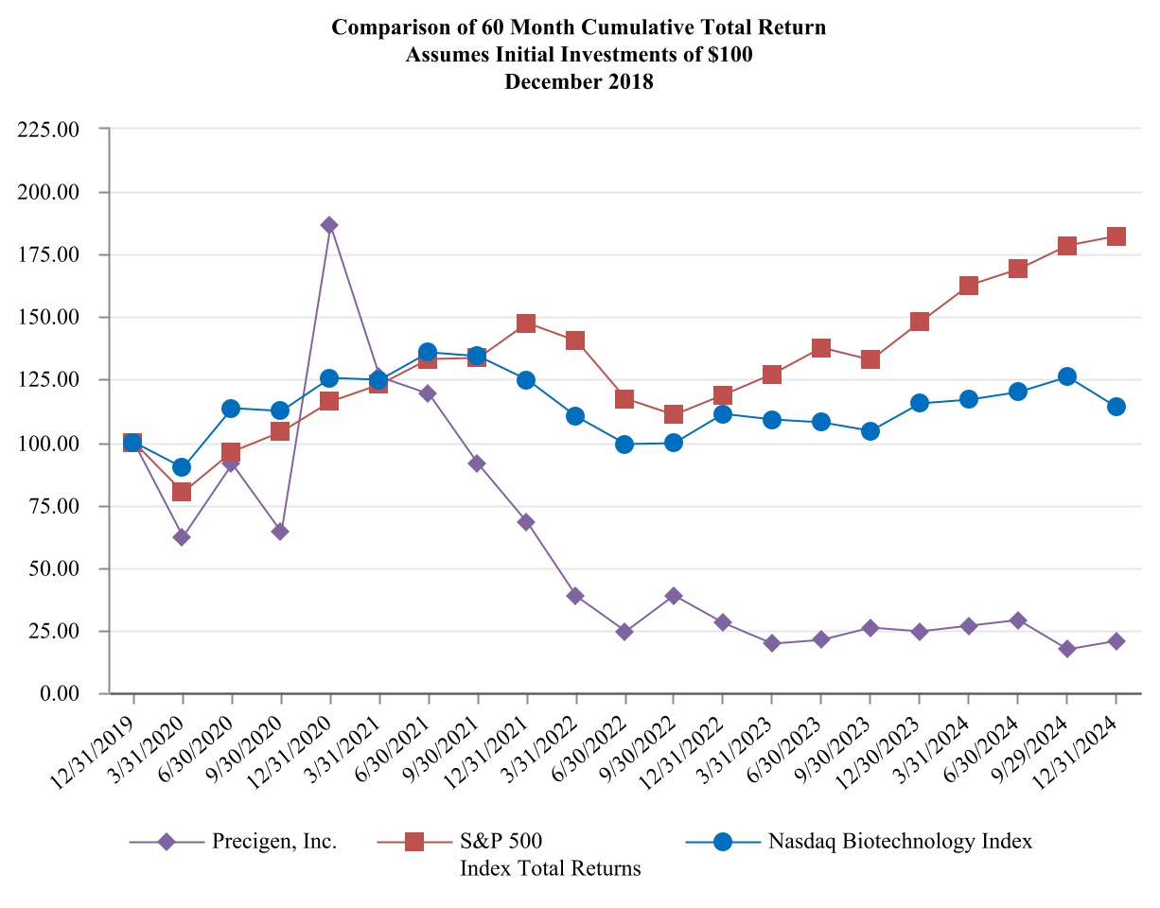
Company / Index |  |  |  |  |  | Base Period 12/31/2019 |  |  |  |  |  | 3/31/2020 |  |  |  |  |  | 6/30/2020 |  |  |  |  |  | 9/30/2020 |  |  |  |  |  | 12/31/2020
Precigen, Inc. |  |  |  |  |  | $ | 100.00 |  |  |  |  | $ | 62.04 |  |  |  |  | $ | 91.06 |  |  |  |  | $ | 63.87 |  |  |  |  | $ | 186.13
S&P 500 Index |  |  |  |  |  | 100.00 |  |  |  |  |  | 80.00 |  |  |  |  |  | 95.96 |  |  |  |  |  | 104.09 |  |  |  |  |  | 116.26
Nasdaq Biotechnology Index |  |  |  |  |  | 100.00 |  |  |  |  |  | 89.59 |  |  |  |  |  | 113.40 |  |  |  |  |  | 112.40 |  |  |  |  |  | 125.60
Company / Index |  |  | 3/31/2021 |  |  |  |  |  | 6/30/2021 |  |  |  |  |  | 9/30/2021 |  |  |  |  |  | 12/31/2021 |  |  |  |  |  | 3/31/2022 |  |  |  |  |  | 6/30/2022 |  |  |  |  |  | 9/30/2022 |  |  |  |  |  | 12/31/2022
Precigen, Inc. |  |  | $ | 125.73 |  |  |  |  | $ | 118.98 |  |  |  |  | $ | 91.06 |  |  |  |  | $ | 67.70 |  |  |  |  | $ | 38.50 |  |  |  |  | $ | 24.45 |  |  |  |  | $ | 38.69 |  |  |  |  | $ | 27.74
S&P 500 Index |  |  | 122.97 |  |  |  |  |  | 133.02 |  |  |  |  |  | 133.33 |  |  |  |  |  | 147.52 |  |  |  |  |  | 140.23 |  |  |  |  |  | 117.17 |  |  |  |  |  | 110.98 |  |  |  |  |  | 118.84
Nasdaq Biotechnology Index |  |  | 124.70 |  |  |  |  |  | 135.90 |  |  |  |  |  | 134.20 |  |  |  |  |  | 124.80 |  |  |  |  |  | 110.00 |  |  |  |  |  | 99.00 |  |  |  |  |  | 99.50 |  |  |  |  |  | 111.20
Company / Index |  |  | 3/31/2023 |  |  |  |  |  | 6/30/2023 |  |  |  |  |  | 9/30/2023 |  |  |  |  |  | 12/30/2023 |  |  |  |  |  | 3/31/2024 |  |  |  |  |  | 6/30/2024 |  |  |  |  |  | 9/29/2024 |  |  |  |  |  | 12/31/2024
Precigen, Inc. |  |  | $ | 19.34 |  |  |  |  | $ | 20.99 |  |  |  |  | $ | 25.91 |  |  |  |  | $ | 24.45 |  |  |  |  | $ | 26.46 |  |  |  |  | $ | 28.83 |  |  |  |  | $ | 17.28 |  |  |  |  | $ | 20.44
S&P 500 Index |  |  | 127.19 |  |  |  |  |  | 137.75 |  |  |  |  |  | 132.72 |  |  |  |  |  | 147.64 |  |  |  |  |  | 162.63 |  |  |  |  |  | 169.01 |  |  |  |  |  | 178.36 |  |  |  |  |  | 182.05
Nasdaq Biotechnology Index |  |  | 108.90 |  |  |  |  |  | 107.60 |  |  |  |  |  | 104.40 |  |  |  |  |  | 115.40 |  |  |  |  |  | 116.90 |  |  |  |  |  | 120.00 |  |  |  |  |  | 125.90 |  |  |  |  |  | 113.80
Recent Sales of Unregistered Securities and Use of Proceeds from Registered Securities
(a) Sales of Unregistered Securities

On December 27, 2024, we announced that we had entered into a Securities Purchase Agreement dated December 27, 2024 with investors, including Randal J. Kirk, our executive chairman of our board of directors, affiliates of Patient Capital

Table of Contents

Management and Bill Miller, as well as certain other investors for the sale of our 8.00% Series A Convertible Perpetual Preferred Stock (the "Series A Preferred Stock") and warrants to purchase 52,666,669 shares of our common stock, at an exercise price of $0.75 per share (the "Warrants") in a private placement. We sold an aggregate of 79,000 shares of Series A Preferred Stock, with an initial liquidation preference and stated value of $1,000 per share, together with the Warrants, for net proceeds of approximately $78.5 million, after deducting offering expenses. We expect to use the net proceeds of the offering for working capital and general corporate purposes. The offering closed on December 30, 2024.
(b) Use of Proceeds
None.
(c) Issuer Repurchases of Equity Securities
None.

Item 6. [Reserved]

Item 7. Management's Discussion and Analysis of Financial Condition and Results of Operations
The following discussion and analysis of financial condition and results of operations is provided to enhance the understanding of, and should be read in conjunction with, Part I, Item 1, "Business" and Item 8, "Financial Statements and Supplementary Data." For information on risks and uncertainties related to our business that may make past performance not indicative of future results, or cause actual results to differ materially from any forward-looking statements, see "Special Note Regarding Forward-Looking Statements," and Part I, Item 1A, "Risk Factors." Refer to Item 7: Management’s Discussion and Analysis of Financial Condition and Results of Operations in our 2023 Annual Report on Form 10-K for management’s discussion and analysis of financial condition and results of operations for the fiscal year 2023 compared to fiscal year 2022.
Overview
We are a dedicated discovery and clinical-stage biopharmaceutical company advancing the next generation of gene and cell therapies with the overall goal of improving outcomes for patients with significant unmet medical needs. We are leveraging our proprietary technology platforms to develop product candidates designed to target urgent and intractable diseases in our core therapeutic areas of immuno-oncology, autoimmune disorders, and infectious diseases. We have developed an extensive pipeline of therapies across multiple indications.
We believe that our array of technology platforms uniquely positions us among other biotechnology companies to advance precision medicine. Precision medicine is the practice of therapeutic product development that takes into account specific genetic variations within populations impacted by a disease to design targeted therapies to improve outcomes for a disease or patient population. Our proprietary and complementary technology platforms provide a strong foundation to realize the core promise of precision medicine by supporting our efforts to construct powerful gene programs to drive efficacy, deliver these programs through viral, non-viral, and microbe-based approaches to drive lower costs, and control gene expression to drive safety. Our therapeutic platforms, including UltraCAR-T, AdenoVerse immunotherapy, and ActoBiotics, are designed to allow us to precisely control the level and physiological location of gene expression and modify biological molecules to control the function and output of living cells to treat underlying disease conditions. We have developed a proprietary electroporation device, UltraPorator, designed to further streamline and ensure the rapid and cost-effective manufacturing of UltraCAR-T therapies. UltraPorator has received FDA clearance for manufacturing UltraCAR-T cells in clinical trials, and we have been dosing patients with UltraCAR-T cells manufactured with UltraPorator in our clinical trials.
Our clinical pipeline includes PRGN-2012 and PRGN-2009, which are based on our AdenoVerse immunotherapy platform; and PRGN-3005, PRGN-3006 and PRGN-3007, which are built on our UltraCAR-T platform. We have completed enrollment in the Phase 1b clinical trial of PRGN-3006. As part of the strategic prioritization of our pipeline, we have paused enrollment in the PRGN-3005 and PRGN-3007 clinical trials. In addition, we have completed a Phase 1b/2a study of AG019, which is built on our ActoBiotics platform, which we have completed the shut-down of, as discussed below under our Biopharmaceuticals segment (Precigen ActoBio, Inc.). We have reduced our focus on preclinical programs, while continuing select projects that we believe could provide further near-term validation of our technology platforms.
Fiscal Year 2024 Business Update

Table of Contents

In August 2024, we announced strategic prioritization of our pipeline to focus on development of our lead program, PRGN-2012. We plan to minimize UltraCAR-T spend and focus on strategic partnerships to further advance UltraCAR-T programs. As part of this restructuring, we have paused enrollment in PRGN-3005 and PRGN-3007 UltraCAR-T clinical trials. In addition, we are continuing PRGN-2009 Phase 2 clinical trials under a cooperative research and development agreement ("CRADA") with the National Cancer Institute ("NCI") in recurrent/metastatic cervical cancer and in newly diagnosed HPV-associated oropharyngeal cancer. We have reduced our focus on preclinical programs, while continuing select projects that we believe could provide further near-term validation of our technology platforms. We have completed the shutdown of our ActoBio subsidiary operations, including the elimination of all ActoBio personnel. In conjunction with this shutdown, ActoBio's portfolio of intellectual property is available for prospective transactions. These strategic changes are designed to enable us to focus on pre-commercialization efforts on PRGN-2012, including supporting regulatory approval, conducting the confirmatory clinical trial, and manufacturing of commercial product. Additionally, we will continue acceleration of commercial readiness efforts for a potential launch.
In December 2024, we announced the completion of the rolling submission for a BLA to the FDA for PRGN-2012 for the treatment of adults with RRP. The FDA has accepted the BLA and granted priority review, with a PDUFA target action date set for August 27, 2025.

See further discussion of 2024 financing transactions below under the Liquidity and capital resources section of Item 7.
Financial operations overview
Sources of revenue
Currently, our primary revenues arise from Exemplar, which generates product and service revenues through the development and sale of genetically engineered miniature swine models. We recognize revenue when control of the promised product or service is transferred to the customer.
In future periods, our revenues will primarily depend on our ability to advance and create our own programs and the extent to which we bring products enabled by our technologies to market. Other than for collaboration revenues recognized upon cancellation or modification of an existing collaboration or for revenues generated pursuant to future strategic transactions for any of our existing platforms or programs, we expect our collaboration revenues will continue to be minimal or zero in the near term, although if any new collaboration agreements or strategic transactions are entered into, revenue could be positively impacted. Our revenues will also depend upon our ability to maintain or improve the volume and pricing of Exemplar's current product and service offerings. We anticipate that our expenses will increase substantially if, and as, we continue to advance the preclinical and clinical development of our existing product candidates and our research programs. We expect some period of time, and in most cases a significant period of time, could pass before commercialization of our various product candidates or before the achievement of contractual milestones and the realization of royalties on product candidates commercialized under our collaborations. Accordingly, there can be no assurance as to the timing, magnitude, and predictability of revenues, if any, to which we might be entitled.
We do not expect any revenues that we may generate in the near term to be significant enough to fund our operations.
Cost of products and services
Cost of products and services, all which are related to our Exemplar reporting segment, includes primarily labor and related costs, drugs and supplies, feed used in production, and facility charges, including rent and depreciation. Fluctuations in the price of livestock and feed have not had a significant impact on our operating margins and no derivative financial instruments are used to mitigate the price risk.
Research and development expenses
We recognize research and development expenses as they are incurred. Our research and development expenses consist primarily of:
•salaries and benefits, including stock-based compensation expense, as well as severance costs related to personnel in research and development functions;
•fees paid to consultants and contract research organizations who perform research on our behalf and under our direction;

Table of Contents

•costs related to laboratory supplies used in our research and development efforts and acquiring, developing, and manufacturing preclinical study and clinical trial materials;
•costs related to certain in-licensed technology rights or reacquired in-process research and development;
•amortization of patents and related technologies acquired in mergers and acquisitions; and
•facility-related expenses, which include direct depreciation costs and unallocated expenses for rent and maintenance of facilities and other operating costs.
Our research and development expenses are generally incurred by our reportable segments and primarily relate to either costs incurred to expand or otherwise improve our technologies, or the costs incurred to develop our own products and services. Prior to August 2024, our Biopharmaceuticals segment was progressing preclinical and clinical programs that targeted urgent and intractable diseases in our core therapeutic areas of immuno-oncology, autoimmune disorders, and infectious diseases, including PRGN-3005, PRGN-3006, PRGN-3007, PRGN-2009, AG019 and PRGN-2012. As discussed in "Notes to the Consolidated Financial Statements - Note 1 " appearing elsewhere in this Annual Report, in August 2024, we announced a strategic prioritization of our clinical portfolio and streamlining of resources, to focus on potential commercialization of the PRGN-2012 AdenoVerse® gene therapy for the treatment of RRP. Our Exemplar segment's research and development activities relate to new and improved pig research models. The following table summarizes our research and development expenses on the consolidated statements of operations for the years ended December 31, 2024, 2023, and 2022 incurred by reportable segment.
 |  |  | Year Ended December 31,
 |  |  | 2024 |  |  |  |  |  | 2023 |  |  |  |  |  | 2022
 |  |  | (In thousands)
Biopharmaceuticals |  |  | $ | 52,971 |  |  |  |  | $ | 48,353 |  |  |  |  | $ | 46,850
Exemplar |  |  | 99 |  |  |  |  |  | 261 |  |  |  |  |  | 320
Total consolidated research and development expenses |  |  | $ | 53,070 |  |  |  |  | $ | 48,614 |  |  |  |  | $ | 47,170
In addition to the strategic prioritization, the amount of research and development expenses may be impacted by, among other things, the number and nature of our own proprietary programs.
Research and development expenses may also increase as a result of in-licensing of technologies or ongoing research and development operations that we might assume through mergers and acquisitions.
Selling, general and administrative expenses
Selling, general and administrative, or SG&A, expenses consist primarily of salaries and related costs, including stock-based compensation expense and severance, for employees in executive, operational (including commercialization), finance, information technology, legal, and corporate communications functions. Other significant SG&A expenses include rent and utilities, insurance, accounting, and legal services (including the cost of settling any claims and lawsuits), and expenses associated with obtaining and maintaining our intellectual property.
SG&A expenses may fluctuate in the future depending on the scaling of our corporate functions required to support our corporate initiatives, the strategic prioritization, the build-up of our commercialization efforts and the outcomes of legal claims and assessments against us.

Table of Contents

Other income (expense), net
Other income consists of interest earned on our cash and cash equivalents and short-term and long-term investments (which may fluctuate based on amounts invested and current interest rates), gain on dispositions of intellectual and property rights (for 2024), and gain on convertible debt retirement (for 2023).
Other expense consists primarily of interest on our convertible notes, which were fully retired in the second quarter of 2023, and the reclassification of cumulative foreign translation losses due to closing the operations of ActoBio in the third quarter of 2024. See "Notes to the Consolidated Financial Statements - Notes 10 and 12 " appearing elsewhere in this Annual Report for further discussion.
Segment performance
We use Segment Adjusted EBITDA as our primary measure of segment performance. We define Segment Adjusted EBITDA as net income (loss) before (i) interest expense and interest income, (ii) income tax expense or benefit, (iii) depreciation and amortization, (iv) stock-based compensation expense, (v) loss on settlement agreements where noncash consideration is paid, (vi) adjustments for accrued bonuses paid in equity awards, (vii) gain or loss on disposals of assets, (viii) loss on impairment of goodwill and other noncurrent assets, (ix) equity in net income (loss) of affiliates, (x) reclassification of cumulative translation gain (loss), and (xi) recognition of previously deferred revenue associated with upfront and milestone payments as well as cash outflows from capital expenditures and investments in affiliates, but includes proceeds from the sale of assets in the period sold. See "Notes to the Consolidated Financial Statements - Note 16" appearing elsewhere in this Annual Report for further discussion of Segment Adjusted EBITDA.
Results of operations
Comparison of the year ended December 31, 2024 to the year ended December 31, 2023
The following table summarizes our results of operations for the years ended December 31, 2024, and 2023, together with the changes in those items in dollars and as a percentage (dollar amounts in thousands):
 |  |  | Year Ended  December 31, |  |  |  |  |  |  |  |  |  |  |  | Dollar  Change |  |  |  |  |  | Percent  Change
 |  |  | 2024 |  |  |  |  |  | 2023
 |  |  | (In thousands)
Revenues
Collaboration and licensing revenues |  |  | $ | — |  |  |  |  | $ | 75 |  |  |  |  | $ | (75) |  |  |  |  | (100.0) |  | %
Product revenues |  |  | 422 |  |  |  |  |  | 840 |  |  |  |  |  | (418) |  |  |  |  |  | (49.8) |  | %
Service revenues |  |  | 3,470 |  |  |  |  |  | 5,301 |  |  |  |  |  | (1,831) |  |  |  |  |  | (34.5) |  | %
Other revenues |  |  | 33 |  |  |  |  |  | 9 |  |  |  |  |  | 24 |  |  |  |  |  | >200%
Total revenues |  |  | 3,925 |  |  |  |  |  | 6,225 |  |  |  |  |  | (2,300) |  |  |  |  |  | (36.9) |  | %
Operating expenses
Cost of products and services |  |  | 4,267 |  |  |  |  |  | 6,119 |  |  |  |  |  | (1,852) |  |  |  |  |  | (30.3) |  | %
Research and development |  |  | 53,070 |  |  |  |  |  | 48,614 |  |  |  |  |  | 4,456 |  |  |  |  |  | 9.2 |  | %
Selling, general and administrative |  |  | 41,293 |  |  |  |  |  | 40,415 |  |  |  |  |  | 878 |  |  |  |  |  | 2.2 |  | %
Impairment of goodwill |  |  | 7,409 |  |  |  |  |  | 10,390 |  |  |  |  |  | (2,981) |  |  |  |  |  | (28.7) |  | %
Impairment of other noncurrent assets |  |  | 32,915 |  |  |  |  |  | 445 |  |  |  |  |  | 32,470 |  |  |  |  |  | >200%
Total operating expenses |  |  | 138,954 |  |  |  |  |  | 105,983 |  |  |  |  |  | 32,971 |  |  |  |  |  | 31.1 |  | %
Operating loss |  |  | (135,029) |  |  |  |  |  | (99,758) |  |  |  |  |  | (35,271) |  |  |  |  |  | 35.4 |  | %
Total other income net |  |  | 7,001 |  |  |  |  |  | 3,396 |  |  |  |  |  | 3,605 |  |  |  |  |  | 106.2 |  | %
Loss before income taxes |  |  | (128,028) |  |  |  |  |  | (96,362) |  |  |  |  |  | (31,666) |  |  |  |  |  | 32.9 |  | %
Income tax benefit |  |  | 1,793 |  |  |  |  |  | 458 |  |  |  |  |  | 1,335 |  |  |  |  |  | >200%
Net loss |  |  | $ | (126,235) |  |  |  |  | $ | (95,904) |  |  |  |  | $ | (30,331) |  |  |  |  | 31.6 |  | %

Table of Contents

Collaboration and licensing revenues
Collaboration and licensing revenues decreased $0.1 million, or 100.0%, compared to the year ended December 31, 2023, primarily due to the termination of the License Agreement with Alaunos in 2024.
Product and services revenues, and cost of products and services
Product and service revenues decreased $2.2 million or 36.6%, compared to the year ended December 31, 2023. This decrease is related to reductions in products sold and services performed at Exemplar. Costs of products and services declined in the current year primarily for the same reason as the revenue declined.
Research and development expenses
Research and development expenses increased $4.5 million, or 9.2%, compared to the year ended December 31, 2023. This increase was primarily the result of $3.1 million of increased costs associated with the initiation of the PRGN-2012 confirmatory clinical trial, increased drug manufacturing material costs related to PRGN-2012 for potential commercial use, and professional fees incurred in conjunction with the Company’s completed BLA submission and commercial readiness planning as well as the design and implementation of our manufacturing facility. Additionally, employee-related expenses rose by $3.0 million primarily due to severance charges incurred as a result of the Precigen workforce reduction in 2024 and the suspension of ActoBio's operations.These increases were partially offset by a $1.9 million reduction in depreciation and amortization expense as a result of the impairment of noncurrent assets related to the suspension of ActoBio’s operations during the second quarter of 2024, as well as a reduction in clinical study expenses associated with programs that were deprioritized during the third quarter of 2024.
Selling, general and administrative expenses
SG&A expenses increased $0.9 million, or 2.2%, compared to the year ended December 31, 2023. As a result of the Company's increased focus on PRG-2012, commercial readiness cost increased in the current quarter versus prior year period. In addition, the second and third quarters of 2024 included higher severance cost associated with the suspension of ActoBio's operations and the 2024 Precigen workforce reduction. These increases were partially offset by a decrease in stock compensation and insurance rates in 2024 compared to the same period in 2023.
Impairment of goodwill and other noncurrent assets
In connection with the suspension of ActoBio’s operations, the Company recorded $34.5 million of impairment charges related to goodwill and long-lived assets in the second quarter of 2024. Additionally, we recorded $5.8 million of impairment charges related to our Exemplar reporting segment, compared to a $10.8 million impairment loss recorded during the year ended December 31, 2023. See "Notes to the Consolidated Financial Statements - Note 9" appearing elsewhere in this Annual Report for further discussion of ActoBio long-lived assets and goodwill impairment and Exemplar goodwill impairment.
Total other income (expense), net
Total other income, net, increased $3.6 million, or 106% compared to the year ended December 31, 2023. This increase was primarily derived from an $8.5 million gain on the sale of intellectual property rights and royalty rights related to FCX-007 in December 2024 as well as a $0.5 million reduction in interest expense due to the final retirement of our Convertible Notes in the second quarter of 2023. This increase was partially offset by a reclassification of cumulative translation losses of $2.9 million, which resulted from the final closing of the ActoBio facilities in the third quarter of 2024, as well as a reduction of $1.8 million in interest income due to lower investment balances compared to the same period in 2023. See "Notes to the Consolidated Financial Statements - Note 2" appearing elsewhere in this Annual Report for further discussion on gain on transfers of nonfinancial assets.

Table of Contents

Segment performance
The following table summarizes Segment Adjusted EBITDA, which is our primary measure of segment performance, for the years ended December 31, 2024, and 2023, for each of our reportable segments.
 |  |  | Year Ended  December 31, |  |  |  |  |  |  |  |  |  |  |  | Dollar  Change |  |  |  |  |  | Percent  Change
 |  |  | 2024 |  |  |  |  |  | 2023
 |  |  | (In thousands)
Segment Adjusted EBITDA:
Biopharmaceuticals |  |  | $ | (82,287) |  |  |  |  | $ | (75,339) |  |  |  |  | $ | (6,948) |  |  |  |  | (9.2) |  | %
Exemplar |  |  | (929) |  |  |  |  |  | (726) |  |  |  |  |  | (203) |  |  |  |  |  | (28.0) |  | %
For a reconciliation of Segment Adjusted EBITDA to net loss from continuing operations before income taxes, see "Notes to the Consolidated Financial Statements - Note 16" appearing elsewhere in this Annual Report.
The following table summarizes revenues from external customers for the years ended December 31, 2024, and 2023, for each of our reportable segments.
 |  |  | Year Ended  December 31, |  |  |  |  |  |  |  |  |  |  |  | Dollar  Change |  |  |  |  |  | Percent  Change
 |  |  | 2024 |  |  |  |  |  | 2023
 |  |  | (In thousands)
Biopharmaceuticals |  |  | $ | — |  |  |  |  | $ | 75 |  |  |  |  | $ | (75) |  |  |  |  | (100.0) |  | %
Exemplar |  |  | 3,925 |  |  |  |  |  | 6,150 |  |  |  |  |  | (2,225) |  |  |  |  |  | (36.2) |  | %
Biopharmaceuticals
The decline in revenues for Biopharmaceuticals was primarily due to the cancellation of the License Agreement with Alaunos in 2024. See "Notes to the Consolidated Financial Statements - Note 5 " appearing elsewhere in this Annual Report for further detail. The increase in Segment Adjusted EBITDA loss was driven by capital expenditures incurred related to the build out of our cGMP manufacturing capabilities for PRGN-2012 production, costs associated with our BLA submission, the confirmatory clinical trial for PRGN-2012, the conclusion of pivotal clinical trial activities for PRGN-2012 and an increase in severance expenses linked to the closure of ActoBio and restructuring expenses at Precigen. There was also an increase in commercialization cost in preparation for PRGN-2012’s market readiness.
These increased costs were partially offset by the sale of intellectual property and royalty rights related to FCX-007 in December 2024.
Exemplar
Revenues for Exemplar decreased due to a decrease in services performed resulting from a lower demand from existing customers. The decline in Segment Adjusted EBITDA was primarily due to the decreased revenues, offset by cost reduction initiatives implemented at Exemplar.
Liquidity and capital resources
Sources of liquidity
We have incurred losses from operations since our inception, and as of December 31, 2024, we had an accumulated deficit of $2.1 billion. From our inception through December 31, 2024, we have funded our operations principally with proceeds received from private and public equity and debt offerings, cash received from our collaborators, and through product and service sales made directly to customers, and sales of non-core businesses. As of December 31, 2024, we had cash and cash equivalents of $29.5 million and short-term and long-term investments of $68.4 million. Cash in excess of immediate requirements is typically invested primarily in money market funds, United States government debt securities, and certificates of deposit in order to maintain liquidity and preserve capital.

Table of Contents

In January 2023, we closed a public offering of 43,962,640 shares of our common stock, resulting in net proceeds to us of $72.8 million, after deducting underwriting discounts, fees, and other offering expenses.
In August 2024, we closed a public offering of 39,878,939 shares of our common stock, resulting in net proceeds to us of $30.9 million, after deducting underwriting discounts, fees, and an estimate of other offering expenses.
In December 2024, we issued 79,000 shares of 8.00% Series A Convertible Perpetual Preferred Stock with an initial liquidation preference and stated value of $1,000 per share, together with warrants to purchase 52,666,669 shares of common stock for net proceeds of approximately $78.5 million, after deducting offering expenses, which expenses had not been paid as of December 31, 2024.
Cash Flows
The following table sets forth the significant sources and uses of cash for the periods set forth below (dollar amounts in thousands):
 |  |  | Year Ended December 31,
 |  |  | 2024 |  |  |  |  |  | 2023 |  |  |  |  |  | 2022
 |  |  | (In thousands)
Net cash provided by (used in):
Operating activities |  |  | $ | (68,173) |  |  |  |  | $ | (66,930) |  |  |  |  | $ | (65,045)
Investing activities |  |  | (20,714) |  |  |  |  |  | (3,087) |  |  |  |  |  | 226,417
Financing activities |  |  | 110,583 |  |  |  |  |  | 29,589 |  |  |  |  |  | (155,292)
Effect of exchange rate changes on cash, cash equivalents, and restricted cash |  |  | (27) |  |  |  |  |  | (320) |  |  |  |  |  | (827)
Net increase (decrease) in cash, cash equivalents, and restricted cash |  |  | $ | 21,669 |  |  |  |  | $ | (40,748) |  |  |  |  | $ | 5,253
Cash flows from operating activities:
In 2024, our net loss was $126.2 million, which includes the following significant noncash expenses and benefits totaling $55.1 million: (i) $40.3 million impairment losses, (ii) $9.5 million of stock-based compensation expense, (iii) $4.5 million of depreciation and amortization expense, (iv) $2.9 million due to reclassification of cumulative translation losses, and (v) $0.6 million of shares issued as payment for services, partially offset by non-cash benefits of $1.8 million due to deferred income taxes and $0.9 million due to amortization of discounts on investments. In addition, changes in operating assets and liabilities provided $2.7 million of cash for operating activities.
In 2023, our net loss was $95.9 million, which includes the following significant noncash expenses: (i) $9.9 million of stock-based compensation expense, (ii) $10.8 million impairment losses, (iii) $6.7 million of depreciation and amortization expense, offset by (iv) $1.8 million due to amortization of discounts on investments. In addition, changes in operating assets and liabilities increased cash from operating activities by $3.4 million.
In 2022, our net income was $28.3 million, which included a gain on sale of discontinued operations of $94.7 million which is presented as an adjustment to net income to net cash used in operating activities. Additional adjustments to reconcile net income to net cash used in operating activities netted to approximately $24.0 million, from both continuing and discontinued operations, with the most significant adjustments including: (i) $10.2 million of stock-based compensation expense, (ii) $10.8 million of depreciation and amortization expense, and (iii) $1.0 million accretion of debt discount and amortization of deferred financing costs. In addition, changes in operating assets and liabilities reduced net income by $22.7 million, which the most significant change being a reduction in deferred revenue of $23.4 million.
Our 2024 cash used in operations increased by $1.2 million from the year ended December 31, 2023, primarily due to increase in cash outflows related to ActoBio during 2024 as we ceased operations and paid severance cost.
Our 2023 cash used in operations increased by $1.9 million from the year ended December 31, 2022, primarily due to decreased cash flow from operations provided by Trans Ova (which was sold in August 2022) and a decrease in cash flow from operations at Exemplar partially offset by a reduction in selling, general and administrative expenses, a decrease in interest paid in 2023 compared to 2022 due to the retirement in 2023 of our Convertible Notes, and cash paid to acquire Intrexon Energy Partners

Table of Contents

and Intrexon Energy Partners II membership interest, which was recorded as a reduction in revenue in 2022 that did not occur in 2023.
Cash flows from investing activities:
During 2024, we purchased $12.2 million of investments, net, and purchased $8.6 million of property plant and equipment, primarily related to the build-out of our cGMP manufacturing facility.
During 2023, we purchased $185.0 million of investments, using both the proceeds received from the underwritten public offering discussed below under cash flows from financing activities as well as reinvesting a portion of the proceeds received from the $183.4 million sales and maturities of investments. We also purchased $1.5 million of property plant and equipment.
During 2022, we received $68.4 million proceeds during the year from the maturities and sales of investments and $162.3 million from the sale of Trans Ova.
Cash flows from financing activities:
During 2024, we received $31.2 million of proceeds, net of certain issuance costs, from the sale of our common stock in an underwritten public offering, $79.0 million of gross proceeds from the issuance of the Series A Preferred Stock and the Warrants and $0.3 million of proceeds from stock option exercises.
During 2023, we received $72.8 million of proceeds from the sale of our common stock in an underwritten public offering and retired $43.2 million of our Convertible Notes using restricted cash.
During 2022, we repurchased Convertible Notes for $155.3 million using restricted cash.
Future capital requirements
Our future capital requirements will depend on many factors, including:
•progress in our research and development programs, as well as the magnitude and speed of development of these programs;
•capital expenditures related to our manufacturing capabilities and preparing for commercial readiness;
•the timing of regulatory approval of our product candidates and those of our collaborations;
•the timing, receipt, and amount of any payments received in connection with strategic transactions;
•the timing, receipt, and amount of upfront, milestone, and other payments, if any, from present and future collaborators, if any;
•the timing, receipt, and amount of sales and royalties, if any, from our product candidates;
•the timing and capital requirements to scale up our various product candidates and service offerings and customer acceptance thereof;
•our ability to maintain and establish additional collaborative arrangements and/or new strategic initiatives;
•the resources, time, and cost required for the preparation, filing, prosecution, maintenance, and enforcement of our intellectual property portfolio;
•strategic mergers and acquisitions, if any, including both the upfront acquisition cost as well as the cost to integrate, maintain, and expand the strategic target; and
•the costs associated with legal activities, including litigation, arising in the course of our business activities and our ability to prevail in any such legal disputes.

Table of Contents

Until such time, if ever, as we can regularly generate positive operating cash flows, we plan to finance our cash needs through a combination of equity offerings, debt and/or royalty financings, government, or other third-party funding, strategic alliances, sales of assets, and licensing arrangements. We may not be able to raise sufficient additional funds on terms that are favorable to us, if at all. To the extent that we raise additional capital through the sale of equity, convertible debt, warrants or preferred securities, the ownership interests of our common shareholders will be diluted, and the terms of these securities may include liquidation or other preferences that adversely affect the rights of our common shareholders. Our current stock price may make it more difficult to pursue equity financings and lead to substantial dilution if the price of our common stock does not increase. Debt financing, if available, may involve agreements that include covenants limiting or restricting our ability to take specific actions, such as incurring additional debt, making capital expenditures, or declaring dividends. If we raise additional funds through strategic transactions, collaborations, or licensing arrangements with third parties, we may have to relinquish valuable rights to our technologies, future revenue streams, research programs, or product candidates, or to grant licenses on terms that may not be favorable to us.
We are subject to a number of risks similar to those of other companies conducting high-risk, early-stage research and development of product candidates. Principal among these risks are dependence on key individuals and intellectual property, competition from other products and companies, and the technical risks associated with the successful research, development, and clinical manufacturing of its product candidates. Our success is dependent upon our ability to continue to raise additional capital in order to fund ongoing research and development, obtain regulatory approval of our products, successfully commercialize our products, generate revenue, meet our obligations, and, ultimately, attain profitable operations.
Our consolidated financial statements as of and for the year ended December 31, 2024 have been prepared on the basis that we will continue as a going concern, which contemplates the realization of assets and satisfaction of liabilities in the normal course of business.
Based on current projections, management believes that its existing cash, cash equivalents and short-term investments, combined with anticipated potential revenue from the commercialization of PRGN-2012, which is outside of our direct control, will enable us to continue our operations for at least one year from the date of this filing. These assumptions include the receipt of future payments that are dependent upon the successful FDA approval of the PRGN-2012 BLA, and therefore revenue from this product is uncertain at this time. Based on this factor, we do not know when, or if, we will generate sufficient revenue from commercialization to offset our operating expenses. We are subject to all of the risks inherent in the development of new products, and we may encounter unforeseen expenses, difficulties, complications, delays and other unknown factors that may adversely affect our business. In addition, because our forecasted potential revenues are currently outside of our direct control, they have not been included in our going concern analysis. These conditions raise substantial doubt about our ability to continue as a going concern for at least 12 months after the issuance of the accompanying consolidated financial statements. Our financial statements do not include any adjustments that might result from the outcome of this uncertainty.

Our ability to continue as a going concern is dependent upon the successful execution of management’s plans, which include the successful commercialization of PRGN-2012. In addition, we may decide, or be required to raise additional capital. This additional capital could be raised through a combination of non-dilutive financings (including debt financings, collaborations, strategic alliances, monetization of non-core assets, marketing, distribution or licensing arrangements), dilutive financings (including equity and/or debt financings with an equity component) and, ultimately from revenue related to product sales, to the extent our product candidates receive marketing approval and can be commercialized. There can be no assurance that new financings or other transactions will be available to us on commercially acceptable terms, or at all, and such financings may adversely affect the holdings or rights of our stockholders and may cause significant dilution to existing stockholders. The consolidated financial statements do not include any adjustments that might result from the outcome of this uncertainty, which could have a material adverse effect on our financial condition.
Contractual obligations and commitments
The following table summarizes our significant contractual obligations and commitments from continuing operations as of December 31, 2024 and the effects such obligations are expected to have on our liquidity and cash flow in future periods:
 |  |  | Total |  |  |  |  |  | Less Than 1 Year |  |  |  |  |  | 1-3 Years |  |  |  |  |  | 3-5 Years |  |  |  |  |  | More Than 5 Years
 |  |  | (In thousands)
Operating leases |  |  | $ | 7,382 |  |  |  |  | $ | 1,556 |  |  |  |  | $ | 2,718 |  |  |  |  | $ | 2,555 |  |  |  |  | $ | 553
Total |  |  | $ | 7,382 |  |  |  |  | $ | 1,556 |  |  |  |  | $ | 2,718 |  |  |  |  | $ | 2,555 |  |  |  |  | $ | 553

Table of Contents

In addition to the obligations in the table above, as of December 31, 2024, we are party to in-licensed research and development agreements with various academic and commercial institutions where we could be required to make future payments for annual maintenance fees as well as for milestones and royalties we might receive upon commercial sales of products that incorporate their technologies. These agreements are generally subject to termination by us and therefore no amounts are included in the tables above. As of December 31, 2024, we also had research and development commitments with third parties totaling $5.9 million that had not yet been incurred.
Net operating losses
As of December 31, 2024, we had net operating loss carryforwards of approximately $969.9 million for United States federal income tax purposes available to offset future taxable income, including $757.0 million generated after 2017, United States capital loss carryforwards of $100.9 million, and United States federal and state research and development tax credits of approximately $16.2 million, prior to consideration of annual limitations that may be imposed under Section 382 of the Internal Revenue Code of 1986, as amended, ("Section 382"). Net operating loss carryforwards generated prior to 2018 will expire if unutilized from 2025 to 2037, and capital loss carryforwards will expire if unutilized from 2025 to 2027. As a result of our past stock issuances, as well as due to prior mergers and acquisitions, certain of our net operating losses have been subject to limitations pursuant to Section 382. As of December 31, 2024, we had utilized all net operating losses subject to Section 382 limitations, other than those losses inherited via acquisitions. As of December 31, 2024, approximately $35.8 million of domestic net operating losses were acquired via acquisition and are limited based on the value of the target at the time of the transaction. Future changes in stock ownership may also trigger an ownership change and, consequently, a Section 382 limitation. As of December 31, 2024, our direct foreign subsidiaries included in continuing operations had foreign loss carryforwards of approximately $69.8 million, most of which do not expire.
Our net deferred tax assets, which primarily relate to these loss carryforwards, are offset by a valuation allowance due to our history of net losses.
As a result of our past issuances of our common stock, as well as due to prior mergers and acquisitions, certain of our net operating losses have been subject to limitations pursuant to Section 382. As of December 31, 2024, Precigen has utilized all net operating losses subject to Section 382 limitations, other than those losses inherited via acquisitions. As of December 31, 2024, approximately $35.8 million of domestic net operating losses were inherited via acquisitions and are limited based on the value of the target at the time of the transaction. Future changes in stock ownership may also trigger an ownership change and, consequently, a Section 382 limitation.
Critical accounting estimates
Our management's discussion and analysis of our financial condition and results of operations is based on our consolidated financial statements, which we have prepared in accordance with U.S. GAAP. The preparation of these consolidated financial statements requires us to make estimates and assumptions that affect the reported amounts of assets and liabilities and the disclosure of contingent assets and liabilities at the date of the financial statements, as well as the reported revenues and expenses during the reporting periods. We evaluate these estimates and judgments on an ongoing basis. We base our estimates on historical experience and on various other factors that we believe are reasonable under the circumstances, the results of which form the basis for making judgments about the carrying value of assets and liabilities that are not readily apparent from other sources. Our actual results may differ from these estimates under different assumptions or conditions.
While our significant accounting policies are more fully described in "Notes to the Consolidated Financial Statements - Note 2" appearing elsewhere in this Annual Report, we believe that the following accounting policies are the most critical for fully understanding and evaluating our financial condition and results of operations.
Revenue recognition
We recognize revenue when our customer obtains control of the promised goods or services, in an amount that reflects the consideration that we expect to receive in exchange for those goods or services. To determine revenue recognition for arrangements that are within the scope of ASC 606, we perform the following five steps: (i) identify the contract(s) with a customer, (ii) identify the promises and distinct performance obligations in the contract, (iii) determine the transaction price, (iv) allocate the transaction price to the performance obligations in the contract, and (v) recognize revenue when (or as) we satisfy the performance obligations. In 2022 and 2021, collaboration and licensing revenues were considered a critical accounting policy and estimate since the associated revenue or deferred revenue were significant. Refer to Item 7: Management’s Discussion and Analysis of Financial Condition and Results of Operations in our 2022 Annual Report on Form

Table of Contents

10-K for management’s discussion of this critical accounting policy and estimate. In 2024, such accounting policy and estimate is not considered critical as the associated revenue and deferred revenue are not significant.
Product and service revenues
Our product and service revenues are generated primarily through Exemplar, it generates product and service revenues through the development and sale of genetically engineered miniature swine models. We evaluate each promised product or service under our contracts and identify performance obligations for each distinct product or services. We then allocate the transaction price of the contract to each performance obligation, recognizing the transaction price as revenue at a point in time when control of the promised product is transferred to the customer or over time when the promised service is rendered. We typically recognize revenue using an out-based measure, generally time elapsed or days of service, to measure progress and transfer of the control of the performance obligation to the customer. Payment terms are typically due within 30 days of invoicing, which occurs prior to or when revenue is recognized. We recognized $3.9 million, $6.1 million, and $12.0 million of product and service revenues for the years ended December 31, 2024, 2023, and 2022, respectively.
Pre-Launch Inventory
Prior to an initial regulatory authorization for our drug product candidates, we expense costs relating to raw materials and inventory production as research and development expenses in our consolidated statements of operations in the period incurred. We capitalize the costs of production as inventory when we believe regulatory authorization and subsequent commercialization is considered probable and we expect to realize future economic benefit from the sales of the drug product candidate. We have not capitalized any inventory to date in our Biopharmaceuticals reporting segment.
Valuation of goodwill and long-lived assets
We evaluate long-lived assets to be held and used, which include property, plant and equipment and intangible assets subject to amortization, for impairment whenever events or changes in circumstances indicate that the carrying amount of the assets may not be recoverable. Conditions that would necessitate an impairment assessment include a significant decline in the observable market value of an asset, a significant change in the extent or manner an asset is used, or a significant adverse change that would indicate that the carrying amount of an asset or group of assets is not recoverable.
Goodwill is tested for impairment annually at December 31, or more frequently if events or circumstances between annual tests indicate that the assets may be impaired. We perform a qualitative assessment to determine whether it is more-likely-than-not that the fair value of a reporting unit is less than its carrying amount prior to performing the quantitative goodwill impairment test. If this is the case, the quantitative goodwill impairment test is required. If the quantitative goodwill impairment test is required or elected to be performed, first, the fair value of the reporting unit is compared with its carrying amount (including goodwill). Impairment losses on goodwill are recognized based solely on a comparison of their fair value to carrying value, without consideration of any recoverability test.
When we perform quantitative evaluations, the fair value of the reporting units is primarily determined based on the income approach. The income approach is a valuation technique in which fair value is based on forecasted future cash flows, discounted at the appropriate rate of return commensurate with the risk as well as current rates of return for equity and debt capital as of the valuation date. The forecast used in our estimation of fair value was developed by management based on historical operating results, incorporating adjustments to reflect management's planned changes in operations and market considerations.
During the years ended December 31, 2024 and 2023, we recorded $40.3 million and $10.8 million, respectively, of impairment charges from continuing operations to write down the values of goodwill and other long-lived assets. See additional discussion regarding these impairments in "Notes to the Consolidated Financial Statements - Note 8 and 9" appearing elsewhere in this Annual Report.
Research and Development Expense, Including Clinical Trial Accruals/Expenses
We consider that regulatory requirements inherent in the research and development of new products preclude us from capitalizing such costs. Research and development costs consist of salaries and related costs of research and development personnel, including stock-based compensation expense, costs to acquire technology rights, contract research organizations and consultants, facilities, materials and supplies associated with research and development projects as well as various laboratory studies.

Table of Contents

Clinical trial expenses are a significant component of research and development expenses, and we outsource a significant portion of these costs to third parties. Third party clinical trial expenses include investigator fees, site and patient costs, CRO costs, costs for central laboratory testing, and data management costs. The accrual for site and patient costs includes inputs such as estimates of patient enrollment, patient cycles incurred, clinical site activations, and other pass-through costs. These inputs are required to be estimated due to a lag in receiving the actual clinical information from third parties. Payments for these activities are based on the terms of the individual arrangements, which may differ from the pattern of costs incurred, and are reflected on the consolidated balance sheets as prepaid expenses and other or other accrued liabilities. These third-party agreements are generally cancellable, and related costs are recorded as research and development expenses as incurred. Non-refundable advance clinical payments for goods or services that will be used or rendered for future research and development activities are recorded as a prepaid asset and recognized as expense as the related goods are delivered or the related services are performed. When evaluating the adequacy of the accrued expenses, we analyze the progress of the studies, including the phase or completion of events, invoices received and contracted costs. Significant judgments and estimates may be made in determining the accrued balances at the end of any reporting period. Actual results could differ from the estimates made. The historical clinical accrual estimates have not been materially different from the actual costs.
Warrant liabilities
The Warrants were accounted for as liabilities in accordance with ASC 815-40 and are presented within warrant liabilities in the accompanying consolidated balance sheet. The warrant liabilities are measured at fair value at inception and on a recurring basis, with changes in fair value presented within the consolidated statement of operations. Derivative warrant liabilities are classified as non-current liabilities as their liquidation is not reasonably expected to require the use of current assets or require the creation of current liabilities.
We determined the initial value of the Warrants using a combination of the Black-Scholes option pricing model and Monte Carlo model, which are considered Level 3 fair value measurements. These models consider several variables and assumptions in estimating the fair value of financial instruments, including the per-share fair value of the underlying common stock, exercise price, expected term, risk-free interest rate, expected stock price volatility over the expected term, and expected annual dividend yield. Certain inputs utilized in our Black-Scholes option pricing model may fluctuate in future periods based upon factors which are outside of the Company’s control. A significant change in one or more of these inputs used in the calculation of the fair value may cause a significant change to the fair value of our warrant liability which could also result in material non-cash gain or loss being reported in our consolidated statement of operations.
See additional discussion in "Notes to the Consolidated Financial Statements - Note 7 and 12" appearing elsewhere in this Annual Report.
Recent accounting pronouncements
See "Notes to the Consolidated Financial Statements - Note 2" appearing elsewhere in this Annual Report for a description of recent accounting pronouncements applicable to our business, which is incorporated herein by reference.

Item 7A. Quantitative and Qualitative Disclosures About Market Risk
The following section provides quantitative information on our exposure to interest rate risk. We make use of sensitivity analyses that are inherently limited in estimating actual losses in fair value that can occur from changes in market conditions.
Interest rate risk
We had cash, cash equivalents and short-term investments of $97.9 million and $62.9 million as of December 31, 2024 and 2023, respectively. Our cash and cash equivalents and short-term and long-term investments consist of cash, money market funds, corporate bonds, United States government debt securities, and certificates of deposit. The primary objectives of our investment activities are to preserve principal, maintain liquidity, and maximize income without significantly increasing risk. Our investments consist of corporate bonds, United States government debt securities and certificates of deposit, which may be subject to market risk due to changes in prevailing interest rates that may cause the fair values of our investments to fluctuate. We believe that a hypothetical 100 basis point increase in interest rates would not materially affect the fair value of our interest-sensitive financial instruments and any such losses would only be realized if we sold the investments prior to maturity.

Item 8. Financial Statements and Supplementary Data
The information required by this Item 8 is contained on pages F-1 through F-53 of this Annual Report.

Table of Contents

Item 9. Changes in and Disagreements with Accountants on Accounting and Financial Disclosure
None.

Item 9A. Controls and Procedures
Evaluation of Disclosure Controls and Procedures
Management, with the participation of our chief executive officer and our chief financial officer, evaluated the effectiveness of our disclosure controls and procedures as of December 31, 2024. The term "disclosure controls and procedures," as defined in Rules 13a-15(e) and 15d-15(e) under the Exchange Act means controls and other procedures of a company that are designed to ensure that information required to be disclosed by a company in the reports that it files or submits under the Exchange Act is recorded, processed, summarized and reported, within the time periods specified in the SEC's rules and forms. Disclosure controls and procedures include, without limitation, controls and procedures designed to ensure that information required to be disclosed by a company in the reports that it files or submits under the Exchange Act is accumulated and communicated to the company's management, including its principal executive and principal financial officers, as appropriate to allow timely decisions regarding required disclosure. Management recognizes that any controls and procedures, no matter how well designed and operated, can provide only reasonable assurance of achieving their objectives and management necessarily applies its judgment in evaluating the cost-benefit relationship of possible controls and procedures. Based on their evaluation of our disclosure controls and procedures as of December 31, 2024, our chief executive officer and chief financial officer have concluded that, as of such date, our disclosure controls and procedures were effective at the reasonable assurance level.
Management's Annual Report on Internal Control Over Financial Reporting
Our management is responsible for establishing and maintaining adequate internal control over financial reporting as such term is defined in Rules 13a-15(f) and Rule 15d-15(f) of the Exchange Act. Our internal control over financial reporting is a process designed to provide reasonable assurance regarding the reliability of financial reporting and the preparation of financial statements for external purposes in accordance with generally accepted accounting principles. Our internal control over financial reporting includes those policies and procedures that:
(i) pertain to the maintenance of records that in reasonable detail accurately and fairly reflect the transactions and dispositions of our assets;
(ii) provide reasonable assurance that transactions are recorded as necessary to permit preparation of consolidated financial statements in accordance with generally accepted accounting principles, and that our receipts and expenditures are being made only in accordance with authorizations of our management and directors; and
(iii) provide reasonable assurance regarding prevention or timely detection of unauthorized acquisition, use or disposition of our assets that could have a material effect on the consolidated financial statements.
Because of its inherent limitations, internal control over financial reporting may not prevent or detect misstatements. Also, projections of any evaluation of effectiveness to future periods are subject to the risk that controls may become inadequate because of changes in conditions or that the degree of compliance with the policies or procedures may deteriorate.
Our management assessed the effectiveness of our internal control over financial reporting as of December 31, 2024. In making this assessment, our management used the criteria set forth by the Committee of Sponsoring Organizations of the Treadway Commission (COSO) in Internal Control - Integrated Framework (2013). Based on this evaluation, management concluded that our internal control over financial reporting was effective as of December 31, 2024.
Changes in Internal Control Over Financial Reporting
There have been no changes in our internal control over financial reporting during the quarter ended December 31, 2024 that have materially affected, or are reasonably likely to materially affect, our internal control over financial reporting.

Item 9B. Other Information
None.

Table of Contents

Item 9C. Disclosure Regarding Foreign Jurisdictions that Prevent Inspections
None.

Table of Contents

PART III

Item 10. Directors, Executive Officers and Corporate Governance
The information required by this item is hereby incorporated by reference to our Definitive Proxy Statement relating to our 2025 Annual Meeting of Shareholders to be filed with the SEC within 120 days of the fiscal year ended December 31, 2024.
Our board of directors has adopted a Code of Business Conduct and Ethics applicable to all officers, directors, and employees, which is available on our website (investors.precigen.com) under "Corporate Governance." We will provide a copy of this document, without charge, upon request, by writing to us at Precigen, Inc., 20374 Seneca Meadows Parkway, Germantown, Maryland 20876, Attention: Investor Relations. We intend to satisfy the disclosure requirement under Item 5.05 of Form 8-K regarding amendment to, or waiver from, a provision of our Code of Business Conduct and Ethics by posting such information on our website at the address and location specified above.
Insider Trading Policies and Procedures
The Company has insider trading policies and procedures that govern the purchase, sale, and other dispositions of its securities by directors, officers, and employees, and by the Company itself/and have implemented processes for the Company. We believe these policies and procedures are reasonably designed to promote compliance with insider trading laws, rules and regulations, and applicable listing standards.

Item 11. Executive Compensation
The information required by this item is hereby incorporated by reference to our Definitive Proxy Statement relating to our 2025 Annual Meeting of Shareholders to be filed with the SEC within 120 days of the fiscal year ended December 31, 2024.

Item 12. Security Ownership of Certain Beneficial Owners and Management and Related Stockholder Matters
The information required by this item is hereby incorporated by reference to our Definitive Proxy Statement relating to our 2025 Annual Meeting of Shareholders to be filed with the SEC within 120 days of the fiscal year ended December 31, 2024.

Item 13. Certain Relationships and Related Transactions, and Director Independence
The information required by this item is hereby incorporated by reference to our Definitive Proxy Statement relating to our 2025 Annual Meeting of Shareholders to be filed with the SEC within 120 days of the fiscal year ended December 31, 2024.

Item 14. Principal Accounting Fees and Services
The information required by this item is hereby incorporated by reference to our Definitive Proxy Statement relating to our 2025 Annual Meeting of Shareholders to be filed with the SEC within 120 days of the fiscal year ended December 31, 2024.

Table of Contents

PART IV

Item 15. Exhibits, Financial Statement Schedules
(a)The following documents are filed as part of this Annual Report:
1.Financial Statements.
Consolidated Financial Statements of Precigen, Inc. and Subsidiaries
Report of Independent Registered Public Accounting Firm
Consolidated Balance Sheets as of December 31, 2024 and 2023
Consolidated Statements of Operations for the Years Ended December 31, 2024, 2023, and 2022
Consolidated Statements of Comprehensive (Loss) Income for the Years Ended December 31, 2024, 2023, and 2022
Consolidated Statements of Mezzanine Equity and Shareholders' Equity for the Years Ended December 31, 2024, 2023, and 2022
Consolidated Statements of Cash Flows for the Years Ended December 31, 2024, 2023, and 2022
Notes to the Consolidated Financial Statements
2.Financial Statement Schedules.
All financial statement schedules have been omitted because either the required information is not applicable or the information required is included in the consolidated financial statements and notes thereto included in this Annual Report.
3.Exhibits.
The exhibits are listed in Item 15(b) below.
(b)Exhibits
The following exhibits are filed with this Annual Report or incorporated by reference:
Exhibit No. |  |  |  |  |  | Description
3.1* |  |  |  |  |  | Amended and Restated Articles of Incorporation (11)
3.1A* |  |  |  |  |  | Articles of Amendment to the Amended and Restated Articles of Incorporation (18)
3.2* |  |  |  |  |  | Amended and Restated Bylaws (14)
4.1* |  |  |  |  |  | Specimen certificate evidencing shares of common stock (16)
4.3 |  |  |  |  |  | Description of Securities (12)
4.4* |  |  |  |  |  | Form of Certificate for the 8.00% Series A Convertible Perpetual Preferred Stock (18)
10.1†* |  |  |  |  |  | Amended and Restated 2013 Omnibus Incentive Plan of the Company, effective as of June 9, 2014 (2)
10.1A†* |  |  |  |  |  | Amended and Restated 2013 Omnibus Incentive Plan of the Company, Form of Restricted Stock Agreement (2)
10.1B†* |  |  |  |  |  | Amended and Restated 2013 Omnibus Incentive Plan of the Company, Form of Incentive Stock Option Agreement (2)

Table of Contents

10.1C†* |  |  |  |  |  | Amended and Restated 2013 Omnibus Incentive Plan of the Company, Form of Nonqualified Stock Option Agreement (2)
10.1D†* |  |  |  |  |  | Amendment to the Amended and Restated 2013 Omnibus Incentive Plan of the Company, effective as of June 11, 2015 (3)
10.1E†* |  |  |  |  |  | Amendment to the Amended and Restated 2013 Omnibus Incentive Plan of the Company, effective as of June 9, 2016 (4)
10.1F†* |  |  |  |  |  | Amendment to the Amended and Restated 2013 Omnibus Incentive Plan of the Company, effective as of June 28, 2017 (5)
10.1G†* |  |  |  |  |  | Amendment to the Amended and Restated 2013 Omnibus Incentive Plan of the Company, as amended, effective as of June 7, 2018 (7)
10.1H†* |  |  |  |  |  | Amendment to the Amended and Restated 2013 Omnibus Incentive Plan of the Company, as amended, effective as of June 12, 2019 (9)
10.1I†* |  |  |  |  |  | Amendment to the Amended and Restated 2013 Omnibus Incentive Plan of the Company, as amended, effective January 5, 2020 (13)
10.1J†* |  |  |  |  |  | Amendment to the Amended and Restated 2013 Omnibus Incentive Plan of the Company, as amended, effective as of June 19, 2020 (15)
10.1K†* |  |  |  |  |  | 2013 Amended and Restated Omnibus Incentive Plan of the Company, as amended, Form of Restricted Stock Unit Agreement for Officers (6)
10.1L†* |  |  |  |  |  | 2013 Amended and Restated Omnibus Incentive Plan of the Company, as amended, Form of Restricted Stock Unit Agreement for Directors (6)
10.2* |  |  |  |  |  | 2019 Incentive Plan of the Company for Non-Employee Service Providers, effective as of June 12, 2019 (9)
10.3†* |  |  |  |  |  | Form of Continuing Employment Agreement (2019) (8)
10.4†* |  |  |  |  |  | Employment Agreement, dated January 1, 2020, by and between the Company and Helen Sabzevari, Ph.D. (10)
10.5†* |  |  |  |  |  | Executive Chairman Compensation Arrangement, by and between the Company and Randal J. Kirk (17)
10.6* |  |  |  |  |  | Securities Issuance Agreement by and among the Company, The University of Texas System Board of Regents on behalf of The University of Texas MD Anderson Cancer Center dated as of January 13, 2015 (1)
10.7†* |  |  |  |  |  | Precigen, Inc. 2023 Omnibus Incentive Plan (10)
10.8†* |  |  |  |  |  | Form of Restricted Stock Unit Agreement under the 2023 Omnibus Incentive Plan (19)
10.9†** |  |  |  |  |  | Form of Incentive Stock Option Agreement under the 2023 Omnibus Incentive Plan (19)
10.10†** |  |  |  |  |  | Form of Continuing Employment Agreement (19)
10.11†* |  |  |  |  |  | Form of Performance Stock Unit Agreement under the 2023 Omnibus Incentive Plan (17)
10.12* |  |  |  |  |  | Securities Purchase Agreement, dated December 27, 2024 between Precigen Inc. and the Investors party thereto (18)
10.13* |  |  |  |  |  | Registration Rights Agreement, dated December 30, 2024 between Precigen Inc. and the Investors party thereto (18)
10.14* |  |  |  |  |  | Form of Common Stock Purchase Warrant (18)
10.15†† |  |  |  |  |  | Product Commercialization Agreement with EVERSANA Life Science Services, LLC, dated March 19, 2025
19.1 |  |  |  |  |  | Insider Trading Policy
21.1 |  |  |  |  |  | List of Subsidiaries of Precigen, Inc.
23.1 |  |  |  |  |  | Consent of Deloitte & Touche LLP
31.1 |  |  |  |  |  | Certification of Helen Sabzevari, Chief Executive Officer (Principal Executive Officer) of Precigen, Inc., pursuant to Rules 13a-14(a) and 15d-14(a) promulgated under the Securities Exchange Act of 1934, as amended, as adopted pursuant to Section 302 of the Sarbanes-Oxley Act of 2002

Table of Contents

31.2 |  |  |  |  |  | Certification of Harry Thomasian Jr., Chief Financial Officer (Principal Financial Officer) of Precigen, Inc., pursuant to Rules 13a-14(a) and 15d-14(a) promulgated under the Securities Exchange Act of 1934, as amended, as adopted pursuant to Section 302 of the Sarbanes-Oxley Act of 2002
32.1** |  |  |  |  |  | Certification of Helen Sabzevari, Chief Executive Officer (Principal Executive Officer) of Precigen, Inc., pursuant to 18 U.S.C. Section 1350, as adopted pursuant to Section 906 of the Sarbanes-Oxley Act of 2002
32.2** |  |  |  |  |  | Certification of Harry Thomasian Jr., Chief Financial Officer (Principal Financial Officer) of Precigen, Inc., pursuant to 18 U.S.C. Section 1350, as adopted pursuant to Section 906 of the Sarbanes-Oxley Act of 2002
97** |  |  |  |  |  | Precigen, Inc. Financial Statement Compensation Recoupment Policy
101** |  |  |  |  |  | Interactive Data File (Precigen, Inc. and Subsidiaries Consolidated Financial Statements for the years ended December 31, 2024, 2023, and 2022, formatted in Inline XBRL (eXtensible Business Reporting Language)).
 |  |  |  |  |  | Attached as Exhibit 101 are the following documents formatted in XBRL: (i) the Consolidated Balance Sheets as of December 31, 2024 and 2023, (ii) the Consolidated Statements of Operations for the years ended December 31, 2024, 2023, and 2022, (iii) the Consolidated Statements of Shareholders' and Total Equity for the years ended December 31, 2024, 2023, and 2022, (iv) the Consolidated Statements of Cash Flows for the years ended December 31, 2024, 2023, and 2022 and (v) the Notes to the Consolidated Financial Statements.
104** |  |  |  |  |  | Cover Page Interactive Data File (embedded within the Inline XBRL document)
* Previously filed and incorporated by reference to the exhibit indicated in the following filings by the Company:
(1) |  |  |  |  |  | Current Report on Form 8-K, filed with the Securities and Exchange Commission on January 14, 2015.
(2) |  |  |  |  |  | Current Report on Form 8-K, filed with the Securities and Exchange Commission on June 13, 2014.
(3) |  |  |  |  |  | Current Report on Form 8-K, filed with the Securities and Exchange Commission on June 17, 2015.
(4) |  |  |  |  |  | Current Report on Form 8-K, filed with the Securities and Exchange Commission on June 13, 2016.
(5) |  |  |  |  |  | Current Report on Form 8-K, filed with the Securities and Exchange Commission on June 30, 2017.
(6) |  |  |  |  |  | Annual Report on Form 10-K, filed with the Securities and Exchange Commission on March 1, 2018.
(7) |  |  |  |  |  | Current Report on Form 8-K, filed with the Securities and Exchange Commission on June 8, 2018.
(8) |  |  |  |  |  | Quarterly Report on Form 10-Q, filed with the Securities and Exchange Commission on May 9, 2019.
(9) |  |  |  |  |  | Quarterly Report on Form 10-Q, filed with the Securities and Exchange Commission on August 9, 2019.
(10) |  |  |  |  |  | Registration Statement on Form S-8, filed with the Securities and Exchange Commission on July 6, 2023.
(11) |  |  |  |  |  | Current Report on Form 8-K, filed with the Securities and Exchange Commission on February 4, 2020.
(12) |  |  |  |  |  | Annual Report on Form 10-K, filed with the Securities and Exchange Commission on March 2, 2020.
(13) |  |  |  |  |  | Quarterly Report on Form 10-Q, filed with the Securities and Exchange Commission on May 11, 2020.
(14) |  |  |  |  |  | Current Report on Form 8-K, filed with the Securities and Exchange Commission on June 4, 2020.
(15) |  |  |  |  |  | Current Report on Form 8-K, filed with the Securities and Exchange Commission on June 19, 2020.
(16) |  |  |  |  |  | Registration Statement on Form S-3, filed with the Securities and Exchange Commission on June 22, 2020.
(17) |  |  |  |  |  | Quarterly Report on Form 10-Q, filed with the Securities and Exchange Commission on November 9, 2020.
(18) |  |  |  |  |  | Current Report on Form 8-K, filed with the Securities and Exchange Commission on December 30, 2024
(19) |  |  |  |  |  | Annual Report on Form 10-K, filed with the Securities and Exchange Commission on March 19, 2024.
** Furnished herewith

Table of Contents

† Indicates management contract or compensatory plan.

†† Portions of this exhibit have been redacted pursuant to Item 601(b)(10)(iv) of Regulation S-K.
(c)Financial Statement Schedules
The response to Item 15(a)2 is incorporated herein by reference as applicable.

Item 16. Form 10-K Summary
None.

Table of Contents

SIGNATURES
Pursuant to the requirements of Section 13 or 15(d) of the Securities Exchange Act of 1934, as amended, the Registrant has duly caused this report to be signed on its behalf by the undersigned, thereunto duly authorized.
Dated: March 19, 2025

PRECIGEN, INC.
 |  |  | By: |  |  | /S/ HELEN SABZEVARI
Helen Sabzevari
Chief Executive Officer and Director
Pursuant to the requirements of the Securities Exchange Act of 1934, as amended, this report has been signed below by the following persons on behalf of the Registrant and in the capacities and on the dates indicated.
Signature |  |  |  |  |  | Title |  |  |  |  |  | Date
/S/ HELEN SABZEVARI |  |  |  |  |  | Chief Executive Officer and Director  (Principal Executive Officer) |  |  |  |  |  | 3/19/2025
Helen Sabzevari
/S/ HARRY THOMASIAN JR. |  |  |  |  |  | Chief Financial Officer  (Principal Accounting and Financial Officer) |  |  |  |  |  | 3/19/2025
Harry Thomasian Jr.
/S/ RANDAL J. KIRK |  |  |  |  |  | Executive Chairman |  |  |  |  |  | 3/19/2025
Randal J. Kirk
/S/ NANCY H. AGEE |  |  |  |  |  | Director |  |  |  |  |  | 3/19/2025
Nancy H. Agee
/S/ CESAR L. ALVAREZ |  |  |  |  |  | Director |  |  |  |  |  | 3/19/2025
Cesar L. Alvarez
/S/ STEVEN FRANK |  |  |  |  |  | Director |  |  |  |  |  | 3/19/2025
Steven Frank
/S/ VINITA D. GUPTA |  |  |  |  |  | Director |  |  |  |  |  | 3/19/2025
Vinita D. Gupta
/S/ FRED HASSAN |  |  |  |  |  | Director |  |  |  |  |  | 3/19/2025
Fred Hassan
/S/ JEFFREY B. KINDLER |  |  |  |  |  | Director |  |  |  |  |  | 3/19/2025
Jeffrey B. Kindler
/S/ JAMES S. TURLEY |  |  |  |  |  | Director |  |  |  |  |  | 3/19/2025
James S. Turley

Table of Contents

Index to the Financial Statements and Schedules
 |  |  | Page(s)
Consolidated Financial Statements of Precigen, Inc. and Subsidiaries |  |  | F-2
Report of Independent Registered Public Accounting Firm (PCAOB ID No. 34) |  |  | F-3
Consolidated Balance Sheets as of December 31, 2024 and 2023 |  |  | F-5
Consolidated Statements of Operations for the Years Ended December 31, 2024, 2023, and 2022 |  |  | F-7
Consolidated Statements of Comprehensive (Loss) Income for the Years Ended December 31, 2024, 2023, and 2022 |  |  | F-8
Consolidated Statements of Mezzanine Equity and Shareholders' and Total Equity for the Years Ended December 31, 2024, 2023, and 2022 |  |  | F-9
Consolidated Statements of Cash Flows for the Years Ended December 31, 2024, 2023, and 2022 |  |  | F-12
Notes to the Consolidated Financial Statements |  |  | F-15

F-1
Table of Contents

Precigen, Inc. and Subsidiaries
Consolidated Financial Statements
December 31, 2024, 2023, and 2022

F-2
Table of Contents

REPORT OF INDEPENDENT REGISTERED PUBLIC ACCOUNTING FIRM
To the shareholders and the Board of Directors of Precigen, Inc.
Opinion on the Financial Statements
We have audited the accompanying consolidated balance sheets of Precigen, Inc. and subsidiaries (the "Company") as of December 31, 2024 and 2023, the related consolidated statements of operations, comprehensive income (loss), shareholders' equity, and cash flows, for each of the three years in the period ended December 31, 2024, and the related notes (collectively referred to as the "financial statements"). In our opinion, the financial statements present fairly, in all material respects, the financial position of the Company as of December 31, 2024 and 2023, and the results of its operations and its cash flows for each of the three years in the period ended December 31, 2024, in conformity with accounting principles generally accepted in the United States of America.
Going Concern
The accompanying financial statements have been prepared assuming that the Company will continue as a going concern. As discussed in Note 1 to the financial statements, the Company has incurred net losses, cash used in operations, and had an accumulated deficit that raise substantial doubt about its ability to continue as a going concern. Management’s plans in regard to these matters are also described in Note 1. The financial statements do not include any adjustments that might result from the outcome of this uncertainty.
Basis for Opinion
These financial statements are the responsibility of the Company's management. Our responsibility is to express an opinion on the Company's financial statements based on our audits. We are a public accounting firm registered with the Public Company Accounting Oversight Board (United States) (PCAOB) and are required to be independent with respect to the Company in accordance with the US federal securities laws and the applicable rules and regulations of the Securities and Exchange Commission and the PCAOB.
We conducted our audits in accordance with the standards of the PCAOB. Those standards require that we plan and perform the audit to obtain reasonable assurance about whether the financial statements are free of material misstatement, whether due to error or fraud. The Company is not required to have, nor were we engaged to perform, an audit of its internal control over financial reporting. As part of our audits, we are required to obtain an understanding of internal control over financial reporting but not for the purpose of expressing an opinion on the effectiveness of the Company’s internal control over financial reporting. Accordingly, we express no such opinion.
Our audits included performing procedures to assess the risks of material misstatement of the financial statements, whether due to error or fraud, and performing procedures that respond to those risks. Such procedures included examining, on a test basis, evidence regarding the amounts and disclosures in the financial statements. Our audits also included evaluating the accounting principles used and significant estimates made by management, as well as evaluating the overall presentation of the financial statements. We believe that our audits provide a reasonable basis for our opinion.
Critical Audit Matter
The critical audit matter communicated below is a matter arising from the current-period audit of the financial statements that was communicated or required to be communicated to the audit committee and that (1) relates to accounts or disclosures that are material to the financial statements and (2) involved our especially challenging, subjective, or complex judgments. The communication of critical audit matters does not alter in any way our opinion on the financial statements, taken as a whole, and we are not, by communicating the critical audit matter below, providing a separate opinion on the critical audit matter or on the accounts or disclosures to which it relates.
Warrant Liability – Refer to Notes 2, 7, and 12 to the financial statements
Critical Audit Matter Description
The Company accounts for warrants as either equity-classified or liability-classified instruments based on an assessment of the warrant’s specific terms. Liability-classified warrants are recorded at their fair value and are subject to subsequent remeasurement at each consolidated balance sheet date until the warrants are exercised or expired, and any change in fair value is recognized in the Company’s statements of operations and comprehensive loss. The Company entered into a Securities
F-3
Table of Contents

Purchase Agreement with investors for the sale of its 8.00% Series A Convertible Perpetual Preferred Stock and warrants to purchase 52,666,669 shares of its common stock, no par value per share at an exercise price of $0.75 per share in a private placement. The Company sold an aggregate of 79,000 shares of Preferred Stock. As the warrants do not meet all the requirements for equity classification under ASC 815, Derivatives and Hedging, they are therefore accounted for as a warrant liability at fair value on the Company’s consolidated balance sheet, with subsequent changes in fair value recognized in the consolidated statement of operations at each reporting date.
The Company uses the Black-Scholes option pricing model (“Black-Scholes model”) to estimate the fair value of the warrants and the Black-Scholes model within a Monte Carlo simulation model to determine the fair value of the PIK warrants. Estimates and assumptions affecting the fair value measurement as of December 31, 2024 include the Term to PIK dividend payment rate; risk-free interest rate; the expected volatility of common stock; the fair value per share of the underlying shares of common stock; the expected term of the warrants; and a zero-dividend yield. The most significant assumption impacting the fair value of the warrants is the expected volatility of common stock, which the Company based primarily on the blended equity volatiles of the Company and guideline public companies, which were selected based on the similarity of their operations to those of the Company as well as their tenure as a public company. As of December 31, 2024, the warrant liability was $50.5 million.
We identified warrants as a critical audit matter because of the significant judgments necessary in determining the consolidated balance sheet classification and the fair value of the warrant liability. This required a high degree of auditor judgment and an increased extent of effort, including the need to involve our fair value specialists, when performing audit procedures to evaluate the reasonableness of management’s expected volatility of common stock, including selection of the comparable public companies.
How the Critical Audit Matter Was Addressed in the Audit
Our audit procedures related to determining the consolidated balance sheet classification and the fair value of the warrant liability included the following, among others:
•We evaluated the adequacy of management’s accounting assessment and their conclusion to classify warrants as a liability considering ASC 815 and ASC 480, Distinguishing Liabilities from Equity.
•With the assistance of our fair value specialists, we evaluated the reasonableness of the fair value measurement of the warrant liability, as follows:
–Evaluated management’s selection of the Black-Scholes model and Monte Carlo model to determine the fair value measurements of the warrant liability.
–Evaluated the incorporation of the applicable estimates and assumptions into the Black-Scholes model and risk-free interest rate as well as testing the model’s mathematical accuracy.
–Tested the underlying source information used by management in making the estimates and assumptions, including the selection of the comparable public companies used in the expected volatility of the common stock.
–Developed an independent estimate and compared our estimate to that used by management.
•We evaluated the presentation of the warrants in the financial statements and the related fair value measurement disclosure.
/s/ Deloitte & Touche LLP
Baltimore, Maryland
March 19, 2025
We have served as the Company’s auditor since 2019.

F-4
Table of Contents

Precigen, Inc. and Subsidiaries
Consolidated Balance Sheets
December 31, 2024, and 2023

(Amounts in thousands, except share data) |  |  | 2024 |  |  |  |  |  | 2023
Assets
Current assets
Cash and cash equivalents |  |  | $ | 29,517 |  |  |  |  | $ | 7,578
Short-term investments |  |  | 68,393 |  |  |  |  |  | 55,277
Receivables
Trade, less allowance for credit losses of $0 and $184 as of December 31, 2024 and 2023, respectively. |  |  | 926 |  |  |  |  |  | 902
Other |  |  | 237 |  |  |  |  |  | 673
Prepaid expenses and other |  |  | 3,341 |  |  |  |  |  | 4,325
Total current assets |  |  | 102,414 |  |  |  |  |  | 68,755
Property, plant and equipment, net |  |  | 13,831 |  |  |  |  |  | 7,111
Intangible assets, net |  |  | 4,455 |  |  |  |  |  | 40,701
Goodwill |  |  | 19,139 |  |  |  |  |  | 26,612
Right-of-use assets |  |  | 5,056 |  |  |  |  |  | 7,097
Other assets |  |  | 371 |  |  |  |  |  | 767
Total assets |  |  | $ | 145,266 |  |  |  |  | $ | 151,043

The accompanying notes are an integral part of these consolidated financial statements.
F-5
Table of Contents

Precigen, Inc. and Subsidiaries
Consolidated Balance Sheets
December 31, 2024 and 2023
(Amounts in thousands, except share data) |  |  | 2024 |  |  |  |  |  | 2023
Liabilities, Mezzanine Equity and Shareholders' Equity
Current liabilities
Accounts payable |  |  | $ | 3,531 |  |  |  |  | $ | 1,726
Accrued compensation and benefits |  |  | 8,417 |  |  |  |  |  | 8,250
Other accrued liabilities |  |  | 4,812 |  |  |  |  |  | 6,223
Indemnification accrual |  |  | 3,213 |  |  |  |  |  | 5,075
Deferred revenue |  |  | 589 |  |  |  |  |  | 509
Current portion of lease liabilities |  |  | 956 |  |  |  |  |  | 1,202
Total current liabilities |  |  | 21,518 |  |  |  |  |  | 22,985
Deferred revenue, net of current portion |  |  | 1,934 |  |  |  |  |  | 1,818
Lease liabilities, net of current portion |  |  | 4,546 |  |  |  |  |  | 5,895
Deferred tax liabilities |  |  | — |  |  |  |  |  | 1,847
Warrant liabilities |  |  | 50,537 |  |  |  |  |  | —
Total liabilities |  |  | 78,535 |  |  |  |  |  | 32,545
Commitments and contingencies (Note 15)
Mezzanine Equity
Series A Preferred Stock, no par value, 81,000 shares and zero shares authorized as of December 31, 2024 and December 31, 2023, respectively; 79,000 shares and zero shares issued as of December 31, 2024 and December 31, 2023, respectively; aggregate liquidation preference of $79,000 as of December 31, 2024. |  |  | 28,218 |  |  |  |  |  | —
Shareholders' equity
Common stock, no par value, 400,000,000 shares authorized as of December 31, 2024 and 2023; 292,869,097 shares and 256,398,527 shares issued as of December 31, 2024 and 2023, 107,130,903 shares and 248,919,096 shares outstanding as of December 31, 2024 and 2023, respectively. |  |  | — |  |  |  |  |  | —
Additional paid-in capital |  |  | 2,129,207 |  |  |  |  |  | 2,084,916
Accumulated deficit |  |  | (2,090,706) |  |  |  |  |  | (1,964,471)
Accumulated other comprehensive income (loss) |  |  | 12 |  |  |  |  |  | (1,947)
Total shareholders' equity |  |  | 38,513 |  |  |  |  |  | 118,498
Total liabilities, mezzanine equity and shareholders' equity |  |  | $ | 145,266 |  |  |  |  | $ | 151,043

The accompanying notes are an integral part of these consolidated financial statements.

F-6
Table of Contents

Precigen, Inc. and Subsidiaries
Consolidated Statements of Operations
Years Ended December 31, 2024, 2023, and 2022
(Amounts in thousands, except share and per share data) |  |  | 2024 |  |  |  |  |  | 2023 |  |  |  |  |  | 2022
Revenues
Collaboration and licensing revenues, including $14,561 from related parties in 2022. |  |  | $ | — |  |  |  |  | $ | 75 |  |  |  |  | $ | 14,661
Product revenues |  |  | 422 |  |  |  |  |  | 840 |  |  |  |  |  | 1,903
Service revenues |  |  | 3,470 |  |  |  |  |  | 5,301 |  |  |  |  |  | 10,094
Other revenues |  |  | 33 |  |  |  |  |  | 9 |  |  |  |  |  | 251
Total revenues |  |  | 3,925 |  |  |  |  |  | 6,225 |  |  |  |  |  | 26,909
Operating Expenses
Cost of products and services |  |  | 4,267 |  |  |  |  |  | 6,119 |  |  |  |  |  | 6,339
Research and development |  |  | 53,070 |  |  |  |  |  | 48,614 |  |  |  |  |  | 47,170
Selling, general and administrative |  |  | 41,293 |  |  |  |  |  | 40,415 |  |  |  |  |  | 48,006
Impairment of goodwill |  |  | 7,409 |  |  |  |  |  | 10,390 |  |  |  |  |  | 482
Impairment of other noncurrent assets |  |  | 32,915 |  |  |  |  |  | 445 |  |  |  |  |  | 638
Total operating expenses |  |  | 138,954 |  |  |  |  |  | 105,983 |  |  |  |  |  | 102,635
Operating loss |  |  | (135,029) |  |  |  |  |  | (99,758) |  |  |  |  |  | (75,726)
Other Income (Expense), Net
Interest expense |  |  | (6) |  |  |  |  |  | (468) |  |  |  |  |  | (6,774)
Interest income |  |  | 1,418 |  |  |  |  |  | 3,237 |  |  |  |  |  | 133
Other income, net |  |  | 5,589 |  |  |  |  |  | 627 |  |  |  |  |  | 1,539
Total other income (expense), net |  |  | 7,001 |  |  |  |  |  | 3,396 |  |  |  |  |  | (5,102)
Equity in net income of affiliates |  |  | — |  |  |  |  |  | — |  |  |  |  |  | 862
Loss from continuing operations before income taxes |  |  | (128,028) |  |  |  |  |  | (96,362) |  |  |  |  |  | (79,966)
Income tax benefit |  |  | 1,793 |  |  |  |  |  | 458 |  |  |  |  |  | 189
Loss from continuing operations |  |  | (126,235) |  |  |  |  |  | (95,904) |  |  |  |  |  | (79,777)
Income from discontinued operations, net of income tax benefit |  |  | — |  |  |  |  |  | — |  |  |  |  |  | 108,094
Net (loss) income |  |  | $ | (126,235) |  |  |  |  | $ | (95,904) |  |  |  |  | $ | 28,317
Net (Loss) Income per Share
Net loss from continuing operations per share, basic and diluted |  |  | $ | (0.47) |  |  |  |  | $ | (0.39) |  |  |  |  | $ | (0.40)
Net income from discontinued operations per share, basic and diluted |  |  | — |  |  |  |  |  | — |  |  |  |  |  | 0.54
Net (loss) Income per share, basic and diluted |  |  | $ | (0.47) |  |  |  |  | $ | (0.39) |  |  |  |  | $ | 0.14
Weighted average shares outstanding, basic and diluted |  |  | 267,727,426 |  |  |  |  |  | 244,536,221 |  |  |  |  |  | 200,360,821

The accompanying notes are an integral part of these consolidated financial statements.

F-7
Table of Contents

Precigen, Inc. and Subsidiaries
Consolidated Statements of Comprehensive (Loss) Income
Years Ended December 31, 2024, 2023, and 2022

(Amounts in thousands) |  |  | 2024 |  |  |  |  |  | 2023 |  |  |  |  |  | 2022
Net (loss) income |  |  | $ | (126,235) |  |  |  |  | $ | (95,904) |  |  |  |  | $ | 28,317
Other comprehensive income (loss):
Unrealized gain (loss) on investments |  |  | 43 |  |  |  |  |  | 727 |  |  |  |  |  | (431)
Gain (loss) on foreign currency translation adjustments |  |  | (999) |  |  |  |  |  | 814 |  |  |  |  |  | (3,262)
Release of cumulative foreign currency translation adjustments to net loss from discontinued operations |  |  | 2,915 |  |  |  |  |  | — |  |  |  |  |  | —
Comprehensive (loss) income |  |  | $ | (124,276) |  |  |  |  | $ | (94,363) |  |  |  |  | $ | 24,624

The accompanying notes are an integral part of these consolidated financial statements.

F-8
Table of Contents

Precigen, Inc. and Subsidiaries
Consolidated Statements of Mezzanine Equity and Shareholders' Equity
Years Ended December 31, 2024, 2023, and 2022
(Amounts in thousands, except share data) |  |  | Mezzanine Stock |  |  |  |  |  |  |  |  |  |  |  | Common Stock |  |  |  |  |  |  |  |  |  |  |  | Treasury Stock |  |  |  |  |  |  |  |  |  |  |  | Additional  Paid-in  Capital |  |  |  |  |  | Accumulated  Other  Comprehensive  (Loss) Income |  |  |  |  |  | Accumulated  Deficit |  |  |  |  |  | Total  Shareholders'  Equity
 |  |  | Shares |  |  |  |  |  | Amount |  |  |  |  |  | Shares |  |  |  |  |  | Amount |  |  |  |  |  | Shares |  |  |  |  |  | Amount
Balances at December 31, 2021 |  |  | — |  |  |  |  |  | $ | — |  |  |  |  | 206,739,874 |  |  |  |  |  | $ | — |  |  |  |  | — |  |  |  |  |  | $ | — |  |  |  |  | $ | 2,022,701 |  |  |  |  | $ | 203 |  |  |  |  | $ | (1,915,556) |  |  |  |  | $ | 107,348
Cumulative effect of adoption of ASU 2020-06 |  |  | — |  |  |  |  |  | — |  |  |  |  |  | — |  |  |  |  |  | — |  |  |  |  |  | — |  |  |  |  |  | — |  |  |  |  |  | (36,868) |  |  |  |  |  | — |  |  |  |  |  | 18,672 |  |  |  |  |  | (18,196)
Stock-based compensation expense |  |  | — |  |  |  |  |  | — |  |  |  |  |  | — |  |  |  |  |  | — |  |  |  |  |  | — |  |  |  |  |  | — |  |  |  |  |  | 10,207 |  |  |  |  |  | — |  |  |  |  |  |  |  |  |  |  |  | 10,207
Shares issued upon vesting of restricted stock units and for exercises of stock options |  |  | — |  |  |  |  |  | — |  |  |  |  |  | 354,089 |  |  |  |  |  | — |  |  |  |  |  | — |  |  |  |  |  | — |  |  |  |  |  | 1 |  |  |  |  |  | — |  |  |  |  |  | — |  |  |  |  |  | 1
Shares issued for accrued compensation |  |  | — |  |  |  |  |  | — |  |  |  |  |  | 772,071 |  |  |  |  |  | — |  |  |  |  |  | — |  |  |  |  |  | — |  |  |  |  |  | 1,698 |  |  |  |  |  | — |  |  |  |  |  | — |  |  |  |  |  | 1,698
Shares issued as payment for services |  |  | — |  |  |  |  |  | — |  |  |  |  |  | 283,987 |  |  |  |  |  | — |  |  |  |  |  | — |  |  |  |  |  | — |  |  |  |  |  | 575 |  |  |  |  |  | — |  |  |  |  |  | — |  |  |  |  |  | 575
Net income |  |  | — |  |  |  |  |  | — |  |  |  |  |  | — |  |  |  |  |  | — |  |  |  |  |  | — |  |  |  |  |  | — |  |  |  |  |  | — |  |  |  |  |  | — |  |  |  |  |  | 28,317 |  |  |  |  |  | 28,317
Other comprehensive loss |  |  | — |  |  |  |  |  | — |  |  |  |  |  | — |  |  |  |  |  | — |  |  |  |  |  | — |  |  |  |  |  | — |  |  |  |  |  | — |  |  |  |  |  | (3,691) |  |  |  |  |  | — |  |  |  |  |  | (3,691)
Balances at December 31, 2022 |  |  | — |  |  |  |  |  | $ | — |  |  |  |  | 208,150,021 |  |  |  |  |  | $ | — |  |  |  |  | — |  |  |  |  |  | $ | — |  |  |  |  | $ | 1,998,314 |  |  |  |  | $ | (3,488) |  |  |  |  | $ | (1,868,567) |  |  |  |  | $ | 126,259

The accompanying notes are an integral part of these consolidated financial statements.
F-9
Table of Contents

Precigen, Inc. and Subsidiaries
Consolidated Statements of Mezzanine Equity and Shareholders' Equity
Years Ended December 31, 2024, 2023, and 2022
(Amounts in thousands, except share data) |  |  | Mezzanine Stock |  |  |  |  |  |  |  |  |  |  |  | Common Stock |  |  |  |  |  |  |  |  |  |  |  | Treasury Stock |  |  |  |  |  |  |  |  |  |  |  | Additional  Paid-in  Capital |  |  |  |  |  | Accumulated  Other  Comprehensive  (Loss) Income |  |  |  |  |  | Accumulated  Deficit |  |  |  |  |  | Total  Shareholders'  Equity
 |  |  | Shares |  |  |  |  |  | Amount |  |  |  |  |  | Shares |  |  |  |  |  | Amount |  |  |  |  |  | Shares |  |  |  |  |  | Amount
Balances at December 31, 2022 |  |  | — |  |  |  |  |  | $ | — |  |  |  |  | 208,150,021 |  |  |  |  |  | $ | — |  |  |  |  | — |  |  |  |  |  | $ | — |  |  |  |  | $ | 1,998,314 |  |  |  |  | $ | (3,488) |  |  |  |  | $ | (1,868,567) |  |  |  |  | $ | 126,259
Stock-based compensation expense |  |  | — |  |  |  |  |  | — |  |  |  |  |  | — |  |  |  |  |  | — |  |  |  |  |  | — |  |  |  |  |  | — |  |  |  |  |  | 9,888 |  |  |  |  |  | — |  |  |  |  |  | — |  |  |  |  |  | 9,888
Shares issued upon vesting of restricted stock units and for  exercises of stock options |  |  | — |  |  |  |  |  | — |  |  |  |  |  | 751,233 |  |  |  |  |  | — |  |  |  |  |  | — |  |  |  |  |  | — |  |  |  |  |  | — |  |  |  |  |  | — |  |  |  |  |  | — |  |  |  |  |  | —
Shares issued for accrued compensation |  |  | — |  |  |  |  |  | — |  |  |  |  |  | 3,068,825 |  |  |  |  |  | — |  |  |  |  |  | — |  |  |  |  |  | — |  |  |  |  |  | 3,361 |  |  |  |  |  | — |  |  |  |  |  | — |  |  |  |  |  | 3,361
Shares issued as payment for services |  |  | — |  |  |  |  |  | — |  |  |  |  |  | 465,808 |  |  |  |  |  | — |  |  |  |  |  | — |  |  |  |  |  | — |  |  |  |  |  | 545 |  |  |  |  |  | — |  |  |  |  |  | — |  |  |  |  |  | 545
Shares issued in public offering, net of issuance costs |  |  | — |  |  |  |  |  | — |  |  |  |  |  | 43,962,640 |  |  |  |  |  | — |  |  |  |  |  | — |  |  |  |  |  | — |  |  |  |  |  | 72,808 |  |  |  |  |  | — |  |  |  |  |  | — |  |  |  |  |  | 72,808
Shares returned pursuant to share lending agreement |  |  | — |  |  |  |  |  | — |  |  |  |  |  | (7,479,431) |  |  |  |  |  | — |  |  |  |  |  | 7,479,431 |  |  |  |  |  | — |  |  |  |  |  | — |  |  |  |  |  | — |  |  |  |  |  | — |  |  |  |  |  | —
Net loss |  |  | — |  |  |  |  |  | — |  |  |  |  |  | — |  |  |  |  |  | — |  |  |  |  |  | — |  |  |  |  |  | — |  |  |  |  |  | — |  |  |  |  |  | — |  |  |  |  |  | (95,904) |  |  |  |  |  | (95,904)
Other comprehensive income |  |  | — |  |  |  |  |  | — |  |  |  |  |  | — |  |  |  |  |  | — |  |  |  |  |  | — |  |  |  |  |  | — |  |  |  |  |  | — |  |  |  |  |  | 1,541 |  |  |  |  |  | — |  |  |  |  |  | 1,541
Balances at December 31, 2023 |  |  | — |  |  |  |  |  | $ | — |  |  |  |  | 248,919,096 |  |  |  |  |  | $ | — |  |  |  |  | 7,479,431 |  |  |  |  |  | $ | — |  |  |  |  | $ | 2,084,916 |  |  |  |  | $ | (1,947) |  |  |  |  | $ | (1,964,471) |  |  |  |  | $ | 118,498

The accompanying notes are an integral part of these consolidated financial statements.

F-10
Table of Contents

Precigen, Inc. and Subsidiaries
Consolidated Statements of Mezzanine Equity and Shareholders' Equity
Years Ended December 31, 2024, 2023, and 2022
(Amounts in thousands, except share data) |  |  | Mezzanine Stock |  |  |  |  |  |  |  |  |  |  |  | Common Stock |  |  |  |  |  |  |  |  |  |  |  | Treasury Stock |  |  |  |  |  |  |  |  |  |  |  | Additional  Paid-in  Capital |  |  |  |  |  | Accumulated  Other  Comprehensive  (Loss) Income |  |  |  |  |  | Accumulated  Deficit |  |  |  |  |  | Total  Shareholders'  Equity
 |  |  | Shares |  |  |  |  |  | Amount |  |  |  |  |  | Shares |  |  |  |  |  | Amount |  |  |  |  |  | Shares |  |  |  |  |  | Amount
Balances at December 31, 2023 |  |  | — |  |  |  |  |  | $ | — |  |  |  |  | 248,919,096 |  |  |  |  |  | $ | — |  |  |  |  | 7,479,431 |  |  |  |  |  | $ | — |  |  |  |  | $ | 2,084,916 |  |  |  |  | $ | (1,947) |  |  |  |  | $ | (1,964,471) |  |  |  |  | $ | 118,498
Stock-based compensation expense |  |  | — |  |  |  |  |  | — |  |  |  |  |  | — |  |  |  |  |  | — |  |  |  |  |  | — |  |  |  |  |  | — |  |  |  |  |  | 9,471 |  |  |  |  |  | — |  |  |  |  |  | — |  |  |  |  |  | 9,471
Shares issued upon vesting of restricted stock units and for exercises of stock options |  |  | — |  |  |  |  |  | — |  |  |  |  |  | 1,514,394 |  |  |  |  |  | — |  |  |  |  |  | (1,514,394) |  |  |  |  |  | — |  |  |  |  |  | 346 |  |  |  |  |  | — |  |  |  |  |  | — |  |  |  |  |  | 346
Shares issued for accrued compensation |  |  | — |  |  |  |  |  | — |  |  |  |  |  | 2,170,885 |  |  |  |  |  | — |  |  |  |  |  | (2,170,885) |  |  |  |  |  | — |  |  |  |  |  | 3,039 |  |  |  |  |  | — |  |  |  |  |  | — |  |  |  |  |  | 3,039
Shares issued as payment for services |  |  | — |  |  |  |  |  | — |  |  |  |  |  | 385,783 |  |  |  |  |  | — |  |  |  |  |  | (385,783) |  |  |  |  |  | — |  |  |  |  |  | 553 |  |  |  |  |  | — |  |  |  |  |  | — |  |  |  |  |  | 553
Shares issued in public offering, net of issuance costs |  |  | — |  |  |  |  |  | — |  |  |  |  |  | 39,878,939 |  |  |  |  |  | — |  |  |  |  |  | (3,408,369) |  |  |  |  |  | — |  |  |  |  |  | 30,882 |  |  |  |  |  | — |  |  |  |  |  | — |  |  |  |  |  | 30,882
Net loss |  |  | — |  |  |  |  |  | — |  |  |  |  |  | — |  |  |  |  |  | — |  |  |  |  |  | — |  |  |  |  |  | — |  |  |  |  |  | — |  |  |  |  |  | — |  |  |  |  |  | (126,235) |  |  |  |  |  | (126,235)
Issuance of Series A Preferred Stock |  |  | 79,000 |  |  |  |  |  | 28,218 |  |  |  |  |  | — |  |  |  |  |  | — |  |  |  |  |  | — |  |  |  |  |  | — |  |  |  |  |  | — |  |  |  |  |  | — |  |  |  |  |  | — |  |  |  |  |  | —
Reclassification of cumulative foreign currency translation adjustments to other income (expense), net |  |  | — |  |  |  |  |  | — |  |  |  |  |  | — |  |  |  |  |  | — |  |  |  |  |  | — |  |  |  |  |  | — |  |  |  |  |  | — |  |  |  |  |  | 2,915 |  |  |  |  |  | — |  |  |  |  |  | 2,915
Other comprehensive loss |  |  | — |  |  |  |  |  | — |  |  |  |  |  | — |  |  |  |  |  | — |  |  |  |  |  | — |  |  |  |  |  | — |  |  |  |  |  | — |  |  |  |  |  | (956) |  |  |  |  |  | — |  |  |  |  |  | (956)
Balances at December 31, 2024 |  |  | 79,000 |  |  |  |  |  | $ | 28,218 |  |  |  |  | 292,869,097 |  |  |  |  |  | $ | — |  |  |  |  | — |  |  |  |  |  | $ | — |  |  |  |  | $ | 2,129,207 |  |  |  |  | $ | 12 |  |  |  |  | $ | (2,090,706) |  |  |  |  | $ | 38,513

The accompanying notes are an integral part of these consolidated financial statements.

F-11
Table of Contents

Precigen, Inc. and Subsidiaries
Consolidated Statements of Cash Flows
Years Ended December 31, 2024, 2023, and 2022
(Amounts in thousands) |  |  | 2024 |  |  |  |  |  | 2023 |  |  |  |  |  | 2022
Cash flows from operating activities
Net (loss) income |  |  | $ | (126,235) |  |  |  |  | $ | (95,904) |  |  |  |  | $ | 28,317
Adjustments to reconcile net (loss) income to net cash used in operating activities:
Depreciation and amortization |  |  | 4,526 |  |  |  |  |  | 6,668 |  |  |  |  |  | 10,765
(Loss) Gain on disposals of assets, net |  |  | (2) |  |  |  |  |  | (72) |  |  |  |  |  | 421
Impairment of goodwill |  |  | 7,409 |  |  |  |  |  | 10,390 |  |  |  |  |  | 482
Impairment of other noncurrent assets |  |  | 32,915 |  |  |  |  |  | 445 |  |  |  |  |  | 638
Gain on sale of discontinued operations |  |  | — |  |  |  |  |  | — |  |  |  |  |  | (94,702)
Gain on debt retirement |  |  | — |  |  |  |  |  | (60) |  |  |  |  |  | (961)
Loss on reclassification of cumulative foreign currency translation adjustments |  |  | 2,915 |  |  |  |  |  | — |  |  |  |  |  | —
Amortization of premiums (discounts) on investments, net |  |  | (883) |  |  |  |  |  | (1,809) |  |  |  |  |  | 832
Equity in net income of affiliates |  |  | — |  |  |  |  |  | — |  |  |  |  |  | (862)
Stock-based compensation expense |  |  | 9,471 |  |  |  |  |  | 9,888 |  |  |  |  |  | 10,206
Shares issued as payment for services |  |  | 553 |  |  |  |  |  | 545 |  |  |  |  |  | 575
Provision for credit losses |  |  | — |  |  |  |  |  | — |  |  |  |  |  | 944
Accretion of debt discount and amortization of deferred financing costs |  |  | — |  |  |  |  |  | 60 |  |  |  |  |  | 1,042
Deferred income taxes |  |  | (1,795) |  |  |  |  |  | (479) |  |  |  |  |  | (150)
Issuance cost related to Warrants |  |  | 292 |  |  |  |  |  | — |  |  |  |  |  | —
Other noncash items |  |  | — |  |  |  |  |  | 2 |  |  |  |  |  | 107
Changes in operating assets and liabilities:
Receivables:
Trade |  |  | (24) |  |  |  |  |  | 76 |  |  |  |  |  | (2,175)
Other |  |  | 438 |  |  |  |  |  | 12,153 |  |  |  |  |  | (11,338)
Prepaid expenses and other |  |  | 981 |  |  |  |  |  | 748 |  |  |  |  |  | 2,630
Other assets |  |  | 120 |  |  |  |  |  | 129 |  |  |  |  |  | (101)
Accounts payable |  |  | 1,549 |  |  |  |  |  | (2,421) |  |  |  |  |  | 379
Accrued compensation and benefits |  |  | 3,145 |  |  |  |  |  | 5,227 |  |  |  |  |  | (37)
Other accrued liabilities |  |  | (1,827) |  |  |  |  |  | 782 |  |  |  |  |  | (1,517)
Deferred revenue |  |  | 196 |  |  |  |  |  | 484 |  |  |  |  |  | (23,396)
Lease liabilities |  |  | (55) |  |  |  |  |  | (107) |  |  |  |  |  | (107)
Other long-term liabilities |  |  | — |  |  |  |  |  | — |  |  |  |  |  | (37)
Indemnification Accruals |  |  | (1,862) |  |  |  |  |  | (13,675) |  |  |  |  |  | 13,000
Net cash used in operating activities |  |  | (68,173) |  |  |  |  |  | (66,930) |  |  |  |  |  | (65,045)
The accompanying notes are an integral part of these consolidated financial statements.

F-12
Table of Contents

Precigen, Inc. and Subsidiaries
Consolidated Statements of Cash Flows
Years Ended December 31, 2024, 2023, and 2022
(Amounts in thousands) |  |  | 2024 |  |  |  |  |  | 2023 |  |  |  |  |  | 2022
Cash flows from investing activities
Purchases of investments |  |  | (187,206) |  |  |  |  |  | (185,026) |  |  |  |  |  | —
Sales and maturities of investments |  |  | 175,016 |  |  |  |  |  | 183,377 |  |  |  |  |  | 68,441
Purchases of property, plant and equipment |  |  | (8,584) |  |  |  |  |  | (1,536) |  |  |  |  |  | (4,924)
Proceeds from sale of assets |  |  | 60 |  |  |  |  |  | 98 |  |  |  |  |  | 594
Proceeds from sale of discontinued operations |  |  | — |  |  |  |  |  | — |  |  |  |  |  | 162,306
Net cash (used in) provided by investing activities |  |  | (20,714) |  |  |  |  |  | (3,087) |  |  |  |  |  | 226,417
Cash flows from financing activities
Proceeds from issuance of common stock , net of issuance costs |  |  | 31,237 |  |  |  |  |  | 72,808 |  |  |  |  |  | —
Payments of long-term debt, including cost to retire of $120 and $588 in 2023 and 2022, respectively |  |  | — |  |  |  |  |  | (43,219) |  |  |  |  |  | (155,293)
Proceeds from issuance of Series A Preferred Stock and Warrants |  |  | 79,000 |  |  |  |  |  | — |  |  |  |  |  | —
Proceeds from stock option exercises |  |  | 346 |  |  |  |  |  | — |  |  |  |  |  | 1
Net cash provided by (used in) financing activities |  |  | 110,583 |  |  |  |  |  | 29,589 |  |  |  |  |  | (155,292)
Effect of exchange rate changes on cash, cash equivalents, and restricted cash |  |  | (27) |  |  |  |  |  | (320) |  |  |  |  |  | (827)
Net increase (decrease) in cash, cash equivalents, and restricted cash |  |  | 21,669 |  |  |  |  |  | (40,748) |  |  |  |  |  | 5,253
Cash, cash equivalents, and restricted cash
Beginning of year |  |  | 7,848 |  |  |  |  |  | 48,596 |  |  |  |  |  | 43,343
End of year |  |  | $ | 29,517 |  |  |  |  | $ | 7,848 |  |  |  |  | $ | 48,596

The accompanying notes are an integral part of these consolidated financial statements.
F-13
Table of Contents

Precigen, Inc. and Subsidiaries
Consolidated Statements of Cash Flows
Years Ended December 31, 2024, 2023, and 2022
(Amounts in thousands) |  |  | 2024 |  |  |  |  |  | 2023 |  |  |  |  |  | 2022
Supplemental disclosure of cash flow information
Cash paid during the period for interest |  |  | $ | 7 |  |  |  |  | $ | 1,171 |  |  |  |  | $ | 8,535
Cash paid during the period for income taxes |  |  | 4 |  |  |  |  |  | 21 |  |  |  |  |  | —
Significant noncash activities
Accrued compensation paid in equity awards |  |  | 3,039 |  |  |  |  |  | 3,361 |  |  |  |  |  | 1,698
Purchases of property and equipment included in accounts payable and other accrued liabilities |  |  | 341 |  |  |  |  |  | 566 |  |  |  |  |  | 40
Issuance costs included in accounts payable and other accrued liabilities |  |  | 892 |  |  |  |  |  | — |  |  |  |  |  | —

The following table provides a reconciliation of the cash, cash equivalents, and restricted cash balances as of December 31, 2024 and 2023 as shown above:
 |  |  | 2024 |  |  |  |  |  | 2023
Cash and cash equivalents |  |  | $ | 29,517 |  |  |  |  | $ | 7,578
Restricted cash included in other assets |  |  | — |  |  |  |  |  | 270
Cash, cash equivalents, and restricted cash |  |  | $ | 29,517 |  |  |  |  | $ | 7,848

The accompanying notes are an integral part of these consolidated financial statements.

F-14
Table of Contents

Precigen, Inc. and Subsidiaries
Notes to the Consolidated Financial Statements
(Amounts in thousands, except share and per share data)

1. Organization and Basis of Presentation
Precigen, Inc. ("Precigen"), a Virginia corporation, is a dedicated discovery and clinical-stage biopharmaceutical company advancing the next generation of gene and cell therapies with the overall goal of improving outcomes for patients with significant unmet medical needs. Precigen is leveraging its proprietary technology platforms to develop product candidates designed to target urgent and intractable diseases in its core therapeutic areas of immuno-oncology, autoimmune disorders, and infectious diseases. Precigen has developed an extensive pipeline of therapies across multiple indications within these core focus areas. Precigen’s primary operations are located in the State of Maryland. Precigen’s leading product candidate is PRGN-2012, an AdenoVerse® gene therapy. Zopapogene imadenovec is the nonproprietary name for the investigational therapeutic known as PRGN-2012. Zopapogene imadenovec has not been approved by any health authority in any country for any indication. The United States Food and Drug Administration ("FDA") granted priority review to PRGN-2012 Biologics License Application ("BLA") with a Prescription Drug User Fee Act ("PDUFA") target action date set for August 27, 2025. This therapy is intended for the treatment of adults with recurrent respiratory papillomatosis ("RRP").
Precigen also has one wholly owned operating subsidiary, consisting of Exemplar Genetics, LLC, doing business as Precigen Exemplar ("Exemplar").
Precigen's other historical operating subsidiary, Precigen ActoBio, Inc. ("ActoBio") ceased operations during 2024. Actobio utilized a proprietary class of microbe-based biopharmaceuticals that enable expression and local delivery of disease-modifying therapeutics, with its primary operations were located in Ghent, Belgium. As part of a continuing effort to strategically prioritize the application of resources to particular development efforts, in 2024, the Company initiated a shutdown of ActoBio's operations. This included terminating leases and employees, and the disposition of certain of its assets and obligations with a focus on the preservation of ActoBio's intellectual property. See Notes 8 and 9 for further discussion related to non-cash impairment charges recorded during 2024, and Note 12 for discussion of cumulative translation losses reclassified into operations in the year ended 2024 in relation to these activities. During the year ended 2024, the Company also recorded a charge related to employee severance and termination benefits related to ActoBio employees of $2,100, fully paid during 2024, of which $1,700 is included in research and development expenses and $400 is included in selling, general and administrative expenses included in the accompanying consolidated statement of operations for the year ended December 31, 2024.
In addition to the actions taken at ActoBio noted above, in August 2024 the Company also began undertaking a strategic prioritization of its clinical portfolio and streamlining of its resources, including a reduction of over 20% of its workforce, to focus on the potential commercialization of the PRGN-2012. These strategic changes are designed to reduce required resources for non-priority programs and enable the Company to focus on pre-commercialization efforts regarding PRGN-2012, including supporting the submission of a rolling biologics license application ("BLA") under an accelerated approval pathway which was filed in the fourth quarter of 2024, conducting a confirmatory clinical trial, and manufacturing commercial product. Additionally, the Company continues the acceleration of commercial readiness efforts for a potential launch in 2025. As a result of the actions taken related to this reduction in its workforce, the Company recorded a charge related to employee severance and termination benefits of $1,639, of which $594 is included in research and development expenses and $1,045 is included in selling, general and administrative expenses included in the accompanying consolidated statement of operations for the year ended December 31, 2024. As of December 31, 2024, $853 of the $1,639 charge was paid, leaving a liability of $786, which is included in accrued compensation and benefits on the consolidated balance sheets.
Exemplar is committed to enabling the study of life-threatening human diseases through the development of MiniSwine Yucatan miniature pig research models and services. Exemplar’s primary operations are located in the State of Iowa.
Precigen and its consolidated subsidiaries are hereinafter collectively referred to as the "Company."
Discontinued Operations
On August 18, 2022, Precigen completed the sale of 100% of the issued and outstanding membership interests in its wholly-owned subsidiary, Trans Ova Genetics, L.C. (“Trans Ova”), a provider of reproductive technologies, including services and products sold to cattle breeders and other producers. Trans Ova has been presented as discontinued operations for all periods through its sale in August of 2022. See Note 3 for further discussion. Trans Ova was formerly a separate reportable segment.
F-15
Table of Contents

Liquidity and Going Concern
During the twelve months ended December 31, 2024, the Company incurred a net loss of $126,235 and used $68,173 of cash in its operations, and as of December 31, 2024, had an accumulated deficit of $2,090,706. The Company has incurred operating losses since its inception and management expects operating losses and negative cash flows from operations, exclusive of cash sources outside of the Company’s direct control, including potential revenue from PRGN-2012 for the treatment of adults with RRP, to continue in the foreseeable future. In addition, as of December 31, 2024, the Company had $97,910 in cash, cash equivalents and short-term investments, and had no committed source of additional funding. Considering only the forecasted cash flows under its direct control, the Company’s current cash and investments position is not sufficient to fund the Company's planned operations for one year after the date the consolidated financial statements are issued and accordingly, these conditions and events raise substantial doubt about the Company's ability to continue as a going concern.
As the Company continues to incur losses, its transition to profitability will depend on the successful development, approval and commercialization of product candidates and on the achievement of sufficient revenues to support the Company's cost structure.
The analysis used to determine the Company's ability to continue as a going concern does not include cash sources outside of the Company's direct control that management expects to be available within the next twelve months, such as the potential revenue from PRGN-2012 for the treatment of adults with RRP. This potential revenue has been excluded as the BLA, which the FDA accepted and granted priority review in February 2025 (with a PDUFA target action date set for August 27, 2025), has not yet been approved.

In addition, the Company may decide, or be required, to raise additional capital. This additional capital could be raised through a combination of non-dilutive financings (including debt financings, collaborations, strategic alliances, monetization of non-core assets, marketing, distribution or licensing arrangements, and/or dilutive financings including equity and/or debt financings which may include an equity component). Also, any collaborations, strategic alliances, monetization of non-core assets or marketing, distribution or licensing arrangement may require the Company to give up some or all of its rights to a product or technology, which in some cases may be at less than the full potential value of such rights. If the approval of the PRGN-2012 BLA is delayed or is not approved, and/or the Company is unable to obtain additional capital, the Company will assess its capital resources and may be required to delay, reduce the scope of, or eliminate some or all of its operations, which may include research and development and clinical trials. As a result, the Company has concluded that management’s plans do not alleviate substantial doubt about the Company's ability to continue as a going concern.

These consolidated financial statements have been prepared in accordance with generally accepted accounting principles applicable to a going concern and do not include any adjustments relating to the recoverability and classification of recorded asset amounts or the amounts and classification of liabilities that might result from the outcome of this uncertainty.

2. Summary of Significant Accounting Policies
Principles of Consolidation
The accompanying consolidated financial statements reflect the operations of Precigen and its majority-owned subsidiaries. All intercompany accounts and transactions have been eliminated.
Risks and Uncertainties
The Company is subject to a number of risks similar to those of other companies conducting high-risk, early-stage research and development of therapeutic product candidates. Principal among these risks are dependence on key individuals and intellectual property, competition from products and companies, and the technical risks associated with the successful research, development and clinical manufacturing of its therapeutic product candidates.
Revenue Recognition
The Company recognizes revenue when its customer obtains control of the promised goods or services, in an amount that reflects the consideration that the Company expects to receive in exchange for those goods or services. To determine revenue recognition for arrangements that are within the scope of Financial Accounting Standards Board ("FASB") Accounting Standards Codification ("ASC") Topic 606, Revenue from Contracts with Customers ("ASC 606"), the Company performs the following five steps: (i) identify the contract(s) with a customer, (ii) identify the promises and distinct performance obligations in the contract, (iii) determine the transaction price, (iv) allocate the transaction price to the performance obligations in the contract, and (v) recognize revenue when (or as) the Company satisfies the performance obligations.
F-16
Table of Contents

Collaboration and licensing revenues
The Company has historically generated collaboration and licensing revenues through agreements with collaborators (known as exclusive channel collaborations or "ECCs") and licensing agreements whereby the collaborators or the licensee obtained exclusive access to the Company's proprietary technologies for use in the research, development and commercialization of products and/or treatments in a contractually specified field of use. Generally, the terms of these agreements provided that the Company received some or all of the following: (i) upfront payments upon consummation of the agreement; (ii) reimbursements for costs incurred by the Company for research and development and/or manufacturing efforts related to specific applications provided for in the agreement; (iii) milestone payments upon the achievement of specified development, regulatory, and commercial activities; and (iv) royalties on sales of products arising from the collaboration or licensing agreement. The agreement typically continued in perpetuity unless terminated and each of the Company's collaborators retain a right to terminate the agreement upon providing the Company written notice a certain period of time prior to such termination, generally 90 days.
The Company's collaboration and licensing agreements typically contain multiple promises, including technology licenses, research and development services and, in certain cases, manufacturing services. The Company determined whether each of the promises is a distinct performance obligation. As the nature of the promises in the Company's collaboration and licensing agreements were highly integrated and interrelated, the Company typically combined most of its promises into a single performance obligation. Because the Company was performing research and development services during early-stage development, the services were integral to the utilization of the technology license. Therefore, the Company determined that the technology license and research and development services were typically inseparable from each other during the performance period of its collaboration and licensing agreements. Options to acquire additional services were considered to determine if they constituted material rights. Contingent manufacturing services that may be provided under certain of the Company's agreements were considered to be a separate future contract and not part of the collaboration or licensing agreement.
At contract inception, the Company determined the transaction price, including fixed consideration and any estimated amounts of variable consideration. The transaction price was allocated to the performance obligations in the agreement based on the standalone selling price of each performance obligation. The Company utilized judgment to determine the most appropriate method to measure its progress of performance under the agreement, primarily based on inputs necessary to fulfill the performance obligation.
From time to time, the Company and certain collaborators may cancel their agreements, relieving the Company of any further performance obligations under the agreement. Upon such cancellation or when the Company has determined no further performance obligations are required of the Company under an agreement, the Company recognizes any remaining deferred revenue as revenue.
Product and service revenues
The Company's product and service revenues are generated through Exemplar which generates product and service revenues through the development and sale of genetically engineered miniature swine models. The Company evaluates each promised product or service under its contracts and identifies performance obligations for each distinct product or service. The Company then allocates the transaction price of the contract to each performance obligation, recognizing the transaction price as revenue at a point in time when control of the promised product or over time when the promised service is rendered. The Company typically recognizes revenue using an output-based measure, generally time elapsed or days of service, to measure progress and transfer of the control of the performance obligation to the customer. Payment terms are typically due within 30 days of invoicing, which occurs prior to or when revenue is recognized.
Research and Development
The Company considers that regulatory requirements inherent in the research and development of new products preclude it from capitalizing such costs. Research and development expenses include salaries and related costs of research and development personnel, including stock-based compensation expense, costs to acquire or reacquire technology rights, contract research organizations and consultants, facilities, materials and supplies associated with research and development projects as well as various laboratory studies. Costs incurred in conjunction with collaboration and licensing arrangements are included in research and development. Indirect research and development costs include depreciation, amortization, and other indirect overhead expenses.
The Company has research and development arrangements with third parties that include upfront and milestone payments. As of December 31, 2024 and 2023, the Company had research and development commitments with third parties that had not yet
F-17
Table of Contents

been incurred totaling $5,885 and $17,800, respectively. The commitments are generally cancellable by the Company by providing written notice at least sixty days before the desire termination date.
Cash and Cash Equivalents
All highly liquid investments with an original maturity of three months or less at the date of purchase are considered to be cash equivalents. Cash balances at a limited number of banks may periodically exceed insurable amounts. The Company believes that it mitigates its risk by investing in or through major financial institutions. Recoverability of investments is dependent upon the performance of the issuer.
Short-term Investments
As of December 31, 2024 and 2023 short-term investments include corporate bonds, United States government debt securities and certificates of deposit. The Company determines the appropriate classification as short-term or long-term at the time of purchase based on original maturities and management's reasonable expectation of sales and redemption. The Company reevaluates such classification at each balance sheet date.
Fair Value of Financial Instruments
Fair value is the price that would be received to sell an asset or paid to transfer a liability in an orderly transaction between market participants at the measurement date. As such, fair value is a market-based measurement that should be determined based on assumptions that market participants would use in pricing an asset and liability. As a basis for considering such assumptions, the Company uses a three-tier fair value hierarchy that prioritizes the inputs used in its fair value measurements. The hierarchy gives the highest priority to unadjusted quoted prices in active markets for identical assets or liabilities (Level 1 measurements) and the lowest priority to unobservable inputs (Level 3 measurements). The three levels of the fair value hierarchy are as follows:
Level 1: |  |  | Quoted prices in active markets for identical assets and liabilities;
Level 2: |  |  | Other than quoted prices included in Level 1 inputs that are observable for the asset or liability, either directly or indirectly; and
Level 3: |  |  | Unobservable inputs for the asset or liability used to measure fair value to the extent that observable inputs are not available.
Pre-Launch Inventory
Prior to an initial regulatory authorization for our drug product candidates, we expense costs relating to raw materials and inventory production as research and development expenses in our consolidated statements of operations in the period incurred. We capitalize the costs of production as inventory when we believe regulatory authorization and subsequent commercialization is considered probable and we expect to realize future economic benefit from the sales of the drug product candidate. We have not capitalized any inventory to date in our Biopharmaceuticals reporting segment.
Concentrations of Risk
Due to the Company's fixed rate securities holdings, the Company's investment portfolio is susceptible to changes in interest rates. As of December 31, 2024, gross unrealized losses on the Company's short-term investments were not material. From time to time, the Company may liquidate some or all of its investments to fund operational needs or other activities, such as capital expenditures or business acquisitions. Although the Company has no intent to liquidate such investments, depending on which investments the Company liquidates to fund these activities, the Company could recognize a portion, or all, of the gross unrealized losses.
Financial instruments that potentially subject the Company to concentration of credit risk consist primarily of trade and other receivables. The Company manages credit risk through credit approvals, credit limits, and monitoring procedures. The Company performs ongoing credit evaluations of its customers but generally does not require collateral to support accounts receivable.
F-18
Table of Contents

Equity Method Investments
The Company has accounted for its investment in its joint ventures ("JVs") using the equity method of accounting based upon relative ownership interest. At December 31, 2024 and 2023, the Company does not hold any material investments in JVs.
Variable Interest Entities
The Company identifies entities that (i) do not have sufficient equity investment at risk to permit the entity to finance its activities without additional subordinated financial support or (ii) in which the equity investors lack an essential characteristic of a controlling financial interest as variable interest entities ("VIEs"). The Company performs an initial and on-going evaluation of the entities with which the Company has variable interests to determine if any of these entities are VIEs. If an entity is identified as a VIE, the Company performs an assessment to determine whether the Company has both (i) the power to direct activities that most significantly impact the VIE's economic performance and (ii) have the obligation to absorb losses from or the right to receive benefits of the VIE that could potentially be significant to the VIE. If both of these criteria are satisfied, the Company is identified as the primary beneficiary of the VIE.
As of December 31, 2024 and 2023, the Company determined that certain of its collaborators and JVs were VIEs. The Company was not the primary beneficiary for these entities since it did not have the power to direct the activities that most significantly impact on the economic performance of the VIEs. As of December 31, 2024 and 2023, the Company had no risk of loss related to the identified VIEs.
Accounts Receivable
The Company's expected loss allowance methodology for accounts receivable is developed using historical collection experience, current and future economic and market conditions, and a review of the current status of accounts receivables. Balances are written off at the point when collection attempts have been exhausted.
Estimates are used to determine the loss allowance, which is based on assessment of anticipated payment and other historical, current, and future information that is reasonably available.
The following table shows the activity in the allowance for credit losses for the years ended December 31, 2024, 2023, and 2022:
 |  |  | 2024 |  |  |  |  |  | 2023 |  |  |  |  |  | 2022
Beginning balance |  |  | $ | 184 |  |  |  |  | $ | 184 |  |  |  |  | $ | 1,693
Charged to operating expenses |  |  | — |  |  |  |  |  | — |  |  |  |  |  | —
Write offs of accounts receivable, net of recoveries |  |  | (184) |  |  |  |  |  | — |  |  |  |  |  | (1,509)
Ending balance |  |  | $ | — |  |  |  |  | $ | 184 |  |  |  |  | $ | 184
Property, Plant and Equipment
Property, plant and equipment are stated at cost, less accumulated depreciation and amortization. Major additions or betterments are capitalized, and repairs and maintenance are expensed as incurred. Depreciation and amortization is calculated using the straight-line method over the estimated useful lives of the assets. The estimated useful lives of these assets from continuing operations are as follows:
 |  |  | Years
Land improvements |  |  | 9–15
Buildings and building improvements |  |  | 9–15
Furniture and fixtures |  |  | 2–7
Equipment |  |  | 3–7
Breeding stock |  |  | 2
Computer hardware and software |  |  | 1–5
Leasehold improvements are amortized over the shorter of the useful life of the asset or the applicable lease term, generally one to eleven years.
F-19
Table of Contents

Operating Leases
The Company determines if an arrangement is a lease at inception. Operating leases are included as right-of-use assets ("ROU Assets") and lease liabilities on the consolidated balance sheets. The Company has elected not to recognize ROU Assets or lease liabilities for leases with lease terms of one year or less.
Lease liabilities are recognized based on the present value of the future minimum lease payments over the lease term at commencement date. The initial measurement of the ROU Asset also includes any lease payments made, adjusted for lease incentives. For leases that contain fixed non-lease payments, the Company accounts for the lease and non-lease components as a single lease component. Variable lease payments, which primarily include payments for non-lease components such as maintenance costs, are excluded from the ROU Assets and lease liabilities and are recognized in the period in which the obligation for those payments is incurred. As the Company's operating leases do not provide an implicit interest rate, the Company uses its incremental borrowing rate at the lease commencement date, which is the estimated rate the Company would be required to pay for a collateralized borrowing equal to the total lease payments over the term of the lease, in determining the present value of future payments. The lease term for all of the Company's leases includes the noncancelable period of the lease plus any additional periods covered by options that the Company is reasonably certain to exercise, either to extend or to not terminate the lease. Lease expense is recognized on a straight-line basis over the lease term.
Goodwill
Goodwill represents the future economic benefits arising from other assets acquired in a business combination that are not individually identified and separately recognized. Goodwill is reviewed for impairment at least annually. The Company may elect to perform a qualitative assessment to determine whether it is more-likely-than-not that the fair value of a reporting unit is less than its carrying amount prior to performing the goodwill impairment test. If this is the case, the quantitative goodwill impairment test is required. If it is more-likely-than-not that the fair value of a reporting unit is greater than the carrying amount, the quantitative goodwill impairment test is not required.
When a quantitative goodwill impairment test is performed, the fair value of the reporting unit is compared with its carrying amount (including goodwill). If the fair value of the reporting unit is less than its carrying amount, the entity must record the impairment charge for the excess carrying amount, which is limited to the amount of goodwill allocated to the reporting unit. If the fair value of the reporting unit exceeds its carrying amount, no goodwill impairment charge is necessary.
The Company performs its annual impairment review of goodwill on December 31 and performs incremental impairment reviews if a triggering event occurs prior to the annual impairment review.
When the Company performs quantitative evaluations, the fair value of the reporting units is primarily determined based on the income approach. The income approach is a valuation technique in which fair value is based on forecasted future cash flows, discounted at the appropriate rate of return commensurate with the risk as well as current rates of return for equity and debt capital as of the valuation date. The forecast used in the Company's estimation of fair value was developed by management based on historical operating results, incorporating adjustments to reflect management's planned changes in operations and market considerations. The discount rate utilizes a risk adjusted weighted average cost of capital.
See Note 9 for additional discussion regarding goodwill impairment charges recorded in the years ended December 31, 2024, and 2023.
Intangible Assets
Intangible assets subject to amortization consist of patents, developed technologies and know-how; customer relationships; and trademarks acquired as a result of mergers and acquisitions. These intangible assets are subject to amortization, were recorded at fair value at the date of acquisition, and are stated net of accumulated amortization.
The Company amortizes long-lived intangible assets to reflect the pattern in which the economic benefits of the intangible asset are expected to be realized. The intangible assets are amortized over their estimated useful lives, ranging from seven to thirteen years with an average of ten years for the patents, developed technologies, and know-how; customer relationships; and trademarks.
F-20
Table of Contents

Impairment of Long-Lived Assets
Long-lived assets to be held and used, including property, plant and equipment, ROU Assets, and intangible assets are reviewed for impairment whenever events or changes in circumstances indicate that the carrying amount of the assets may not be recoverable. Conditions that would necessitate an impairment assessment include a significant decline in the observable market value of an asset, a significant change in the extent or manner in which an asset is used, or a significant adverse change that would indicate that the carrying amount of an asset or group of assets is not recoverable.
See Notes 8 and 9 for additional discussion of impairment of long-lived assets for the years ended December 31, 2024, 2023, and 2022.
Foreign Currency Translation
The assets and liabilities of foreign subsidiaries, where the local currency is the functional currency, are translated from their respective functional currencies into United States dollars at the exchange rates in effect at the balance sheet date, with resulting foreign currency translation adjustments recorded in the Consolidated Statement of Operations after the closure of ActoBio in 2024. Prior to that, foreign currency translations adjustments were recorded in the consolidate statements of comprehensive (loss) income. Revenue and expense amounts are translated at average rates during the period.
Income Taxes
Income taxes are accounted for under the asset and liability method. Deferred tax assets and liabilities are recognized for the future tax consequences attributable to both differences between the financial statement carrying amounts of existing assets and liabilities and their respective tax bases as well as operating loss and tax credit carryforwards. Deferred tax assets and liabilities are measured using enacted tax rates expected to apply to taxable income in the years in which those temporary differences are expected to be recovered or settled. The effect on deferred tax assets and liabilities of a change in tax rates is recognized in income in the period that includes the enactment date of the change. Valuation allowances are established when necessary to reduce deferred tax assets to the amount expected to be realized.
The Company identifies any uncertain income tax positions and recognizes the effect of income tax positions only if those positions are more likely than not of being sustained. Recognized income tax positions are measured at the largest amount that is greater than 50% likely of being realized. Changes in recognition or measurement are reflected in the period in which the change in judgment occurs. The Company records interest, if any, related to unrecognized tax benefits as a component of interest expense. Penalties, if any, are recorded in selling, general and administrative expenses.
Share-Based Payments
Precigen uses the Black-Scholes option pricing model to estimate the grant-date fair value of all stock options. The Black-Scholes option pricing model requires the use of assumptions for estimated expected volatility, estimated expected term of stock options, risk-free rate, estimated expected dividend yield, and the fair value of the underlying common stock at the date of grant. Through 2019, since Precigen did not have sufficient history to estimate the expected volatility of its common stock price, expected volatility was based on a blended approach that utilized the volatility of Precigen's common stock and the volatility of peer public entities that were similar in size and industry. Beginning in 2020, for stock options with an expected term where there is sufficient history available, expected volatility is based on the volatility of Precigen's common stock. For any stock options where sufficient history is not available for the expected term, expected volatility is based on the blended approach discussed above. Precigen estimates the expected term of options based on previous history of exercises unless certain terms of the stock option require a different expected term that more appropriately reflects the estimated life of the stock option. The risk-free rate is based on the United States Treasury yield curve in effect at the time of grant for the expected term of the option. The expected dividend yield is 0% as Precigen does not expect to declare cash dividends in the near future. The fair value of the underlying common stock is determined based on the quoted market price on the Nasdaq Global Select Market ("Nasdaq"). Forfeitures are recorded when incurred. The assumptions used in the Black-Scholes option pricing model for the years ended December 31, 2024, 2023, and 2022 are set forth in the table below:
F-21
Table of Contents

 |  |  | 2024 |  |  |  |  |  | 2023 |  |  |  |  |  | 2022
Valuation assumptions
Expected dividend yield |  |  | 0% |  |  |  |  |  | 0% |  |  |  |  |  | 0%
Expected volatility |  |  | 85%–95% |  |  |  |  |  | 85%–95% |  |  |  |  |  | 87%–89%
Expected term (years) |  |  | 6.00-10.00 |  |  |  |  |  | 6.00-10.00 |  |  |  |  |  | 6.25
Risk-free interest rate |  |  | 3.55%–4.56% |  |  |  |  |  | 3.52%–4.80% |  |  |  |  |  | 1.64%–4.12%
Grant date fair value for the Company's restricted stock units ("RSUs") and performance based restricted stocks units ("PSUs") are based on the fair value of the underlying common stock as determined based on the quoted market price on the Nasdaq on the date of grant.
Net Income (Loss) per Share
Basic net income (loss) per share is calculated by dividing net income (loss) attributable to common shareholders by the weighted average shares outstanding during the period, without consideration of common stock equivalents. Diluted net income (loss) per share is calculated by adjusting weighted average shares outstanding for the dilutive effect of common stock equivalents outstanding for the period, using the treasury-stock method. For purposes of the diluted net income (loss) per share calculation, shares to be issued pursuant to stock options, RSUs, PSUs, and the Warrants are considered to be common stock equivalents but are excluded from the calculation of diluted net income (loss) per share because their effect would be anti-dilutive as described in the next paragraph, therefore, basic and diluted net income (loss) per share were the same for all periods presented. See Note 12 for further discussion of the Company's Share Lending Agreement, which was terminated in October 2023.
In accordance with ASC 260, the control number for determining whether including potential common shares in the diluted earnings per share, or EPS, computation would be antidilutive should be income from continuing operations. As a result, if there is a loss from continuing operations, diluted EPS would be computed in the same manner as basic EPS is computed, even if the entity has net income after adjusting for a discontinued operation. The following potentially dilutive securities as of December 31, 2024, 2023, and 2022, have been excluded from the computations of diluted weighted average shares outstanding for the years then ended as they would have been anti-dilutive:
 |  |  | December 31,
 |  |  | 2024 |  |  |  |  |  | 2023 |  |  |  |  |  | 2022
Options |  |  | 25,924,734 |  |  |  |  |  | 22,057,340 |  |  |  |  |  | 15,201,276
Restricted stock units |  |  | 826,057 |  |  |  |  |  | 961,534 |  |  |  |  |  | 697,815
Performance stock units |  |  | 3,178,000 |  |  |  |  |  | — |  |  |  |  |  | —
Total |  |  | 29,928,791 |  |  |  |  |  | 23,018,874 |  |  |  |  |  | 15,899,091
F-22
Table of Contents

In addition, the Company's Convertible Notes, prior to their retirement in the second quarter of 2023, were convertible into common stock at an exercise price of approximately $17.05 per share of common stock, representing approximately 2,542,420 shares at December 31, 2022. The shares underlying the Convertibles Notes were considered for the dilutive calculation but were excluded in all years presented as their effect is antidilutive. See Note 10 for further discussion of the Convertible Notes. The table above does not include approximately 70,222,215 shares of common stock initially underlying the Series A Preferred Stock and 52,666,669 shares of common stock, initially underlying the Warrants, as exercisability of the Series A Preferred Stock and the Warrants is contingent upon the Company increasing the number of authorized shares of common stock, which was not obtained as of December 31, 2024.
Gain on transfers of nonfinancial assets
The Company accounts for dispositions of intellectual and property rights, which are considered nonfinancial assets, in accordance with ASC 610-20, Other Income - Gains and Losses from the Derecognition of Nonfinancial Assets (“ASC 610-20”) and recognizes a gain or loss on sale upon transferring control of the nonfinancial asset to the purchaser, which is generally satisfied at the time of sale. The Company has concluded that the assets are not an output of the entity's ordinary activities, so the transaction is not within the scope of ASC 606. In connection with the sale in December 2024 of intellectual property rights and royalty rights related to FCX-007, a clinical stage product candidate being developed by Castle Creek Biosciences, LLC, the Company recognized a gain of $8,500 recorded in the Consolidated Statement of Operations within Other Income (Expense), net, for the year ended December 31, 2024.
Segment Information
The Company's chief operating decision maker ("CODM") regularly reviews disaggregated financial information for various operating segments. The financial information regularly reviewed by the CODM consists of (i) Biopharmaceuticals and (ii) Exemplar, each an operating segment which were also determined to be reportable segments. The Biopharmaceuticals reportable segment is primarily comprised of the Company's legal entities of Precigen and ActoBio. See Note 1 for a description of Precigen, ActoBio and Exemplar.
F-23
Table of Contents

Warrants
The Company accounts for warrants as either equity-classified or liability-classified instruments based on an assessment of the warrant’s specific terms and applicable authoritative guidance in ASC 480, Distinguishing Liabilities from Equity (“ASC 480”) and ASC 815, Derivatives and Hedging (“ASC 815”). The assessment considers whether the warrants are freestanding financial instruments pursuant to ASC 480, meet the definition of a liability pursuant to ASC 480, and whether the warrants meet all of the requirements for equity classification under ASC 815, including whether the warrants are indexed to the Company’s own common stock and whether the warrant holders could potentially require “net cash settlement” in a circumstance outside of the Company’s control, among other conditions for equity classification. This assessment, which requires the use of professional judgment, is conducted at the time of warrant issuance and as of each subsequent quarterly period end date while the warrants are outstanding. For equity-classified warrants, the fair value is not remeasured.
Mezzanine Equity
Where ordinary or preferred shares are determined to be conditionally redeemable upon the occurrence of certain events that are not solely within the control of the Company, and upon such event, the shares would become redeemable at the option of the holder, or when the Company currently does not have a sufficient number of authorized and unissued shares available to share settle the instrument, they are classified as 'mezzanine equity' (temporary equity). The purpose of this classification is to convey that such a security may not be permanently part of equity and could result in a demand for cash, securities or other assets of the entity in the future.
The Company evaluates whether the contingent redemption provisions are probable of becoming redeemable to determine whether the carrying value of the redeemable convertible preferred units are required to be remeasured to their respective redemption values. All instruments that are classified as mezzanine equity are evaluated for embedded derivative features by evaluating each feature against the nature of the host instrument (e.g. more equity-like or debt-like). Features identified as freestanding instruments or bifurcated embedded derivatives that are material are recognized separately as a derivative asset or liability in the consolidated financial statements.
Use of Estimates
The preparation of financial statements in conformity with U.S. GAAP requires management to make estimates and assumptions that affect the reported amounts of assets and liabilities, the disclosure of contingent assets and liabilities at the date of the financial statements, and the reported amounts of revenues and expenses during the reporting periods. Actual results could differ from those estimates.
Recently Adopted Accounting Pronouncements
In November 2023, the FASB issued ASU 2023-07, Segment Reporting—Improvements to Reportable Segment Disclosures. According to ASU 2023-07, public entities are required to disclose its significant segment expense categories and amounts for each reportable segment. A significant segment expense is an expense that is significant to the segment, regularly provided to or easily computed from information regularly provided to the chief operating decision maker and included in the reported measure of segment profit or loss. In the fiscal year ended December 31, 2024, the Company adopted ASU 2023-07, which was applied retrospectively to all prior periods presented. This adoption resulted in the disclosure of significant expense categories and amounts for each reportable segment, which are regularly provided to the CODM and included in the reported Segment Adjusted EBITDA. Previous Segment Adjusted EBITDA disclosures have been adjusted for comparability. See Note 16 for further discussion on Segment Adjusted EBITDA.
Recently Issued Accounting Pronouncements Not Yet Adopted
In August 2023, the FASB issued Accounting Standards Update No. 2023-05, Business Combinations—Joint Venture Formations (Subtopic 805-60): Recognition and Initial Measurement (“ASU 2023-05”). ASU 2023-05 clarifies existing guidance to reduce diversity in practice and is requiring a joint venture to recognize and initially measure its assets and liabilities using a new basis of accounting, at fair value, upon formation. These amendments are effective prospectively for all joint venture formations with a formation date on or after January 1, 2025. We do not believe the adoption of ASU 2023-05 will have a material impact on our consolidated financial statements and disclosures.

In November 2024, the FASB issued ASU 2024-03, in order to improve the disclosures about a public business entity’s expenses and address requests from investors for more detailed information about the types of expenses in commonly presented expense captions. The amendments in ASU 2024-03 require disclosure, in the notes to the financial statements, of specified information about certain costs and expenses in interim and year-end reporting periods. The amendments in this ASU apply to
F-24
Table of Contents

all public business entities and are effective for annual reporting periods beginning after December 15, 2026, and interim reporting periods beginning after December 15, 2027.

In November 2024, the FASB issued ASU 2024-04 to improve the relevance and consistency in the application of induced conversion guidance in Subtopic 470-20, Debt— Debt with Conversion and Other Options. The amendments in this Update affect entities that settle convertible debt instruments for which the conversion privileges were changed to induce conversion. The amendments in this ASU are effective for all entities for annual reporting periods beginning after December 15, 2025, and interim reporting periods within those annual reporting periods.
There are no other new accounting standards which have not yet been adopted that are expected to have a significant impact on our financial statements and related disclosures.

3. Discontinued Operations
Trans Ova
As part of the Company's strategic shift to becoming a primarily healthcare company, as discussed in Note 1, on August 18, 2022, the Company completed the sale of 100% of the issued and outstanding membership interests in its wholly-owned subsidiary, Trans Ova, to Spring Bidco LLC (the "Buyer"), a Delaware limited liability company for $170,000 and up to $10,000 in cash earn-out payments contingent upon the performance of Trans Ova in each of 2022 and 2023, $5,000 for each year (the “Transaction”). The Company received $162,306 in proceeds, net of certain transaction costs, on August 18, 2022, after giving effect to the preliminary closing purchase price adjustments. The final working capital adjustment of $936 was received in the fourth quarter of 2022. In February 2023, the Buyer notified the company that Trans Ova did not meet the financial measures required in 2022 in order to require the first $5,000 earn-out payment. In April 2024, the Buyer notified the Company that Trans Ova did not meet the financial measures required in 2023 in order to require the second $5,000 earn-out payment. The Company has disputed certain items reflected in the 2023 financial measures presented by the Buyer in the aforementioned notification.
The Company elected to account for the contingent consideration arrangement as a gain contingency in accordance with ASC 450, Contingencies (Subtopic 450-30). Under this approach, the Company recognizes the contingent consideration receivable in earnings after the contingency is resolved. Accordingly, to determine the initial gain on the sale of Trans Ova, the Company did not include an amount related to the contingent consideration arrangement as part of the consideration received. In addition, no amounts have been recorded as a gain contingency subsequent to the sale of Trans Ova.
In connection with the Transaction, the Company is required to indemnify the Buyer for certain expenses incurred post close (related to covenants and certain additional specified liabilities including certain patent infringement lawsuits), if incurred, in amounts not to exceed $5,750, which was recorded as a reduction of the gain on divestiture in the third quarter of 2022. As of December 31, 2024, and 2023, $3,213 and $5,075 were included in indemnification accrual on the consolidated balance sheets, respectively. During 2024, the Company paid $1,862 for expenses incurred by the Buyer for the period from July 2023 to December 2023. In addition, during 2023, the Company paid $675 for indemnification claims against this liability for the period from the date of sale to June 2023.
The following table presents the financial results of discontinued operations related to TransOva through the date of disposition in 2022:
F-25
Table of Contents

 |  |  |  |  | Year Ended December 31,
 |  |  |  |  | 2022
Product revenues |  |  |  |  | $ | 21,494
Service revenues |  |  |  |  | 49,657
Total revenues |  |  |  |  | 71,151
Cost of products |  |  |  |  | 18,634
Cost of services |  |  |  |  | 22,701
Research and development |  |  |  |  | 2,348
Selling, general and administrative |  |  |  |  | 15,215
Total operating expenses |  |  |  |  | 58,898
Operating income |  |  |  |  | 12,253
Other income, net |  |  |  |  | 1,139
Gain on divestiture |  |  |  |  | 94,702
Income before income taxes |  |  |  |  | 108,094
Income tax (expense) benefit |  |  |  |  | —
Income from discontinued operations |  |  |  |  | $ | 108,094
The following table presents the significant noncash items, purchases of property, plant and equipment, and proceeds from sales of assets for the discontinued operations related to Trans Ova that are included in the accompanying consolidated statements of cash flows for the year ended December 31, 2022:
Adjustments to reconcile net loss to net cash used in operating activities
Depreciation and amortization |  |  |  |  |  |  | $ | 3,574
Loss on disposal of assets |  |  |  |  |  |  | 421
Provision for credit losses |  |  |  |  |  |  | 944
Stock-based compensation expense |  |  |  |  |  |  | 9
Cash flows from investing activities
Purchases of property, plant and equipment |  |  |  |  |  |  | (3,529)
Proceeds from sales of assets |  |  |  |  |  |  | 594

4. Investments in Joint Ventures
Intrexon Energy Partners
In 2014, the Company and certain investors (the "IEP Investors"), including an affiliate of Third Security, entered into a Limited Liability Company Agreement that governs the affairs and conduct of business of Intrexon Energy Partners, a JV formed to optimize and scale-up the Company's MBP technology for the production of certain fuels and lubricants. The Company also entered into an ECC with Intrexon Energy Partners providing exclusive rights to the Company's technology for the use in bioconversion for the production of certain fuels and lubricants, as a result of which the Company received a technology access fee of $25,000 while retaining a 50% membership interest in Intrexon Energy Partners at that time. Intrexon Energy Partners was governed by the Intrexon Energy Partners' board of managers, which had five members. Prior to Precigen’s purchase of certain membership interests from the IEP Investors in the third quarter of 2022 as discussed below, two members of the Intrexon Energy Partners Board were designated by the Company and three members were designated by a majority of the IEP Investors. Upon accumulating 87.5% of the membership interests owned by the IEP Investors in the third quarter of 2022, the Company obtained the right to designate all members of the Intrexon Energy Partners Board.
See Note 5 for additional discussion regarding the Company's investment in Intrexon Energy Partners.
F-26
Table of Contents

Intrexon Energy Partners II
In 2015, the Company and certain investors (the "IEPII Investors"), entered into a Limited Liability Company Agreement that governs the affairs and conduct of business of Intrexon Energy Partners II, a JV formed to utilize the Company's MBP technology for the production of 1,4-butanediol, an industrial chemical used to manufacture spandex, polyurethane, plastics, and polyester. The Company also entered into an ECC with Intrexon Energy Partners II that provided exclusive rights to the Company's technology for use in the field, as a result of which the Company received a technology access fee of $18,000 while retaining a 50% membership interest in Intrexon Energy Partners II. Intrexon Energy Partners II was governed by the Intrexon Energy Partners II's board of managers, which had five members. Prior to Precigen’s purchase of the membership interests from the IEPII Investors in the third quarter of 2022, one member of the Intrexon Energy Partners II Board was designated by the Company and four members were designated by a majority of the IEPII Investors. Upon acquisition of 97.1% of the membership interests owned by the IEPII Investors in the third quarter of 2022 (the Company purchased the remaining 2.9% membership units in the fourth quarter of 2022), the Company obtained the right to designate all members of the Intrexon Energy Partners II Board.
See Note 5 for additional discussion regarding the Company's investment in Intrexon Energy Partners II.
Acquisition of Membership Interests in Intrexon Energy Partners and Intrexon Energy Partners II
On December 29, 2021, the Company received a letter from a group of investors in each of Intrexon Energy Partners and Intrexon Energy Partners II, referring certain issues to arbitration pursuant to the arbitration provisions of the Amended and Restated Limited Liability Company Agreements of Intrexon Energy Partners and Intrexon Energy Partners II (the “Arbitration Matters”). In July 2022, the arbitration panel ruled on the Arbitration Matters, and adopted the Company’s proposed terms with respect to each of the Arbitration Matters and, pursuant to that ruling, the Company acquired the membership interests of the investors for an aggregate amount of approximately $7,000 in cash.
The Company recorded the $7,000 payment as a reduction of the revenue in 2022 (from deferred revenue – see Note 5) upon the Company obtaining control of Intrexon Energy Partners and Intrexon Energy Partners II. The fair value of the net assets of Intrexon Energy Partners and Intrexon Energy Partners II at the acquisition date was deemed to be substantially $0. The Company liquidated and dissolved Intrexon Energy Partners and Intrexon Energy Partners II during the fourth quarter of 2022, which did not have a material impact on the financial statements of the Company.

5. Collaboration and Licensing Revenue
The Company's collaborations and licensing agreements may provide for multiple promises to be satisfied by the Company and typically include a license to the Company's technology platforms, participation in collaboration committees, and performance of certain research and development services. Based on the nature of the promises in the Company's collaboration and licensing agreements, the Company typically combines most of its promises into a single performance obligation because the promises are highly interrelated and not individually distinct. Options to acquire additional services are considered to determine if they constitute material rights. At contract inception, the transaction price is typically the upfront payment received and is allocated to the performance obligations. The Company has determined the transaction price should be recognized as revenue based on its measure of progress under the agreement primarily based on inputs necessary to fulfill the performance obligation.
The Company determines whether collaborations and licensing agreements are individually significant for disclosure based on a number of factors, including total revenue recorded by the Company pursuant to collaboration and licensing agreements, collaborators or licensees with equity method investments, or other qualitative factors. Collaboration and licensing revenues generated from consolidated subsidiaries are eliminated in consolidation.
F-27
Table of Contents

The following table summarizes the amounts recorded as revenue in the consolidated statements of operations for each significant counterparty to a collaboration or licensing agreement for the years ended December 31, 2023 and 2022. There was no such revenue in the year ended December 31, 2024.
 |  |  |  |  | Year Ended December 31,
 |  |  |  |  | 2023 |  |  |  |  |  | 2022
Intrexon Energy Partners, LLC |  |  |  |  | — |  |  |  |  |  | 3,768
Intrexon Energy Partners II, LLC |  |  |  |  | — |  |  |  |  |  | 10,793
Other |  |  |  |  | 75 |  |  |  |  |  | 100
Total (1) |  |  |  |  | $ | 75 |  |  |  |  | $ | 14,661
(1)Collaboration and licensing revenue recognized for the year ended December 31, 2022, includes the recognition of $14,561, associated with upfront and milestone payments which were previously deferred.
The following is a summary of the terms of the Company's significant collaborations and licensing agreements from continuing operations.
Intrexon Energy Partners and Intrexon Energy Partners II Collaborations
As discussed in Note 4 in July 2022, the Company obtained control of both of Intrexon Energy Partners' board of managers and Intrexon Energy Partners II's board of managers. Based on its assessment of the status of each collaboration and ultimate dissolution of Intrexon Energy Partners and Intrexon Energy Partners II, the Company determined that it was probable that no further performance obligations would occur under the respective collaboration agreements. Accordingly, the Company recognized the remaining balance of deferred revenue associated with Intrexon Energy Partners and Intrexon Energy Partners II, less the amounts paid to acquire the membership interests of the investors of $7,000, for an aggregate amount of revenue recognized of approximately $14,561.
Alaunos License Agreement
On April 3, 2023, the Company entered into an amended and restated exclusive license agreement (the “License Agreement”), with Alaunos Therapeutics (“Alaunos”). The License Agreement amended and replaced an Exclusive License Agreement by and between the Company and Alaunos, dated October 5, 2018.
On October 4, 2024, the License Agreement was terminated. Following the termination of the License Agreement, Precigen has regained all rights previously licensed to Alaunos and Alaunos retains no rights to utilize any of Precigen’s technology.
Deferred Revenue
Deferred revenue primarily consists of consideration received for the Company's collaboration and licensing agreements. The arrangements classified as long-term are not active while the respective counterparties evaluate the status of the project and its desired future development activities since the Company cannot reasonably estimate the amount of service to be performed over the next year.
Deferred revenue consisted of the following:
 |  |  | December 31,
 |  |  | 2024 |  |  |  |  |  | 2023
Collaboration and licensing agreements |  |  | $ | 1,818 |  |  |  |  | $ | 1,818
Prepaid product and service revenues |  |  | 15 |  |  |  |  |  | 15
Other |  |  | 690 |  |  |  |  |  | 494
Total |  |  | $ | 2,523 |  |  |  |  | $ | 2,327
Current portion of deferred revenue |  |  | $ | 589 |  |  |  |  | $ | 509
Long-term portion of deferred revenue |  |  | 1,934 |  |  |  |  |  | 1,818
Total |  |  | $ | 2,523 |  |  |  |  | $ | 2,327

F-28
Table of Contents

6. Short-term Investments
The Company's investments are classified as available-for-sale. The following table summarizes the amortized cost, gross unrealized gains and losses, and fair value of available-for-sale investments as of December 31, 2024:
 |  |  | Amortized  Cost |  |  |  |  |  | Gross  Unrealized  Gains |  |  |  |  |  | Gross  Unrealized  Losses |  |  |  |  |  | Aggregate  Fair Value
United States government debt securities |  |  | $ | 67,464 |  |  |  |  | $ | 15 |  |  |  |  | $ | (5) |  |  |  |  | $ | 67,474
Certificates of deposit |  |  | 848 |  |  |  |  |  | 3 |  |  |  |  |  | — |  |  |  |  |  | 851
Corporate Bonds |  |  | 69 |  |  |  |  |  | — |  |  |  |  |  | (1) |  |  |  |  |  | 68
Total |  |  | $ | 68,381 |  |  |  |  | $ | 18 |  |  |  |  | $ | (6) |  |  |  |  | $ | 68,393
The following table summarizes the amortized cost, gross unrealized gains and losses, and fair value of available-for-sale investments as of December 31, 2023:
 |  |  | Amortized  Cost |  |  |  |  |  | Gross  Unrealized  Gains |  |  |  |  |  | Gross  Unrealized  Losses |  |  |  |  |  | Aggregate  Fair Value
United States government debt securities |  |  | $ | 51,704 |  |  |  |  | $ | 102 |  |  |  |  | $ | (135) |  |  |  |  | $ | 51,671
Certificates of deposit |  |  | 3,361 |  |  |  |  |  | 1 |  |  |  |  |  | (1) |  |  |  |  |  | 3,361
Corporate Bonds |  |  | 245 |  |  |  |  |  | — |  |  |  |  |  | — |  |  |  |  |  | $ | 245
Total |  |  | $ | 55,310 |  |  |  |  | $ | 103 |  |  |  |  | $ | (136) |  |  |  |  | $ | 55,277
In addition, at December 31, 2024 and December 31, 2023, the Company held U.S. government debt securities valued at $24,169 and $1,502, respectively, which was included in cash and cash equivalents in the consolidated balance sheets as these investments had an original maturity of less than three months when purchased.
See Notes 2 and 7 for further discussion on the Company's method for determining the fair value of its assets.
The estimated fair value of available-for-sale investments was $68,393 at December 31, 2024, and these available-for-sale investments all contractually mature within one year.
Changes in market interest rates and bond yields cause certain investments to fall below their cost basis, resulting in unrealized losses on investments.

7. Fair Value Measurements
The carrying amount of cash and cash equivalents, receivables, accounts payable, accrued compensation and benefits, and other accrued liabilities approximate fair value due to the short maturity of these instruments.
F-29
Table of Contents

The following table presents the placement in the fair value hierarchy of financial assets and liabilities that are measured at fair value on a recurring basis as of December 31, 2024:
 |  |  | Quoted Prices in Active Markets  (Level 1) |  |  |  |  |  | Significant Other Observable Inputs  (Level 2) |  |  |  |  |  | Significant Unobservable Inputs  (Level 3) |  |  |  |  |  | December 31,  2024
Assets
United States government debt securities |  |  | $ | — |  |  |  |  | $ | 67,474 |  |  |  |  | $ | — |  |  |  |  | $ | 67,474
Certificates of deposit |  |  | — |  |  |  |  |  | 851 |  |  |  |  |  | — |  |  |  |  |  | 851
Corporate Bonds |  |  | — |  |  |  |  |  | 68 |  |  |  |  |  | — |  |  |  |  |  | 68
Total Assets |  |  | $ | — |  |  |  |  | $ | 68,393 |  |  |  |  | $ | — |  |  |  |  | $ | 68,393
Liabilities
Warrant liabilities - 2024 Warrants |  |  | $ | — |  |  |  |  | $ | — |  |  |  |  | $ | 50,537 |  |  |  |  | $ | 50,537
Total liabilities |  |  | $ | — |  |  |  |  | $ | — |  |  |  |  | $ | 50,537 |  |  |  |  | $ | 50,537
The following table presents the placement in the fair value hierarchy of financial assets that are measured at fair value on a recurring basis as of December 31, 2023:
 |  |  | Quoted Prices in Active Markets  (Level 1) |  |  |  |  |  | Significant Other Observable Inputs  (Level 2) |  |  |  |  |  | Significant Unobservable Inputs  (Level 3) |  |  |  |  |  | December 31,  2023
Assets
United States government debt securities |  |  | $ | — |  |  |  |  | $ | 51,671 |  |  |  |  | $ | — |  |  |  |  | $ | 51,671
Certificates of deposit |  |  | — |  |  |  |  |  | 3,361 |  |  |  |  |  | — |  |  |  |  |  | 3,361
Corporate Bonds |  |  | — |  |  |  |  |  | 245 |  |  |  |  |  | — |  |  |  |  |  | 245
Total Assets |  |  | $ | — |  |  |  |  | $ | 55,277 |  |  |  |  | $ | — |  |  |  |  | $ | 55,277
The method used to estimate the fair value of the Level 2 short-term debt investments in the tables above is based on professional pricing sources for identical or comparable instruments, rather than direct observations of quoted prices in active markets.
Warrant liabilities
The Warrant liabilities (as defined below) are comprised of outstanding warrants to purchase 52,666,669 shares of common stock, no par value per share at an exercise price of $0.75 per share issued in a private placement in December 2024.

The Warrants were accounted for as liabilities as the Warrants provide the holder the right to acquire, via a paid in kind dividend on the Series A Preferred Stock for the first two years following the issue date of the Series A Preferred Stock (see Note 12), a number of additional warrants to purchase shares of common stock equal to 50% of the amount of such paid in kind dividends divided by the $0.75 exercise price ("PIK Warrants"), upon obtaining Shareholder Approval (as defined in Note 12) which fails the requirement of the indexation guidance under ASC 815-40. Furthermore, the Company does not have a sufficient number of authorized and unissued shares available to share settle the instrument and for that reason the Warrants cannot be accounted as an equity-linked instrument. The Warrants and PIK Warrants (together the "Warrant liabilities") are measured at fair value at inception. The fair value of the outstanding Warrants will be re-measured at fair value at the end of each reporting period, unless and until they are reclassified to equity.

We use various option pricing models, such as the Black-Scholes option pricing model and the Monte Carlo simulation model, to estimate fair value of the warrants. In using these models, we make certain assumptions about risk-free interest rates, dividend yields, volatility, expected term of the Warrants and other assumptions. Risk-free interest rates are derived from the yield on U.S. Treasury debt securities. Dividend yields are based on our historical dividend payments, which have been zero to date. Volatility is estimated from the historical volatility of our common stock as traded on the Nasdaq. The expected term of the Warrants is based on the time to expiration of the Warrants from the date of measurement.

F-30
Table of Contents

The fair value of the Warrants is estimated using a Black-Scholes option-pricing model. The significant assumptions used in preparing the option pricing model for valuing the Warrant liabilities as of December 31, 2024, include (i) volatility of 86% (discounted for lack of marketability), (ii) risk free interest rate of 4.5%, (iii) strike price ($0.75), (iv) fair value of common stock ($0.93), and (v) expected life of 10 years.

The fair value of the PIK Warrants is estimated using a Black-Scholes option pricing model within a Monte Carlo simulation model framework. The significant assumptions used in preparing the simulation model for valuing the PIK Warrant as of December 31, 2024, include (i) volatility of 86% (discounted for lack of marketability), (ii) risk free interest rate range of 4.13% to 4.2%, (iii) strike price ($0.75), (iii) term to PIK Warrant payment date of one to two years and (vii) expected Company's stock price range to the corresponding PIK Warrant payment date of $0.06 to $3.05.
See Notes 8 and 9 for discussion of non-recurring fair value estimates used in calculating impairment charges recorded during the years ended December 31, 2024, 2023, and 2022.

8. Property, Plant and Equipment, Net
Property, plant and equipment consist of the following:
 |  |  | December 31,
 |  |  | 2024 |  |  |  |  |  | 2023
Land and land improvements |  |  | $ | 164 |  |  |  |  | $ | 164
Buildings and building improvements |  |  | 2,629 |  |  |  |  |  | 2,629
Furniture and fixtures |  |  | 364 |  |  |  |  |  | 530
Equipment |  |  | 16,774 |  |  |  |  |  | 18,576
Leasehold improvements |  |  | 4,478 |  |  |  |  |  | 4,380
Breeding stock |  |  | 88 |  |  |  |  |  | 79
Computer hardware and software |  |  | 3,186 |  |  |  |  |  | 3,459
Construction and other assets in progress |  |  | 9,019 |  |  |  |  |  | 1,577
 |  |  | 36,702 |  |  |  |  |  | 31,394
Less: Accumulated depreciation and amortization |  |  | (22,871) |  |  |  |  |  | (24,283)
Property, plant and equipment, net |  |  | $ | 13,831 |  |  |  |  | $ | 7,111
Depreciation expense was $1,467, $1,820, and $2,393 for the years ended December 31, 2024, 2023, and 2022, respectively.
Recorded impairment losses of $598, $445 and $638 for the years ended December 31, 2024, 2023, and 2022, respectively, are included in impairment of other noncurrent assets on the accompanying consolidated statement of operations and are primarily related to right-of-use assets and fixed assets at certain of the Company's leased locations.
As discussed in Note 1, during 2024, the Company suspended ActoBio's operations. As a result, the Company reviewed the related property, plant and equipment and right-of-use assets for impairment. Based on the estimated undiscounted cash flows, the Company determined that the related asset values were not fully recoverable and calculated estimated fair values using market participant assumptions. The estimated fair values were lower than the carrying values, and the Company recorded impairment losses of $110 related to property, plant, and equipment and $488 related to the right-of-use assets, which are included in impairment of other noncurrent assets in the accompanying consolidated statements of operations for the year ended December 31, 2024.

9. Goodwill and Intangible Assets, Net
The changes in the carrying amount of goodwill for the years ended December 31, 2024, and 2023, are as follows:
 |  |  | 2024 |  |  |  |  |  | 2023
Beginning of year |  |  | $ | 26,612 |  |  |  |  | $ | 36,923
Impairment |  |  | (7,409) |  |  |  |  |  | (10,390)
Foreign currency translation adjustments |  |  | (64) |  |  |  |  |  | 79
End of year |  |  | $ | 19,139 |  |  |  |  | $ | 26,612
F-31
Table of Contents

The Company had $32,282 and $24,873 of cumulative goodwill impairment losses as of December 31, 2024, and 2023.
During the second quarter of 2024, in connection with the suspension of ActoBio's operations, as discussed in Note 1, the Company determined the fair value of the ActoBio reporting unit was less than its carrying amount. As a result, the Company recorded a goodwill impairment charge of $1,630, which represented the full amount of goodwill associated with the ActoBio reporting unit.
For the year ended December 31, 2024, and December 31, 2023, the Company recorded $5,779 and $10,390 of impairment charges related to the Exemplar reporting unit, respectively. In connection with the annual 2024 evaluation, the Company completed its calendar year 2025 forecast and revised its outlook for the Exemplar business, resulting in lower financial projections compared to the prior year strategic planning cycle. The revised projections were used as a key input into Exemplar's reporting unit’s annual goodwill impairment test performed as of December 31, 2024. The impairment charge represented the estimated excess of carrying value over fair value of this reporting unit.
The Company determined the fair value of the Exemplar reporting unit in both 2024 and 2023 using the income approach in which fair value derived from forecasted future cash flows, discounted at the appropriate rate of return commensurate with the risk as well as current rates of return for equity and debt capital as of the valuation date. The projections incorporated the effect of current market conditions, including revenue growth, customer attrition, operating margins, capital expenditures, and working capital dynamics. The market-based weighted average cost of capital used in the income approach for the Exemplar reporting unit was 13.0% for 2024 and 12.5% for 2023, and the terminal growth rate used in the discounted cash flow model was 3% for both 2024 and 2023.
See Note 16 for information regarding goodwill by reportable segment.
Intangible assets consist of the following as of December 31, 2024:
 |  |  | Weighted Average Useful Life (Years) |  |  |  |  |  | Gross Carrying Amount |  |  |  |  |  | Accumulated Amortization |  |  |  |  |  | Net
Patents, developed technologies and know-how |  |  | 10.7 |  |  |  |  |  | $ | 15,912 |  |  |  |  | $ | (11,457) |  |  |  |  | $ | 4,455
Intangible assets consist of the following as of December 31, 2023:
 |  |  | Gross Carrying Amount |  |  |  |  |  | Accumulated Amortization |  |  |  |  |  | Net
Patents, developed technologies and know-how |  |  | $ | 82,501 |  |  |  |  | $ | (41,800) |  |  |  |  | $ | 40,701
During 2024, in connection with the suspension of ActoBio's operations, the Company determined the fair value of ActoBio's certain developed technologies was less than their carrying amount. As a result, the Company recorded an impairment charge of $32,317, which is included in impairment of other noncurrent assets in the accompanying consolidated statements of operations for the year ended December 31, 2024.
Amortization expense was $3,059, $4,848, and $4,798 for the years ended December 31, 2024, 2023, and 2022, respectively. Estimated aggregate amortization expense for definite lived intangible assets is expected to be as follows:
2025 |  |  | $ | 1,273
2026 |  |  | 1,273
2027 |  |  | 1,273
2028 |  |  | 636
Total |  |  | $ | 4,455

F-32
Table of Contents

10. Debt
Lines of Credit
Exemplar has a $5,000 revolving line of credit with American State Bank that matures on November 1, 2025. As of December 31, 2024, the line of credit bore interest at 8.00% per annum. As of December 31, 2024 and December 31, 2023, there was no outstanding balance.
Convertible Notes
In July 2018, Precigen completed a registered underwritten public offering of $200,000 aggregate principal amount of Convertible Notes and issued the Convertible Notes under an indenture (the "Base Indenture") between Precigen and The Bank of New York Mellon Trust Company, N.A., as trustee, as supplemented by the First Supplemental Indenture.
The Convertible Notes matured on July 1, 2023, although certain notes were repurchased prior to their maturity beginning in third quarter of 2022. On June 30, 2023, the Company repurchased all remaining outstanding Convertible Notes at par plus accrued interest.
The components of interest expense related to the Convertible Notes were as follows:
 |  |  |  |  | Year Ended December 31,
 |  |  |  |  | 2023 |  |  |  |  |  | 2022
Cash interest expense |  |  |  |  | $ | 397 |  |  |  |  | $ | 5,727
Non-cash interest expense |  |  |  |  | 60 |  |  |  |  |  | 1,042
Total interest expense |  |  |  |  | $ | 457 |  |  |  |  | $ | 6,769

11. Income Taxes
The components of loss from continuing operations before income taxes are presented below:
 |  |  | Year Ended December 31,
 |  |  | 2024 |  |  |  |  |  | 2023 |  |  |  |  |  | 2022
Domestic |  |  | $ | (85,879) |  |  |  |  | $ | (93,522) |  |  |  |  | $ | (76,572)
Foreign |  |  | (42,149) |  |  |  |  |  | (2,840) |  |  |  |  |  | (3,394)
Loss from continuing operations before income taxes |  |  | $ | (128,028) |  |  |  |  | $ | (96,362) |  |  |  |  | $ | (79,966)
The components of income tax benefit from continuing operations are presented below:
 |  |  | Year Ended December 31,
 |  |  | 2024 |  |  |  |  |  | 2023 |  |  |  |  |  | 2022
United States federal income taxes:
Deferred |  |  | $ | (41) |  |  |  |  | $ | (247) |  |  |  |  | $ | 37
Foreign income taxes:
Current |  |  | — |  |  |  |  |  | — |  |  |  |  |  | (39)
Deferred |  |  | (1,743) |  |  |  |  |  | (152) |  |  |  |  |  | (198)
State income taxes:
Current |  |  | 2 |  |  |  |  |  | 21 |  |  |  |  |  | —
Deferred |  |  | (11) |  |  |  |  |  | (80) |  |  |  |  |  | 11
Income tax benefit from continuing operations |  |  | $ | (1,793) |  |  |  |  | $ | (458) |  |  |  |  | $ | (189)
F-33
Table of Contents

Income tax benefit from continuing operations for the years ended December 31, 2024, 2023, and 2022 differed from amounts computed by applying the applicable United States federal corporate income tax rate of 21% to loss before income taxes as a result of the following:
 |  |  | 2024 |  |  |  |  |  | 2023 |  |  |  |  |  | 2022
Computed statutory income tax benefit from continuing operations |  |  | $ | (26,886) |  |  |  |  | $ | (20,236) |  |  |  |  | $ | (16,793)
State and provincial income tax benefit, net of federal income taxes |  |  | (4,092) |  |  |  |  |  | (6,693) |  |  |  |  |  | (2,884)
Nondeductible stock based compensation |  |  | 313 |  |  |  |  |  | 3,417 |  |  |  |  |  | 179
Nondeductible officer compensation |  |  | 309 |  |  |  |  |  | 278 |  |  |  |  |  | 263
Impairment of goodwill |  |  | 551 |  |  |  |  |  | — |  |  |  |  |  | 101
Nondeductible equity investment loss |  |  | — |  |  |  |  |  | — |  |  |  |  |  | 3,093
Research and development tax incentives |  |  | (1,750) |  |  |  |  |  | (1,383) |  |  |  |  |  | (991)
United States-foreign rate differential |  |  | (1,081) |  |  |  |  |  | (15) |  |  |  |  |  | 18
Other, net |  |  | 60 |  |  |  |  |  | 1,109 |  |  |  |  |  | 533
 |  |  | (32,576) |  |  |  |  |  | (23,523) |  |  |  |  |  | (16,481)
Change in valuation allowance for deferred tax assets |  |  | 30,783 |  |  |  |  |  | 23,065 |  |  |  |  |  | 16,292
Total income tax benefit from continuing operations |  |  | $ | (1,793) |  |  |  |  | $ | (458) |  |  |  |  | $ | (189)
The tax effects of temporary differences that comprise the deferred tax assets and liabilities included in continuing operations as of December 31, 2024, and 2023, are as follows:
 |  |  | 2024 |  |  |  |  |  | 2023
Deferred tax assets
Allowance for doubtful accounts |  |  | $ | — |  |  |  |  | $ | 48
Equity securities and investments in affiliates |  |  | 472 |  |  |  |  |  | 413
Property, plant and equipment |  |  | 237 |  |  |  |  |  | 369
Intangible assets |  |  | 56,113 |  |  |  |  |  | 64,013
Accrued liabilities |  |  | 2,478 |  |  |  |  |  | 3,262
Lease liabilities |  |  | 1,383 |  |  |  |  |  | 1,834
Stock-based compensation |  |  | 14,205 |  |  |  |  |  | 14,465
Deferred revenue |  |  | 503 |  |  |  |  |  | 478
Capitalized research and development cost |  |  | 29,796 |  |  |  |  |  | 23,918
Research and development tax credits |  |  | 16,232 |  |  |  |  |  | 13,577
Net operating, capital loss, and interest expense carryforwards |  |  | 283,926 |  |  |  |  |  | 311,154
Total deferred tax assets |  |  | 405,345 |  |  |  |  |  | 433,531
Less: (Valuation allowance) |  |  | 404,074 |  |  |  |  |  | 424,432
Net deferred tax assets |  |  | 1,271 |  |  |  |  |  | 9,099
Deferred tax liabilities
Right-of-use assets |  |  | 1,271 |  |  |  |  |  | 1,830
Foreign intangible asset |  |  | — |  |  |  |  |  | 9,116
Total deferred tax liabilities |  |  | 1,271 |  |  |  |  |  | 10,946
Net deferred tax liabilities included in continuing operations |  |  | $ | — |  |  |  |  | $ | (1,847)
F-34
Table of Contents

Activity within the valuation allowance for deferred tax assets included in continuing operations during the years ended December 31, 2024, 2023, and 2022 was as follows:
 |  |  | 2024 |  |  |  |  |  | 2023 |  |  |  |  |  | 2022
Valuation allowance at beginning of year |  |  | $ | 424,432 |  |  |  |  | $ | 401,086 |  |  |  |  | $ | 408,396
Increase (decrease) in valuation allowance as a result of
Current year continuing operations |  |  | 30,783 |  |  |  |  |  | 23,065 |  |  |  |  |  | 16,292
Discontinued operations treated as asset sales |  |  | — |  |  |  |  |  | — |  |  |  |  |  | (27,909)
Expired attributes |  |  | (50,269) |  |  |  |  |  | — |  |  |  |  |  | —
Adoption of ASU 2020-06 |  |  | — |  |  |  |  |  | — |  |  |  |  |  | 4,698
Foreign currency translation adjustment |  |  | (872) |  |  |  |  |  | 281 |  |  |  |  |  | (391)
Valuation allowance at end of year |  |  | $ | 404,074 |  |  |  |  | $ | 424,432 |  |  |  |  | $ | 401,086
In assessing the realizability of deferred tax assets, management considers whether it is more likely than not that some portion or all of the deferred tax assets will not be realized. The ultimate realization of deferred tax assets is dependent upon the generation of future taxable income during the periods in which those temporary differences become deductible. Management considers the scheduled reversal of deferred tax liabilities, projected future taxable income and tax planning strategies in making this assessment. Due to the Company and its subsidiaries' histories of net losses incurred from inception, any corresponding net domestic and certain foreign deferred tax assets have been fully reserved as the Company and its subsidiaries cannot sufficiently be assured that these deferred tax assets will be realized.
The Company's past issuances of stock and mergers and acquisitions have resulted in ownership changes as defined in Section 382 of the Internal Revenue Code of 1986, as amended ("Section 382"). As a result, utilization of portions of the net operating losses may be subject to annual limitations, however as of December 31, 2024, all such limited losses applicable to Precigen, other than losses inherited via acquisition, have been fully utilized. As of December 31, 2024, approximately $35,800 of the Company's domestic net operating losses were inherited via acquisition and are limited based on the value of the target at the time of the transaction.
As of December 31, 2024, the Company had net operating loss carryforwards of approximately $969,900 for United States federal income tax purposes available to offset future taxable income, including $757,000 generated after 2017, United States capital loss carryforwards of $100,900, and United States federal and state research and development tax credits of approximately $16,200, prior to consideration of annual limitations that may be imposed under Section 382 of the Internal Revenue Code of 1986, as amended, or ("Section 382"). Net operating loss carryforwards generated prior to 2018 will expire if unutilized from 2025 to 2037, and capital loss carryforwards will expire if unutilized from 2025 to 2027. As a result of our past stock issuances, as well as due to prior mergers and acquisitions, certain of our net operating losses have been subject to limitations pursuant to Section 382. As of December 31, 2024, we had utilized all net operating losses subject to Section 382 limitations, other than those losses inherited via acquisitions. As of December 31, 2024, approximately $69,800 of domestic net operating losses were acquired via acquisition and are limited based on the value of the target at the time of the transaction. Future changes in stock ownership may also trigger an ownership change and, consequently, a Section 382 limitation. As of December 31, 2024, our direct foreign subsidiaries included in continuing operations had foreign loss carryforwards of approximately $69,800, most of which do not expire.

The increase in tax benefit recognized in the twelve months ended December 31, 2024 is primarily caused by the non-cash impairment of ActoBio's developed technology and goodwill, which resulted in the reduction of the associated deferred tax liability, and was recorded as a discrete item during the second quarter of 2024.
The Company and its subsidiaries do not have material unrecognized tax benefits as of December 31, 2024. The Company does not anticipate significant changes in the amount of unrecognized tax benefits in the next 12 months. The Company's tax returns for the years 2005 and forward are subject to examination by federal or state tax authorities due to the carryforward of unutilized net operating and capital losses and research and development tax credits.

F-35
Table of Contents

12. Mezzanine Equity and Shareholders' Equity
Under the Company’s amended and restated articles of incorporation the Company is authorized to issue 400,000,000 shares of common stock and 25,000,000 shares of preferred stock.
Amendment to the Articles of Incorporation - Series A Preferred Stock
On December 27, 2024, Precigen filed articles of amendment (the “Articles of Amendment”) to its amended and restated articles of incorporation with the State Corporation Commission of the Commonwealth of Virginia ("SCC") , including a form of certificate for the Series A Preferred Stock, designating 81,000 shares of its authorized and unissued preferred stock as 8.00% Series A Convertible Perpetual Preferred Stock (the "Series A Preferred Stock") and establishing the preferences, limitations and relative rights of the Series A Preferred Stock. The Articles of Amendment became effective following the issuance of a Certificate of Amendment by the SCC to Precigen on December 30, 2024.
Issuances of Preferred Stock and Warrants
On December 30, 2024, the Company issued 79,000 shares of the Series A Preferred Stock with an initial liquidation preference and stated value of $1,000 per share, together with the Warrants (see Note 7), for gross proceeds of $79,000 and net proceeds of $78,463, after deducting offering expenses, which had not been paid as of December 31, 2024. The aggregate exercise price of the Warrants is approximately $39,500, exercisable for an aggregate of 52,666,669 shares of common stock. The terms of the Series A Preferred Stock are summarized below.
Series A Preferred Stock Rights:
Dividend. Dividends on the Series A Preferred Stock will be paid annually in cash at a rate of 8.00% when, as and if declared by the board of directors of Precigen, except that for the first two years following the issue date of the Series A Preferred Stock, such dividends will be paid in kind in the form of an increase to the stated value and the liquidation preference of the Series A Preferred Stock by the amount of such dividends, together with Warrants to acquire a number of additional shares of common stock equal to 50% of the amount of such dividends divided by the $0.75 exercise price of the Warrants, subject to the Shareholder Approval (as described below).
Redemption. The Series A Preferred Stock is redeemable, in whole or in part, for cash at Precigen’s option at any time. The redemption price will be equal to the stated value of the Series A Preferred Stock to be redeemed, plus accumulated and unpaid dividends, if any, to, but excluding, the redemption date. If a fundamental change occurs (as defined in the Articles of Amendment), then holders of the Series A Preferred Stock may require Precigen to repurchase their shares of Series A Preferred Stock for cash. The repurchase price will be equal to the stated value of the shares of Series A Preferred Stock to be repurchased, plus accumulated and unpaid dividends, if any, to, but excluding, the repurchase date.
Conversion. The Series A Preferred Stock will be convertible into common stock at the option of the holders of the Series A Preferred Stock at any time on or after the later of the six-month anniversary of the issue date of the Series A Preferred Stock and the date on which Precigen has, among other things, obtained (1) any shareholder approval that may be required under the listing rules of the Nasdaq Global Select Market, (2) any shareholder approval that may be required to increase the number of authorized shares of common stock sufficient to permit the exercise of the Warrants and to permit the conversion of the Series A Preferred Stock into the maximum number of shares of common stock deliverable upon conversion of all shares of Series A Preferred Stock no later than 180 days after December 30, 2024 and (3) the filing with the SCC and effectiveness of an amendment to Precigen’s amended and restated articles of incorporation evidencing such shareholder approval (collectively, the “Shareholder Approval”). The Series A Preferred Stock will also be convertible into common stock at Precigen’s option at any time on or after the third anniversary of the issue date of the Series A Preferred Stock, but only if the closing sale price per share of common stock equals or exceeds $4.00 for a specified period of time and certain other conditions are satisfied. The Series A Preferred Stock is initially convertible into shares of common stock at a conversion rate of 888.8888 shares of common stock per $1,000 of stated value, for an initial conversion price of approximately $1.125 per share. However, if the arithmetic average of the closing sale prices of the common stock over the five trading day period ending on, and including, the last trading day of the fiscal quarter immediately preceding any conversion date exceeds the conversion price otherwise in effect on such conversion date, then the conversion rate for purposes of such conversion will be a number of shares of common stock per $1,000 of stated value equal to $1,000 divided by such arithmetic average. The conversion rate is also subject to customary adjustments.
The Series A Preferred Stock has no maturity date, ranks senior to the outstanding shares of common stock with respect to the payment of dividends and distributions in liquidation and has a liquidation preference equal to its stated value plus any accrued
F-36
Table of Contents

and unpaid dividends (whether or not declared). Subject to certain limited exceptions, the Series A Preferred Stock and the Warrants are not transferable for six months.
Mezzanine Classification
ASC 480-10-S99-3A(2) of the SEC's Accounting Series Release N0. 268 ("ASR 268") requires preferred securities that are redeemable for cash or other assets to be classified outside of permanent equity if they are redeemable (i) at a fixed or determinable price on a fixed or determinable date, (ii) at the option of the holder, or (iii) upon the occurrence of an event that is not solely within the control of the issuer. Preferred securities that are mandatorily redeemable are required to be classified by the issuer as liabilities whereas under ASR 268, a company should classify a preferred security whose redemption is contingent on an event not entirely in control of the issuer as mezzanine equity. The Series A Preferred Stock is redeemable at the option of the holder upon a "fundamental change" (as defined in the agreements) that is not solely within control of the Company, and accordingly, the Company determined that mezzanine treatment is appropriate for the Series A Preferred Stock.

The Series A Preferred Stock was measured at the amount of total proceeds less any offering costs and proceeds allocated to the Warrants, and is presented as such in our consolidated balance sheets and consolidated statements of changes in mezzanine equity and shareholders’ equity as of and for the year ended December 31, 2024. Further, the Company evaluated all embedded features against an equity-like host and concluded none of the embedded features identified within the Series A Preferred Stock require bifurcation as they are either deemed clearly and closely related or not net settleable as a result of a lack of an active market.
Issuances of Precigen Common Stock
In August 2024, the Company closed a public offering of 39,878,939 shares of its common stock, resulting in net proceeds to the Company of $30,882, after deducting underwriting discounts, fees, and other offering expenses. This included the sale of 4,584,821 shares of the Company’s common stock pursuant to the underwriter’s exercise of its option to purchase additional shares. Of the 39,878,939 shares, 23,588,234 shares were purchased by related parties and their affiliates, including the Company's Chairman of the Board of Directors and his affiliates, and one of the Company's executive officers.
In January 2023, the Company closed a public offering of 43,962,640 shares of its common stock, resulting in net proceeds of $72,808, after deducting underwriting discounts, fees, and other underwriting expenses. Of the 43,962,640 shares issued, 11,517,712 shares were purchased by related parties and their affiliates, including the Company's Chief Executive Officer, its Chairman of the Board of Directors and his affiliates, and certain other of the Company's officers.
The Company completed the offering of shares of common stock, utilizing a number of underwriters, with J.P. Morgan Securities LLC acting as representative of the underwriters. The services provided by JP Morgan Securities LLC were in the ordinary course of their role as lead underwriter, for which they received customary fees and commissions.
Share Lending Agreement
Concurrently with the offering of the Convertible Notes (Note 10), Precigen entered into a share lending agreement (the "Share Lending Agreement") with J.P. Morgan Securities LLC (the "Share Borrower") pursuant to which Precigen loaned and delivered 7,479,431 shares of its common stock (the "Borrowed Shares") to the Share Borrower. The Share Lending Agreement terminated on October 1, 2023, and the Borrowed Shares were returned to Precigen on October 5, 2023, and were recorded as treasury shares at that time.
The Share Lending Agreement was entered into at fair value and met the requirements for equity classification. Therefore, the value was netted against the issuance of the Borrowed Shares in additional paid-in capital. Additionally, the Borrowed Shares were not included in the denominator for loss per share attributable to Precigen shareholders.
F-37
Table of Contents

Components of Accumulated Other Comprehensive (loss) income
The components of accumulated other comprehensive (loss) income are as follows:
 |  |  | December 31,
 |  |  | 2024 |  |  |  |  |  | 2023
Unrealized income (loss) on investments |  |  | $ | 12 |  |  |  |  | $ | (33)
Loss on foreign currency translation adjustments |  |  | — |  |  |  |  |  | (1,914)
Total accumulated other comprehensive (loss) income |  |  | $ | 12 |  |  |  |  | $ | (1,947)
During the year ended December 31, 2024, the Company reclassified $2,915 of cumulative foreign translation losses associated with ActoBio upon final closing of its facilities, which is included in other income (expenses) in the accompanying consolidated statements of operations. These translation losses were previously recorded within accumulated other comprehensive (loss) income.

13. Share-Based Payments
The Company measures the fair value of stock options, RSUs and PSUs issued to employees and nonemployees as of the grant date for recognition of stock-based compensation expense. Stock-based compensation expense for employees and nonemployees is recognized over the requisite service period, which is typically the vesting period. Adjustments to stock-based compensation expense for RSUs and PSUs are made, as needed, each reporting period based on changes in the Company’s estimate of the number of units that are probable of vesting. Stock-based compensation costs included in the consolidated statements of operations are presented below:
 |  |  | Year Ended December 31,
 |  |  | 2024 |  |  |  |  |  | 2023 |  |  |  |  |  | 2022
Cost of products and services |  |  | $ | 41 |  |  |  |  | $ | 72 |  |  |  |  | $ | 110
Research and development |  |  | 2,828 |  |  |  |  |  | 2,237 |  |  |  |  |  | 2,188
Selling, general and administrative |  |  | 6,602 |  |  |  |  |  | 7,579 |  |  |  |  |  | 7,899
Discontinued operations |  |  | — |  |  |  |  |  | — |  |  |  |  |  | 9
Total |  |  | $ | 9,471 |  |  |  |  | $ | 9,888 |  |  |  |  | $ | 10,206
Equity Plans
In August 2013, Precigen adopted the 2013 Omnibus Incentive Plan (the "2013 Plan"), for employees and nonemployees pursuant to which Precigen's board of directors granted share-based awards, including stock options, restricted stock units, shares of common stock and other awards, to employees, officers, consultants, advisors, and nonemployee directors. Upon the effectiveness of the 2023 Omnibus Incentive Plan (the "2023 Plan") by Precigen's shareholders in June 2023, as discussed in the next paragraph, no new awards may be granted under the 2013 Plan and any awards granted under the 2013 Plan prior to the effectiveness of the 2023 Plan will remain outstanding under such plan and will continue to vest and/or become exercisable in accordance with their original terms and conditions. As of December 31, 2024, there were 16,414,686 stock options and no RSUs outstanding under the 2013 Plan.
In April 2023, Precigen adopted the 2023 Plan, which became effective upon shareholder approval in June 2023. The 2023 Plan permits the grant of share-based awards, including stock options, restricted stock awards, RSUs, PSUs and other awards, to officers, employees and nonemployees. The 2023 Plan initially authorized for issuance pursuant to awards under the 2023 Plan an aggregate of 18,418,137 shares, which included shares remaining available for issuance under the 2013 Plan as of the adoption of the 2023 Plan. At Precigen's annual meeting of shareholders held on July 5, 2024, shareholders approved an increase of 2,000,000 shares of common stock available for issuance under the 2023 Plan. As of December 31, 2024, there were 5,824,000 stock options, 3,178,000 PSUs and no RSUs outstanding under the 2023 Plan and 7,043,377 shares were available for future grants.
In April 2019, Precigen adopted the 2019 Incentive Plan for Non-Employee Service Providers (the "2019 Plan"), which became effective upon shareholder approval in June 2019. The 2019 Plan permits the grant of share-based awards, including stock options, restricted stock awards, and RSUs, to non-employee service providers, including board members. As of December 31,
F-38
Table of Contents

2024, there were 12,000,000 shares authorized for issuance under the 2019 Plan, of which 3,686,048 stock options and 826,057 RSUs were outstanding, and 2,448,058 shares were available for grant.
Stock Options
Stock options may be granted with an exercise price equal to or greater than the stock's fair market value at the date of grant. Stock options may be granted with an exercise price less than the stock's fair market value at the date of grant only if the stock options are replacement options in accordance with certain United States Treasury regulations. All stock options have terms of up to ten-year and vest four years from the date of grant.
Stock option activity was as follows:
 |  |  | Number of Shares |  |  |  |  |  | Weighted Average Exercise Price |  |  |  |  |  | Weighted Average Remaining Contractual Term (Years)
Balances at December 31, 2021 |  |  | 12,260,187 |  |  |  |  |  | $ | 14.06 |  |  |  |  | 6.79
Granted |  |  | 4,451,890 |  |  |  |  |  | 2.22
Exercised |  |  | (375) |  |  |  |  |  | (2.28)
Forfeited |  |  | (567,179) |  |  |  |  |  | (5.19)
Expired |  |  | (943,247) |  |  |  |  |  | (22.32)
Balances at December 31, 2022 |  |  | 15,201,276 |  |  |  |  |  | 10.41 |  |  |  |  |  | 6.87
Granted |  |  | 7,847,869 |  |  |  |  |  | 1.19
Exercised |  |  | — |  |  |  |  |  | —
Forfeited |  |  | (275,250) |  |  |  |  |  | (2.65)
Expired |  |  | (716,555) |  |  |  |  |  | (20.41)
Balances at December 31, 2023 |  |  | 22,057,340 |  |  |  |  |  | 6.90 |  |  |  |  |  | 7.12
Granted |  |  | 7,361,674 |  |  |  |  |  | 1.40
Exercised |  |  | (265,448) |  |  |  |  |  | (1.30)
Forfeited |  |  | (1,586,732) |  |  |  |  |  | (1.72)
Expired |  |  | (1,642,100) |  |  |  |  |  | (17.10)
Balances at December 31, 2024 |  |  | 25,924,734 |  |  |  |  |  | 5.07 |  |  |  |  |  | 7.05
Exercisable at December 31, 2024 |  |  | 15,384,119 |  |  |  |  |  | 7.42 |  |  |  |  |  | 5.89
Total unrecognized compensation costs related to unvested awards as of December 31, 2024 were $10,135 and are expected to be recognized over a weighted-average period of approximately 2.5 years.
The weighted average grant date fair value of options granted during 2024, 2023, and 2022 was $1.12, $0.92, and $1.65, respectively. The aggregate intrinsic value of options exercised during 2024, 2023, and 2022 was $60, $0, and $0, respectively. The aggregate intrinsic value of options is calculated as the difference between the exercise price of the underlying options and the fair value of Precigen's common stock for those shares where the exercise price was lower than the fair value of Precigen's common stock on the date of exercise.
F-39
Table of Contents

PSUs and RSUs
In 2024, the Company’s Compensation and Human Capital Management Committee of the Board of Directors (the "Compensation Committee") approved the grant of 3,178,000 PSUs under the 2023 Plan to certain key employees of the Company. Of the PSUs granted, 2,978,000 are subject to vesting in two equal 50% installments based upon the achievement of two specified operational milestones relating to (i) the Company’s good faith submission to the U.S. Food and Drug Administration (the “FDA”) of a complete BLA for the Company’s PRGN-2012 investigational product and (ii) the approval of the BLA by the FDA. The remaining 200,000 PSUs granted in 2024 are subject to vesting in two equal 50% installments based on (i) the achievement of the approval of the BLA by the FDA and (ii) continued employment with the Company on the six-month anniversary of the approval of the BLA by the FDA.
The performance milestones may be achieved (and the PSUs earned) at any time through December 31, 2026 (the “Performance Period”), and the PSUs will vest and be settled in shares of the Company’s common stock at such time as the Compensation Committee certifies that an applicable performance milestone has been achieved, subject to the employee's continued employment through the applicable achievement date (subject to certain exceptions). Any PSUs for which a performance milestone has not been achieved by the end of the Performance Period will be cancelled and forfeited.
The Company recognizes stock-based compensation expense over the performance period, if it is probable that the performance condition will be achieved. Adjustments to stock-based compensation expense are made, as needed, each reporting period based on changes in the Company's estimate of the number of units that are probable of vesting.
RSU and PSU activity was as follows:
 |  |  | Number of RSUs and PSUs |  |  |  |  |  | Weighted Average Grant Date Fair Value |  |  |  |  |  | Weighted Average Remaining Contractual Term (Years)
Balances at December 31, 2021 |  |  | 468,481 |  |  |  |  |  | $ | 8.47 |  |  |  |  | 0.33
Granted |  |  | 1,387,831 |  |  |  |  |  | 2.12
Vested |  |  | (1,125,785) |  |  |  |  |  | (4.29)
Forfeited |  |  | (32,712) |  |  |  |  |  | (7.26)
Balances at December 31, 2022 |  |  | 697,815 |  |  |  |  |  | 2.66 |  |  |  |  |  | 0.13
Granted |  |  | 4,083,777 |  |  |  |  |  | 1.01
Vested |  |  | (3,820,058) |  |  |  |  |  | (1.27)
Forfeited |  |  | — |  |  |  |  |  | —
Balances at December 31, 2023 |  |  | 961,534 |  |  |  |  |  | 1.17 |  |  |  |  |  | 0.19
Granted |  |  | 7,769,484 |  |  |  |  |  | 1.29
Vested |  |  | (4,726,961) |  |  |  |  |  | (1.37)
Forfeited |  |  | — |  |  |  |  |  | —
Balances at December 31, 2024 |  |  | 4,004,057 |  |  |  |  |  | 1.16 |  |  |  |  |  | 0.55
Total unrecognized compensation costs related to unvested RSU awards as of December 31, 2024 were $292 and are expected to be recognized over a weighted-average period of approximately 0.3 years.
As of December 31, 2024, the underlying performance milestone relating to the Company's submission of a BLA to the FDA was considered probable of achievement and stock-based compensation expense was recognized during the year ended December 31, 2024 related to this milestone. The underlying performance milestone related to the approval of the BLA by the FDA was determined to be not probable of achievement, as such approval is outside of the Company's control. Therefore, no stock-based compensation expense was recognized for this performance milestone during the year ended December 31, 2024.
Precigen uses treasury shares (to the extent available) and authorized and unissued shares to satisfy share award vesting.

F-40
Table of Contents

14. Operating Leases
The Company leases certain facilities and equipment under operating leases. Leases with a lease term of twelve months or less are considered short-term leases and are not recorded on the balance sheet, and expense for these leases is recognized over the term of the lease. All other leases have remaining terms of less than one year to six years, some of which may include options to extend the lease and some of which may include options to terminate the lease within one year. The Company uses judgment to determine whether it is reasonably possible to extend the lease beyond the initial term or terminate before the initial term ends and the length of the possible extension or early termination. The leases are renewable at the option of the Company and do not contain residual value guarantees, covenants, or other restrictions.
The components of lease costs were as follows:
 |  |  | Year Ended December 31,
 |  |  | 2024 |  |  |  |  |  | 2023 |  |  |  |  |  | 2022
Operating lease costs |  |  | $ | 2,379 |  |  |  |  | $ | 2,234 |  |  |  |  | $ | 2,444
Short-term lease costs |  |  | 55 |  |  |  |  |  | 52 |  |  |  |  |  | 170
Variable lease costs |  |  | 368 |  |  |  |  |  | 384 |  |  |  |  |  | 422
Lease costs |  |  | $ | 2,802 |  |  |  |  | $ | 2,670 |  |  |  |  | $ | 3,036
As of December 31, 2024, maturities of lease liabilities, excluding short-term and variable leases, for continuing operations were as follows:
2025 |  |  | $ | 1,556
2026 |  |  | 1,433
2027 |  |  | 1,285
2028 |  |  | 1,260
2029 |  |  | 1,295
Thereafter |  |  | 553
Total |  |  | 7,382
Present value adjustment |  |  | (1,880)
Total |  |  | $ | 5,502
Current portion of operating lease liabilities |  |  | $ | 956
Long-term portion of operating lease liabilities |  |  | 4,546
Total |  |  | $ | 5,502
Other information related to operating leases in continuing operations was as follows:
 |  |  | December 31,
 |  |  | 2024 |  |  |  |  |  | 2023
Weighted average remaining lease term (years) |  |  | 4.83 |  |  |  |  |  | 5.39
Weighted average discount rate |  |  | 11.57 |  | % |  |  |  | 11.2 |  | %
 |  |  | Year Ended December 31,
 |  |  | 2024 |  |  |  |  |  | 2023 |  |  |  |  |  | 2022
Supplemental disclosure of cash flow information
Cash paid for operating lease liabilities |  |  | $ | 2,662 |  |  |  |  | $ | 2,326 |  |  |  |  | $ | 2,493
Operating lease right-of-use assets obtained in exchange for new lease liabilities (includes new leases or modifications of existing leases) |  |  | 572 |  |  |  |  |  | 399 |  |  |  |  |  | 466
During the years ended December 31, 2024 and 2022 the Company recorded impairment charges related to right-of-use assets. See Note 8 for further discussion.

F-41
Table of Contents

15. Commitments and Contingencies
Contingencies
In December 2020, a derivative shareholder action, captioned Edward D. Wright, derivatively on behalf of Precigen, Inc. F/K/A Intrexon Corp. v. Alvarez et al, was filed in the Circuit Court for Fairfax County in Virginia on behalf of Precigen, Inc. The complaint named as defendants certain of the Company' directors and certain of the Company's current and former officers. The complaint's claims related to disclosures made by the Company about MBP program from May 10, 2017 to March 1, 2019. The plaintiff seeks damages, forfeiture of benefits received by defendants, and an award of reasonable attorneys' fees and costs. The case was stayed by an order entered on June 14, 2021. On September 24, 2021, an individual shareholder filed a lawsuit in the Circuit Court for Henrico County styled Kent v. Precigen, Inc., Case CL21-6349. The Kent action, also related to disclosures regarding MBP program, demands inspection of certain books and records of the Company pursuant to Virginia statutory and common law. On April 1, 2022, the court denied the demurrer and referred the matter to a hearing on the merits. The Company intends to defend the lawsuits vigorously; however, there can be no assurances regarding the ultimate outcome of these lawsuits.
In the course of its business, the Company is involved in litigation or legal matters, including governmental investigations. Such matters may result in adverse judgments, unfavorable settlements, or concessions by the Company, or adverse regulatory action, any of which could harm the Company’s business or operations. Moreover, such matters are subject to many uncertainties and outcomes are not predictable with assurance. The Company accrues liabilities for such matters when it is probable that future expenditures will be made and such expenditures can be reasonably estimated. As of December 31, 2024, the Company does not believe that any such matters, individually or in the aggregate, will have a material adverse effect on the Company's business, financial condition, results of operations, or cash flows.

16. Segments
The Company's CODM assesses the operating performance of and allocates resources for several operating segments using Segment Adjusted EBITDA. Management believes this financial metric is a key indicator of operating results since it excludes noncash revenues and expenses that are not reflective of the underlying business performance of an individual enterprise. The Company defines Segment Adjusted EBITDA as net income (loss) before (i) interest expense and interest income, (ii) income tax expense or benefit, (iii) depreciation and amortization, (iv) stock-based compensation expense, (v) loss on settlement agreements where noncash consideration is paid, (vi) adjustments for accrued bonuses paid in equity awards, (vii) gain or loss on disposals of assets, (viii) loss on impairment of goodwill and other noncurrent assets, (ix) equity in net loss of affiliates, (x) reclassification of cumulative translation gain (loss), and (xi) recognition of previously deferred revenue associated with upfront and milestone payments as well as cash outflows from capital expenditures and investments in affiliates but includes proceeds from the sale of assets in the period sold. Segment Adjusted EBITDA excludes the gain or loss on disposals of assets and include proceeds from the sale of assets in the period sold.
Because the Company uses Segment Adjusted EBITDA as its primary measure of segment performance, it has included this measure in its discussion of segment operating results. The Company has also disclosed revenues from external customers and intersegment revenues for each reportable segment, if any. The Company's CODM is its President and Chief Executive Officer. The CODM does not use total assets by segment to evaluate segment performance or allocate resources, and accordingly, these amounts are not required to be disclosed. The CODM uses Segment Adjusted EBITDA for each segment in order to evaluate performance and allocate resources, reviewing actual results to budget throughout the year as an input into making those decisions.
For the year ended December 31, 2024, the Company's reportable segments were (i) Biopharmaceuticals and (ii) Exemplar. These identified reportable segments met the quantitative thresholds to be reported separately for the year ended December 31, 2024. See Note 2 for a description of Biopharmaceuticals and Exemplar.
Segment Adjusted EBITDA by reportable segment was as follows:
F-42
Table of Contents

 |  |  | Year Ended December 31, 2024
 |  |  | Biopharmaceuticals |  |  |  |  |  | Exemplar |  |  |  |  |  |  |  |  |  | Total
Revenues from external customers/Total segment revenues |  |  | $ | — |  |  |  |  | $ | 3,925 |  |  |  |  |  |  |  |  | $ | 3,925
Less:
Salaries, benefits and other payroll expenses, including severance cost |  |  | (43,363) |  |  |  |  |  | (2,879)
Rent and Utilities |  |  | (3,195) |  |  |  |  |  | (706)
Capital Expenditures |  |  | (8,477) |  |  |  |  |  | (47)
Other Segment Adjusted EBITDA |  |  | (27,252) |  |  |  |  |  | (1,222)
Segment Adjusted EBITDA |  |  | $ | (82,287) |  |  |  |  | $ | (929) |  |  |  |  |  |  |  |  | $ | (83,216)

 |  |  | Year Ended December 31, 2023
 |  |  | Biopharmaceuticals |  |  |  |  |  | Exemplar |  |  |  |  |  |  |  |  |  | Total
Revenues from external customers/Total segment revenues |  |  | $ | 75 |  |  |  |  | $ | 6,150 |  |  |  |  |  |  |  |  | $ | 6,225
Less:
Salaries, benefits and other payroll expenses |  |  | (40,276) |  |  |  |  |  | (3,774)
Rent and Utilities |  |  | (2,854) |  |  |  |  |  | (801)
Capital Expenditures |  |  | (1,251) |  |  |  |  |  | (187)
Other Segment Adjusted EBITDA |  |  | (31,033) |  |  |  |  |  | (2,114)
Segment Adjusted EBITDA |  |  | $ | (75,339) |  |  |  |  | $ | (726) |  |  |  |  |  |  |  |  | $ | (76,065)

 |  |  | Year Ended December 31, 2022
 |  |  | Biopharmaceuticals |  |  |  |  |  | Exemplar |  |  |  |  |  |  |  |  |  | Total
Revenues from external customers/Total segment revenues |  |  | $ | 14,894 |  |  |  |  | $ | 12,015 |  |  |  |  |  |  |  |  | $ | 26,909
Less:
Salaries, benefits and other payroll expenses |  |  | (37,624) |  |  |  |  |  | (3,771)
Rent and Utilities |  |  | (4,093) |  |  |  |  |  | (745)
Capital Expenditures |  |  | (1,254) |  |  |  |  |  | (141)
Other Segment Adjusted EBITDA |  |  | (49,465) |  |  |  |  |  | (2,361)
Segment Adjusted EBITDA |  |  | $ | (77,542) |  |  |  |  | $ | 4,997 |  |  |  |  |  |  |  |  | $ | (72,545)
Other Segment EBITDA for each reportable segment in the table above includes:
–Biopharmaceuticals – external R&D costs including laboratory supplies, third-party commercialization and manufacturing costs, consultant costs, legal and professional fees, insurance, and certain other overhead expenses and EBITDA adjustments.
–Exemplar – cost of sales, external R&D costs including laboratory supplies, sales and marketing expenses, third-party consultants, supplies, insurance, and certain overhead expenses and EBITDA adjustments.

Total segment revenues from reportable segments equal total consolidated revenues.

F-43
Table of Contents

The table below reconciles Segment Adjusted EBITDA for reportable segments to consolidated net loss from continuing operations before income taxes:
 |  |  | Year Ended December 31,
 |  |  | 2024 |  |  |  |  |  | 2023 |  |  |  |  |  | 2022
Segment Adjusted EBITDA for reportable segments |  |  | $ | (83,216) |  |  |  |  | $ | (76,065) |  |  |  |  | $ | (72,545)
Remove cash paid for capital expenditures net of proceeds from sale of assets |  |  | 8,524 |  |  |  |  |  | 1,438 |  |  |  |  |  | 1,395
Interest Income |  |  | 1,418 |  |  |  |  |  | 3,237 |  |  |  |  |  | 133
Add recognition of previously deferred revenue associated with upfront and milestone payments |  |  | — |  |  |  |  |  | — |  |  |  |  |  | 14,561
Other expenses:
Interest expense |  |  | (6) |  |  |  |  |  | (468) |  |  |  |  |  | (6,774)
Depreciation and amortization |  |  | (4,526) |  |  |  |  |  | (6,668) |  |  |  |  |  | (7,191)
Gain (loss) from disposals of assets |  |  | 2 |  |  |  |  |  | 72 |  |  |  |  |  | —
Impairment losses |  |  | (40,324) |  |  |  |  |  | (10,835) |  |  |  |  |  | (1,120)
Stock-based compensation expense |  |  | (9,471) |  |  |  |  |  | (9,888) |  |  |  |  |  | (10,197)
Adjustment related to accrued bonuses paid in equity awards |  |  | 3,039 |  |  |  |  |  | 3,361 |  |  |  |  |  | 1,698
Equity in net income (loss) of affiliates |  |  | — |  |  |  |  |  | — |  |  |  |  |  | 862
Shares issued for payment of services |  |  | (553) |  |  |  |  |  | (545) |  |  |  |  |  | (575)
Other |  |  | — |  |  |  |  |  | (1) |  |  |  |  |  | (107)
Reversal of cumulative foreign translation losses |  |  | (2,915) |  |  |  |  |  | — |  |  |  |  |  | —
Eliminations |  |  | — |  |  |  |  |  | — |  |  |  |  |  | (106)
Consolidated loss from continuing operations before income taxes |  |  | $ | (128,028) |  |  |  |  | $ | (96,362) |  |  |  |  | $ | (79,966)
For the years ended December 31, 2024, 2023, and 2022, 58.1%, 74.6%, and 59.6% of total Exemplar segment revenue was attributable to four customers in 2024 and four for 2023 and 2022, respectively. The Company recognized revenues derived in foreign countries totaling $0 for the years ended December 31, 2024, 2023 and $233 for the year ended December 31, 2022, respectively.
Goodwill by reportable segment was as follows:
 |  |  | Biopharmaceuticals |  |  |  |  |  | Exemplar |  |  |  |  |  |  |  |  |  | Total
Goodwill
Balances at December 31, 2022 |  |  | $ | 16,847 |  |  |  |  | $ | 20,076 |  |  |  |  |  |  |  |  | $ | 36,923
Impairments |  |  | — |  |  |  |  |  | (10,390) |  |  |  |  |  |  |  |  |  | $ | (10,390)
Foreign currency translation adjustments |  |  | 79 |  |  |  |  |  | — |  |  |  |  |  |  |  |  |  | 79
Balances at December 31, 2023 |  |  | 16,926 |  |  |  |  |  | 9,686 |  |  |  |  |  |  |  |  |  | 26,612
Foreign currency translation adjustments |  |  | (64) |  |  |  |  |  | — |  |  |  |  |  |  |  |  |  | (64)
Impairments |  |  | (1,630) |  |  |  |  |  | (5,779) |  |  |  |  |  |  |  |  |  | (7,409)
Balances at December 31, 2024 |  |  | $ | 15,232 |  |  |  |  | $ | 3,907 |  |  |  |  |  |  |  |  | $ | 19,139

As of December 31, 2024 and 2023, the Company had $0 and $1,958, respectively, of long-lived assets in foreign countries.

17. Defined Contribution Plans
The Company sponsors defined contribution plans covering employees who meet certain eligibility requirements. The Company makes contributions to the plans in accordance with terms specified in the plan agreement. The Company's contributions to the plans were $417, $178, and $564 for the years ended December 31, 2024, 2023, and 2022, respectively.
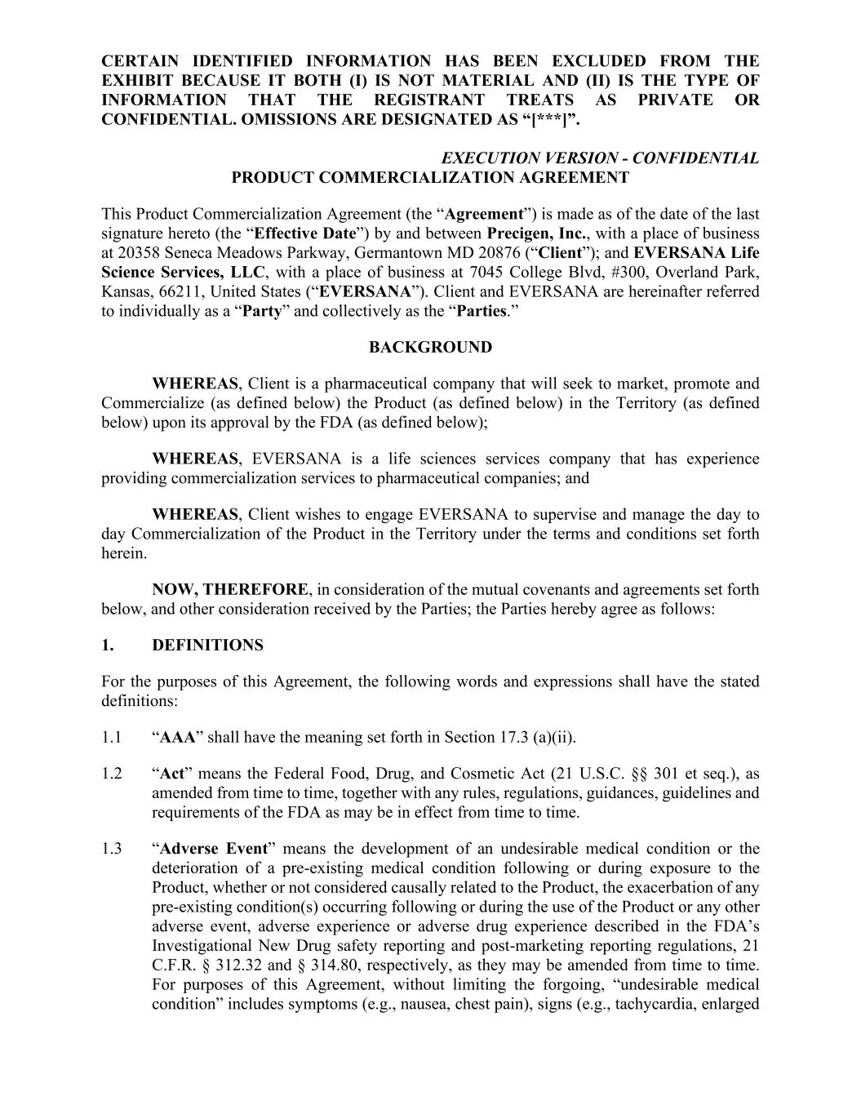
F-44
CERTAIN IDENTIFIED INFORMATION HAS BEEN EXCLUDED FROM THE EXHIBIT BECAUSE IT BOTH (I) IS NOT MATERIAL AND (II) IS THE TYPE OF INFORMATION THAT THE REGISTRANT TREATS AS PRIVATE OR CONFIDENTIAL. OMISSIONS ARE DESIGNATED AS “[***]”. EXECUTION VERSION - CONFIDENTIAL PRODUCT COMMERCIALIZATION AGREEMENT This Product Commercialization Agreement (the “Agreement”) is made as of the date of the last signature hereto (the “Effective Date”) by and between Precigen, Inc., with a place of business at 20358 Seneca Meadows Parkway, Germantown MD 20876 (“Client”); and EVERSANA Life Science Services, LLC, with a place of business at 7045 College Blvd, #300, Overland Park, Kansas, 66211, United States (“EVERSANA”). Client and EVERSANA are hereinafter referred to individually as a “Party” and collectively as the “Parties.” BACKGROUND WHEREAS, Client is a pharmaceutical company that will seek to market, promote and Commercialize (as defined below) the Product (as defined below) in the Territory (as defined below) upon its approval by the FDA (as defined below); WHEREAS, EVERSANA is a life sciences services company that has experience providing commercialization services to pharmaceutical companies; and WHEREAS, Client wishes to engage EVERSANA to supervise and manage the day to day Commercialization of the Product in the Territory under the terms and conditions set forth herein. NOW, THEREFORE, in consideration of the mutual covenants and agreements set forth below, and other consideration received by the Parties; the Parties hereby agree as follows: 1. DEFINITIONS For the purposes of this Agreement, the following words and expressions shall have the stated definitions: 1.1 “AAA” shall have the meaning set forth in Section 17.3 (a)(ii). 1.2 “Act” means the Federal Food, Drug, and Cosmetic Act (21 U.S.C. §§ 301 et seq.), as amended from time to time, together with any rules, regulations, guidances, guidelines and requirements of the FDA as may be in effect from time to time. 1.3 “Adverse Event” means the development of an undesirable medical condition or the deterioration of a pre-existing medical condition following or during exposure to the Product, whether or not considered causally related to the Product, the exacerbation of any pre-existing condition(s) occurring following or during the use of the Product or any other adverse event, adverse experience or adverse drug experience described in the FDA’s Investigational New Drug safety reporting and post-marketing reporting regulations, 21 C.F.R. § 312.32 and § 314.80, respectively, as they may be amended from time to time. For purposes of this Agreement, without limiting the forgoing, “undesirable medical condition” includes symptoms (e.g., nausea, chest pain), signs (e.g., tachycardia, enlarged

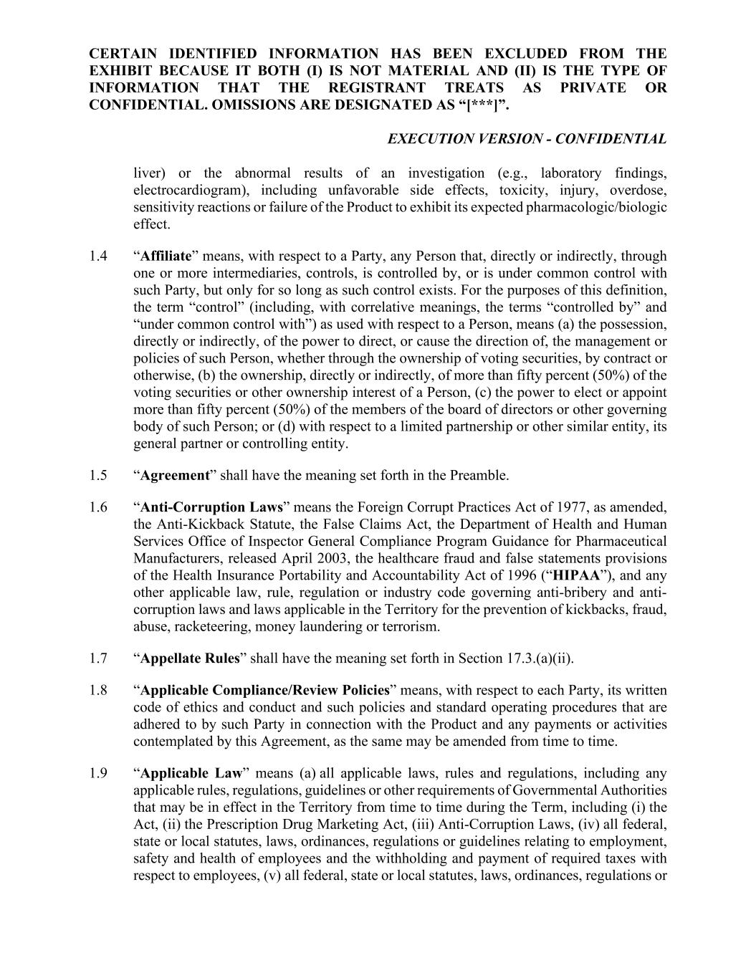
CERTAIN IDENTIFIED INFORMATION HAS BEEN EXCLUDED FROM THE EXHIBIT BECAUSE IT BOTH (I) IS NOT MATERIAL AND (II) IS THE TYPE OF INFORMATION THAT THE REGISTRANT TREATS AS PRIVATE OR CONFIDENTIAL. OMISSIONS ARE DESIGNATED AS “[***]”. EXECUTION VERSION - CONFIDENTIAL liver) or the abnormal results of an investigation (e.g., laboratory findings, electrocardiogram), including unfavorable side effects, toxicity, injury, overdose, sensitivity reactions or failure of the Product to exhibit its expected pharmacologic/biologic effect. 1.4 “Affiliate” means, with respect to a Party, any Person that, directly or indirectly, through one or more intermediaries, controls, is controlled by, or is under common control with such Party, but only for so long as such control exists. For the purposes of this definition, the term “control” (including, with correlative meanings, the terms “controlled by” and “under common control with”) as used with respect to a Person, means (a) the possession, directly or indirectly, of the power to direct, or cause the direction of, the management or policies of such Person, whether through the ownership of voting securities, by contract or otherwise, (b) the ownership, directly or indirectly, of more than fifty percent (50%) of the voting securities or other ownership interest of a Person, (c) the power to elect or appoint more than fifty percent (50%) of the members of the board of directors or other governing body of such Person; or (d) with respect to a limited partnership or other similar entity, its general partner or controlling entity. 1.5 “Agreement” shall have the meaning set forth in the Preamble. 1.6 “Anti-Corruption Laws” means the Foreign Corrupt Practices Act of 1977, as amended, the Anti-Kickback Statute, the False Claims Act, the Department of Health and Human Services Office of Inspector General Compliance Program Guidance for Pharmaceutical Manufacturers, released April 2003, the healthcare fraud and false statements provisions of the Health Insurance Portability and Accountability Act of 1996 (“HIPAA”), and any other applicable law, rule, regulation or industry code governing anti-bribery and anti- corruption laws and laws applicable in the Territory for the prevention of kickbacks, fraud, abuse, racketeering, money laundering or terrorism. 1.7 “Appellate Rules” shall have the meaning set forth in Section 17.3.(a)(ii). 1.8 “Applicable Compliance/Review Policies” means, with respect to each Party, its written code of ethics and conduct and such policies and standard operating procedures that are adhered to by such Party in connection with the Product and any payments or activities contemplated by this Agreement, as the same may be amended from time to time. 1.9 “Applicable Law” means (a) all applicable laws, rules and regulations, including any applicable rules, regulations, guidelines or other requirements of Governmental Authorities that may be in effect in the Territory from time to time during the Term, including (i) the Act, (ii) the Prescription Drug Marketing Act, (iii) Anti-Corruption Laws, (iv) all federal, state or local statutes, laws, ordinances, regulations or guidelines relating to employment, safety and health of employees and the withholding and payment of required taxes with respect to employees, (v) all federal, state or local statutes, laws, ordinances, regulations or

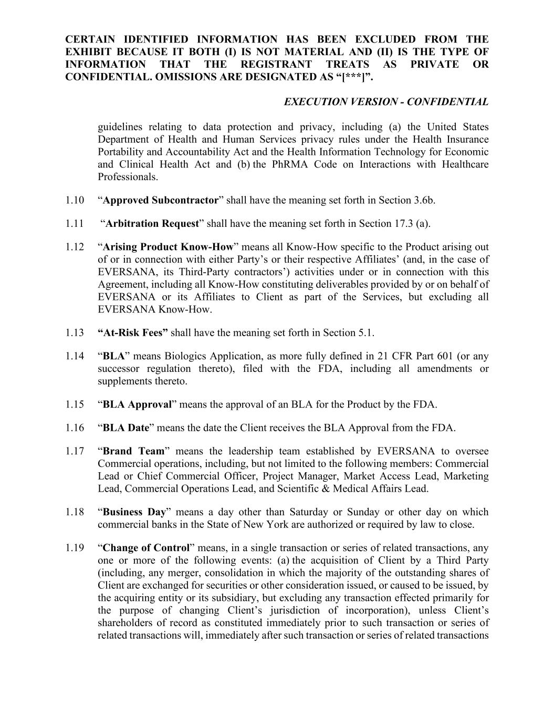
CERTAIN IDENTIFIED INFORMATION HAS BEEN EXCLUDED FROM THE EXHIBIT BECAUSE IT BOTH (I) IS NOT MATERIAL AND (II) IS THE TYPE OF INFORMATION THAT THE REGISTRANT TREATS AS PRIVATE OR CONFIDENTIAL. OMISSIONS ARE DESIGNATED AS “[***]”. EXECUTION VERSION - CONFIDENTIAL guidelines relating to data protection and privacy, including (a) the United States Department of Health and Human Services privacy rules under the Health Insurance Portability and Accountability Act and the Health Information Technology for Economic and Clinical Health Act and (b) the PhRMA Code on Interactions with Healthcare Professionals. 1.10 “Approved Subcontractor” shall have the meaning set forth in Section 3.6b. 1.11 “Arbitration Request” shall have the meaning set forth in Section 17.3 (a). 1.12 “Arising Product Know-How” means all Know-How specific to the Product arising out of or in connection with either Party’s or their respective Affiliates’ (and, in the case of EVERSANA, its Third-Party contractors’) activities under or in connection with this Agreement, including all Know-How constituting deliverables provided by or on behalf of EVERSANA or its Affiliates to Client as part of the Services, but excluding all EVERSANA Know-How. 1.13 “At-Risk Fees” shall have the meaning set forth in Section 5.1. 1.14 “BLA” means Biologics Application, as more fully defined in 21 CFR Part 601 (or any successor regulation thereto), filed with the FDA, including all amendments or supplements thereto. 1.15 “BLA Approval” means the approval of an BLA for the Product by the FDA. 1.16 “BLA Date” means the date the Client receives the BLA Approval from the FDA. 1.17 “Brand Team” means the leadership team established by EVERSANA to oversee Commercial operations, including, but not limited to the following members: Commercial Lead or Chief Commercial Officer, Project Manager, Market Access Lead, Marketing Lead, Commercial Operations Lead, and Scientific & Medical Affairs Lead. 1.18 “Business Day” means a day other than Saturday or Sunday or other day on which commercial banks in the State of New York are authorized or required by law to close. 1.19 “Change of Control” means, in a single transaction or series of related transactions, any one or more of the following events: (a) the acquisition of Client by a Third Party (including, any merger, consolidation in which the majority of the outstanding shares of Client are exchanged for securities or other consideration issued, or caused to be issued, by the acquiring entity or its subsidiary, but excluding any transaction effected primarily for the purpose of changing Client’s jurisdiction of incorporation), unless Client’s shareholders of record as constituted immediately prior to such transaction or series of related transactions will, immediately after such transaction or series of related transactions

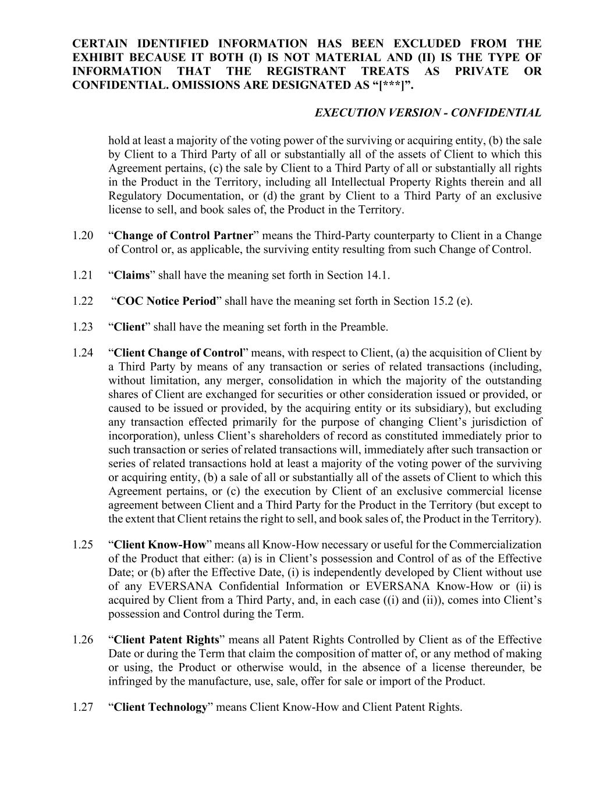
CERTAIN IDENTIFIED INFORMATION HAS BEEN EXCLUDED FROM THE EXHIBIT BECAUSE IT BOTH (I) IS NOT MATERIAL AND (II) IS THE TYPE OF INFORMATION THAT THE REGISTRANT TREATS AS PRIVATE OR CONFIDENTIAL. OMISSIONS ARE DESIGNATED AS “[***]”. EXECUTION VERSION - CONFIDENTIAL hold at least a majority of the voting power of the surviving or acquiring entity, (b) the sale by Client to a Third Party of all or substantially all of the assets of Client to which this Agreement pertains, (c) the sale by Client to a Third Party of all or substantially all rights in the Product in the Territory, including all Intellectual Property Rights therein and all Regulatory Documentation, or (d) the grant by Client to a Third Party of an exclusive license to sell, and book sales of, the Product in the Territory. 1.20 “Change of Control Partner” means the Third-Party counterparty to Client in a Change of Control or, as applicable, the surviving entity resulting from such Change of Control. 1.21 “Claims” shall have the meaning set forth in Section 14.1. 1.22 “COC Notice Period” shall have the meaning set forth in Section 15.2 (e). 1.23 “Client” shall have the meaning set forth in the Preamble. 1.24 “Client Change of Control” means, with respect to Client, (a) the acquisition of Client by a Third Party by means of any transaction or series of related transactions (including, without limitation, any merger, consolidation in which the majority of the outstanding shares of Client are exchanged for securities or other consideration issued or provided, or caused to be issued or provided, by the acquiring entity or its subsidiary), but excluding any transaction effected primarily for the purpose of changing Client’s jurisdiction of incorporation), unless Client’s shareholders of record as constituted immediately prior to such transaction or series of related transactions will, immediately after such transaction or series of related transactions hold at least a majority of the voting power of the surviving or acquiring entity, (b) a sale of all or substantially all of the assets of Client to which this Agreement pertains, or (c) the execution by Client of an exclusive commercial license agreement between Client and a Third Party for the Product in the Territory (but except to the extent that Client retains the right to sell, and book sales of, the Product in the Territory). 1.25 “Client Know-How” means all Know-How necessary or useful for the Commercialization of the Product that either: (a) is in Client’s possession and Control of as of the Effective Date; or (b) after the Effective Date, (i) is independently developed by Client without use of any EVERSANA Confidential Information or EVERSANA Know-How or (ii) is acquired by Client from a Third Party, and, in each case ((i) and (ii)), comes into Client’s possession and Control during the Term. 1.26 “Client Patent Rights” means all Patent Rights Controlled by Client as of the Effective Date or during the Term that claim the composition of matter of, or any method of making or using, the Product or otherwise would, in the absence of a license thereunder, be infringed by the manufacture, use, sale, offer for sale or import of the Product. 1.27 “Client Technology” means Client Know-How and Client Patent Rights.

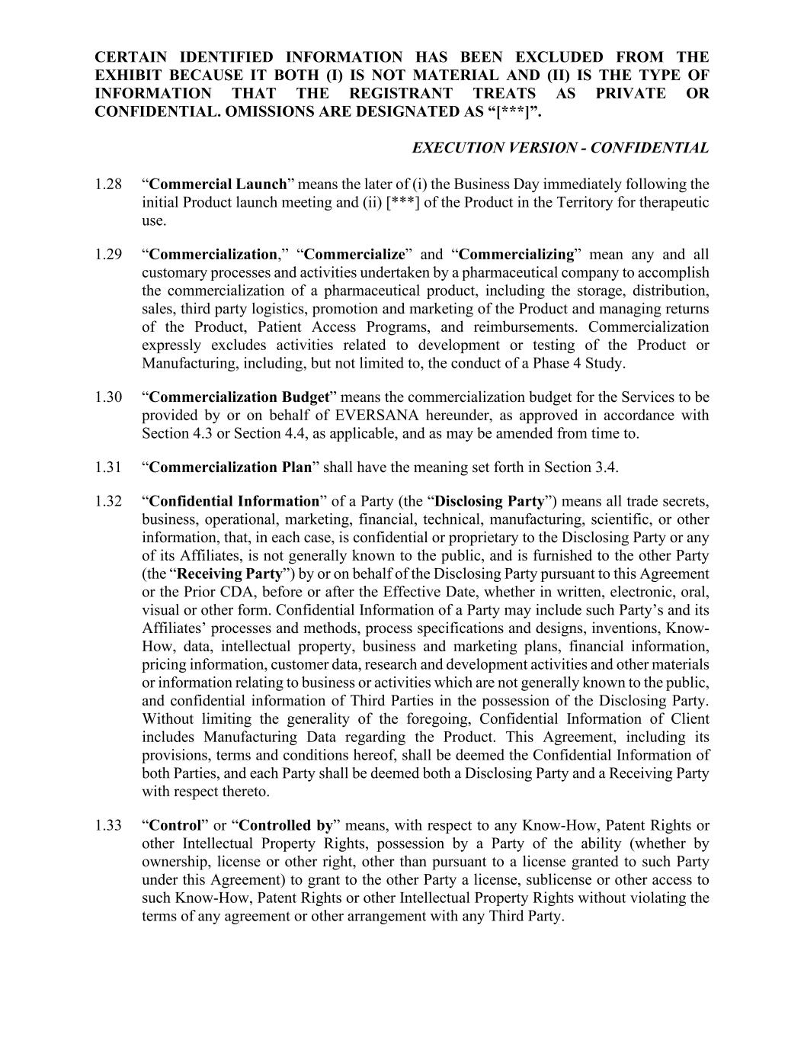
CERTAIN IDENTIFIED INFORMATION HAS BEEN EXCLUDED FROM THE EXHIBIT BECAUSE IT BOTH (I) IS NOT MATERIAL AND (II) IS THE TYPE OF INFORMATION THAT THE REGISTRANT TREATS AS PRIVATE OR CONFIDENTIAL. OMISSIONS ARE DESIGNATED AS “[***]”. EXECUTION VERSION - CONFIDENTIAL 1.28 “Commercial Launch” means the later of (i) the Business Day immediately following the initial Product launch meeting and (ii) [***] of the Product in the Territory for therapeutic use. 1.29 “Commercialization,” “Commercialize” and “Commercializing” mean any and all customary processes and activities undertaken by a pharmaceutical company to accomplish the commercialization of a pharmaceutical product, including the storage, distribution, sales, third party logistics, promotion and marketing of the Product and managing returns of the Product, Patient Access Programs, and reimbursements. Commercialization expressly excludes activities related to development or testing of the Product or Manufacturing, including, but not limited to, the conduct of a Phase 4 Study. 1.30 “Commercialization Budget” means the commercialization budget for the Services to be provided by or on behalf of EVERSANA hereunder, as approved in accordance with Section 4.3 or Section 4.4, as applicable, and as may be amended from time to. 1.31 “Commercialization Plan” shall have the meaning set forth in Section 3.4. 1.32 “Confidential Information” of a Party (the “Disclosing Party”) means all trade secrets, business, operational, marketing, financial, technical, manufacturing, scientific, or other information, that, in each case, is confidential or proprietary to the Disclosing Party or any of its Affiliates, is not generally known to the public, and is furnished to the other Party (the “Receiving Party”) by or on behalf of the Disclosing Party pursuant to this Agreement or the Prior CDA, before or after the Effective Date, whether in written, electronic, oral, visual or other form. Confidential Information of a Party may include such Party’s and its Affiliates’ processes and methods, process specifications and designs, inventions, Know- How, data, intellectual property, business and marketing plans, financial information, pricing information, customer data, research and development activities and other materials or information relating to business or activities which are not generally known to the public, and confidential information of Third Parties in the possession of the Disclosing Party. Without limiting the generality of the foregoing, Confidential Information of Client includes Manufacturing Data regarding the Product. This Agreement, including its provisions, terms and conditions hereof, shall be deemed the Confidential Information of both Parties, and each Party shall be deemed both a Disclosing Party and a Receiving Party with respect thereto. 1.33 “Control” or “Controlled by” means, with respect to any Know-How, Patent Rights or other Intellectual Property Rights, possession by a Party of the ability (whether by ownership, license or other right, other than pursuant to a license granted to such Party under this Agreement) to grant to the other Party a license, sublicense or other access to such Know-How, Patent Rights or other Intellectual Property Rights without violating the terms of any agreement or other arrangement with any Third Party.

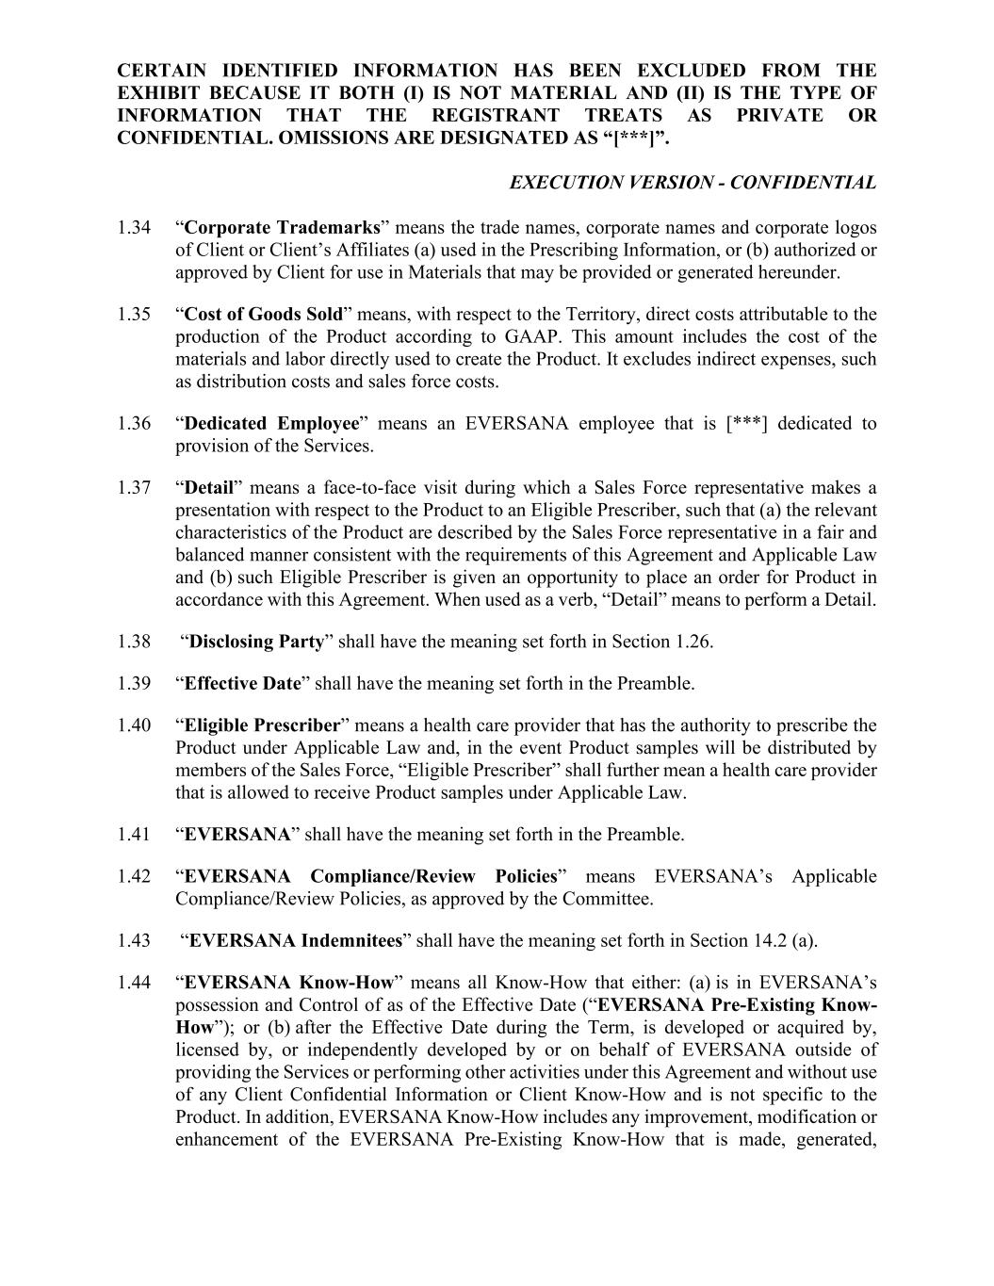
CERTAIN IDENTIFIED INFORMATION HAS BEEN EXCLUDED FROM THE EXHIBIT BECAUSE IT BOTH (I) IS NOT MATERIAL AND (II) IS THE TYPE OF INFORMATION THAT THE REGISTRANT TREATS AS PRIVATE OR CONFIDENTIAL. OMISSIONS ARE DESIGNATED AS “[***]”. EXECUTION VERSION - CONFIDENTIAL 1.34 “Corporate Trademarks” means the trade names, corporate names and corporate logos of Client or Client’s Affiliates (a) used in the Prescribing Information, or (b) authorized or approved by Client for use in Materials that may be provided or generated hereunder. 1.35 “Cost of Goods Sold” means, with respect to the Territory, direct costs attributable to the production of the Product according to GAAP. This amount includes the cost of the materials and labor directly used to create the Product. It excludes indirect expenses, such as distribution costs and sales force costs. 1.36 “Dedicated Employee” means an EVERSANA employee that is [***] dedicated to provision of the Services. 1.37 “Detail” means a face-to-face visit during which a Sales Force representative makes a presentation with respect to the Product to an Eligible Prescriber, such that (a) the relevant characteristics of the Product are described by the Sales Force representative in a fair and balanced manner consistent with the requirements of this Agreement and Applicable Law and (b) such Eligible Prescriber is given an opportunity to place an order for Product in accordance with this Agreement. When used as a verb, “Detail” means to perform a Detail. 1.38 “Disclosing Party” shall have the meaning set forth in Section 1.26. 1.39 “Effective Date” shall have the meaning set forth in the Preamble. 1.40 “Eligible Prescriber” means a health care provider that has the authority to prescribe the Product under Applicable Law and, in the event Product samples will be distributed by members of the Sales Force, “Eligible Prescriber” shall further mean a health care provider that is allowed to receive Product samples under Applicable Law. 1.41 “EVERSANA” shall have the meaning set forth in the Preamble. 1.42 “EVERSANA Compliance/Review Policies” means EVERSANA’s Applicable Compliance/Review Policies, as approved by the Committee. 1.43 “EVERSANA Indemnitees” shall have the meaning set forth in Section 14.2 (a). 1.44 “EVERSANA Know-How” means all Know-How that either: (a) is in EVERSANA’s possession and Control of as of the Effective Date (“EVERSANA Pre-Existing Know- How”); or (b) after the Effective Date during the Term, is developed or acquired by, licensed by, or independently developed by or on behalf of EVERSANA outside of providing the Services or performing other activities under this Agreement and without use of any Client Confidential Information or Client Know-How and is not specific to the Product. In addition, EVERSANA Know-How includes any improvement, modification or enhancement of the EVERSANA Pre-Existing Know-How that is made, generated,

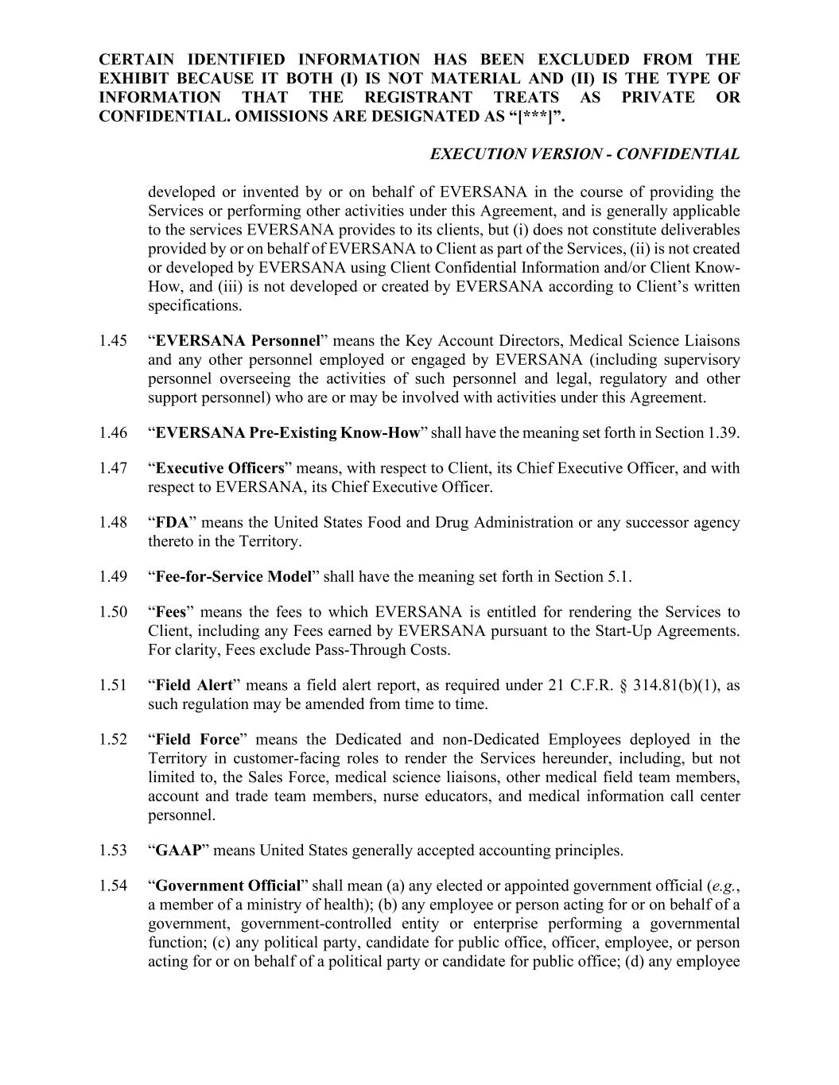
CERTAIN IDENTIFIED INFORMATION HAS BEEN EXCLUDED FROM THE EXHIBIT BECAUSE IT BOTH (I) IS NOT MATERIAL AND (II) IS THE TYPE OF INFORMATION THAT THE REGISTRANT TREATS AS PRIVATE OR CONFIDENTIAL. OMISSIONS ARE DESIGNATED AS “[***]”. EXECUTION VERSION - CONFIDENTIAL developed or invented by or on behalf of EVERSANA in the course of providing the Services or performing other activities under this Agreement, and is generally applicable to the services EVERSANA provides to its clients, but (i) does not constitute deliverables provided by or on behalf of EVERSANA to Client as part of the Services, (ii) is not created or developed by EVERSANA using Client Confidential Information and/or Client Know- How, and (iii) is not developed or created by EVERSANA according to Client’s written specifications. 1.45 “EVERSANA Personnel” means the Key Account Directors, Medical Science Liaisons and any other personnel employed or engaged by EVERSANA (including supervisory personnel overseeing the activities of such personnel and legal, regulatory and other support personnel) who are or may be involved with activities under this Agreement. 1.46 “EVERSANA Pre-Existing Know-How” shall have the meaning set forth in Section 1.39. 1.47 “Executive Officers” means, with respect to Client, its Chief Executive Officer, and with respect to EVERSANA, its Chief Executive Officer. 1.48 “FDA” means the United States Food and Drug Administration or any successor agency thereto in the Territory. 1.49 “Fee-for-Service Model” shall have the meaning set forth in Section 5.1. 1.50 “Fees” means the fees to which EVERSANA is entitled for rendering the Services to Client, including any Fees earned by EVERSANA pursuant to the Start-Up Agreements. For clarity, Fees exclude Pass-Through Costs. 1.51 “Field Alert” means a field alert report, as required under 21 C.F.R. § 314.81(b)(1), as such regulation may be amended from time to time. 1.52 “Field Force” means the Dedicated and non-Dedicated Employees deployed in the Territory in customer-facing roles to render the Services hereunder, including, but not limited to, the Sales Force, medical science liaisons, other medical field team members, account and trade team members, nurse educators, and medical information call center personnel. 1.53 “GAAP” means United States generally accepted accounting principles. 1.54 “Government Official” shall mean (a) any elected or appointed government official (e.g., a member of a ministry of health); (b) any employee or person acting for or on behalf of a government, government-controlled entity or enterprise performing a governmental function; (c) any political party, candidate for public office, officer, employee, or person acting for or on behalf of a political party or candidate for public office; (d) any employee

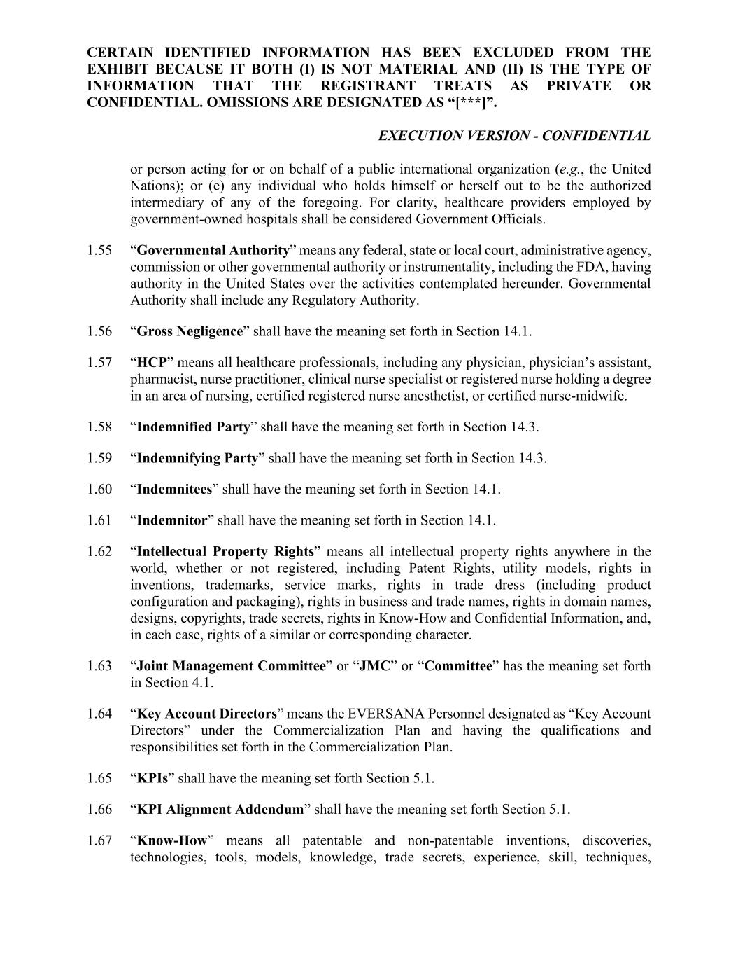
CERTAIN IDENTIFIED INFORMATION HAS BEEN EXCLUDED FROM THE EXHIBIT BECAUSE IT BOTH (I) IS NOT MATERIAL AND (II) IS THE TYPE OF INFORMATION THAT THE REGISTRANT TREATS AS PRIVATE OR CONFIDENTIAL. OMISSIONS ARE DESIGNATED AS “[***]”. EXECUTION VERSION - CONFIDENTIAL or person acting for or on behalf of a public international organization (e.g., the United Nations); or (e) any individual who holds himself or herself out to be the authorized intermediary of any of the foregoing. For clarity, healthcare providers employed by government-owned hospitals shall be considered Government Officials. 1.55 “Governmental Authority” means any federal, state or local court, administrative agency, commission or other governmental authority or instrumentality, including the FDA, having authority in the United States over the activities contemplated hereunder. Governmental Authority shall include any Regulatory Authority. 1.56 “Gross Negligence” shall have the meaning set forth in Section 14.1. 1.57 “HCP” means all healthcare professionals, including any physician, physician’s assistant, pharmacist, nurse practitioner, clinical nurse specialist or registered nurse holding a degree in an area of nursing, certified registered nurse anesthetist, or certified nurse-midwife. 1.58 “Indemnified Party” shall have the meaning set forth in Section 14.3. 1.59 “Indemnifying Party” shall have the meaning set forth in Section 14.3. 1.60 “Indemnitees” shall have the meaning set forth in Section 14.1. 1.61 “Indemnitor” shall have the meaning set forth in Section 14.1. 1.62 “Intellectual Property Rights” means all intellectual property rights anywhere in the world, whether or not registered, including Patent Rights, utility models, rights in inventions, trademarks, service marks, rights in trade dress (including product configuration and packaging), rights in business and trade names, rights in domain names, designs, copyrights, trade secrets, rights in Know-How and Confidential Information, and, in each case, rights of a similar or corresponding character. 1.63 “Joint Management Committee” or “JMC” or “Committee” has the meaning set forth in Section 4.1. 1.64 “Key Account Directors” means the EVERSANA Personnel designated as “Key Account Directors” under the Commercialization Plan and having the qualifications and responsibilities set forth in the Commercialization Plan. 1.65 “KPIs” shall have the meaning set forth Section 5.1. 1.66 “KPI Alignment Addendum” shall have the meaning set forth Section 5.1. 1.67 “Know-How” means all patentable and non-patentable inventions, discoveries, technologies, tools, models, knowledge, trade secrets, experience, skill, techniques,

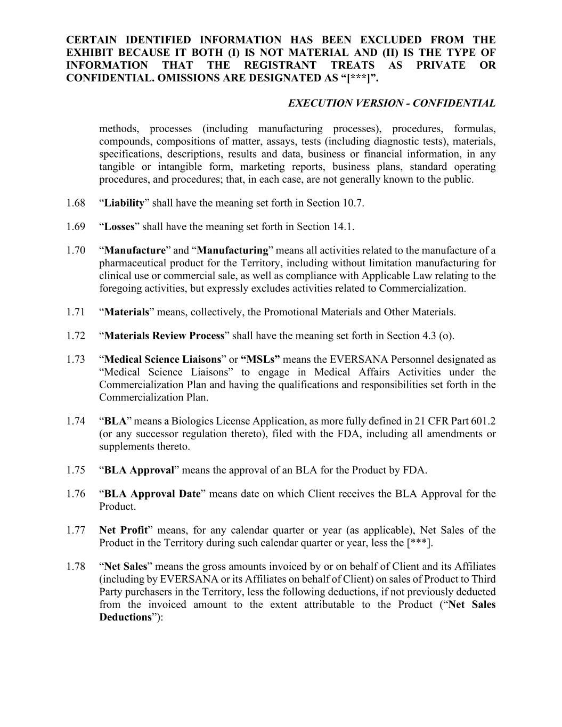
CERTAIN IDENTIFIED INFORMATION HAS BEEN EXCLUDED FROM THE EXHIBIT BECAUSE IT BOTH (I) IS NOT MATERIAL AND (II) IS THE TYPE OF INFORMATION THAT THE REGISTRANT TREATS AS PRIVATE OR CONFIDENTIAL. OMISSIONS ARE DESIGNATED AS “[***]”. EXECUTION VERSION - CONFIDENTIAL methods, processes (including manufacturing processes), procedures, formulas, compounds, compositions of matter, assays, tests (including diagnostic tests), materials, specifications, descriptions, results and data, business or financial information, in any tangible or intangible form, marketing reports, business plans, standard operating procedures, and procedures; that, in each case, are not generally known to the public. 1.68 “Liability” shall have the meaning set forth in Section 10.7. 1.69 “Losses” shall have the meaning set forth in Section 14.1. 1.70 “Manufacture” and “Manufacturing” means all activities related to the manufacture of a pharmaceutical product for the Territory, including without limitation manufacturing for clinical use or commercial sale, as well as compliance with Applicable Law relating to the foregoing activities, but expressly excludes activities related to Commercialization. 1.71 “Materials” means, collectively, the Promotional Materials and Other Materials. 1.72 “Materials Review Process” shall have the meaning set forth in Section 4.3 (o). 1.73 “Medical Science Liaisons” or “MSLs” means the EVERSANA Personnel designated as “Medical Science Liaisons” to engage in Medical Affairs Activities under the Commercialization Plan and having the qualifications and responsibilities set forth in the Commercialization Plan. 1.74 “BLA” means a Biologics License Application, as more fully defined in 21 CFR Part 601.2 (or any successor regulation thereto), filed with the FDA, including all amendments or supplements thereto. 1.75 “BLA Approval” means the approval of an BLA for the Product by FDA. 1.76 “BLA Approval Date” means date on which Client receives the BLA Approval for the Product. 1.77 Net Profit” means, for any calendar quarter or year (as applicable), Net Sales of the Product in the Territory during such calendar quarter or year, less the [***]. 1.78 “Net Sales” means the gross amounts invoiced by or on behalf of Client and its Affiliates (including by EVERSANA or its Affiliates on behalf of Client) on sales of Product to Third Party purchasers in the Territory, less the following deductions, if not previously deducted from the invoiced amount to the extent attributable to the Product (“Net Sales Deductions”):

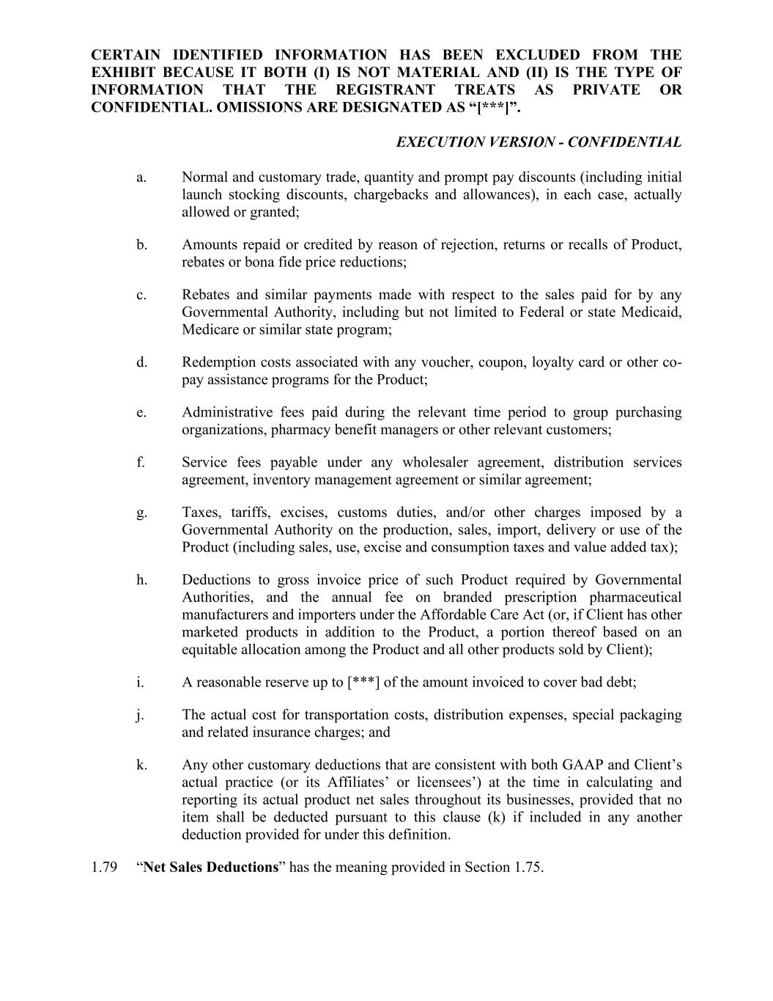
CERTAIN IDENTIFIED INFORMATION HAS BEEN EXCLUDED FROM THE EXHIBIT BECAUSE IT BOTH (I) IS NOT MATERIAL AND (II) IS THE TYPE OF INFORMATION THAT THE REGISTRANT TREATS AS PRIVATE OR CONFIDENTIAL. OMISSIONS ARE DESIGNATED AS “[***]”. EXECUTION VERSION - CONFIDENTIAL a. Normal and customary trade, quantity and prompt pay discounts (including initial launch stocking discounts, chargebacks and allowances), in each case, actually allowed or granted; b. Amounts repaid or credited by reason of rejection, returns or recalls of Product, rebates or bona fide price reductions; c. Rebates and similar payments made with respect to the sales paid for by any Governmental Authority, including but not limited to Federal or state Medicaid, Medicare or similar state program; d. Redemption costs associated with any voucher, coupon, loyalty card or other co- pay assistance programs for the Product; e. Administrative fees paid during the relevant time period to group purchasing organizations, pharmacy benefit managers or other relevant customers; f. Service fees payable under any wholesaler agreement, distribution services agreement, inventory management agreement or similar agreement; g. Taxes, tariffs, excises, customs duties, and/or other charges imposed by a Governmental Authority on the production, sales, import, delivery or use of the Product (including sales, use, excise and consumption taxes and value added tax); h. Deductions to gross invoice price of such Product required by Governmental Authorities, and the annual fee on branded prescription pharmaceutical manufacturers and importers under the Affordable Care Act (or, if Client has other marketed products in addition to the Product, a portion thereof based on an equitable allocation among the Product and all other products sold by Client); i. A reasonable reserve up to [***] of the amount invoiced to cover bad debt; j. The actual cost for transportation costs, distribution expenses, special packaging and related insurance charges; and k. Any other customary deductions that are consistent with both GAAP and Client’s actual practice (or its Affiliates’ or licensees’) at the time in calculating and reporting its actual product net sales throughout its businesses, provided that no item shall be deducted pursuant to this clause (k) if included in any another deduction provided for under this definition. 1.79 “Net Sales Deductions” has the meaning provided in Section 1.75.

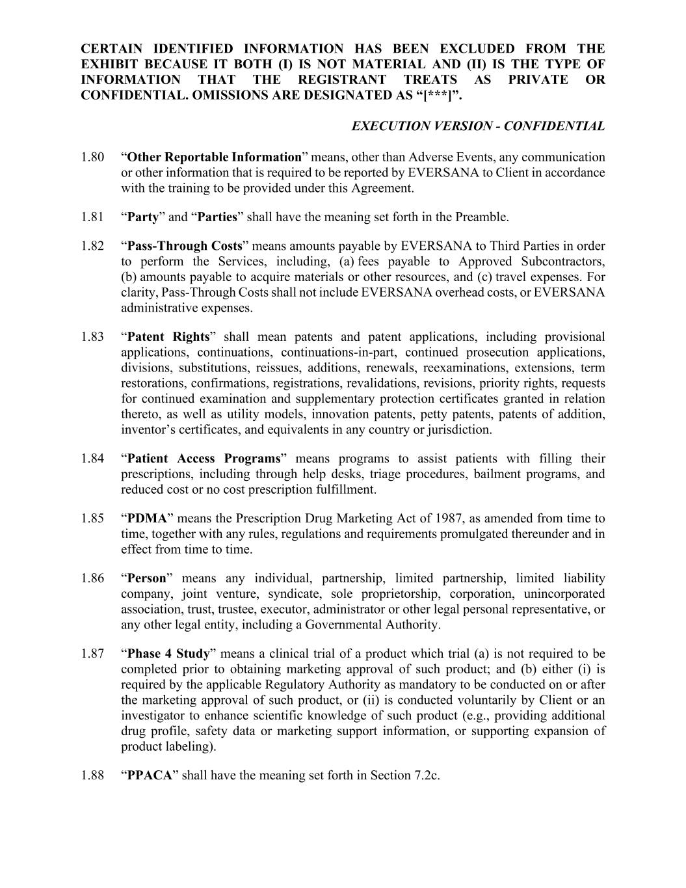
CERTAIN IDENTIFIED INFORMATION HAS BEEN EXCLUDED FROM THE EXHIBIT BECAUSE IT BOTH (I) IS NOT MATERIAL AND (II) IS THE TYPE OF INFORMATION THAT THE REGISTRANT TREATS AS PRIVATE OR CONFIDENTIAL. OMISSIONS ARE DESIGNATED AS “[***]”. EXECUTION VERSION - CONFIDENTIAL 1.80 “Other Reportable Information” means, other than Adverse Events, any communication or other information that is required to be reported by EVERSANA to Client in accordance with the training to be provided under this Agreement. 1.81 “Party” and “Parties” shall have the meaning set forth in the Preamble. 1.82 “Pass-Through Costs” means amounts payable by EVERSANA to Third Parties in order to perform the Services, including, (a) fees payable to Approved Subcontractors, (b) amounts payable to acquire materials or other resources, and (c) travel expenses. For clarity, Pass-Through Costs shall not include EVERSANA overhead costs, or EVERSANA administrative expenses. 1.83 “Patent Rights” shall mean patents and patent applications, including provisional applications, continuations, continuations-in-part, continued prosecution applications, divisions, substitutions, reissues, additions, renewals, reexaminations, extensions, term restorations, confirmations, registrations, revalidations, revisions, priority rights, requests for continued examination and supplementary protection certificates granted in relation thereto, as well as utility models, innovation patents, petty patents, patents of addition, inventor’s certificates, and equivalents in any country or jurisdiction. 1.84 “Patient Access Programs” means programs to assist patients with filling their prescriptions, including through help desks, triage procedures, bailment programs, and reduced cost or no cost prescription fulfillment. 1.85 “PDMA” means the Prescription Drug Marketing Act of 1987, as amended from time to time, together with any rules, regulations and requirements promulgated thereunder and in effect from time to time. 1.86 “Person” means any individual, partnership, limited partnership, limited liability company, joint venture, syndicate, sole proprietorship, corporation, unincorporated association, trust, trustee, executor, administrator or other legal personal representative, or any other legal entity, including a Governmental Authority. 1.87 “Phase 4 Study” means a clinical trial of a product which trial (a) is not required to be completed prior to obtaining marketing approval of such product; and (b) either (i) is required by the applicable Regulatory Authority as mandatory to be conducted on or after the marketing approval of such product, or (ii) is conducted voluntarily by Client or an investigator to enhance scientific knowledge of such product (e.g., providing additional drug profile, safety data or marketing support information, or supporting expansion of product labeling). 1.88 “PPACA” shall have the meaning set forth in Section 7.2c.

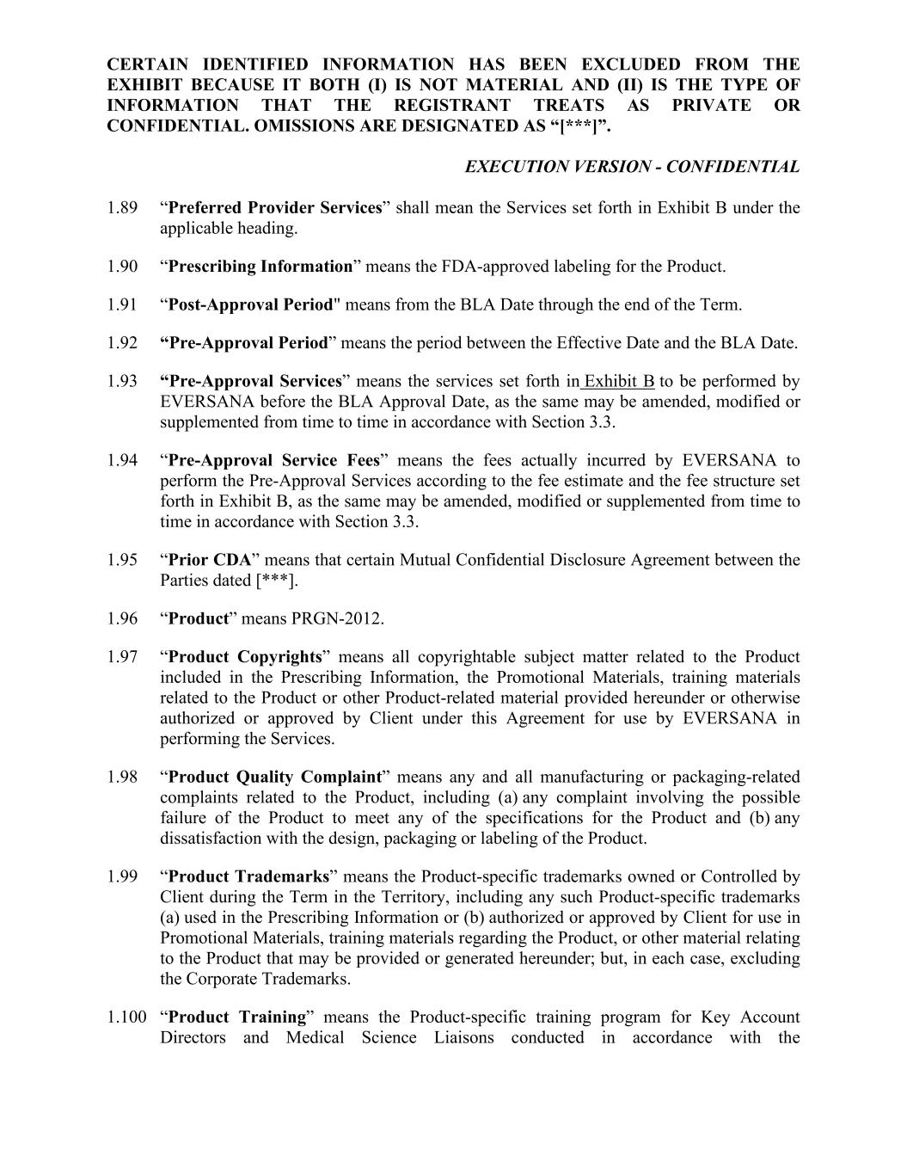
CERTAIN IDENTIFIED INFORMATION HAS BEEN EXCLUDED FROM THE EXHIBIT BECAUSE IT BOTH (I) IS NOT MATERIAL AND (II) IS THE TYPE OF INFORMATION THAT THE REGISTRANT TREATS AS PRIVATE OR CONFIDENTIAL. OMISSIONS ARE DESIGNATED AS “[***]”. EXECUTION VERSION - CONFIDENTIAL 1.89 “Preferred Provider Services” shall mean the Services set forth in Exhibit B under the applicable heading. 1.90 “Prescribing Information” means the FDA-approved labeling for the Product. 1.91 “Post-Approval Period" means from the BLA Date through the end of the Term. 1.92 “Pre-Approval Period” means the period between the Effective Date and the BLA Date. 1.93 “Pre-Approval Services” means the services set forth in Exhibit B to be performed by EVERSANA before the BLA Approval Date, as the same may be amended, modified or supplemented from time to time in accordance with Section 3.3. 1.94 “Pre-Approval Service Fees” means the fees actually incurred by EVERSANA to perform the Pre-Approval Services according to the fee estimate and the fee structure set forth in Exhibit B, as the same may be amended, modified or supplemented from time to time in accordance with Section 3.3. 1.95 “Prior CDA” means that certain Mutual Confidential Disclosure Agreement between the Parties dated [***]. 1.96 “Product” means PRGN-2012. 1.97 “Product Copyrights” means all copyrightable subject matter related to the Product included in the Prescribing Information, the Promotional Materials, training materials related to the Product or other Product-related material provided hereunder or otherwise authorized or approved by Client under this Agreement for use by EVERSANA in performing the Services. 1.98 “Product Quality Complaint” means any and all manufacturing or packaging-related complaints related to the Product, including (a) any complaint involving the possible failure of the Product to meet any of the specifications for the Product and (b) any dissatisfaction with the design, packaging or labeling of the Product. 1.99 “Product Trademarks” means the Product-specific trademarks owned or Controlled by Client during the Term in the Territory, including any such Product-specific trademarks (a) used in the Prescribing Information or (b) authorized or approved by Client for use in Promotional Materials, training materials regarding the Product, or other material relating to the Product that may be provided or generated hereunder; but, in each case, excluding the Corporate Trademarks. 1.100 “Product Training” means the Product-specific training program for Key Account Directors and Medical Science Liaisons conducted in accordance with the

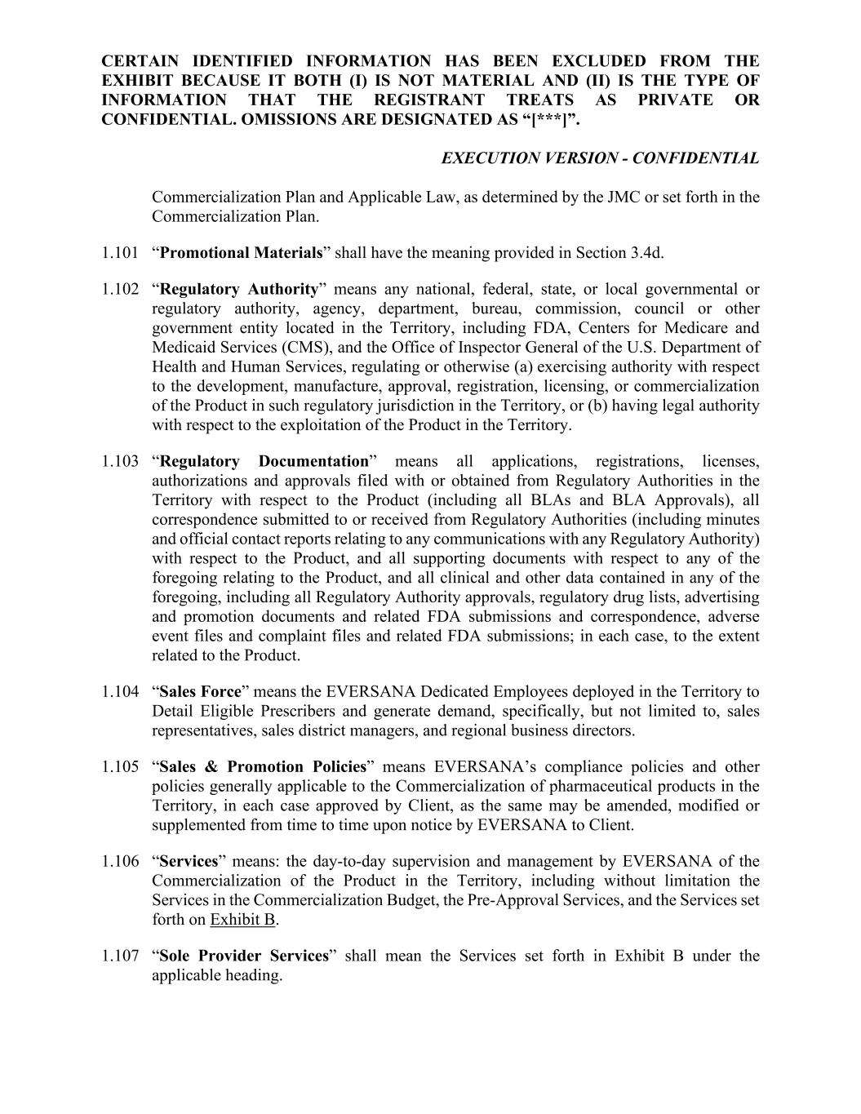
CERTAIN IDENTIFIED INFORMATION HAS BEEN EXCLUDED FROM THE EXHIBIT BECAUSE IT BOTH (I) IS NOT MATERIAL AND (II) IS THE TYPE OF INFORMATION THAT THE REGISTRANT TREATS AS PRIVATE OR CONFIDENTIAL. OMISSIONS ARE DESIGNATED AS “[***]”. EXECUTION VERSION - CONFIDENTIAL Commercialization Plan and Applicable Law, as determined by the JMC or set forth in the Commercialization Plan. 1.101 “Promotional Materials” shall have the meaning provided in Section 3.4d. 1.102 “Regulatory Authority” means any national, federal, state, or local governmental or regulatory authority, agency, department, bureau, commission, council or other government entity located in the Territory, including FDA, Centers for Medicare and Medicaid Services (CMS), and the Office of Inspector General of the U.S. Department of Health and Human Services, regulating or otherwise (a) exercising authority with respect to the development, manufacture, approval, registration, licensing, or commercialization of the Product in such regulatory jurisdiction in the Territory, or (b) having legal authority with respect to the exploitation of the Product in the Territory. 1.103 “Regulatory Documentation” means all applications, registrations, licenses, authorizations and approvals filed with or obtained from Regulatory Authorities in the Territory with respect to the Product (including all BLAs and BLA Approvals), all correspondence submitted to or received from Regulatory Authorities (including minutes and official contact reports relating to any communications with any Regulatory Authority) with respect to the Product, and all supporting documents with respect to any of the foregoing relating to the Product, and all clinical and other data contained in any of the foregoing, including all Regulatory Authority approvals, regulatory drug lists, advertising and promotion documents and related FDA submissions and correspondence, adverse event files and complaint files and related FDA submissions; in each case, to the extent related to the Product. 1.104 “Sales Force” means the EVERSANA Dedicated Employees deployed in the Territory to Detail Eligible Prescribers and generate demand, specifically, but not limited to, sales representatives, sales district managers, and regional business directors. 1.105 “Sales & Promotion Policies” means EVERSANA’s compliance policies and other policies generally applicable to the Commercialization of pharmaceutical products in the Territory, in each case approved by Client, as the same may be amended, modified or supplemented from time to time upon notice by EVERSANA to Client. 1.106 “Services” means: the day-to-day supervision and management by EVERSANA of the Commercialization of the Product in the Territory, including without limitation the Services in the Commercialization Budget, the Pre-Approval Services, and the Services set forth on Exhibit B. 1.107 “Sole Provider Services” shall mean the Services set forth in Exhibit B under the applicable heading.

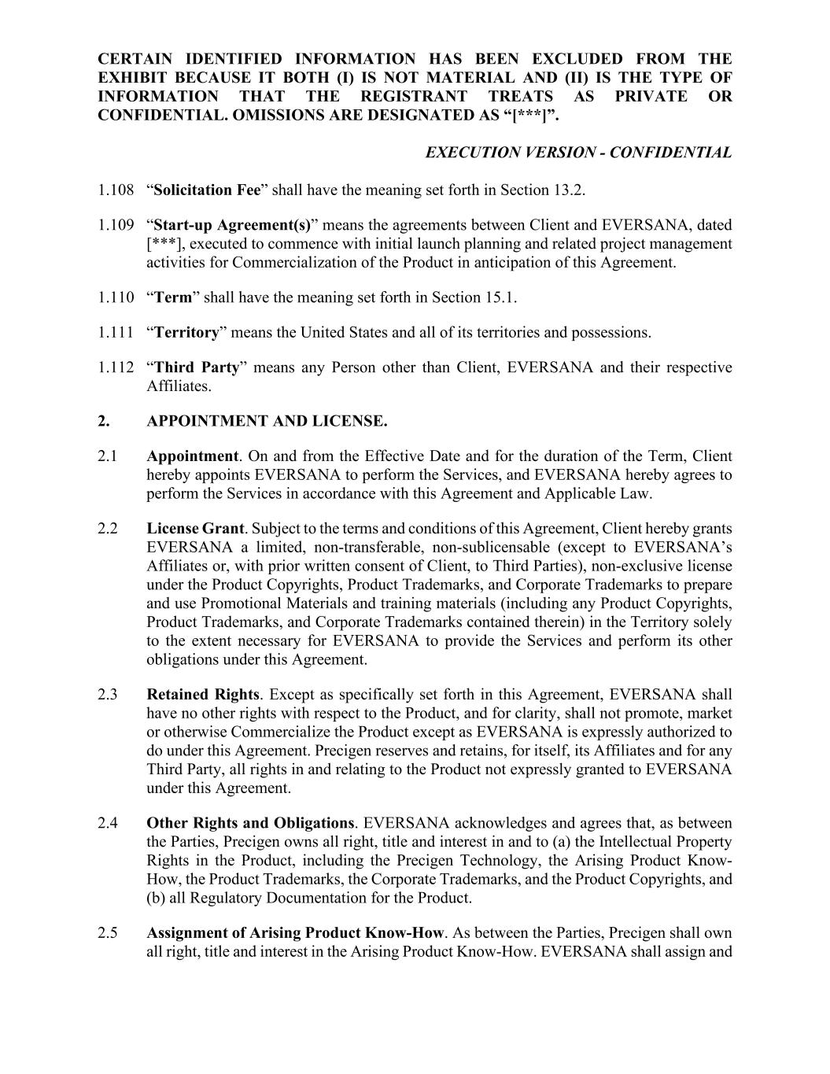
CERTAIN IDENTIFIED INFORMATION HAS BEEN EXCLUDED FROM THE EXHIBIT BECAUSE IT BOTH (I) IS NOT MATERIAL AND (II) IS THE TYPE OF INFORMATION THAT THE REGISTRANT TREATS AS PRIVATE OR CONFIDENTIAL. OMISSIONS ARE DESIGNATED AS “[***]”. EXECUTION VERSION - CONFIDENTIAL 1.108 “Solicitation Fee” shall have the meaning set forth in Section 13.2. 1.109 “Start-up Agreement(s)” means the agreements between Client and EVERSANA, dated [***], executed to commence with initial launch planning and related project management activities for Commercialization of the Product in anticipation of this Agreement. 1.110 “Term” shall have the meaning set forth in Section 15.1. 1.111 “Territory” means the United States and all of its territories and possessions. 1.112 “Third Party” means any Person other than Client, EVERSANA and their respective Affiliates. 2. APPOINTMENT AND LICENSE. 2.1 Appointment. On and from the Effective Date and for the duration of the Term, Client hereby appoints EVERSANA to perform the Services, and EVERSANA hereby agrees to perform the Services in accordance with this Agreement and Applicable Law. 2.2 License Grant. Subject to the terms and conditions of this Agreement, Client hereby grants EVERSANA a limited, non-transferable, non-sublicensable (except to EVERSANA’s Affiliates or, with prior written consent of Client, to Third Parties), non-exclusive license under the Product Copyrights, Product Trademarks, and Corporate Trademarks to prepare and use Promotional Materials and training materials (including any Product Copyrights, Product Trademarks, and Corporate Trademarks contained therein) in the Territory solely to the extent necessary for EVERSANA to provide the Services and perform its other obligations under this Agreement. 2.3 Retained Rights. Except as specifically set forth in this Agreement, EVERSANA shall have no other rights with respect to the Product, and for clarity, shall not promote, market or otherwise Commercialize the Product except as EVERSANA is expressly authorized to do under this Agreement. Precigen reserves and retains, for itself, its Affiliates and for any Third Party, all rights in and relating to the Product not expressly granted to EVERSANA under this Agreement. 2.4 Other Rights and Obligations. EVERSANA acknowledges and agrees that, as between the Parties, Precigen owns all right, title and interest in and to (a) the Intellectual Property Rights in the Product, including the Precigen Technology, the Arising Product Know- How, the Product Trademarks, the Corporate Trademarks, and the Product Copyrights, and (b) all Regulatory Documentation for the Product. 2.5 Assignment of Arising Product Know-How. As between the Parties, Precigen shall own all right, title and interest in the Arising Product Know-How. EVERSANA shall assign and

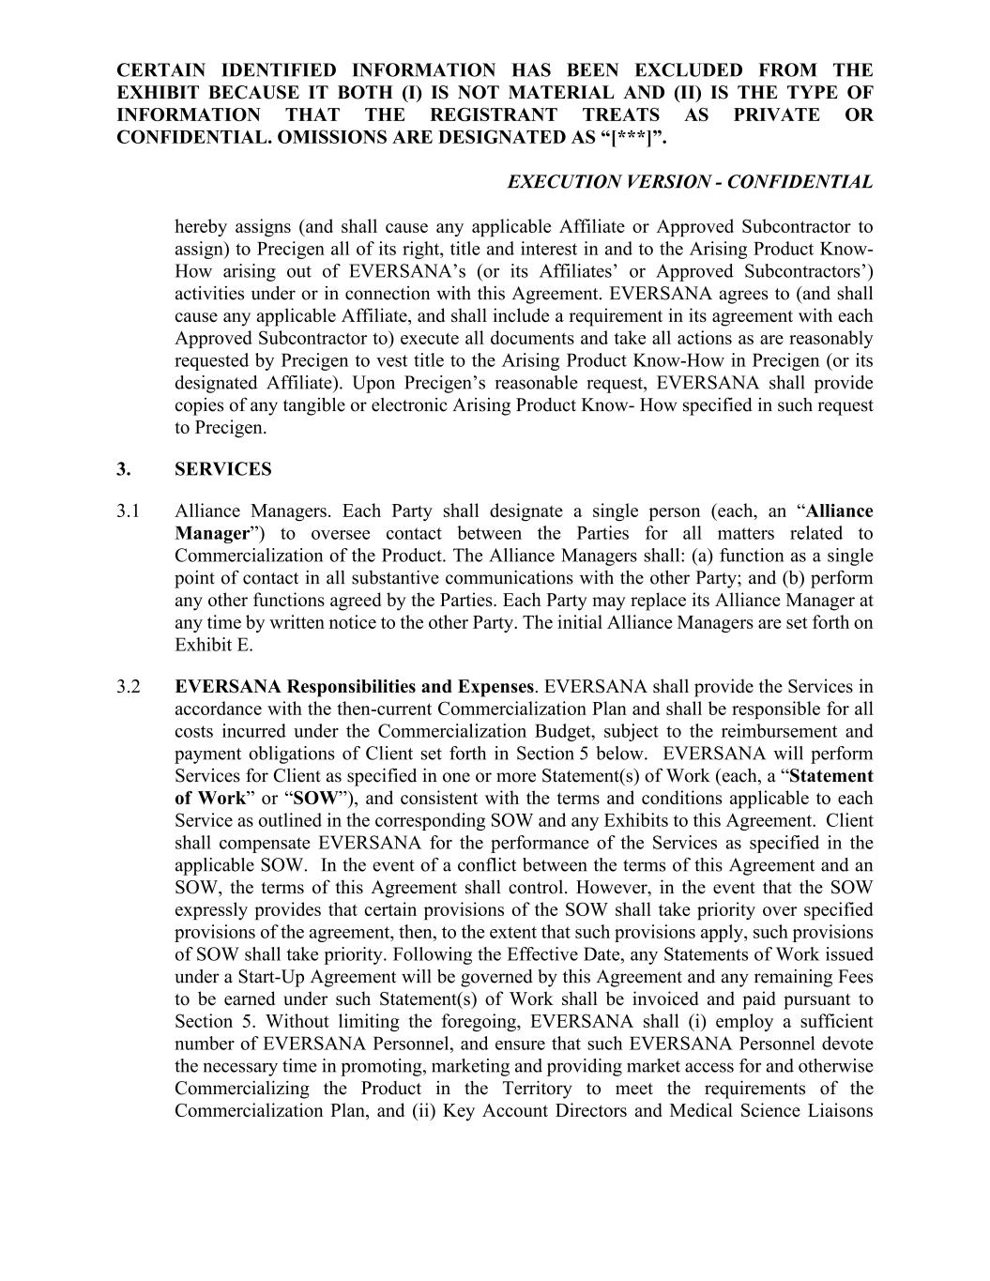
CERTAIN IDENTIFIED INFORMATION HAS BEEN EXCLUDED FROM THE EXHIBIT BECAUSE IT BOTH (I) IS NOT MATERIAL AND (II) IS THE TYPE OF INFORMATION THAT THE REGISTRANT TREATS AS PRIVATE OR CONFIDENTIAL. OMISSIONS ARE DESIGNATED AS “[***]”. EXECUTION VERSION - CONFIDENTIAL hereby assigns (and shall cause any applicable Affiliate or Approved Subcontractor to assign) to Precigen all of its right, title and interest in and to the Arising Product Know- How arising out of EVERSANA’s (or its Affiliates’ or Approved Subcontractors’) activities under or in connection with this Agreement. EVERSANA agrees to (and shall cause any applicable Affiliate, and shall include a requirement in its agreement with each Approved Subcontractor to) execute all documents and take all actions as are reasonably requested by Precigen to vest title to the Arising Product Know-How in Precigen (or its designated Affiliate). Upon Precigen’s reasonable request, EVERSANA shall provide copies of any tangible or electronic Arising Product Know- How specified in such request to Precigen. 3. SERVICES 3.1 Alliance Managers. Each Party shall designate a single person (each, an “Alliance Manager”) to oversee contact between the Parties for all matters related to Commercialization of the Product. The Alliance Managers shall: (a) function as a single point of contact in all substantive communications with the other Party; and (b) perform any other functions agreed by the Parties. Each Party may replace its Alliance Manager at any time by written notice to the other Party. The initial Alliance Managers are set forth on Exhibit E. 3.2 EVERSANA Responsibilities and Expenses. EVERSANA shall provide the Services in accordance with the then-current Commercialization Plan and shall be responsible for all costs incurred under the Commercialization Budget, subject to the reimbursement and payment obligations of Client set forth in Section 5 below. EVERSANA will perform Services for Client as specified in one or more Statement(s) of Work (each, a “Statement of Work” or “SOW”), and consistent with the terms and conditions applicable to each Service as outlined in the corresponding SOW and any Exhibits to this Agreement. Client shall compensate EVERSANA for the performance of the Services as specified in the applicable SOW. In the event of a conflict between the terms of this Agreement and an SOW, the terms of this Agreement shall control. However, in the event that the SOW expressly provides that certain provisions of the SOW shall take priority over specified provisions of the agreement, then, to the extent that such provisions apply, such provisions of SOW shall take priority. Following the Effective Date, any Statements of Work issued under a Start-Up Agreement will be governed by this Agreement and any remaining Fees to be earned under such Statement(s) of Work shall be invoiced and paid pursuant to Section 5. Without limiting the foregoing, EVERSANA shall (i) employ a sufficient number of EVERSANA Personnel, and ensure that such EVERSANA Personnel devote the necessary time in promoting, marketing and providing market access for and otherwise Commercializing the Product in the Territory to meet the requirements of the Commercialization Plan, and (ii) Key Account Directors and Medical Science Liaisons

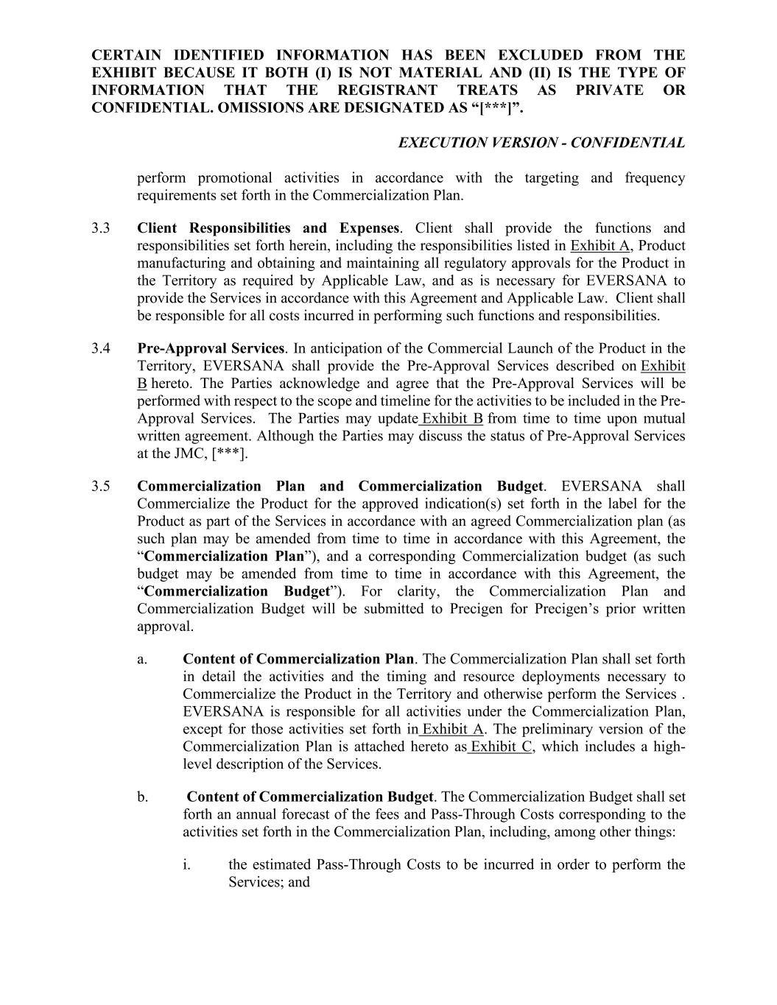
CERTAIN IDENTIFIED INFORMATION HAS BEEN EXCLUDED FROM THE EXHIBIT BECAUSE IT BOTH (I) IS NOT MATERIAL AND (II) IS THE TYPE OF INFORMATION THAT THE REGISTRANT TREATS AS PRIVATE OR CONFIDENTIAL. OMISSIONS ARE DESIGNATED AS “[***]”. EXECUTION VERSION - CONFIDENTIAL perform promotional activities in accordance with the targeting and frequency requirements set forth in the Commercialization Plan. 3.3 Client Responsibilities and Expenses. Client shall provide the functions and responsibilities set forth herein, including the responsibilities listed in Exhibit A, Product manufacturing and obtaining and maintaining all regulatory approvals for the Product in the Territory as required by Applicable Law, and as is necessary for EVERSANA to provide the Services in accordance with this Agreement and Applicable Law. Client shall be responsible for all costs incurred in performing such functions and responsibilities. 3.4 Pre-Approval Services. In anticipation of the Commercial Launch of the Product in the Territory, EVERSANA shall provide the Pre-Approval Services described on Exhibit B hereto. The Parties acknowledge and agree that the Pre-Approval Services will be performed with respect to the scope and timeline for the activities to be included in the Pre- Approval Services. The Parties may update Exhibit B from time to time upon mutual written agreement. Although the Parties may discuss the status of Pre-Approval Services at the JMC, [***]. 3.5 Commercialization Plan and Commercialization Budget. EVERSANA shall Commercialize the Product for the approved indication(s) set forth in the label for the Product as part of the Services in accordance with an agreed Commercialization plan (as such plan may be amended from time to time in accordance with this Agreement, the “Commercialization Plan”), and a corresponding Commercialization budget (as such budget may be amended from time to time in accordance with this Agreement, the “Commercialization Budget”). For clarity, the Commercialization Plan and Commercialization Budget will be submitted to Precigen for Precigen’s prior written approval. a. Content of Commercialization Plan. The Commercialization Plan shall set forth in detail the activities and the timing and resource deployments necessary to Commercialize the Product in the Territory and otherwise perform the Services . EVERSANA is responsible for all activities under the Commercialization Plan, except for those activities set forth in Exhibit A. The preliminary version of the Commercialization Plan is attached hereto as Exhibit C, which includes a high- level description of the Services. b. Content of Commercialization Budget. The Commercialization Budget shall set forth an annual forecast of the fees and Pass-Through Costs corresponding to the activities set forth in the Commercialization Plan, including, among other things: i. the estimated Pass-Through Costs to be incurred in order to perform the Services; and

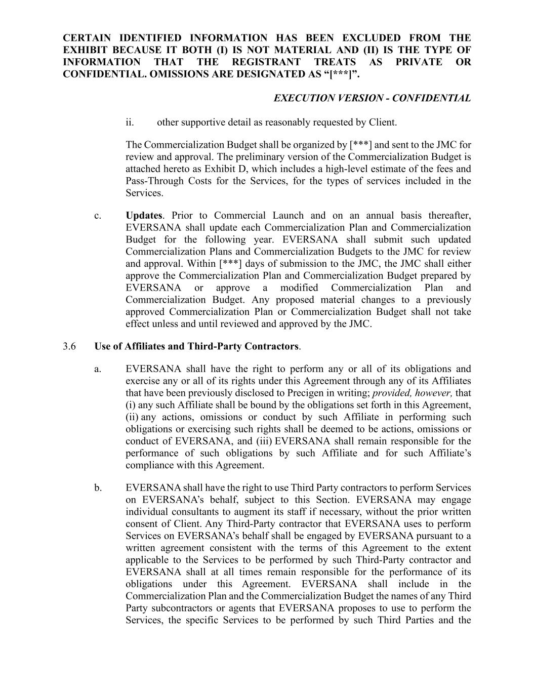
CERTAIN IDENTIFIED INFORMATION HAS BEEN EXCLUDED FROM THE EXHIBIT BECAUSE IT BOTH (I) IS NOT MATERIAL AND (II) IS THE TYPE OF INFORMATION THAT THE REGISTRANT TREATS AS PRIVATE OR CONFIDENTIAL. OMISSIONS ARE DESIGNATED AS “[***]”. EXECUTION VERSION - CONFIDENTIAL ii. other supportive detail as reasonably requested by Client. The Commercialization Budget shall be organized by [***] and sent to the JMC for review and approval. The preliminary version of the Commercialization Budget is attached hereto as Exhibit D, which includes a high-level estimate of the fees and Pass-Through Costs for the Services, for the types of services included in the Services. c. Updates. Prior to Commercial Launch and on an annual basis thereafter, EVERSANA shall update each Commercialization Plan and Commercialization Budget for the following year. EVERSANA shall submit such updated Commercialization Plans and Commercialization Budgets to the JMC for review and approval. Within [***] days of submission to the JMC, the JMC shall either approve the Commercialization Plan and Commercialization Budget prepared by EVERSANA or approve a modified Commercialization Plan and Commercialization Budget. Any proposed material changes to a previously approved Commercialization Plan or Commercialization Budget shall not take effect unless and until reviewed and approved by the JMC. 3.6 Use of Affiliates and Third-Party Contractors. a. EVERSANA shall have the right to perform any or all of its obligations and exercise any or all of its rights under this Agreement through any of its Affiliates that have been previously disclosed to Precigen in writing; provided, however, that (i) any such Affiliate shall be bound by the obligations set forth in this Agreement, (ii) any actions, omissions or conduct by such Affiliate in performing such obligations or exercising such rights shall be deemed to be actions, omissions or conduct of EVERSANA, and (iii) EVERSANA shall remain responsible for the performance of such obligations by such Affiliate and for such Affiliate’s compliance with this Agreement. b. EVERSANA shall have the right to use Third Party contractors to perform Services on EVERSANA’s behalf, subject to this Section. EVERSANA may engage individual consultants to augment its staff if necessary, without the prior written consent of Client. Any Third-Party contractor that EVERSANA uses to perform Services on EVERSANA’s behalf shall be engaged by EVERSANA pursuant to a written agreement consistent with the terms of this Agreement to the extent applicable to the Services to be performed by such Third-Party contractor and EVERSANA shall at all times remain responsible for the performance of its obligations under this Agreement. EVERSANA shall include in the Commercialization Plan and the Commercialization Budget the names of any Third Party subcontractors or agents that EVERSANA proposes to use to perform the Services, the specific Services to be performed by such Third Parties and the

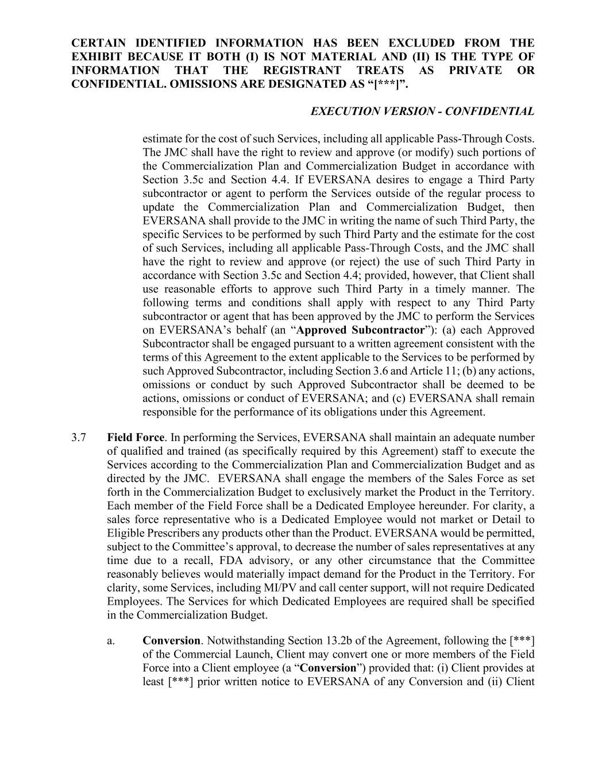
CERTAIN IDENTIFIED INFORMATION HAS BEEN EXCLUDED FROM THE EXHIBIT BECAUSE IT BOTH (I) IS NOT MATERIAL AND (II) IS THE TYPE OF INFORMATION THAT THE REGISTRANT TREATS AS PRIVATE OR CONFIDENTIAL. OMISSIONS ARE DESIGNATED AS “[***]”. EXECUTION VERSION - CONFIDENTIAL estimate for the cost of such Services, including all applicable Pass-Through Costs. The JMC shall have the right to review and approve (or modify) such portions of the Commercialization Plan and Commercialization Budget in accordance with Section 3.5c and Section 4.4. If EVERSANA desires to engage a Third Party subcontractor or agent to perform the Services outside of the regular process to update the Commercialization Plan and Commercialization Budget, then EVERSANA shall provide to the JMC in writing the name of such Third Party, the specific Services to be performed by such Third Party and the estimate for the cost of such Services, including all applicable Pass-Through Costs, and the JMC shall have the right to review and approve (or reject) the use of such Third Party in accordance with Section 3.5c and Section 4.4; provided, however, that Client shall use reasonable efforts to approve such Third Party in a timely manner. The following terms and conditions shall apply with respect to any Third Party subcontractor or agent that has been approved by the JMC to perform the Services on EVERSANA’s behalf (an “Approved Subcontractor”): (a) each Approved Subcontractor shall be engaged pursuant to a written agreement consistent with the terms of this Agreement to the extent applicable to the Services to be performed by such Approved Subcontractor, including Section 3.6 and Article 11; (b) any actions, omissions or conduct by such Approved Subcontractor shall be deemed to be actions, omissions or conduct of EVERSANA; and (c) EVERSANA shall remain responsible for the performance of its obligations under this Agreement. 3.7 Field Force. In performing the Services, EVERSANA shall maintain an adequate number of qualified and trained (as specifically required by this Agreement) staff to execute the Services according to the Commercialization Plan and Commercialization Budget and as directed by the JMC. EVERSANA shall engage the members of the Sales Force as set forth in the Commercialization Budget to exclusively market the Product in the Territory. Each member of the Field Force shall be a Dedicated Employee hereunder. For clarity, a sales force representative who is a Dedicated Employee would not market or Detail to Eligible Prescribers any products other than the Product. EVERSANA would be permitted, subject to the Committee’s approval, to decrease the number of sales representatives at any time due to a recall, FDA advisory, or any other circumstance that the Committee reasonably believes would materially impact demand for the Product in the Territory. For clarity, some Services, including MI/PV and call center support, will not require Dedicated Employees. The Services for which Dedicated Employees are required shall be specified in the Commercialization Budget. a. Conversion. Notwithstanding Section 13.2b of the Agreement, following the [***] of the Commercial Launch, Client may convert one or more members of the Field Force into a Client employee (a “Conversion”) provided that: (i) Client provides at least [***] prior written notice to EVERSANA of any Conversion and (ii) Client

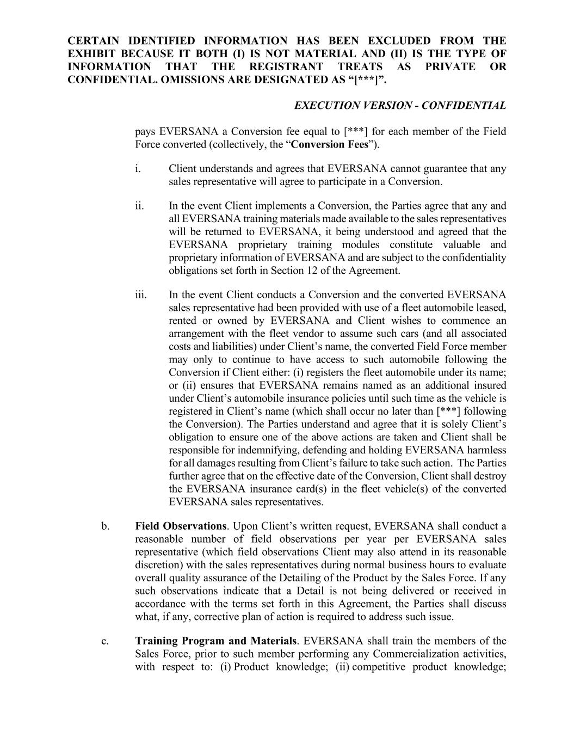
CERTAIN IDENTIFIED INFORMATION HAS BEEN EXCLUDED FROM THE EXHIBIT BECAUSE IT BOTH (I) IS NOT MATERIAL AND (II) IS THE TYPE OF INFORMATION THAT THE REGISTRANT TREATS AS PRIVATE OR CONFIDENTIAL. OMISSIONS ARE DESIGNATED AS “[***]”. EXECUTION VERSION - CONFIDENTIAL pays EVERSANA a Conversion fee equal to [***] for each member of the Field Force converted (collectively, the “Conversion Fees”). i. Client understands and agrees that EVERSANA cannot guarantee that any sales representative will agree to participate in a Conversion. ii. In the event Client implements a Conversion, the Parties agree that any and all EVERSANA training materials made available to the sales representatives will be returned to EVERSANA, it being understood and agreed that the EVERSANA proprietary training modules constitute valuable and proprietary information of EVERSANA and are subject to the confidentiality obligations set forth in Section 12 of the Agreement. iii. In the event Client conducts a Conversion and the converted EVERSANA sales representative had been provided with use of a fleet automobile leased, rented or owned by EVERSANA and Client wishes to commence an arrangement with the fleet vendor to assume such cars (and all associated costs and liabilities) under Client’s name, the converted Field Force member may only to continue to have access to such automobile following the Conversion if Client either: (i) registers the fleet automobile under its name; or (ii) ensures that EVERSANA remains named as an additional insured under Client’s automobile insurance policies until such time as the vehicle is registered in Client’s name (which shall occur no later than [***] following the Conversion). The Parties understand and agree that it is solely Client’s obligation to ensure one of the above actions are taken and Client shall be responsible for indemnifying, defending and holding EVERSANA harmless for all damages resulting from Client’s failure to take such action. The Parties further agree that on the effective date of the Conversion, Client shall destroy the EVERSANA insurance card(s) in the fleet vehicle(s) of the converted EVERSANA sales representatives. b. Field Observations. Upon Client’s written request, EVERSANA shall conduct a reasonable number of field observations per year per EVERSANA sales representative (which field observations Client may also attend in its reasonable discretion) with the sales representatives during normal business hours to evaluate overall quality assurance of the Detailing of the Product by the Sales Force. If any such observations indicate that a Detail is not being delivered or received in accordance with the terms set forth in this Agreement, the Parties shall discuss what, if any, corrective plan of action is required to address such issue. c. Training Program and Materials. EVERSANA shall train the members of the Sales Force, prior to such member performing any Commercialization activities, with respect to: (i) Product knowledge; (ii) competitive product knowledge;

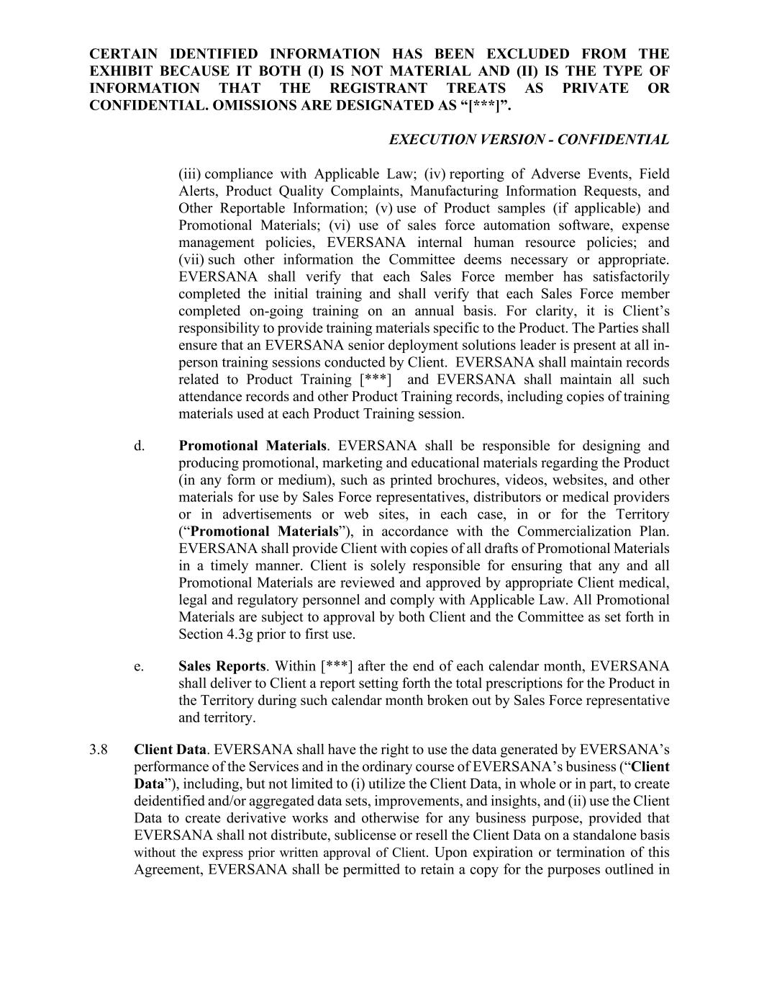
CERTAIN IDENTIFIED INFORMATION HAS BEEN EXCLUDED FROM THE EXHIBIT BECAUSE IT BOTH (I) IS NOT MATERIAL AND (II) IS THE TYPE OF INFORMATION THAT THE REGISTRANT TREATS AS PRIVATE OR CONFIDENTIAL. OMISSIONS ARE DESIGNATED AS “[***]”. EXECUTION VERSION - CONFIDENTIAL (iii) compliance with Applicable Law; (iv) reporting of Adverse Events, Field Alerts, Product Quality Complaints, Manufacturing Information Requests, and Other Reportable Information; (v) use of Product samples (if applicable) and Promotional Materials; (vi) use of sales force automation software, expense management policies, EVERSANA internal human resource policies; and (vii) such other information the Committee deems necessary or appropriate. EVERSANA shall verify that each Sales Force member has satisfactorily completed the initial training and shall verify that each Sales Force member completed on-going training on an annual basis. For clarity, it is Client’s responsibility to provide training materials specific to the Product. The Parties shall ensure that an EVERSANA senior deployment solutions leader is present at all in- person training sessions conducted by Client. EVERSANA shall maintain records related to Product Training [***] and EVERSANA shall maintain all such attendance records and other Product Training records, including copies of training materials used at each Product Training session. d. Promotional Materials. EVERSANA shall be responsible for designing and producing promotional, marketing and educational materials regarding the Product (in any form or medium), such as printed brochures, videos, websites, and other materials for use by Sales Force representatives, distributors or medical providers or in advertisements or web sites, in each case, in or for the Territory (“Promotional Materials”), in accordance with the Commercialization Plan. EVERSANA shall provide Client with copies of all drafts of Promotional Materials in a timely manner. Client is solely responsible for ensuring that any and all Promotional Materials are reviewed and approved by appropriate Client medical, legal and regulatory personnel and comply with Applicable Law. All Promotional Materials are subject to approval by both Client and the Committee as set forth in Section 4.3g prior to first use. e. Sales Reports. Within [***] after the end of each calendar month, EVERSANA shall deliver to Client a report setting forth the total prescriptions for the Product in the Territory during such calendar month broken out by Sales Force representative and territory. 3.8 Client Data. EVERSANA shall have the right to use the data generated by EVERSANA’s performance of the Services and in the ordinary course of EVERSANA’s business (“Client Data”), including, but not limited to (i) utilize the Client Data, in whole or in part, to create deidentified and/or aggregated data sets, improvements, and insights, and (ii) use the Client Data to create derivative works and otherwise for any business purpose, provided that EVERSANA shall not distribute, sublicense or resell the Client Data on a standalone basis without the express prior written approval of Client. Upon expiration or termination of this Agreement, EVERSANA shall be permitted to retain a copy for the purposes outlined in

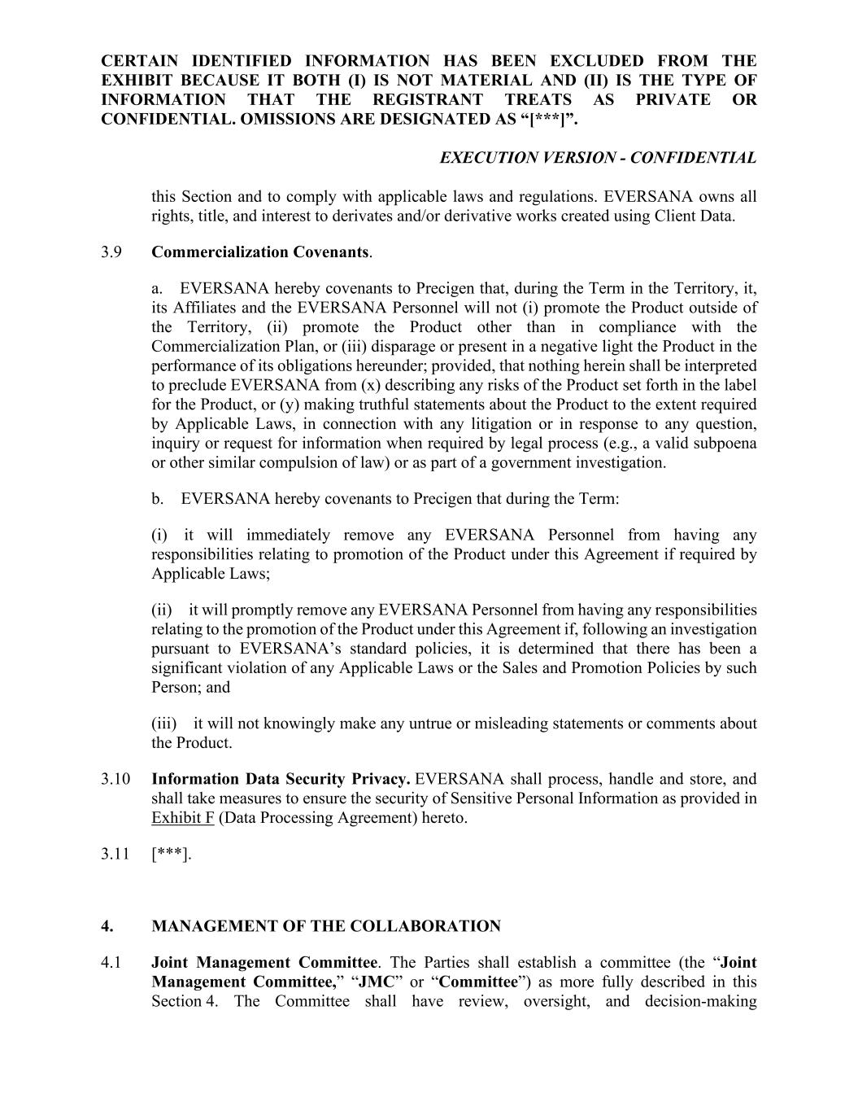
CERTAIN IDENTIFIED INFORMATION HAS BEEN EXCLUDED FROM THE EXHIBIT BECAUSE IT BOTH (I) IS NOT MATERIAL AND (II) IS THE TYPE OF INFORMATION THAT THE REGISTRANT TREATS AS PRIVATE OR CONFIDENTIAL. OMISSIONS ARE DESIGNATED AS “[***]”. EXECUTION VERSION - CONFIDENTIAL this Section and to comply with applicable laws and regulations. EVERSANA owns all rights, title, and interest to derivates and/or derivative works created using Client Data. 3.9 Commercialization Covenants. a. EVERSANA hereby covenants to Precigen that, during the Term in the Territory, it, its Affiliates and the EVERSANA Personnel will not (i) promote the Product outside of the Territory, (ii) promote the Product other than in compliance with the Commercialization Plan, or (iii) disparage or present in a negative light the Product in the performance of its obligations hereunder; provided, that nothing herein shall be interpreted to preclude EVERSANA from (x) describing any risks of the Product set forth in the label for the Product, or (y) making truthful statements about the Product to the extent required by Applicable Laws, in connection with any litigation or in response to any question, inquiry or request for information when required by legal process (e.g., a valid subpoena or other similar compulsion of law) or as part of a government investigation. b. EVERSANA hereby covenants to Precigen that during the Term: (i) it will immediately remove any EVERSANA Personnel from having any responsibilities relating to promotion of the Product under this Agreement if required by Applicable Laws; (ii) it will promptly remove any EVERSANA Personnel from having any responsibilities relating to the promotion of the Product under this Agreement if, following an investigation pursuant to EVERSANA’s standard policies, it is determined that there has been a significant violation of any Applicable Laws or the Sales and Promotion Policies by such Person; and (iii) it will not knowingly make any untrue or misleading statements or comments about the Product. 3.10 Information Data Security Privacy. EVERSANA shall process, handle and store, and shall take measures to ensure the security of Sensitive Personal Information as provided in Exhibit F (Data Processing Agreement) hereto. 3.11 [***]. 4. MANAGEMENT OF THE COLLABORATION 4.1 Joint Management Committee. The Parties shall establish a committee (the “Joint Management Committee,” “JMC” or “Committee”) as more fully described in this Section 4. The Committee shall have review, oversight, and decision-making

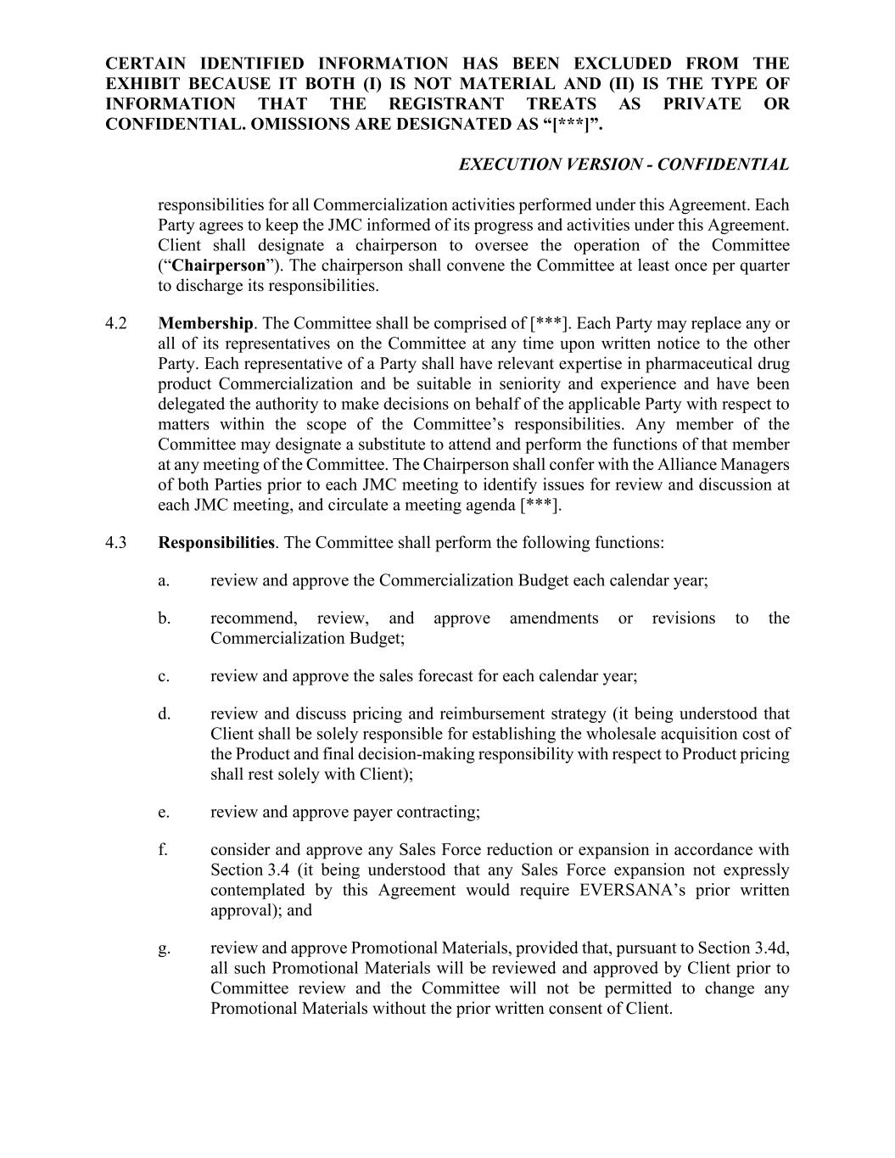
CERTAIN IDENTIFIED INFORMATION HAS BEEN EXCLUDED FROM THE EXHIBIT BECAUSE IT BOTH (I) IS NOT MATERIAL AND (II) IS THE TYPE OF INFORMATION THAT THE REGISTRANT TREATS AS PRIVATE OR CONFIDENTIAL. OMISSIONS ARE DESIGNATED AS “[***]”. EXECUTION VERSION - CONFIDENTIAL responsibilities for all Commercialization activities performed under this Agreement. Each Party agrees to keep the JMC informed of its progress and activities under this Agreement. Client shall designate a chairperson to oversee the operation of the Committee (“Chairperson”). The chairperson shall convene the Committee at least once per quarter to discharge its responsibilities. 4.2 Membership. The Committee shall be comprised of [***]. Each Party may replace any or all of its representatives on the Committee at any time upon written notice to the other Party. Each representative of a Party shall have relevant expertise in pharmaceutical drug product Commercialization and be suitable in seniority and experience and have been delegated the authority to make decisions on behalf of the applicable Party with respect to matters within the scope of the Committee’s responsibilities. Any member of the Committee may designate a substitute to attend and perform the functions of that member at any meeting of the Committee. The Chairperson shall confer with the Alliance Managers of both Parties prior to each JMC meeting to identify issues for review and discussion at each JMC meeting, and circulate a meeting agenda [***]. 4.3 Responsibilities. The Committee shall perform the following functions: a. review and approve the Commercialization Budget each calendar year; b. recommend, review, and approve amendments or revisions to the Commercialization Budget; c. review and approve the sales forecast for each calendar year; d. review and discuss pricing and reimbursement strategy (it being understood that Client shall be solely responsible for establishing the wholesale acquisition cost of the Product and final decision-making responsibility with respect to Product pricing shall rest solely with Client); e. review and approve payer contracting; f. consider and approve any Sales Force reduction or expansion in accordance with Section 3.4 (it being understood that any Sales Force expansion not expressly contemplated by this Agreement would require EVERSANA’s prior written approval); and g. review and approve Promotional Materials, provided that, pursuant to Section 3.4d, all such Promotional Materials will be reviewed and approved by Client prior to Committee review and the Committee will not be permitted to change any Promotional Materials without the prior written consent of Client.

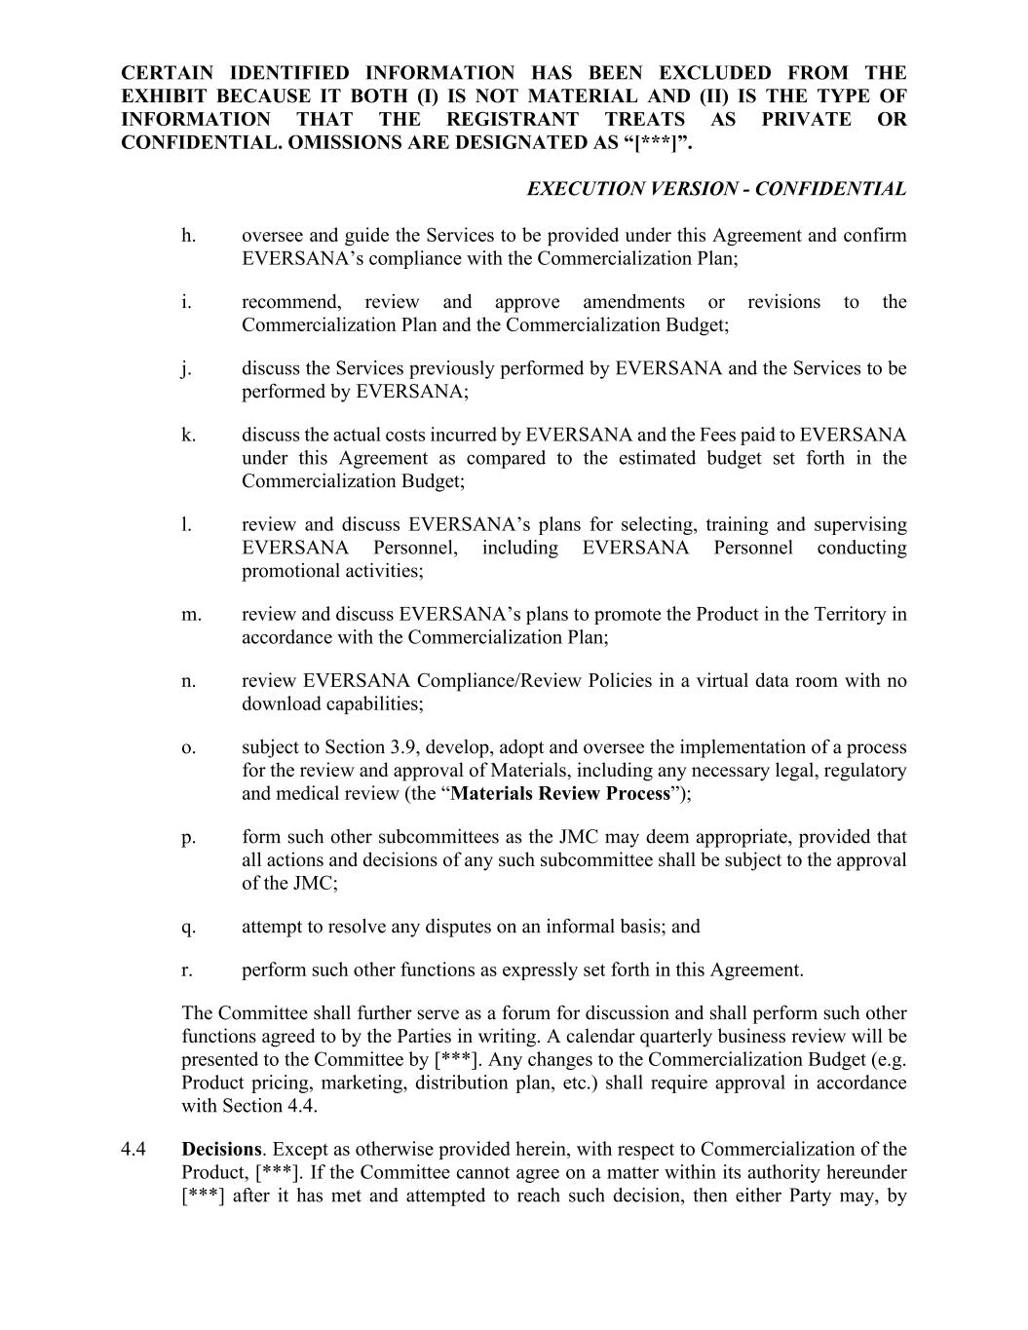
CERTAIN IDENTIFIED INFORMATION HAS BEEN EXCLUDED FROM THE EXHIBIT BECAUSE IT BOTH (I) IS NOT MATERIAL AND (II) IS THE TYPE OF INFORMATION THAT THE REGISTRANT TREATS AS PRIVATE OR CONFIDENTIAL. OMISSIONS ARE DESIGNATED AS “[***]”. EXECUTION VERSION - CONFIDENTIAL h. oversee and guide the Services to be provided under this Agreement and confirm EVERSANA’s compliance with the Commercialization Plan; i. recommend, review and approve amendments or revisions to the Commercialization Plan and the Commercialization Budget; j. discuss the Services previously performed by EVERSANA and the Services to be performed by EVERSANA; k. discuss the actual costs incurred by EVERSANA and the Fees paid to EVERSANA under this Agreement as compared to the estimated budget set forth in the Commercialization Budget; l. review and discuss EVERSANA’s plans for selecting, training and supervising EVERSANA Personnel, including EVERSANA Personnel conducting promotional activities; m. review and discuss EVERSANA’s plans to promote the Product in the Territory in accordance with the Commercialization Plan; n. review EVERSANA Compliance/Review Policies in a virtual data room with no download capabilities; o. subject to Section 3.9, develop, adopt and oversee the implementation of a process for the review and approval of Materials, including any necessary legal, regulatory and medical review (the “Materials Review Process”); p. form such other subcommittees as the JMC may deem appropriate, provided that all actions and decisions of any such subcommittee shall be subject to the approval of the JMC; q. attempt to resolve any disputes on an informal basis; and r. perform such other functions as expressly set forth in this Agreement. The Committee shall further serve as a forum for discussion and shall perform such other functions agreed to by the Parties in writing. A calendar quarterly business review will be presented to the Committee by [***]. Any changes to the Commercialization Budget (e.g. Product pricing, marketing, distribution plan, etc.) shall require approval in accordance with Section 4.4. 4.4 Decisions. Except as otherwise provided herein, with respect to Commercialization of the Product, [***]. If the Committee cannot agree on a matter within its authority hereunder [***] after it has met and attempted to reach such decision, then either Party may, by

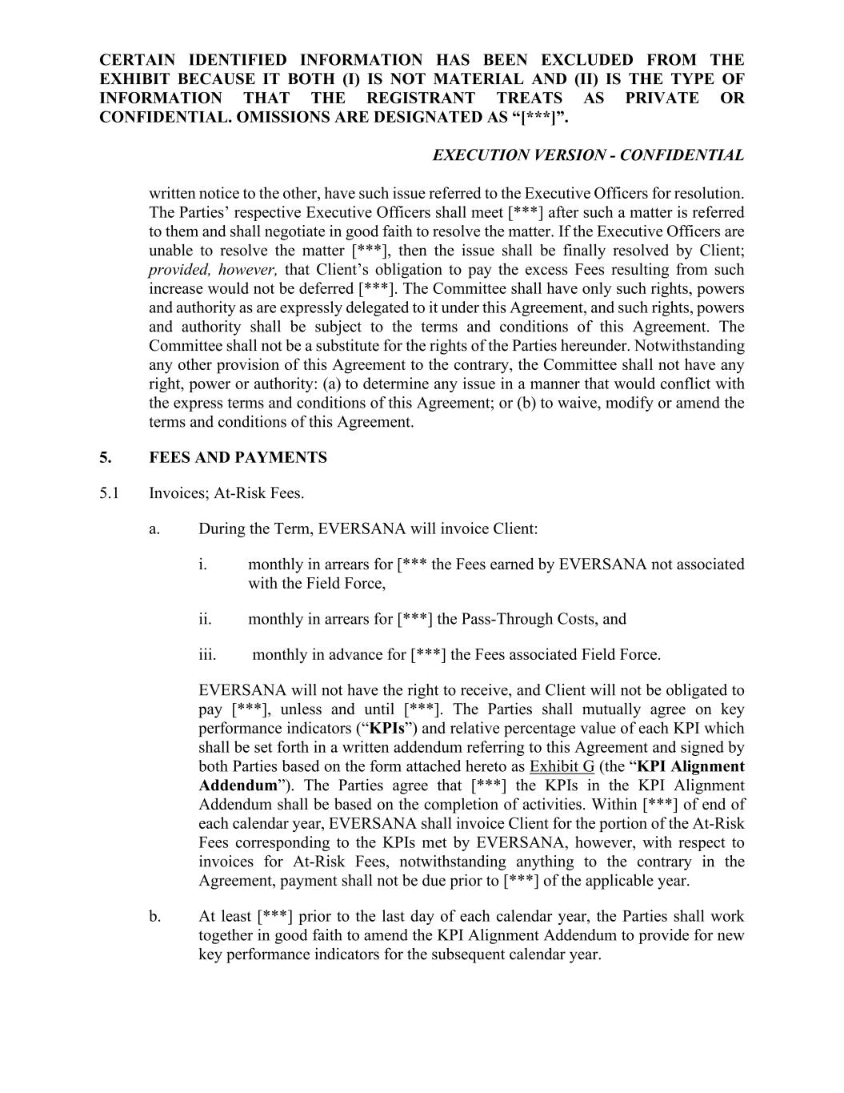
CERTAIN IDENTIFIED INFORMATION HAS BEEN EXCLUDED FROM THE EXHIBIT BECAUSE IT BOTH (I) IS NOT MATERIAL AND (II) IS THE TYPE OF INFORMATION THAT THE REGISTRANT TREATS AS PRIVATE OR CONFIDENTIAL. OMISSIONS ARE DESIGNATED AS “[***]”. EXECUTION VERSION - CONFIDENTIAL written notice to the other, have such issue referred to the Executive Officers for resolution. The Parties’ respective Executive Officers shall meet [***] after such a matter is referred to them and shall negotiate in good faith to resolve the matter. If the Executive Officers are unable to resolve the matter [***], then the issue shall be finally resolved by Client; provided, however, that Client’s obligation to pay the excess Fees resulting from such increase would not be deferred [***]. The Committee shall have only such rights, powers and authority as are expressly delegated to it under this Agreement, and such rights, powers and authority shall be subject to the terms and conditions of this Agreement. The Committee shall not be a substitute for the rights of the Parties hereunder. Notwithstanding any other provision of this Agreement to the contrary, the Committee shall not have any right, power or authority: (a) to determine any issue in a manner that would conflict with the express terms and conditions of this Agreement; or (b) to waive, modify or amend the terms and conditions of this Agreement. 5. FEES AND PAYMENTS 5.1 Invoices; At-Risk Fees. a. During the Term, EVERSANA will invoice Client: i. monthly in arrears for [*** the Fees earned by EVERSANA not associated with the Field Force, ii. monthly in arrears for [***] the Pass-Through Costs, and iii. monthly in advance for [***] the Fees associated Field Force. EVERSANA will not have the right to receive, and Client will not be obligated to pay [***], unless and until [***]. The Parties shall mutually agree on key performance indicators (“KPIs”) and relative percentage value of each KPI which shall be set forth in a written addendum referring to this Agreement and signed by both Parties based on the form attached hereto as Exhibit G (the “KPI Alignment Addendum”). The Parties agree that [***] the KPIs in the KPI Alignment Addendum shall be based on the completion of activities. Within [***] of end of each calendar year, EVERSANA shall invoice Client for the portion of the At-Risk Fees corresponding to the KPIs met by EVERSANA, however, with respect to invoices for At-Risk Fees, notwithstanding anything to the contrary in the Agreement, payment shall not be due prior to [***] of the applicable year. b. At least [***] prior to the last day of each calendar year, the Parties shall work together in good faith to amend the KPI Alignment Addendum to provide for new key performance indicators for the subsequent calendar year.

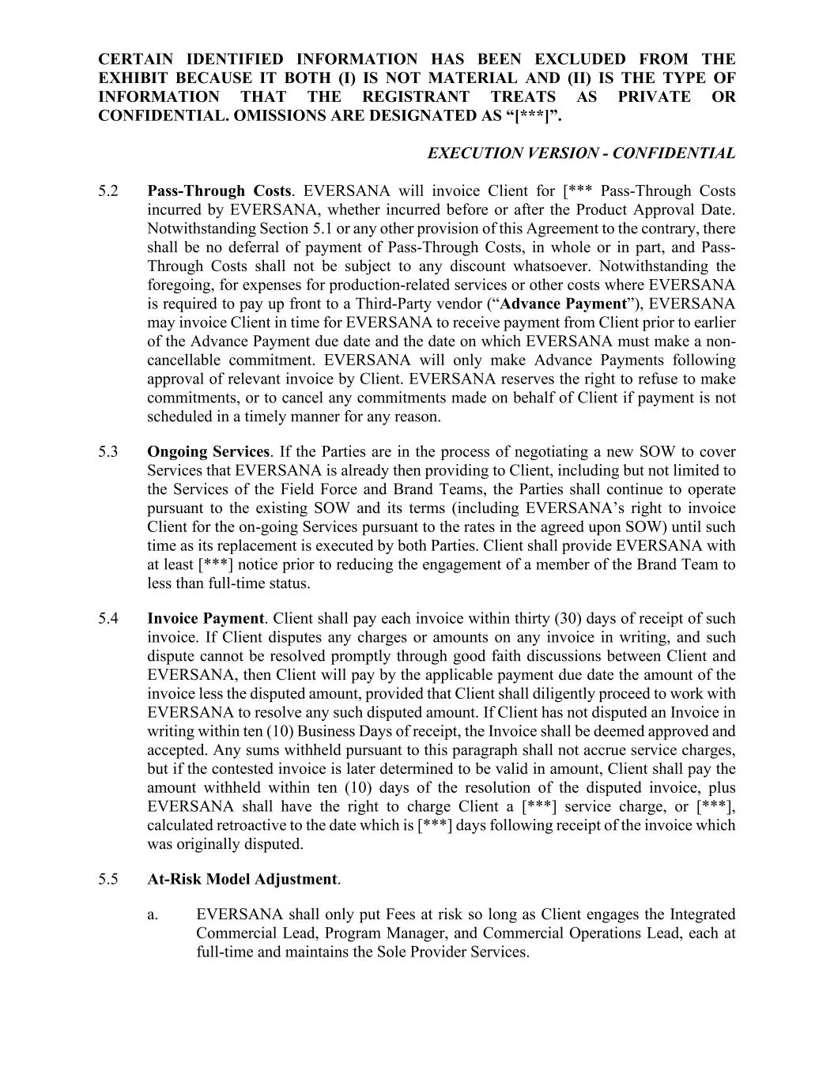
CERTAIN IDENTIFIED INFORMATION HAS BEEN EXCLUDED FROM THE EXHIBIT BECAUSE IT BOTH (I) IS NOT MATERIAL AND (II) IS THE TYPE OF INFORMATION THAT THE REGISTRANT TREATS AS PRIVATE OR CONFIDENTIAL. OMISSIONS ARE DESIGNATED AS “[***]”. EXECUTION VERSION - CONFIDENTIAL 5.2 Pass-Through Costs. EVERSANA will invoice Client for [*** Pass-Through Costs incurred by EVERSANA, whether incurred before or after the Product Approval Date. Notwithstanding Section 5.1 or any other provision of this Agreement to the contrary, there shall be no deferral of payment of Pass-Through Costs, in whole or in part, and Pass- Through Costs shall not be subject to any discount whatsoever. Notwithstanding the foregoing, for expenses for production-related services or other costs where EVERSANA is required to pay up front to a Third-Party vendor (“Advance Payment”), EVERSANA may invoice Client in time for EVERSANA to receive payment from Client prior to earlier of the Advance Payment due date and the date on which EVERSANA must make a non- cancellable commitment. EVERSANA will only make Advance Payments following approval of relevant invoice by Client. EVERSANA reserves the right to refuse to make commitments, or to cancel any commitments made on behalf of Client if payment is not scheduled in a timely manner for any reason. 5.3 Ongoing Services. If the Parties are in the process of negotiating a new SOW to cover Services that EVERSANA is already then providing to Client, including but not limited to the Services of the Field Force and Brand Teams, the Parties shall continue to operate pursuant to the existing SOW and its terms (including EVERSANA’s right to invoice Client for the on-going Services pursuant to the rates in the agreed upon SOW) until such time as its replacement is executed by both Parties. Client shall provide EVERSANA with at least [***] notice prior to reducing the engagement of a member of the Brand Team to less than full-time status. 5.4 Invoice Payment. Client shall pay each invoice within thirty (30) days of receipt of such invoice. If Client disputes any charges or amounts on any invoice in writing, and such dispute cannot be resolved promptly through good faith discussions between Client and EVERSANA, then Client will pay by the applicable payment due date the amount of the invoice less the disputed amount, provided that Client shall diligently proceed to work with EVERSANA to resolve any such disputed amount. If Client has not disputed an Invoice in writing within ten (10) Business Days of receipt, the Invoice shall be deemed approved and accepted. Any sums withheld pursuant to this paragraph shall not accrue service charges, but if the contested invoice is later determined to be valid in amount, Client shall pay the amount withheld within ten (10) days of the resolution of the disputed invoice, plus EVERSANA shall have the right to charge Client a [***] service charge, or [***], calculated retroactive to the date which is [***] days following receipt of the invoice which was originally disputed. 5.5 At-Risk Model Adjustment. a. EVERSANA shall only put Fees at risk so long as Client engages the Integrated Commercial Lead, Program Manager, and Commercial Operations Lead, each at full-time and maintains the Sole Provider Services.

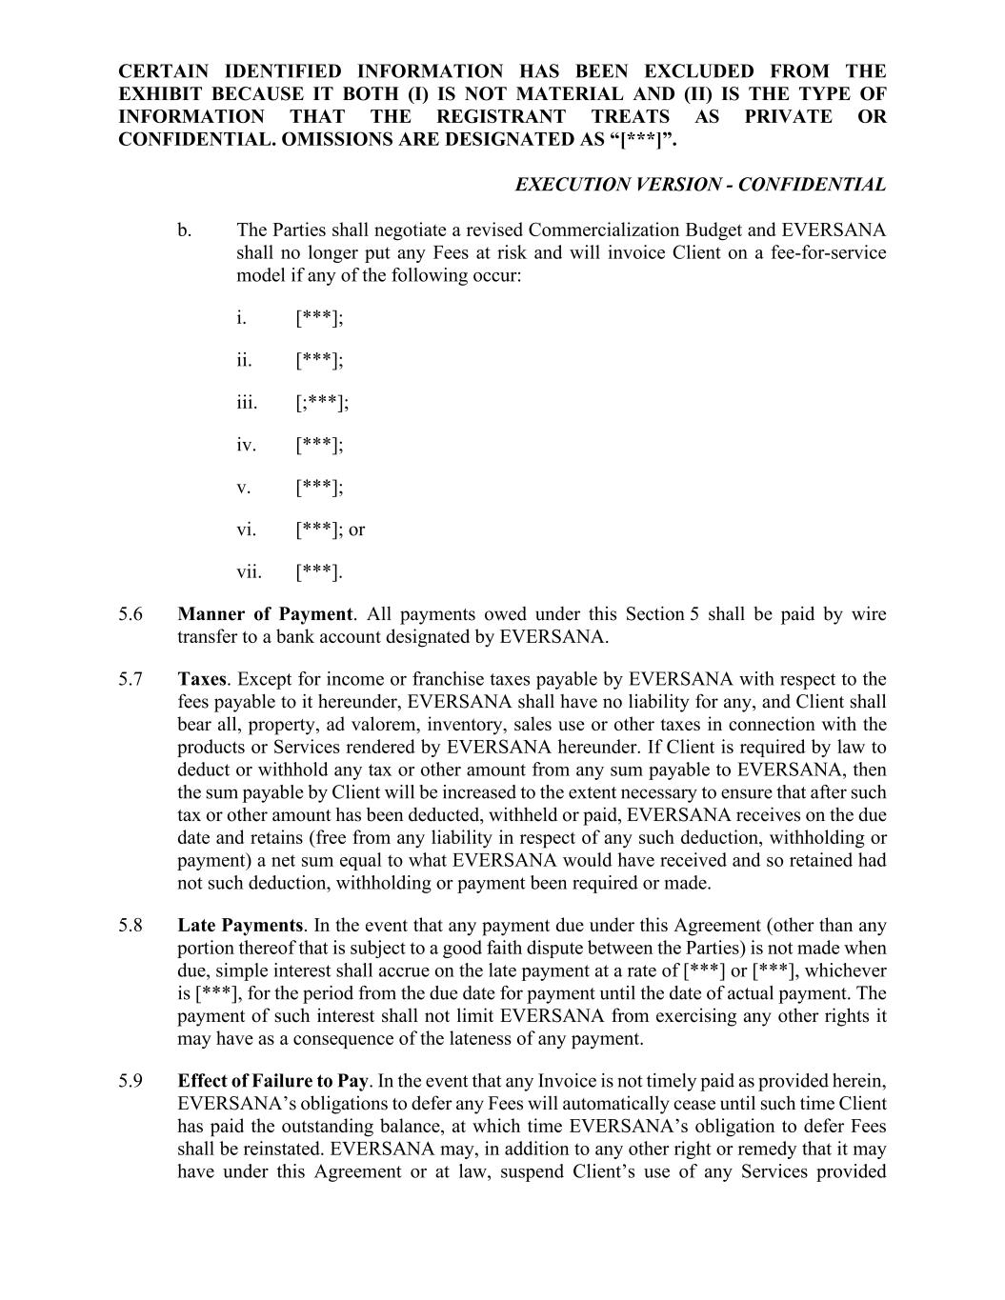
CERTAIN IDENTIFIED INFORMATION HAS BEEN EXCLUDED FROM THE EXHIBIT BECAUSE IT BOTH (I) IS NOT MATERIAL AND (II) IS THE TYPE OF INFORMATION THAT THE REGISTRANT TREATS AS PRIVATE OR CONFIDENTIAL. OMISSIONS ARE DESIGNATED AS “[***]”. EXECUTION VERSION - CONFIDENTIAL b. The Parties shall negotiate a revised Commercialization Budget and EVERSANA shall no longer put any Fees at risk and will invoice Client on a fee-for-service model if any of the following occur: i. [***]; ii. [***]; iii. [;***]; iv. [***]; v. [***]; vi. [***]; or vii. [***]. 5.6 Manner of Payment. All payments owed under this Section 5 shall be paid by wire transfer to a bank account designated by EVERSANA. 5.7 Taxes. Except for income or franchise taxes payable by EVERSANA with respect to the fees payable to it hereunder, EVERSANA shall have no liability for any, and Client shall bear all, property, ad valorem, inventory, sales use or other taxes in connection with the products or Services rendered by EVERSANA hereunder. If Client is required by law to deduct or withhold any tax or other amount from any sum payable to EVERSANA, then the sum payable by Client will be increased to the extent necessary to ensure that after such tax or other amount has been deducted, withheld or paid, EVERSANA receives on the due date and retains (free from any liability in respect of any such deduction, withholding or payment) a net sum equal to what EVERSANA would have received and so retained had not such deduction, withholding or payment been required or made. 5.8 Late Payments. In the event that any payment due under this Agreement (other than any portion thereof that is subject to a good faith dispute between the Parties) is not made when due, simple interest shall accrue on the late payment at a rate of [***] or [***], whichever is [***], for the period from the due date for payment until the date of actual payment. The payment of such interest shall not limit EVERSANA from exercising any other rights it may have as a consequence of the lateness of any payment. 5.9 Effect of Failure to Pay. In the event that any Invoice is not timely paid as provided herein, EVERSANA’s obligations to defer any Fees will automatically cease until such time Client has paid the outstanding balance, at which time EVERSANA’s obligation to defer Fees shall be reinstated. EVERSANA may, in addition to any other right or remedy that it may have under this Agreement or at law, suspend Client’s use of any Services provided

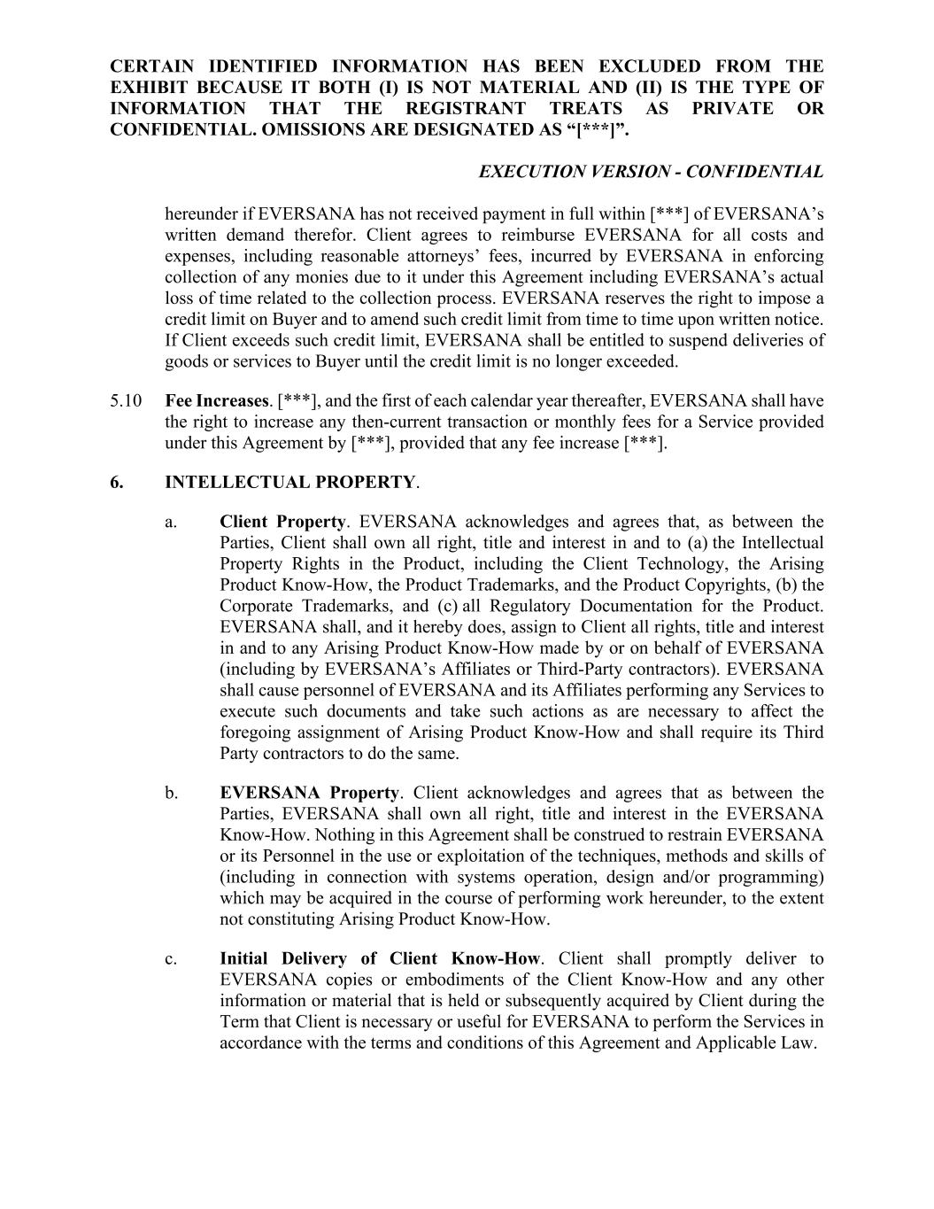
CERTAIN IDENTIFIED INFORMATION HAS BEEN EXCLUDED FROM THE EXHIBIT BECAUSE IT BOTH (I) IS NOT MATERIAL AND (II) IS THE TYPE OF INFORMATION THAT THE REGISTRANT TREATS AS PRIVATE OR CONFIDENTIAL. OMISSIONS ARE DESIGNATED AS “[***]”. EXECUTION VERSION - CONFIDENTIAL hereunder if EVERSANA has not received payment in full within [***] of EVERSANA’s written demand therefor. Client agrees to reimburse EVERSANA for all costs and expenses, including reasonable attorneys’ fees, incurred by EVERSANA in enforcing collection of any monies due to it under this Agreement including EVERSANA’s actual loss of time related to the collection process. EVERSANA reserves the right to impose a credit limit on Buyer and to amend such credit limit from time to time upon written notice. If Client exceeds such credit limit, EVERSANA shall be entitled to suspend deliveries of goods or services to Buyer until the credit limit is no longer exceeded. 5.10 Fee Increases. [***], and the first of each calendar year thereafter, EVERSANA shall have the right to increase any then-current transaction or monthly fees for a Service provided under this Agreement by [***], provided that any fee increase [***]. 6. INTELLECTUAL PROPERTY. a. Client Property. EVERSANA acknowledges and agrees that, as between the Parties, Client shall own all right, title and interest in and to (a) the Intellectual Property Rights in the Product, including the Client Technology, the Arising Product Know-How, the Product Trademarks, and the Product Copyrights, (b) the Corporate Trademarks, and (c) all Regulatory Documentation for the Product. EVERSANA shall, and it hereby does, assign to Client all rights, title and interest in and to any Arising Product Know-How made by or on behalf of EVERSANA (including by EVERSANA’s Affiliates or Third-Party contractors). EVERSANA shall cause personnel of EVERSANA and its Affiliates performing any Services to execute such documents and take such actions as are necessary to affect the foregoing assignment of Arising Product Know-How and shall require its Third Party contractors to do the same. b. EVERSANA Property. Client acknowledges and agrees that as between the Parties, EVERSANA shall own all right, title and interest in the EVERSANA Know-How. Nothing in this Agreement shall be construed to restrain EVERSANA or its Personnel in the use or exploitation of the techniques, methods and skills of (including in connection with systems operation, design and/or programming) which may be acquired in the course of performing work hereunder, to the extent not constituting Arising Product Know-How. c. Initial Delivery of Client Know-How. Client shall promptly deliver to EVERSANA copies or embodiments of the Client Know-How and any other information or material that is held or subsequently acquired by Client during the Term that Client is necessary or useful for EVERSANA to perform the Services in accordance with the terms and conditions of this Agreement and Applicable Law.

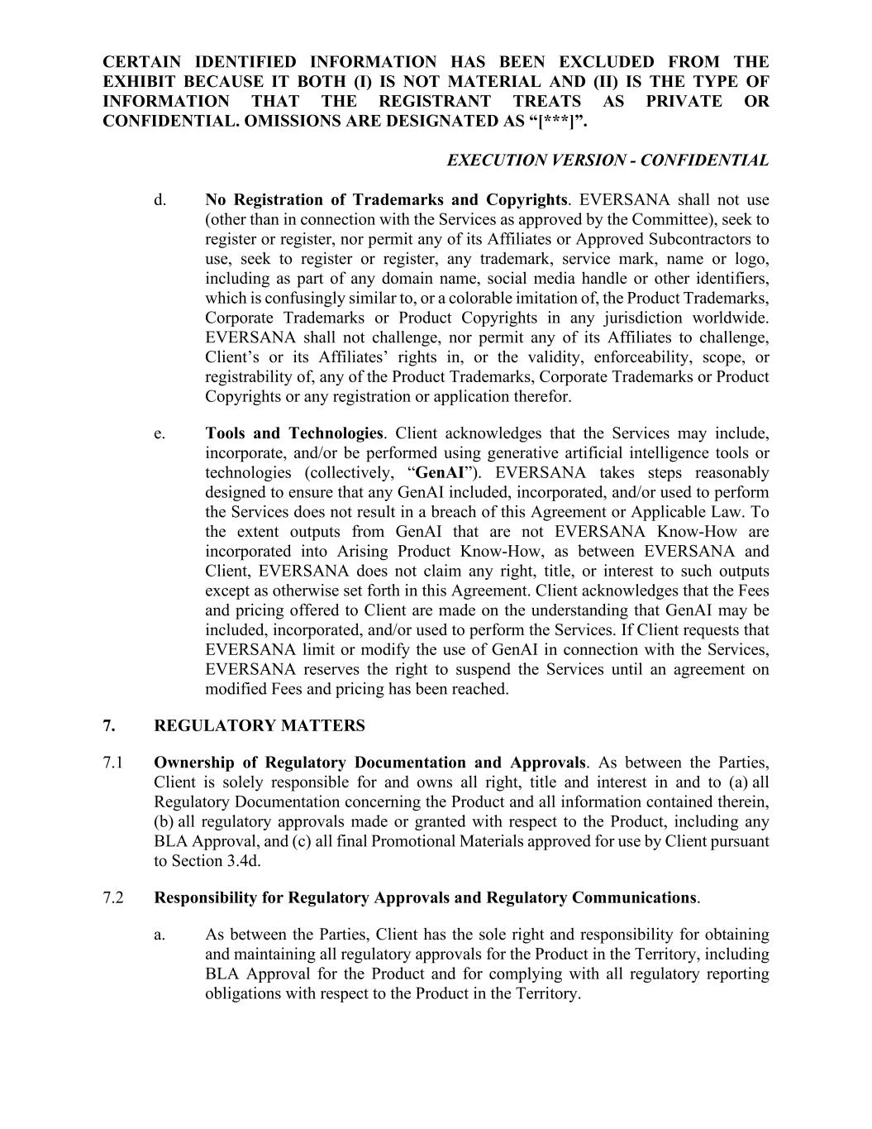
CERTAIN IDENTIFIED INFORMATION HAS BEEN EXCLUDED FROM THE EXHIBIT BECAUSE IT BOTH (I) IS NOT MATERIAL AND (II) IS THE TYPE OF INFORMATION THAT THE REGISTRANT TREATS AS PRIVATE OR CONFIDENTIAL. OMISSIONS ARE DESIGNATED AS “[***]”. EXECUTION VERSION - CONFIDENTIAL d. No Registration of Trademarks and Copyrights. EVERSANA shall not use (other than in connection with the Services as approved by the Committee), seek to register or register, nor permit any of its Affiliates or Approved Subcontractors to use, seek to register or register, any trademark, service mark, name or logo, including as part of any domain name, social media handle or other identifiers, which is confusingly similar to, or a colorable imitation of, the Product Trademarks, Corporate Trademarks or Product Copyrights in any jurisdiction worldwide. EVERSANA shall not challenge, nor permit any of its Affiliates to challenge, Client’s or its Affiliates’ rights in, or the validity, enforceability, scope, or registrability of, any of the Product Trademarks, Corporate Trademarks or Product Copyrights or any registration or application therefor. e. Tools and Technologies. Client acknowledges that the Services may include, incorporate, and/or be performed using generative artificial intelligence tools or technologies (collectively, “GenAI”). EVERSANA takes steps reasonably designed to ensure that any GenAI included, incorporated, and/or used to perform the Services does not result in a breach of this Agreement or Applicable Law. To the extent outputs from GenAI that are not EVERSANA Know-How are incorporated into Arising Product Know-How, as between EVERSANA and Client, EVERSANA does not claim any right, title, or interest to such outputs except as otherwise set forth in this Agreement. Client acknowledges that the Fees and pricing offered to Client are made on the understanding that GenAI may be included, incorporated, and/or used to perform the Services. If Client requests that EVERSANA limit or modify the use of GenAI in connection with the Services, EVERSANA reserves the right to suspend the Services until an agreement on modified Fees and pricing has been reached. 7. REGULATORY MATTERS 7.1 Ownership of Regulatory Documentation and Approvals. As between the Parties, Client is solely responsible for and owns all right, title and interest in and to (a) all Regulatory Documentation concerning the Product and all information contained therein, (b) all regulatory approvals made or granted with respect to the Product, including any BLA Approval, and (c) all final Promotional Materials approved for use by Client pursuant to Section 3.4d. 7.2 Responsibility for Regulatory Approvals and Regulatory Communications. a. As between the Parties, Client has the sole right and responsibility for obtaining and maintaining all regulatory approvals for the Product in the Territory, including BLA Approval for the Product and for complying with all regulatory reporting obligations with respect to the Product in the Territory.

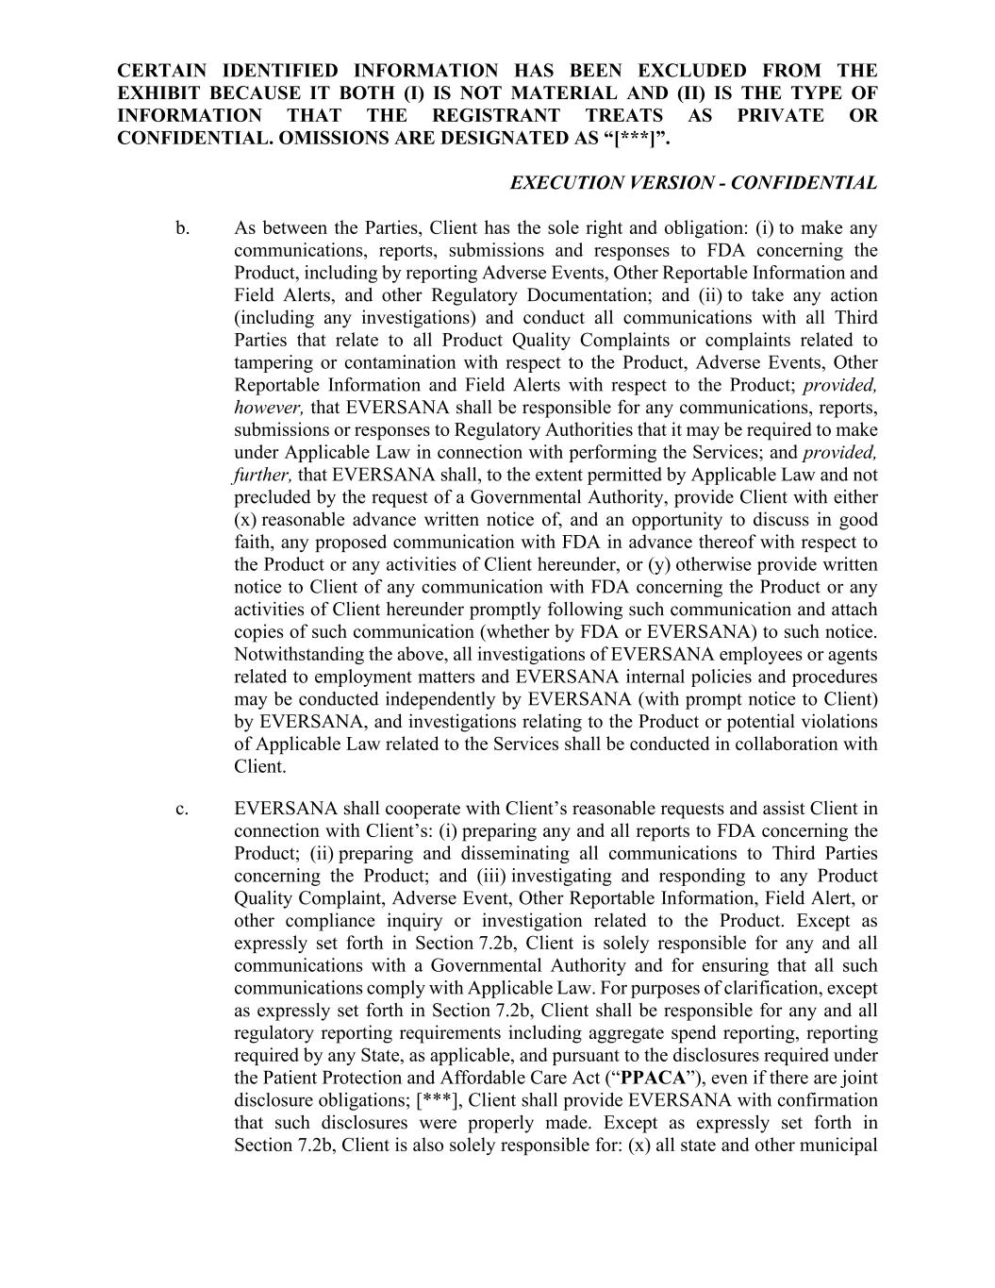
CERTAIN IDENTIFIED INFORMATION HAS BEEN EXCLUDED FROM THE EXHIBIT BECAUSE IT BOTH (I) IS NOT MATERIAL AND (II) IS THE TYPE OF INFORMATION THAT THE REGISTRANT TREATS AS PRIVATE OR CONFIDENTIAL. OMISSIONS ARE DESIGNATED AS “[***]”. EXECUTION VERSION - CONFIDENTIAL b. As between the Parties, Client has the sole right and obligation: (i) to make any communications, reports, submissions and responses to FDA concerning the Product, including by reporting Adverse Events, Other Reportable Information and Field Alerts, and other Regulatory Documentation; and (ii) to take any action (including any investigations) and conduct all communications with all Third Parties that relate to all Product Quality Complaints or complaints related to tampering or contamination with respect to the Product, Adverse Events, Other Reportable Information and Field Alerts with respect to the Product; provided, however, that EVERSANA shall be responsible for any communications, reports, submissions or responses to Regulatory Authorities that it may be required to make under Applicable Law in connection with performing the Services; and provided, further, that EVERSANA shall, to the extent permitted by Applicable Law and not precluded by the request of a Governmental Authority, provide Client with either (x) reasonable advance written notice of, and an opportunity to discuss in good faith, any proposed communication with FDA in advance thereof with respect to the Product or any activities of Client hereunder, or (y) otherwise provide written notice to Client of any communication with FDA concerning the Product or any activities of Client hereunder promptly following such communication and attach copies of such communication (whether by FDA or EVERSANA) to such notice. Notwithstanding the above, all investigations of EVERSANA employees or agents related to employment matters and EVERSANA internal policies and procedures may be conducted independently by EVERSANA (with prompt notice to Client) by EVERSANA, and investigations relating to the Product or potential violations of Applicable Law related to the Services shall be conducted in collaboration with Client. c. EVERSANA shall cooperate with Client’s reasonable requests and assist Client in connection with Client’s: (i) preparing any and all reports to FDA concerning the Product; (ii) preparing and disseminating all communications to Third Parties concerning the Product; and (iii) investigating and responding to any Product Quality Complaint, Adverse Event, Other Reportable Information, Field Alert, or other compliance inquiry or investigation related to the Product. Except as expressly set forth in Section 7.2b, Client is solely responsible for any and all communications with a Governmental Authority and for ensuring that all such communications comply with Applicable Law. For purposes of clarification, except as expressly set forth in Section 7.2b, Client shall be responsible for any and all regulatory reporting requirements including aggregate spend reporting, reporting required by any State, as applicable, and pursuant to the disclosures required under the Patient Protection and Affordable Care Act (“PPACA”), even if there are joint disclosure obligations; [***], Client shall provide EVERSANA with confirmation that such disclosures were properly made. Except as expressly set forth in Section 7.2b, Client is also solely responsible for: (x) all state and other municipal

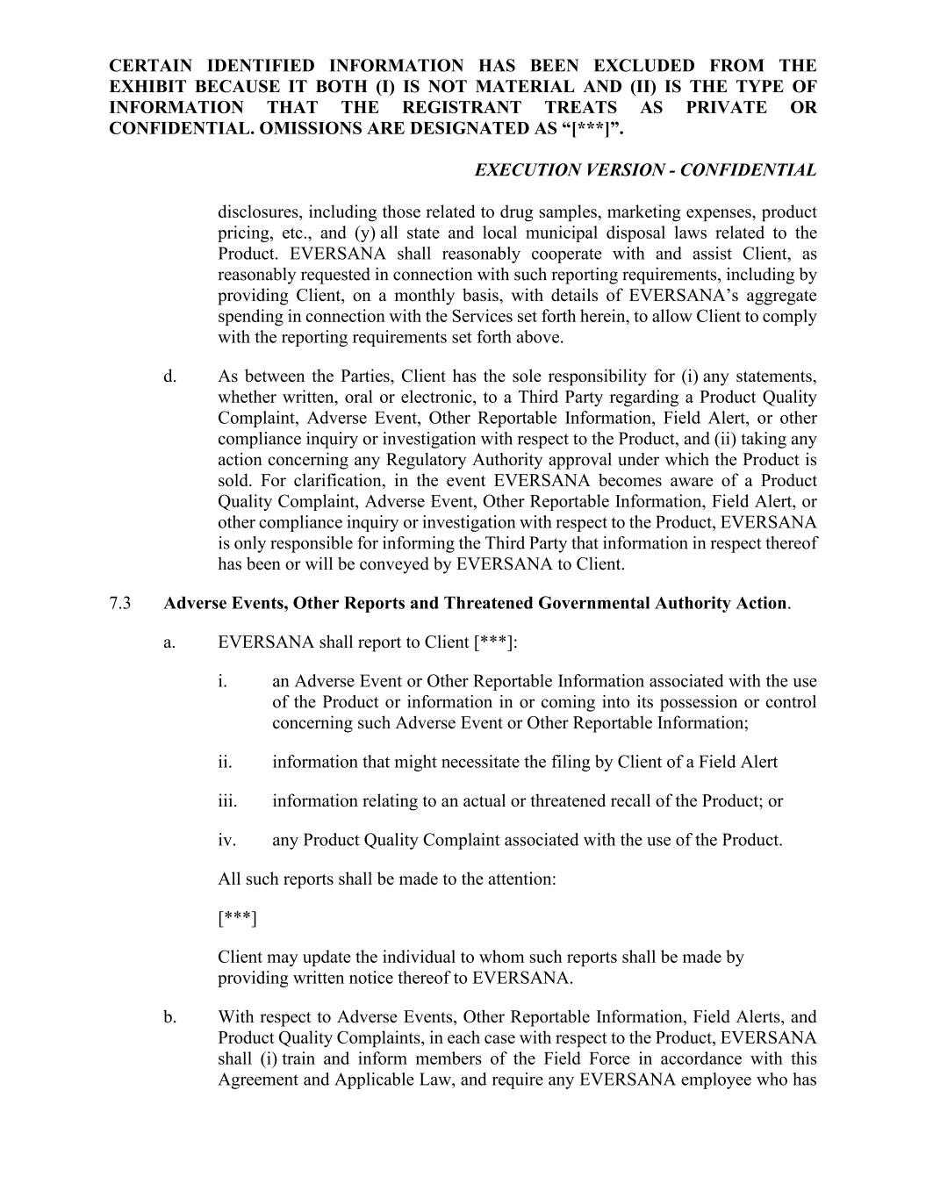
CERTAIN IDENTIFIED INFORMATION HAS BEEN EXCLUDED FROM THE EXHIBIT BECAUSE IT BOTH (I) IS NOT MATERIAL AND (II) IS THE TYPE OF INFORMATION THAT THE REGISTRANT TREATS AS PRIVATE OR CONFIDENTIAL. OMISSIONS ARE DESIGNATED AS “[***]”. EXECUTION VERSION - CONFIDENTIAL disclosures, including those related to drug samples, marketing expenses, product pricing, etc., and (y) all state and local municipal disposal laws related to the Product. EVERSANA shall reasonably cooperate with and assist Client, as reasonably requested in connection with such reporting requirements, including by providing Client, on a monthly basis, with details of EVERSANA’s aggregate spending in connection with the Services set forth herein, to allow Client to comply with the reporting requirements set forth above. d. As between the Parties, Client has the sole responsibility for (i) any statements, whether written, oral or electronic, to a Third Party regarding a Product Quality Complaint, Adverse Event, Other Reportable Information, Field Alert, or other compliance inquiry or investigation with respect to the Product, and (ii) taking any action concerning any Regulatory Authority approval under which the Product is sold. For clarification, in the event EVERSANA becomes aware of a Product Quality Complaint, Adverse Event, Other Reportable Information, Field Alert, or other compliance inquiry or investigation with respect to the Product, EVERSANA is only responsible for informing the Third Party that information in respect thereof has been or will be conveyed by EVERSANA to Client. 7.3 Adverse Events, Other Reports and Threatened Governmental Authority Action. a. EVERSANA shall report to Client [***]: i. an Adverse Event or Other Reportable Information associated with the use of the Product or information in or coming into its possession or control concerning such Adverse Event or Other Reportable Information; ii. information that might necessitate the filing by Client of a Field Alert iii. information relating to an actual or threatened recall of the Product; or iv. any Product Quality Complaint associated with the use of the Product. All such reports shall be made to the attention: [***] Client may update the individual to whom such reports shall be made by providing written notice thereof to EVERSANA. b. With respect to Adverse Events, Other Reportable Information, Field Alerts, and Product Quality Complaints, in each case with respect to the Product, EVERSANA shall (i) train and inform members of the Field Force in accordance with this Agreement and Applicable Law, and require any EVERSANA employee who has

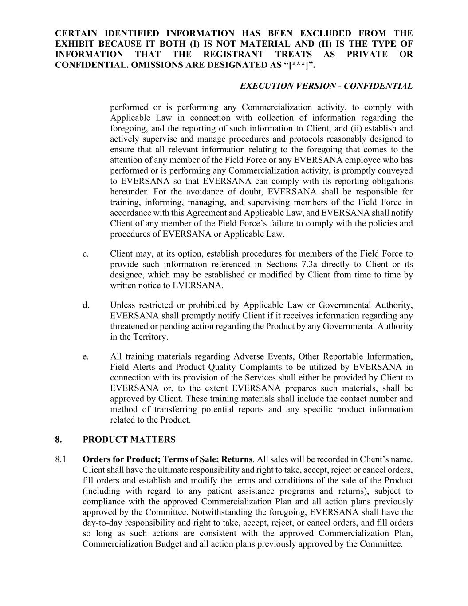
CERTAIN IDENTIFIED INFORMATION HAS BEEN EXCLUDED FROM THE EXHIBIT BECAUSE IT BOTH (I) IS NOT MATERIAL AND (II) IS THE TYPE OF INFORMATION THAT THE REGISTRANT TREATS AS PRIVATE OR CONFIDENTIAL. OMISSIONS ARE DESIGNATED AS “[***]”. EXECUTION VERSION - CONFIDENTIAL performed or is performing any Commercialization activity, to comply with Applicable Law in connection with collection of information regarding the foregoing, and the reporting of such information to Client; and (ii) establish and actively supervise and manage procedures and protocols reasonably designed to ensure that all relevant information relating to the foregoing that comes to the attention of any member of the Field Force or any EVERSANA employee who has performed or is performing any Commercialization activity, is promptly conveyed to EVERSANA so that EVERSANA can comply with its reporting obligations hereunder. For the avoidance of doubt, EVERSANA shall be responsible for training, informing, managing, and supervising members of the Field Force in accordance with this Agreement and Applicable Law, and EVERSANA shall notify Client of any member of the Field Force’s failure to comply with the policies and procedures of EVERSANA or Applicable Law. c. Client may, at its option, establish procedures for members of the Field Force to provide such information referenced in Sections 7.3a directly to Client or its designee, which may be established or modified by Client from time to time by written notice to EVERSANA. d. Unless restricted or prohibited by Applicable Law or Governmental Authority, EVERSANA shall promptly notify Client if it receives information regarding any threatened or pending action regarding the Product by any Governmental Authority in the Territory. e. All training materials regarding Adverse Events, Other Reportable Information, Field Alerts and Product Quality Complaints to be utilized by EVERSANA in connection with its provision of the Services shall either be provided by Client to EVERSANA or, to the extent EVERSANA prepares such materials, shall be approved by Client. These training materials shall include the contact number and method of transferring potential reports and any specific product information related to the Product. 8. PRODUCT MATTERS 8.1 Orders for Product; Terms of Sale; Returns. All sales will be recorded in Client’s name. Client shall have the ultimate responsibility and right to take, accept, reject or cancel orders, fill orders and establish and modify the terms and conditions of the sale of the Product (including with regard to any patient assistance programs and returns), subject to compliance with the approved Commercialization Plan and all action plans previously approved by the Committee. Notwithstanding the foregoing, EVERSANA shall have the day-to-day responsibility and right to take, accept, reject, or cancel orders, and fill orders so long as such actions are consistent with the approved Commercialization Plan, Commercialization Budget and all action plans previously approved by the Committee.

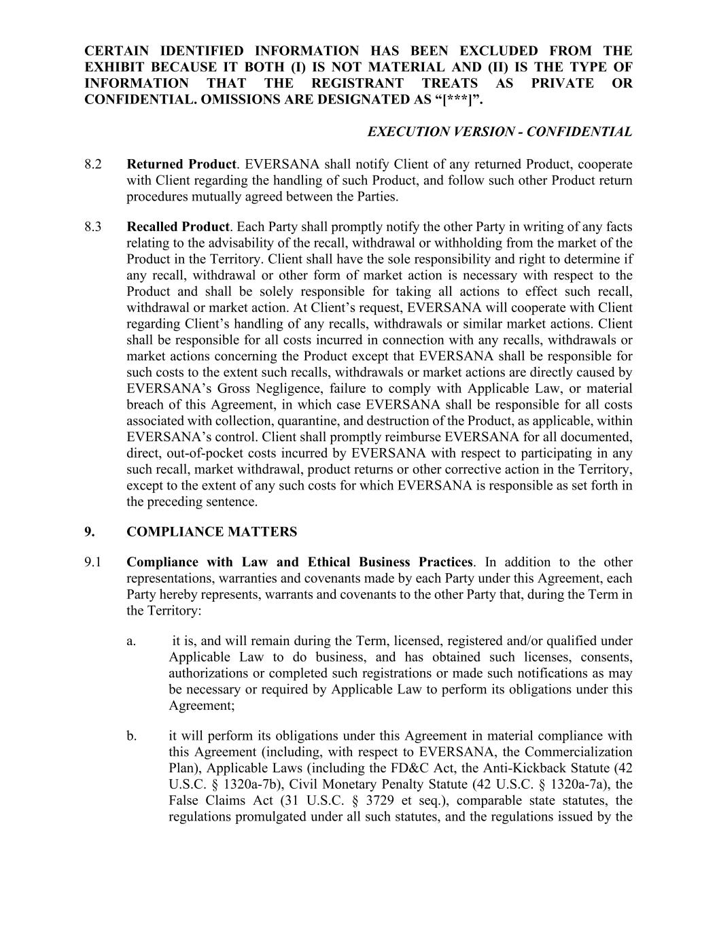
CERTAIN IDENTIFIED INFORMATION HAS BEEN EXCLUDED FROM THE EXHIBIT BECAUSE IT BOTH (I) IS NOT MATERIAL AND (II) IS THE TYPE OF INFORMATION THAT THE REGISTRANT TREATS AS PRIVATE OR CONFIDENTIAL. OMISSIONS ARE DESIGNATED AS “[***]”. EXECUTION VERSION - CONFIDENTIAL 8.2 Returned Product. EVERSANA shall notify Client of any returned Product, cooperate with Client regarding the handling of such Product, and follow such other Product return procedures mutually agreed between the Parties. 8.3 Recalled Product. Each Party shall promptly notify the other Party in writing of any facts relating to the advisability of the recall, withdrawal or withholding from the market of the Product in the Territory. Client shall have the sole responsibility and right to determine if any recall, withdrawal or other form of market action is necessary with respect to the Product and shall be solely responsible for taking all actions to effect such recall, withdrawal or market action. At Client’s request, EVERSANA will cooperate with Client regarding Client’s handling of any recalls, withdrawals or similar market actions. Client shall be responsible for all costs incurred in connection with any recalls, withdrawals or market actions concerning the Product except that EVERSANA shall be responsible for such costs to the extent such recalls, withdrawals or market actions are directly caused by EVERSANA’s Gross Negligence, failure to comply with Applicable Law, or material breach of this Agreement, in which case EVERSANA shall be responsible for all costs associated with collection, quarantine, and destruction of the Product, as applicable, within EVERSANA’s control. Client shall promptly reimburse EVERSANA for all documented, direct, out-of-pocket costs incurred by EVERSANA with respect to participating in any such recall, market withdrawal, product returns or other corrective action in the Territory, except to the extent of any such costs for which EVERSANA is responsible as set forth in the preceding sentence. 9. COMPLIANCE MATTERS 9.1 Compliance with Law and Ethical Business Practices. In addition to the other representations, warranties and covenants made by each Party under this Agreement, each Party hereby represents, warrants and covenants to the other Party that, during the Term in the Territory: a. it is, and will remain during the Term, licensed, registered and/or qualified under Applicable Law to do business, and has obtained such licenses, consents, authorizations or completed such registrations or made such notifications as may be necessary or required by Applicable Law to perform its obligations under this Agreement; b. it will perform its obligations under this Agreement in material compliance with this Agreement (including, with respect to EVERSANA, the Commercialization Plan), Applicable Laws (including the FD&C Act, the Anti-Kickback Statute (42 U.S.C. § 1320a-7b), Civil Monetary Penalty Statute (42 U.S.C. § 1320a-7a), the False Claims Act (31 U.S.C. § 3729 et seq.), comparable state statutes, the regulations promulgated under all such statutes, and the regulations issued by the

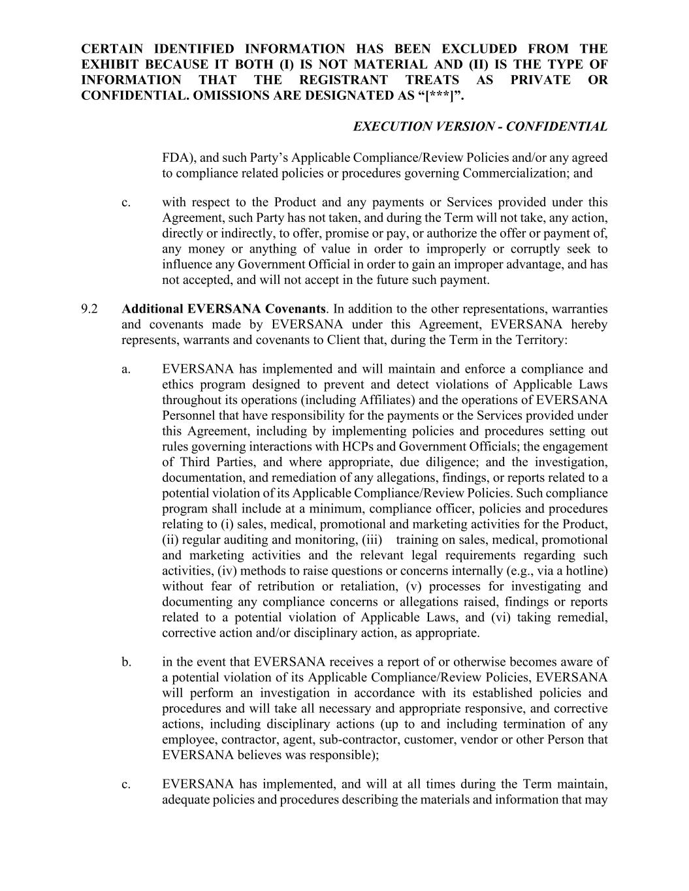
CERTAIN IDENTIFIED INFORMATION HAS BEEN EXCLUDED FROM THE EXHIBIT BECAUSE IT BOTH (I) IS NOT MATERIAL AND (II) IS THE TYPE OF INFORMATION THAT THE REGISTRANT TREATS AS PRIVATE OR CONFIDENTIAL. OMISSIONS ARE DESIGNATED AS “[***]”. EXECUTION VERSION - CONFIDENTIAL FDA), and such Party’s Applicable Compliance/Review Policies and/or any agreed to compliance related policies or procedures governing Commercialization; and c. with respect to the Product and any payments or Services provided under this Agreement, such Party has not taken, and during the Term will not take, any action, directly or indirectly, to offer, promise or pay, or authorize the offer or payment of, any money or anything of value in order to improperly or corruptly seek to influence any Government Official in order to gain an improper advantage, and has not accepted, and will not accept in the future such payment. 9.2 Additional EVERSANA Covenants. In addition to the other representations, warranties and covenants made by EVERSANA under this Agreement, EVERSANA hereby represents, warrants and covenants to Client that, during the Term in the Territory: a. EVERSANA has implemented and will maintain and enforce a compliance and ethics program designed to prevent and detect violations of Applicable Laws throughout its operations (including Affiliates) and the operations of EVERSANA Personnel that have responsibility for the payments or the Services provided under this Agreement, including by implementing policies and procedures setting out rules governing interactions with HCPs and Government Officials; the engagement of Third Parties, and where appropriate, due diligence; and the investigation, documentation, and remediation of any allegations, findings, or reports related to a potential violation of its Applicable Compliance/Review Policies. Such compliance program shall include at a minimum, compliance officer, policies and procedures relating to (i) sales, medical, promotional and marketing activities for the Product, (ii) regular auditing and monitoring, (iii) training on sales, medical, promotional and marketing activities and the relevant legal requirements regarding such activities, (iv) methods to raise questions or concerns internally (e.g., via a hotline) without fear of retribution or retaliation, (v) processes for investigating and documenting any compliance concerns or allegations raised, findings or reports related to a potential violation of Applicable Laws, and (vi) taking remedial, corrective action and/or disciplinary action, as appropriate. b. in the event that EVERSANA receives a report of or otherwise becomes aware of a potential violation of its Applicable Compliance/Review Policies, EVERSANA will perform an investigation in accordance with its established policies and procedures and will take all necessary and appropriate responsive, and corrective actions, including disciplinary actions (up to and including termination of any employee, contractor, agent, sub-contractor, customer, vendor or other Person that EVERSANA believes was responsible); c. EVERSANA has implemented, and will at all times during the Term maintain, adequate policies and procedures describing the materials and information that may

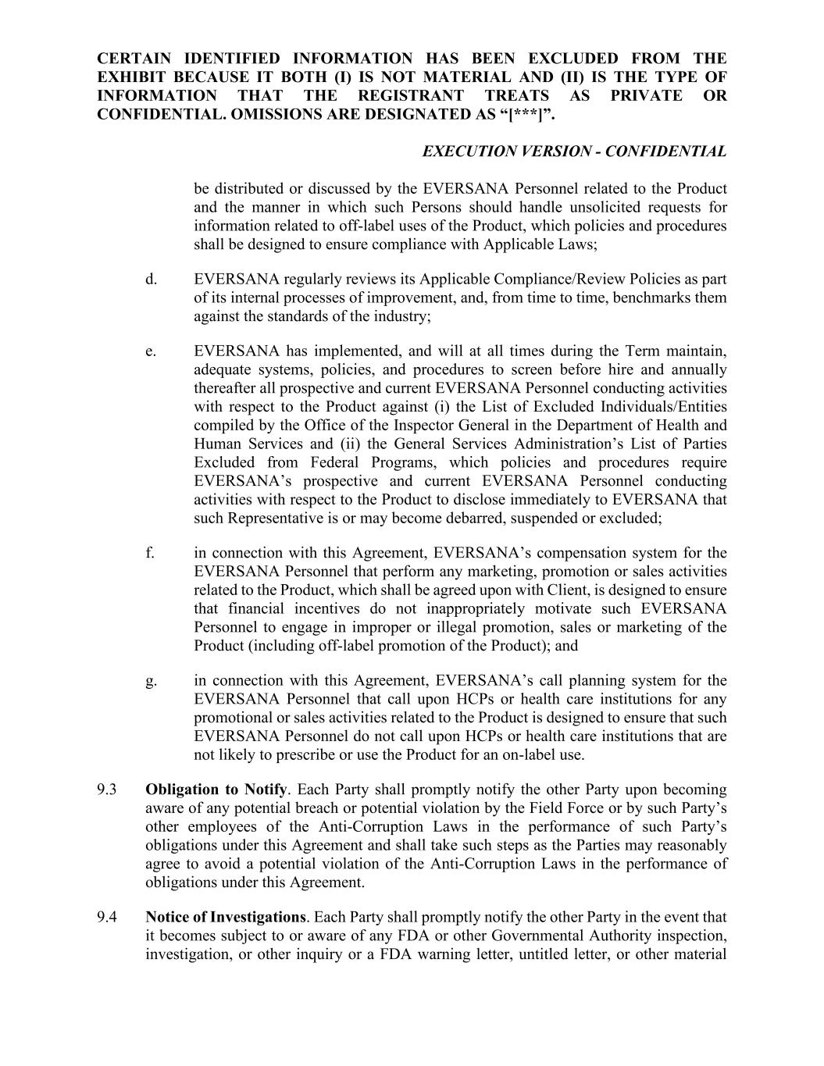
CERTAIN IDENTIFIED INFORMATION HAS BEEN EXCLUDED FROM THE EXHIBIT BECAUSE IT BOTH (I) IS NOT MATERIAL AND (II) IS THE TYPE OF INFORMATION THAT THE REGISTRANT TREATS AS PRIVATE OR CONFIDENTIAL. OMISSIONS ARE DESIGNATED AS “[***]”. EXECUTION VERSION - CONFIDENTIAL be distributed or discussed by the EVERSANA Personnel related to the Product and the manner in which such Persons should handle unsolicited requests for information related to off-label uses of the Product, which policies and procedures shall be designed to ensure compliance with Applicable Laws; d. EVERSANA regularly reviews its Applicable Compliance/Review Policies as part of its internal processes of improvement, and, from time to time, benchmarks them against the standards of the industry; e. EVERSANA has implemented, and will at all times during the Term maintain, adequate systems, policies, and procedures to screen before hire and annually thereafter all prospective and current EVERSANA Personnel conducting activities with respect to the Product against (i) the List of Excluded Individuals/Entities compiled by the Office of the Inspector General in the Department of Health and Human Services and (ii) the General Services Administration’s List of Parties Excluded from Federal Programs, which policies and procedures require EVERSANA’s prospective and current EVERSANA Personnel conducting activities with respect to the Product to disclose immediately to EVERSANA that such Representative is or may become debarred, suspended or excluded; f. in connection with this Agreement, EVERSANA’s compensation system for the EVERSANA Personnel that perform any marketing, promotion or sales activities related to the Product, which shall be agreed upon with Client, is designed to ensure that financial incentives do not inappropriately motivate such EVERSANA Personnel to engage in improper or illegal promotion, sales or marketing of the Product (including off-label promotion of the Product); and g. in connection with this Agreement, EVERSANA’s call planning system for the EVERSANA Personnel that call upon HCPs or health care institutions for any promotional or sales activities related to the Product is designed to ensure that such EVERSANA Personnel do not call upon HCPs or health care institutions that are not likely to prescribe or use the Product for an on-label use. 9.3 Obligation to Notify. Each Party shall promptly notify the other Party upon becoming aware of any potential breach or potential violation by the Field Force or by such Party’s other employees of the Anti-Corruption Laws in the performance of such Party’s obligations under this Agreement and shall take such steps as the Parties may reasonably agree to avoid a potential violation of the Anti-Corruption Laws in the performance of obligations under this Agreement. 9.4 Notice of Investigations. Each Party shall promptly notify the other Party in the event that it becomes subject to or aware of any FDA or other Governmental Authority inspection, investigation, or other inquiry or a FDA warning letter, untitled letter, or other material

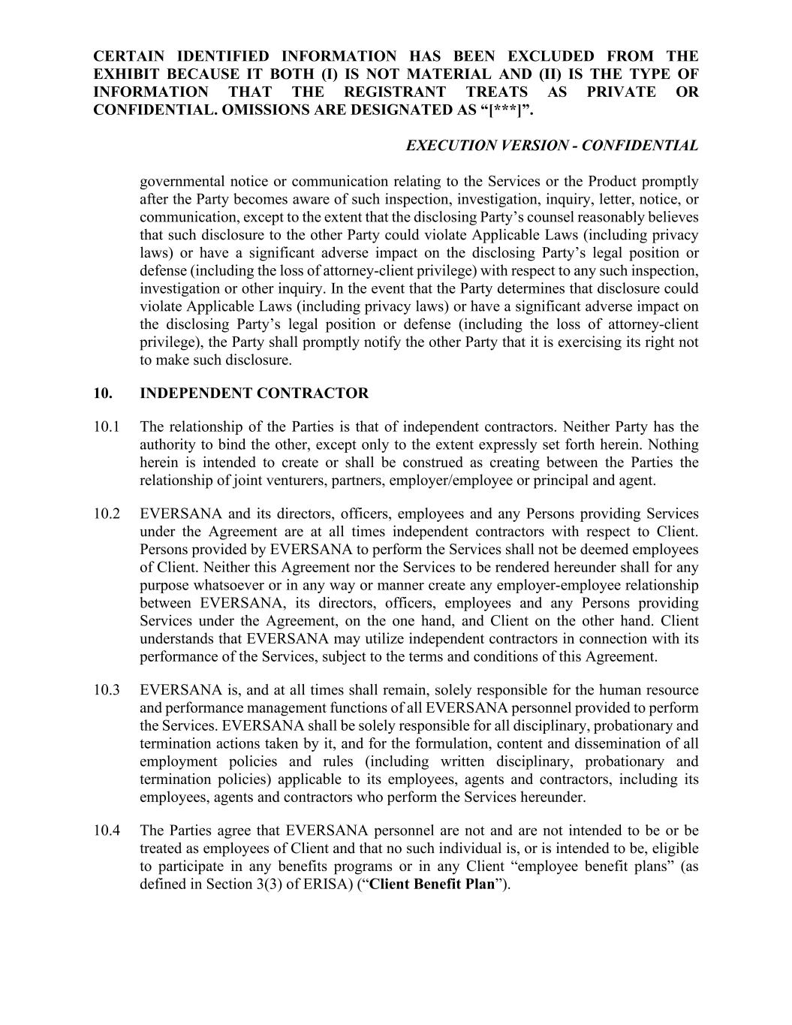
CERTAIN IDENTIFIED INFORMATION HAS BEEN EXCLUDED FROM THE EXHIBIT BECAUSE IT BOTH (I) IS NOT MATERIAL AND (II) IS THE TYPE OF INFORMATION THAT THE REGISTRANT TREATS AS PRIVATE OR CONFIDENTIAL. OMISSIONS ARE DESIGNATED AS “[***]”. EXECUTION VERSION - CONFIDENTIAL governmental notice or communication relating to the Services or the Product promptly after the Party becomes aware of such inspection, investigation, inquiry, letter, notice, or communication, except to the extent that the disclosing Party’s counsel reasonably believes that such disclosure to the other Party could violate Applicable Laws (including privacy laws) or have a significant adverse impact on the disclosing Party’s legal position or defense (including the loss of attorney-client privilege) with respect to any such inspection, investigation or other inquiry. In the event that the Party determines that disclosure could violate Applicable Laws (including privacy laws) or have a significant adverse impact on the disclosing Party’s legal position or defense (including the loss of attorney-client privilege), the Party shall promptly notify the other Party that it is exercising its right not to make such disclosure. 10. INDEPENDENT CONTRACTOR 10.1 The relationship of the Parties is that of independent contractors. Neither Party has the authority to bind the other, except only to the extent expressly set forth herein. Nothing herein is intended to create or shall be construed as creating between the Parties the relationship of joint venturers, partners, employer/employee or principal and agent. 10.2 EVERSANA and its directors, officers, employees and any Persons providing Services under the Agreement are at all times independent contractors with respect to Client. Persons provided by EVERSANA to perform the Services shall not be deemed employees of Client. Neither this Agreement nor the Services to be rendered hereunder shall for any purpose whatsoever or in any way or manner create any employer-employee relationship between EVERSANA, its directors, officers, employees and any Persons providing Services under the Agreement, on the one hand, and Client on the other hand. Client understands that EVERSANA may utilize independent contractors in connection with its performance of the Services, subject to the terms and conditions of this Agreement. 10.3 EVERSANA is, and at all times shall remain, solely responsible for the human resource and performance management functions of all EVERSANA personnel provided to perform the Services. EVERSANA shall be solely responsible for all disciplinary, probationary and termination actions taken by it, and for the formulation, content and dissemination of all employment policies and rules (including written disciplinary, probationary and termination policies) applicable to its employees, agents and contractors, including its employees, agents and contractors who perform the Services hereunder. 10.4 The Parties agree that EVERSANA personnel are not and are not intended to be or be treated as employees of Client and that no such individual is, or is intended to be, eligible to participate in any benefits programs or in any Client “employee benefit plans” (as defined in Section 3(3) of ERISA) (“Client Benefit Plan”).

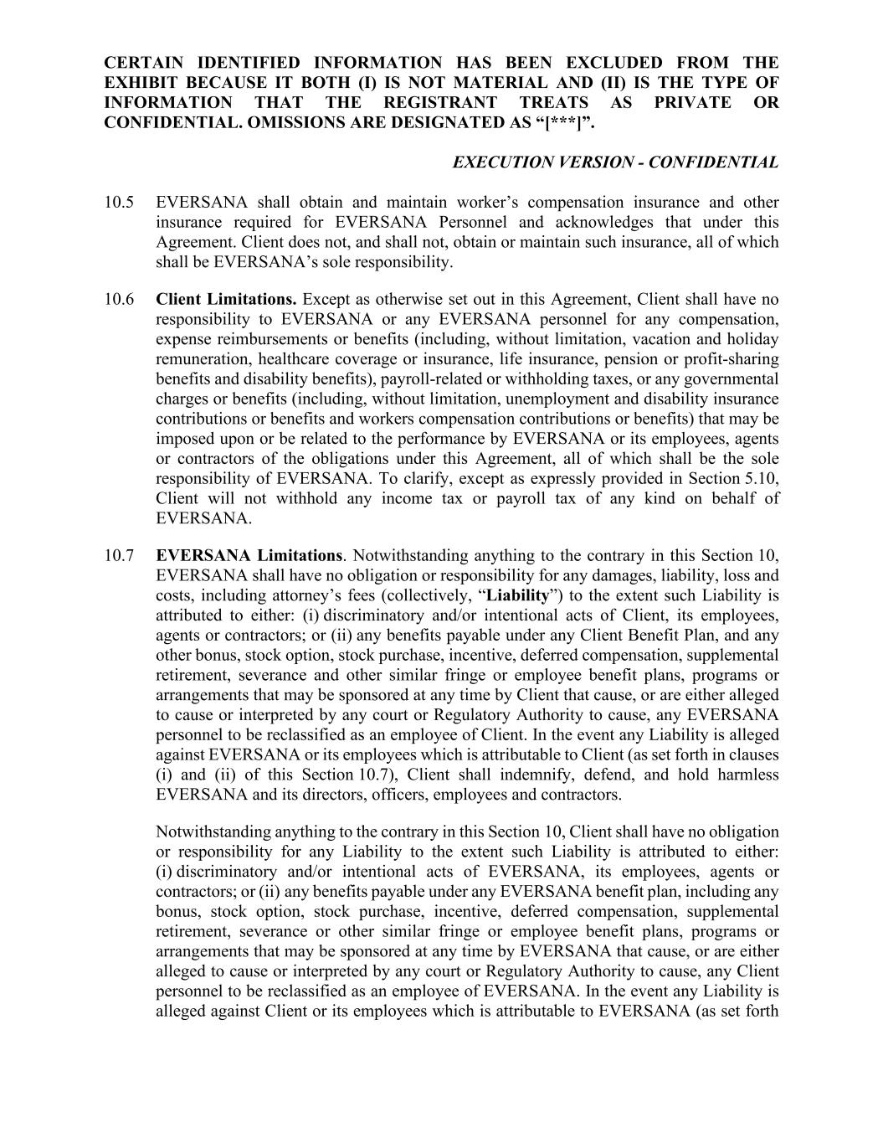
CERTAIN IDENTIFIED INFORMATION HAS BEEN EXCLUDED FROM THE EXHIBIT BECAUSE IT BOTH (I) IS NOT MATERIAL AND (II) IS THE TYPE OF INFORMATION THAT THE REGISTRANT TREATS AS PRIVATE OR CONFIDENTIAL. OMISSIONS ARE DESIGNATED AS “[***]”. EXECUTION VERSION - CONFIDENTIAL 10.5 EVERSANA shall obtain and maintain worker’s compensation insurance and other insurance required for EVERSANA Personnel and acknowledges that under this Agreement. Client does not, and shall not, obtain or maintain such insurance, all of which shall be EVERSANA’s sole responsibility. 10.6 Client Limitations. Except as otherwise set out in this Agreement, Client shall have no responsibility to EVERSANA or any EVERSANA personnel for any compensation, expense reimbursements or benefits (including, without limitation, vacation and holiday remuneration, healthcare coverage or insurance, life insurance, pension or profit-sharing benefits and disability benefits), payroll-related or withholding taxes, or any governmental charges or benefits (including, without limitation, unemployment and disability insurance contributions or benefits and workers compensation contributions or benefits) that may be imposed upon or be related to the performance by EVERSANA or its employees, agents or contractors of the obligations under this Agreement, all of which shall be the sole responsibility of EVERSANA. To clarify, except as expressly provided in Section 5.10, Client will not withhold any income tax or payroll tax of any kind on behalf of EVERSANA. 10.7 EVERSANA Limitations. Notwithstanding anything to the contrary in this Section 10, EVERSANA shall have no obligation or responsibility for any damages, liability, loss and costs, including attorney’s fees (collectively, “Liability”) to the extent such Liability is attributed to either: (i) discriminatory and/or intentional acts of Client, its employees, agents or contractors; or (ii) any benefits payable under any Client Benefit Plan, and any other bonus, stock option, stock purchase, incentive, deferred compensation, supplemental retirement, severance and other similar fringe or employee benefit plans, programs or arrangements that may be sponsored at any time by Client that cause, or are either alleged to cause or interpreted by any court or Regulatory Authority to cause, any EVERSANA personnel to be reclassified as an employee of Client. In the event any Liability is alleged against EVERSANA or its employees which is attributable to Client (as set forth in clauses (i) and (ii) of this Section 10.7), Client shall indemnify, defend, and hold harmless EVERSANA and its directors, officers, employees and contractors. Notwithstanding anything to the contrary in this Section 10, Client shall have no obligation or responsibility for any Liability to the extent such Liability is attributed to either: (i) discriminatory and/or intentional acts of EVERSANA, its employees, agents or contractors; or (ii) any benefits payable under any EVERSANA benefit plan, including any bonus, stock option, stock purchase, incentive, deferred compensation, supplemental retirement, severance or other similar fringe or employee benefit plans, programs or arrangements that may be sponsored at any time by EVERSANA that cause, or are either alleged to cause or interpreted by any court or Regulatory Authority to cause, any Client personnel to be reclassified as an employee of EVERSANA. In the event any Liability is alleged against Client or its employees which is attributable to EVERSANA (as set forth

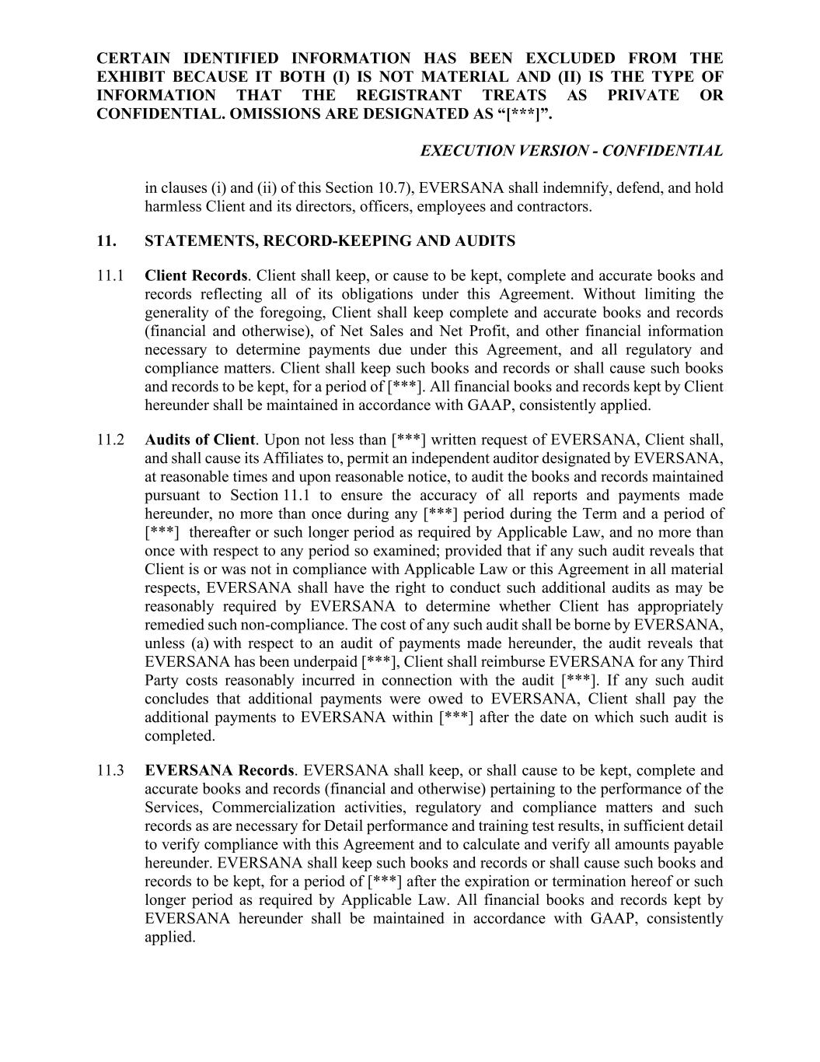
CERTAIN IDENTIFIED INFORMATION HAS BEEN EXCLUDED FROM THE EXHIBIT BECAUSE IT BOTH (I) IS NOT MATERIAL AND (II) IS THE TYPE OF INFORMATION THAT THE REGISTRANT TREATS AS PRIVATE OR CONFIDENTIAL. OMISSIONS ARE DESIGNATED AS “[***]”. EXECUTION VERSION - CONFIDENTIAL in clauses (i) and (ii) of this Section 10.7), EVERSANA shall indemnify, defend, and hold harmless Client and its directors, officers, employees and contractors. 11. STATEMENTS, RECORD-KEEPING AND AUDITS 11.1 Client Records. Client shall keep, or cause to be kept, complete and accurate books and records reflecting all of its obligations under this Agreement. Without limiting the generality of the foregoing, Client shall keep complete and accurate books and records (financial and otherwise), of Net Sales and Net Profit, and other financial information necessary to determine payments due under this Agreement, and all regulatory and compliance matters. Client shall keep such books and records or shall cause such books and records to be kept, for a period of [***]. All financial books and records kept by Client hereunder shall be maintained in accordance with GAAP, consistently applied. 11.2 Audits of Client. Upon not less than [***] written request of EVERSANA, Client shall, and shall cause its Affiliates to, permit an independent auditor designated by EVERSANA, at reasonable times and upon reasonable notice, to audit the books and records maintained pursuant to Section 11.1 to ensure the accuracy of all reports and payments made hereunder, no more than once during any [***] period during the Term and a period of [***] thereafter or such longer period as required by Applicable Law, and no more than once with respect to any period so examined; provided that if any such audit reveals that Client is or was not in compliance with Applicable Law or this Agreement in all material respects, EVERSANA shall have the right to conduct such additional audits as may be reasonably required by EVERSANA to determine whether Client has appropriately remedied such non-compliance. The cost of any such audit shall be borne by EVERSANA, unless (a) with respect to an audit of payments made hereunder, the audit reveals that EVERSANA has been underpaid [***], Client shall reimburse EVERSANA for any Third Party costs reasonably incurred in connection with the audit [***]. If any such audit concludes that additional payments were owed to EVERSANA, Client shall pay the additional payments to EVERSANA within [***] after the date on which such audit is completed. 11.3 EVERSANA Records. EVERSANA shall keep, or shall cause to be kept, complete and accurate books and records (financial and otherwise) pertaining to the performance of the Services, Commercialization activities, regulatory and compliance matters and such records as are necessary for Detail performance and training test results, in sufficient detail to verify compliance with this Agreement and to calculate and verify all amounts payable hereunder. EVERSANA shall keep such books and records or shall cause such books and records to be kept, for a period of [***] after the expiration or termination hereof or such longer period as required by Applicable Law. All financial books and records kept by EVERSANA hereunder shall be maintained in accordance with GAAP, consistently applied.

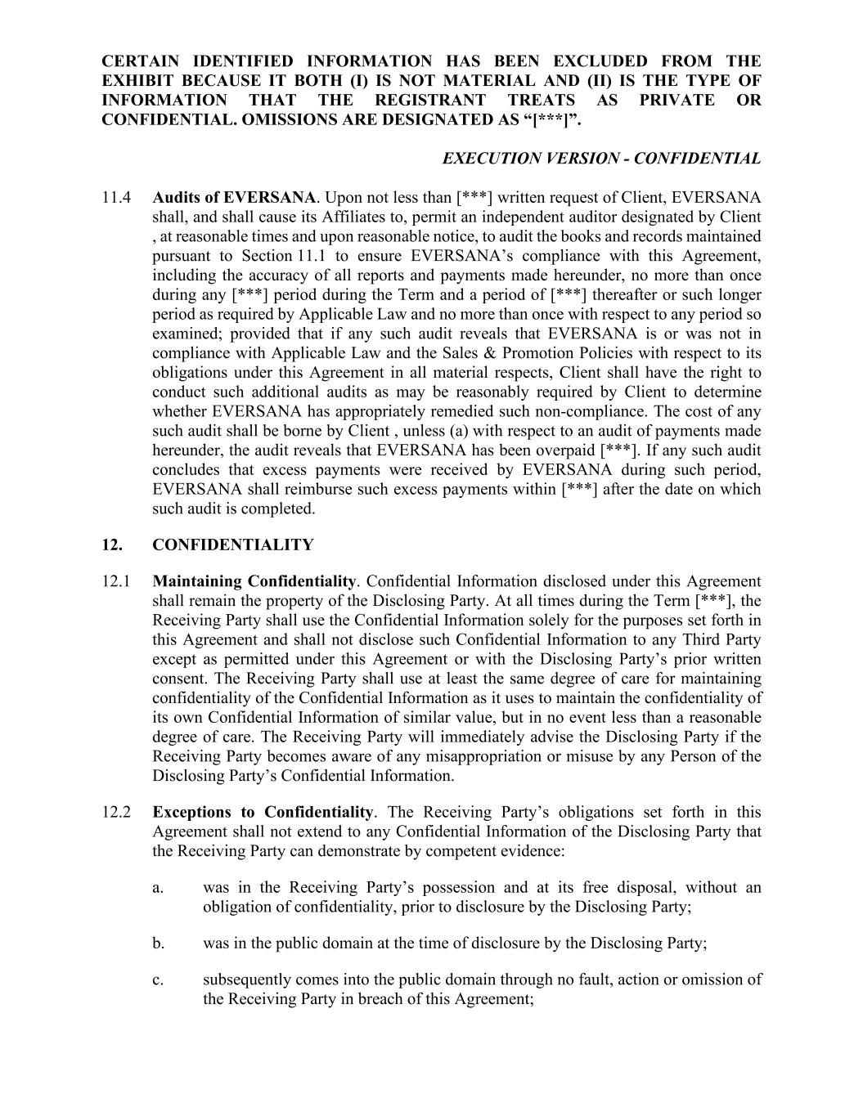
CERTAIN IDENTIFIED INFORMATION HAS BEEN EXCLUDED FROM THE EXHIBIT BECAUSE IT BOTH (I) IS NOT MATERIAL AND (II) IS THE TYPE OF INFORMATION THAT THE REGISTRANT TREATS AS PRIVATE OR CONFIDENTIAL. OMISSIONS ARE DESIGNATED AS “[***]”. EXECUTION VERSION - CONFIDENTIAL 11.4 Audits of EVERSANA. Upon not less than [***] written request of Client, EVERSANA shall, and shall cause its Affiliates to, permit an independent auditor designated by Client , at reasonable times and upon reasonable notice, to audit the books and records maintained pursuant to Section 11.1 to ensure EVERSANA’s compliance with this Agreement, including the accuracy of all reports and payments made hereunder, no more than once during any [***] period during the Term and a period of [***] thereafter or such longer period as required by Applicable Law and no more than once with respect to any period so examined; provided that if any such audit reveals that EVERSANA is or was not in compliance with Applicable Law and the Sales & Promotion Policies with respect to its obligations under this Agreement in all material respects, Client shall have the right to conduct such additional audits as may be reasonably required by Client to determine whether EVERSANA has appropriately remedied such non-compliance. The cost of any such audit shall be borne by Client , unless (a) with respect to an audit of payments made hereunder, the audit reveals that EVERSANA has been overpaid [***]. If any such audit concludes that excess payments were received by EVERSANA during such period, EVERSANA shall reimburse such excess payments within [***] after the date on which such audit is completed. 12. CONFIDENTIALITY 12.1 Maintaining Confidentiality. Confidential Information disclosed under this Agreement shall remain the property of the Disclosing Party. At all times during the Term [***], the Receiving Party shall use the Confidential Information solely for the purposes set forth in this Agreement and shall not disclose such Confidential Information to any Third Party except as permitted under this Agreement or with the Disclosing Party’s prior written consent. The Receiving Party shall use at least the same degree of care for maintaining confidentiality of the Confidential Information as it uses to maintain the confidentiality of its own Confidential Information of similar value, but in no event less than a reasonable degree of care. The Receiving Party will immediately advise the Disclosing Party if the Receiving Party becomes aware of any misappropriation or misuse by any Person of the Disclosing Party’s Confidential Information. 12.2 Exceptions to Confidentiality. The Receiving Party’s obligations set forth in this Agreement shall not extend to any Confidential Information of the Disclosing Party that the Receiving Party can demonstrate by competent evidence: a. was in the Receiving Party’s possession and at its free disposal, without an obligation of confidentiality, prior to disclosure by the Disclosing Party; b. was in the public domain at the time of disclosure by the Disclosing Party; c. subsequently comes into the public domain through no fault, action or omission of the Receiving Party in breach of this Agreement;

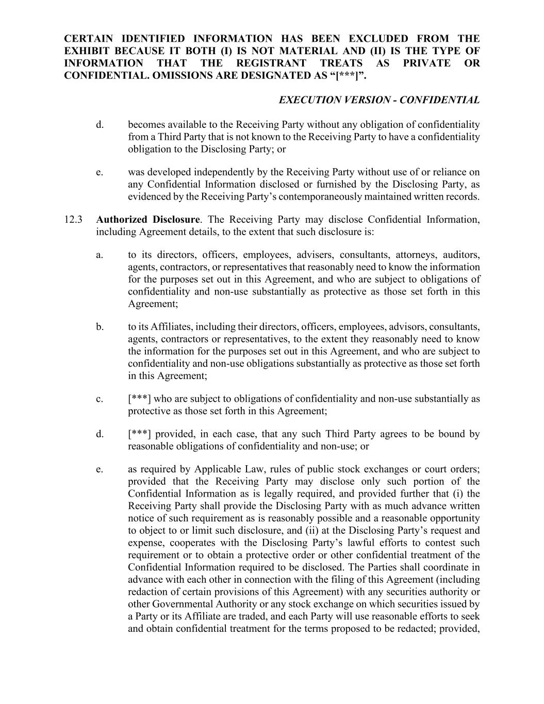
CERTAIN IDENTIFIED INFORMATION HAS BEEN EXCLUDED FROM THE EXHIBIT BECAUSE IT BOTH (I) IS NOT MATERIAL AND (II) IS THE TYPE OF INFORMATION THAT THE REGISTRANT TREATS AS PRIVATE OR CONFIDENTIAL. OMISSIONS ARE DESIGNATED AS “[***]”. EXECUTION VERSION - CONFIDENTIAL d. becomes available to the Receiving Party without any obligation of confidentiality from a Third Party that is not known to the Receiving Party to have a confidentiality obligation to the Disclosing Party; or e. was developed independently by the Receiving Party without use of or reliance on any Confidential Information disclosed or furnished by the Disclosing Party, as evidenced by the Receiving Party’s contemporaneously maintained written records. 12.3 Authorized Disclosure. The Receiving Party may disclose Confidential Information, including Agreement details, to the extent that such disclosure is: a. to its directors, officers, employees, advisers, consultants, attorneys, auditors, agents, contractors, or representatives that reasonably need to know the information for the purposes set out in this Agreement, and who are subject to obligations of confidentiality and non-use substantially as protective as those set forth in this Agreement; b. to its Affiliates, including their directors, officers, employees, advisors, consultants, agents, contractors or representatives, to the extent they reasonably need to know the information for the purposes set out in this Agreement, and who are subject to confidentiality and non-use obligations substantially as protective as those set forth in this Agreement; c. [***] who are subject to obligations of confidentiality and non-use substantially as protective as those set forth in this Agreement; d. [***] provided, in each case, that any such Third Party agrees to be bound by reasonable obligations of confidentiality and non-use; or e. as required by Applicable Law, rules of public stock exchanges or court orders; provided that the Receiving Party may disclose only such portion of the Confidential Information as is legally required, and provided further that (i) the Receiving Party shall provide the Disclosing Party with as much advance written notice of such requirement as is reasonably possible and a reasonable opportunity to object to or limit such disclosure, and (ii) at the Disclosing Party’s request and expense, cooperates with the Disclosing Party’s lawful efforts to contest such requirement or to obtain a protective order or other confidential treatment of the Confidential Information required to be disclosed. The Parties shall coordinate in advance with each other in connection with the filing of this Agreement (including redaction of certain provisions of this Agreement) with any securities authority or other Governmental Authority or any stock exchange on which securities issued by a Party or its Affiliate are traded, and each Party will use reasonable efforts to seek and obtain confidential treatment for the terms proposed to be redacted; provided,

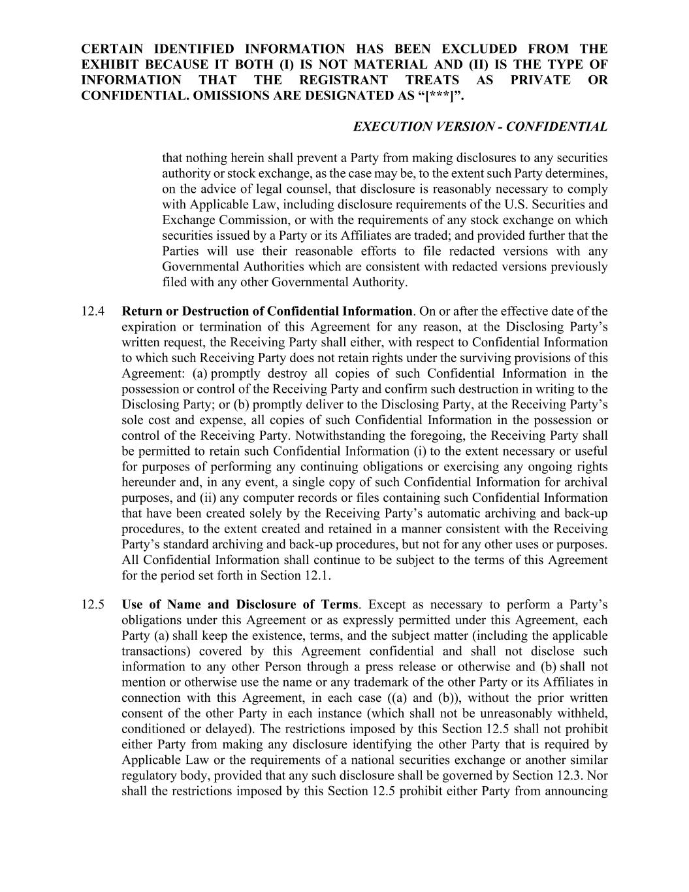
CERTAIN IDENTIFIED INFORMATION HAS BEEN EXCLUDED FROM THE EXHIBIT BECAUSE IT BOTH (I) IS NOT MATERIAL AND (II) IS THE TYPE OF INFORMATION THAT THE REGISTRANT TREATS AS PRIVATE OR CONFIDENTIAL. OMISSIONS ARE DESIGNATED AS “[***]”. EXECUTION VERSION - CONFIDENTIAL that nothing herein shall prevent a Party from making disclosures to any securities authority or stock exchange, as the case may be, to the extent such Party determines, on the advice of legal counsel, that disclosure is reasonably necessary to comply with Applicable Law, including disclosure requirements of the U.S. Securities and Exchange Commission, or with the requirements of any stock exchange on which securities issued by a Party or its Affiliates are traded; and provided further that the Parties will use their reasonable efforts to file redacted versions with any Governmental Authorities which are consistent with redacted versions previously filed with any other Governmental Authority. 12.4 Return or Destruction of Confidential Information. On or after the effective date of the expiration or termination of this Agreement for any reason, at the Disclosing Party’s written request, the Receiving Party shall either, with respect to Confidential Information to which such Receiving Party does not retain rights under the surviving provisions of this Agreement: (a) promptly destroy all copies of such Confidential Information in the possession or control of the Receiving Party and confirm such destruction in writing to the Disclosing Party; or (b) promptly deliver to the Disclosing Party, at the Receiving Party’s sole cost and expense, all copies of such Confidential Information in the possession or control of the Receiving Party. Notwithstanding the foregoing, the Receiving Party shall be permitted to retain such Confidential Information (i) to the extent necessary or useful for purposes of performing any continuing obligations or exercising any ongoing rights hereunder and, in any event, a single copy of such Confidential Information for archival purposes, and (ii) any computer records or files containing such Confidential Information that have been created solely by the Receiving Party’s automatic archiving and back-up procedures, to the extent created and retained in a manner consistent with the Receiving Party’s standard archiving and back-up procedures, but not for any other uses or purposes. All Confidential Information shall continue to be subject to the terms of this Agreement for the period set forth in Section 12.1. 12.5 Use of Name and Disclosure of Terms. Except as necessary to perform a Party’s obligations under this Agreement or as expressly permitted under this Agreement, each Party (a) shall keep the existence, terms, and the subject matter (including the applicable transactions) covered by this Agreement confidential and shall not disclose such information to any other Person through a press release or otherwise and (b) shall not mention or otherwise use the name or any trademark of the other Party or its Affiliates in connection with this Agreement, in each case ((a) and (b)), without the prior written consent of the other Party in each instance (which shall not be unreasonably withheld, conditioned or delayed). The restrictions imposed by this Section 12.5 shall not prohibit either Party from making any disclosure identifying the other Party that is required by Applicable Law or the requirements of a national securities exchange or another similar regulatory body, provided that any such disclosure shall be governed by Section 12.3. Nor shall the restrictions imposed by this Section 12.5 prohibit either Party from announcing

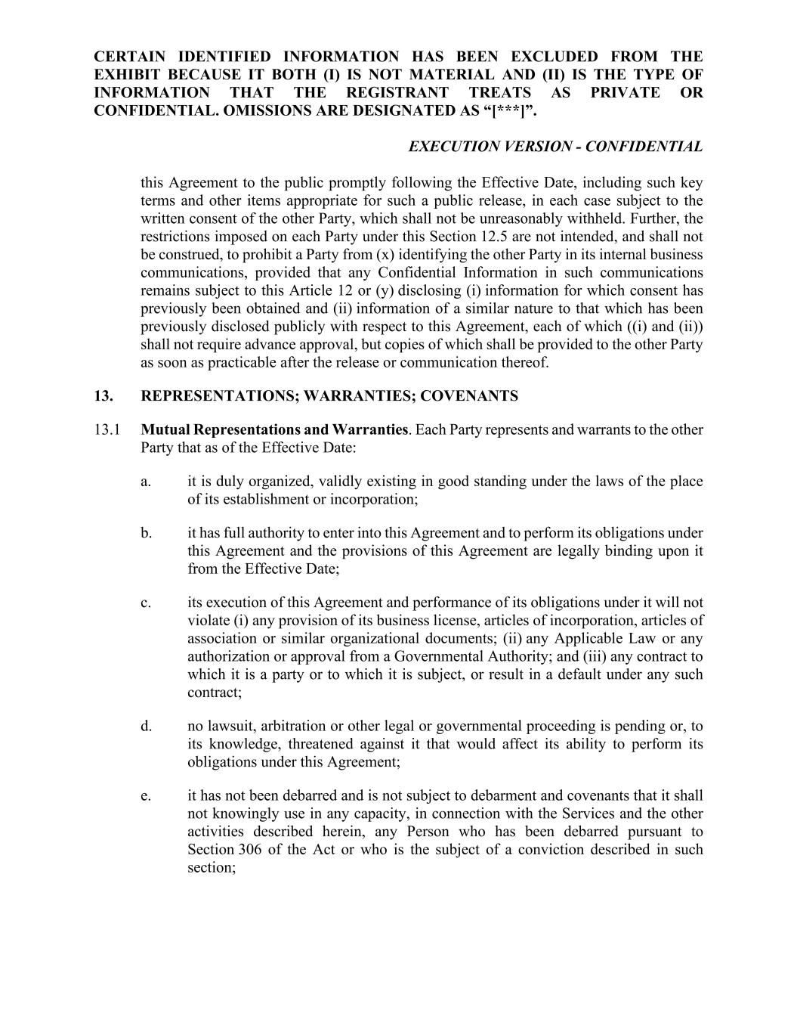
CERTAIN IDENTIFIED INFORMATION HAS BEEN EXCLUDED FROM THE EXHIBIT BECAUSE IT BOTH (I) IS NOT MATERIAL AND (II) IS THE TYPE OF INFORMATION THAT THE REGISTRANT TREATS AS PRIVATE OR CONFIDENTIAL. OMISSIONS ARE DESIGNATED AS “[***]”. EXECUTION VERSION - CONFIDENTIAL this Agreement to the public promptly following the Effective Date, including such key terms and other items appropriate for such a public release, in each case subject to the written consent of the other Party, which shall not be unreasonably withheld. Further, the restrictions imposed on each Party under this Section 12.5 are not intended, and shall not be construed, to prohibit a Party from (x) identifying the other Party in its internal business communications, provided that any Confidential Information in such communications remains subject to this Article 12 or (y) disclosing (i) information for which consent has previously been obtained and (ii) information of a similar nature to that which has been previously disclosed publicly with respect to this Agreement, each of which ((i) and (ii)) shall not require advance approval, but copies of which shall be provided to the other Party as soon as practicable after the release or communication thereof. 13. REPRESENTATIONS; WARRANTIES; COVENANTS 13.1 Mutual Representations and Warranties. Each Party represents and warrants to the other Party that as of the Effective Date: a. it is duly organized, validly existing in good standing under the laws of the place of its establishment or incorporation; b. it has full authority to enter into this Agreement and to perform its obligations under this Agreement and the provisions of this Agreement are legally binding upon it from the Effective Date; c. its execution of this Agreement and performance of its obligations under it will not violate (i) any provision of its business license, articles of incorporation, articles of association or similar organizational documents; (ii) any Applicable Law or any authorization or approval from a Governmental Authority; and (iii) any contract to which it is a party or to which it is subject, or result in a default under any such contract; d. no lawsuit, arbitration or other legal or governmental proceeding is pending or, to its knowledge, threatened against it that would affect its ability to perform its obligations under this Agreement; e. it has not been debarred and is not subject to debarment and covenants that it shall not knowingly use in any capacity, in connection with the Services and the other activities described herein, any Person who has been debarred pursuant to Section 306 of the Act or who is the subject of a conviction described in such section;

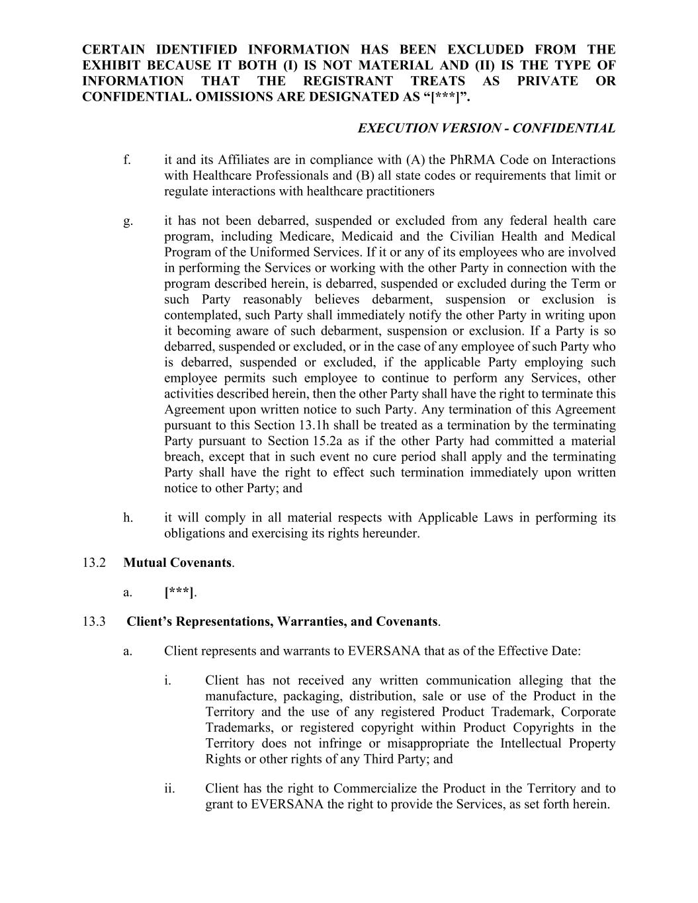
CERTAIN IDENTIFIED INFORMATION HAS BEEN EXCLUDED FROM THE EXHIBIT BECAUSE IT BOTH (I) IS NOT MATERIAL AND (II) IS THE TYPE OF INFORMATION THAT THE REGISTRANT TREATS AS PRIVATE OR CONFIDENTIAL. OMISSIONS ARE DESIGNATED AS “[***]”. EXECUTION VERSION - CONFIDENTIAL f. it and its Affiliates are in compliance with (A) the PhRMA Code on Interactions with Healthcare Professionals and (B) all state codes or requirements that limit or regulate interactions with healthcare practitioners g. it has not been debarred, suspended or excluded from any federal health care program, including Medicare, Medicaid and the Civilian Health and Medical Program of the Uniformed Services. If it or any of its employees who are involved in performing the Services or working with the other Party in connection with the program described herein, is debarred, suspended or excluded during the Term or such Party reasonably believes debarment, suspension or exclusion is contemplated, such Party shall immediately notify the other Party in writing upon it becoming aware of such debarment, suspension or exclusion. If a Party is so debarred, suspended or excluded, or in the case of any employee of such Party who is debarred, suspended or excluded, if the applicable Party employing such employee permits such employee to continue to perform any Services, other activities described herein, then the other Party shall have the right to terminate this Agreement upon written notice to such Party. Any termination of this Agreement pursuant to this Section 13.1h shall be treated as a termination by the terminating Party pursuant to Section 15.2a as if the other Party had committed a material breach, except that in such event no cure period shall apply and the terminating Party shall have the right to effect such termination immediately upon written notice to other Party; and h. it will comply in all material respects with Applicable Laws in performing its obligations and exercising its rights hereunder. 13.2 Mutual Covenants. a. [***]. 13.3 Client’s Representations, Warranties, and Covenants. a. Client represents and warrants to EVERSANA that as of the Effective Date: i. Client has not received any written communication alleging that the manufacture, packaging, distribution, sale or use of the Product in the Territory and the use of any registered Product Trademark, Corporate Trademarks, or registered copyright within Product Copyrights in the Territory does not infringe or misappropriate the Intellectual Property Rights or other rights of any Third Party; and ii. Client has the right to Commercialize the Product in the Territory and to grant to EVERSANA the right to provide the Services, as set forth herein.

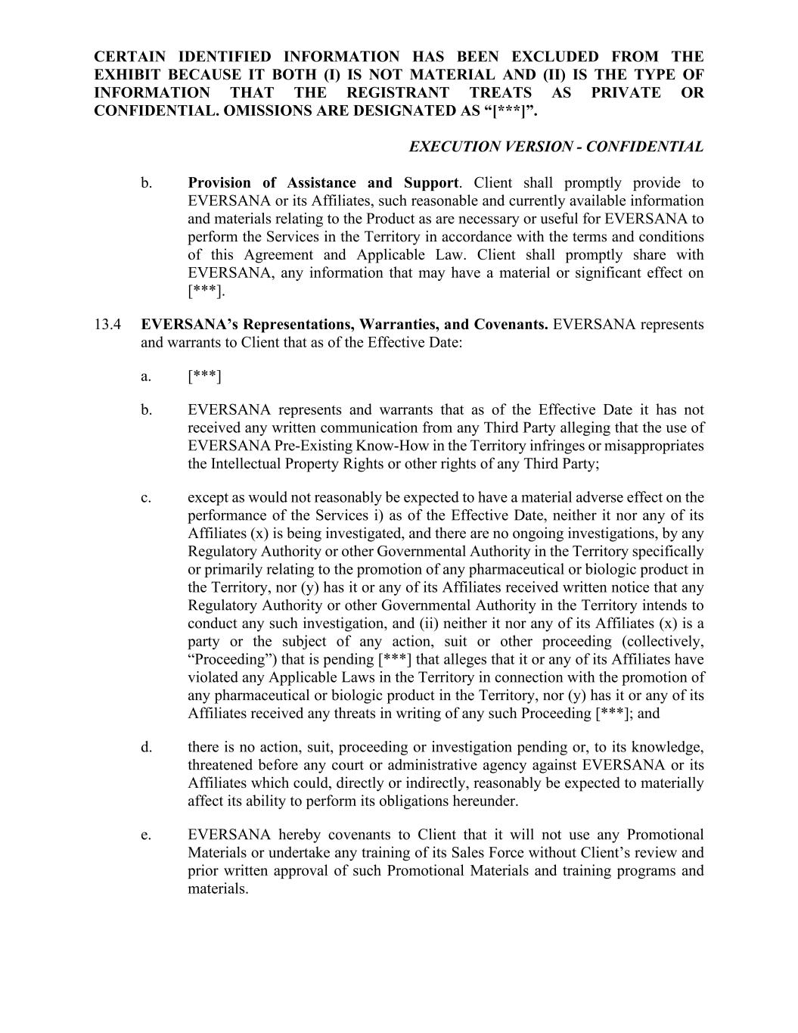
CERTAIN IDENTIFIED INFORMATION HAS BEEN EXCLUDED FROM THE EXHIBIT BECAUSE IT BOTH (I) IS NOT MATERIAL AND (II) IS THE TYPE OF INFORMATION THAT THE REGISTRANT TREATS AS PRIVATE OR CONFIDENTIAL. OMISSIONS ARE DESIGNATED AS “[***]”. EXECUTION VERSION - CONFIDENTIAL b. Provision of Assistance and Support. Client shall promptly provide to EVERSANA or its Affiliates, such reasonable and currently available information and materials relating to the Product as are necessary or useful for EVERSANA to perform the Services in the Territory in accordance with the terms and conditions of this Agreement and Applicable Law. Client shall promptly share with EVERSANA, any information that may have a material or significant effect on [***]. 13.4 EVERSANA’s Representations, Warranties, and Covenants. EVERSANA represents and warrants to Client that as of the Effective Date: a. [***] b. EVERSANA represents and warrants that as of the Effective Date it has not received any written communication from any Third Party alleging that the use of EVERSANA Pre-Existing Know-How in the Territory infringes or misappropriates the Intellectual Property Rights or other rights of any Third Party; c. except as would not reasonably be expected to have a material adverse effect on the performance of the Services i) as of the Effective Date, neither it nor any of its Affiliates (x) is being investigated, and there are no ongoing investigations, by any Regulatory Authority or other Governmental Authority in the Territory specifically or primarily relating to the promotion of any pharmaceutical or biologic product in the Territory, nor (y) has it or any of its Affiliates received written notice that any Regulatory Authority or other Governmental Authority in the Territory intends to conduct any such investigation, and (ii) neither it nor any of its Affiliates (x) is a party or the subject of any action, suit or other proceeding (collectively, “Proceeding”) that is pending [***] that alleges that it or any of its Affiliates have violated any Applicable Laws in the Territory in connection with the promotion of any pharmaceutical or biologic product in the Territory, nor (y) has it or any of its Affiliates received any threats in writing of any such Proceeding [***]; and d. there is no action, suit, proceeding or investigation pending or, to its knowledge, threatened before any court or administrative agency against EVERSANA or its Affiliates which could, directly or indirectly, reasonably be expected to materially affect its ability to perform its obligations hereunder. e. EVERSANA hereby covenants to Client that it will not use any Promotional Materials or undertake any training of its Sales Force without Client’s review and prior written approval of such Promotional Materials and training programs and materials.

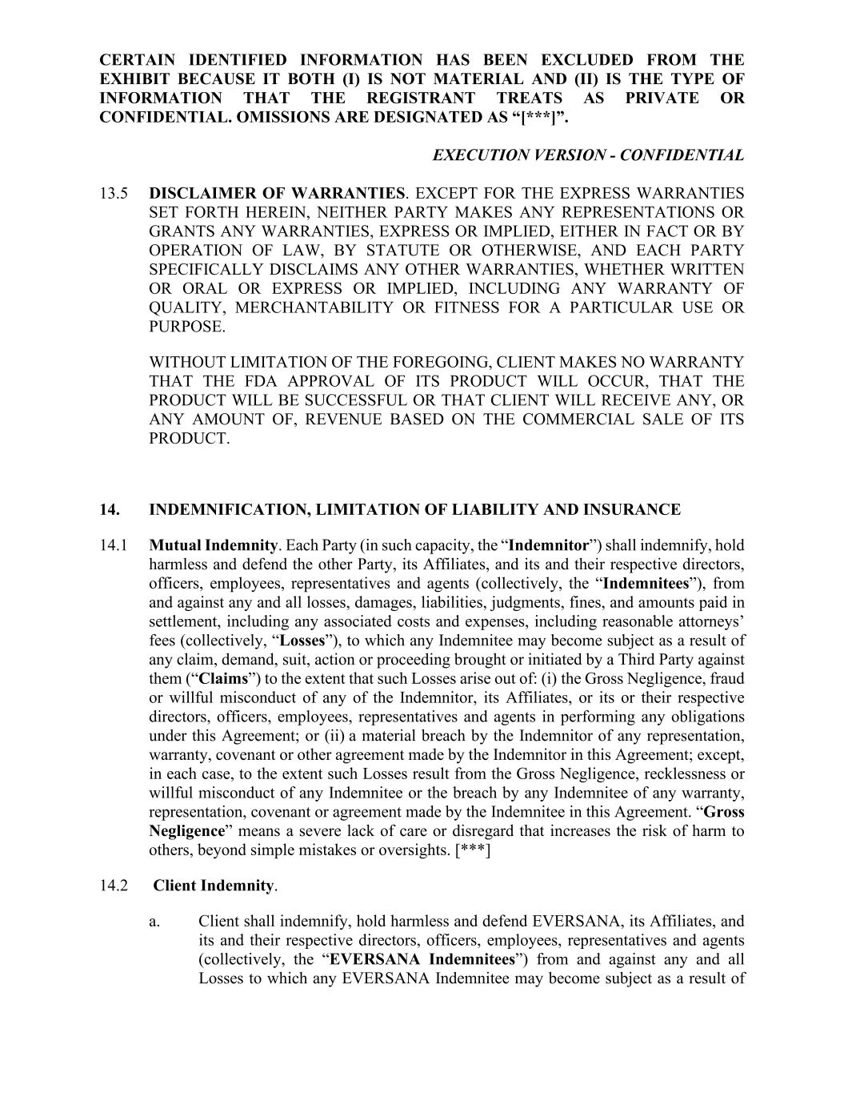
CERTAIN IDENTIFIED INFORMATION HAS BEEN EXCLUDED FROM THE EXHIBIT BECAUSE IT BOTH (I) IS NOT MATERIAL AND (II) IS THE TYPE OF INFORMATION THAT THE REGISTRANT TREATS AS PRIVATE OR CONFIDENTIAL. OMISSIONS ARE DESIGNATED AS “[***]”. EXECUTION VERSION - CONFIDENTIAL 13.5 DISCLAIMER OF WARRANTIES. EXCEPT FOR THE EXPRESS WARRANTIES SET FORTH HEREIN, NEITHER PARTY MAKES ANY REPRESENTATIONS OR GRANTS ANY WARRANTIES, EXPRESS OR IMPLIED, EITHER IN FACT OR BY OPERATION OF LAW, BY STATUTE OR OTHERWISE, AND EACH PARTY SPECIFICALLY DISCLAIMS ANY OTHER WARRANTIES, WHETHER WRITTEN OR ORAL OR EXPRESS OR IMPLIED, INCLUDING ANY WARRANTY OF QUALITY, MERCHANTABILITY OR FITNESS FOR A PARTICULAR USE OR PURPOSE. WITHOUT LIMITATION OF THE FOREGOING, CLIENT MAKES NO WARRANTY THAT THE FDA APPROVAL OF ITS PRODUCT WILL OCCUR, THAT THE PRODUCT WILL BE SUCCESSFUL OR THAT CLIENT WILL RECEIVE ANY, OR ANY AMOUNT OF, REVENUE BASED ON THE COMMERCIAL SALE OF ITS PRODUCT. 14. INDEMNIFICATION, LIMITATION OF LIABILITY AND INSURANCE 14.1 Mutual Indemnity. Each Party (in such capacity, the “Indemnitor”) shall indemnify, hold harmless and defend the other Party, its Affiliates, and its and their respective directors, officers, employees, representatives and agents (collectively, the “Indemnitees”), from and against any and all losses, damages, liabilities, judgments, fines, and amounts paid in settlement, including any associated costs and expenses, including reasonable attorneys’ fees (collectively, “Losses”), to which any Indemnitee may become subject as a result of any claim, demand, suit, action or proceeding brought or initiated by a Third Party against them (“Claims”) to the extent that such Losses arise out of: (i) the Gross Negligence, fraud or willful misconduct of any of the Indemnitor, its Affiliates, or its or their respective directors, officers, employees, representatives and agents in performing any obligations under this Agreement; or (ii) a material breach by the Indemnitor of any representation, warranty, covenant or other agreement made by the Indemnitor in this Agreement; except, in each case, to the extent such Losses result from the Gross Negligence, recklessness or willful misconduct of any Indemnitee or the breach by any Indemnitee of any warranty, representation, covenant or agreement made by the Indemnitee in this Agreement. “Gross Negligence” means a severe lack of care or disregard that increases the risk of harm to others, beyond simple mistakes or oversights. [***] 14.2 Client Indemnity. a. Client shall indemnify, hold harmless and defend EVERSANA, its Affiliates, and its and their respective directors, officers, employees, representatives and agents (collectively, the “EVERSANA Indemnitees”) from and against any and all Losses to which any EVERSANA Indemnitee may become subject as a result of

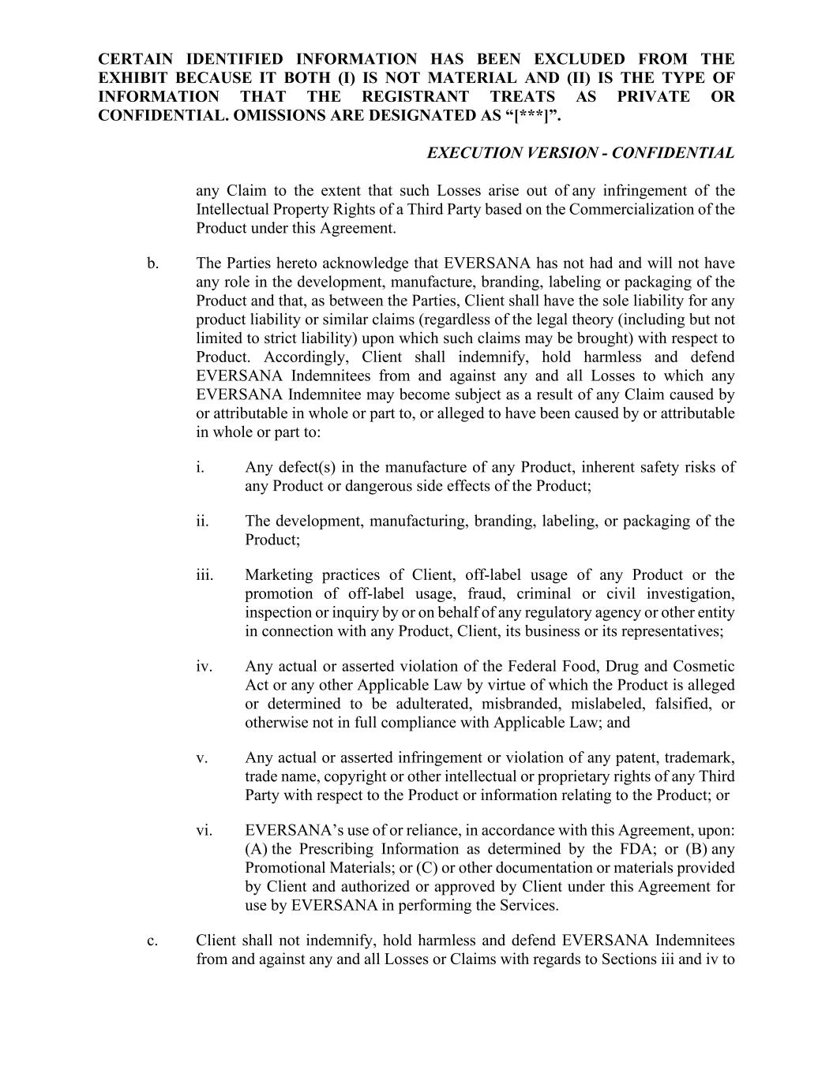
CERTAIN IDENTIFIED INFORMATION HAS BEEN EXCLUDED FROM THE EXHIBIT BECAUSE IT BOTH (I) IS NOT MATERIAL AND (II) IS THE TYPE OF INFORMATION THAT THE REGISTRANT TREATS AS PRIVATE OR CONFIDENTIAL. OMISSIONS ARE DESIGNATED AS “[***]”. EXECUTION VERSION - CONFIDENTIAL any Claim to the extent that such Losses arise out of any infringement of the Intellectual Property Rights of a Third Party based on the Commercialization of the Product under this Agreement. b. The Parties hereto acknowledge that EVERSANA has not had and will not have any role in the development, manufacture, branding, labeling or packaging of the Product and that, as between the Parties, Client shall have the sole liability for any product liability or similar claims (regardless of the legal theory (including but not limited to strict liability) upon which such claims may be brought) with respect to Product. Accordingly, Client shall indemnify, hold harmless and defend EVERSANA Indemnitees from and against any and all Losses to which any EVERSANA Indemnitee may become subject as a result of any Claim caused by or attributable in whole or part to, or alleged to have been caused by or attributable in whole or part to: i. Any defect(s) in the manufacture of any Product, inherent safety risks of any Product or dangerous side effects of the Product; ii. The development, manufacturing, branding, labeling, or packaging of the Product; iii. Marketing practices of Client, off-label usage of any Product or the promotion of off-label usage, fraud, criminal or civil investigation, inspection or inquiry by or on behalf of any regulatory agency or other entity in connection with any Product, Client, its business or its representatives; iv. Any actual or asserted violation of the Federal Food, Drug and Cosmetic Act or any other Applicable Law by virtue of which the Product is alleged or determined to be adulterated, misbranded, mislabeled, falsified, or otherwise not in full compliance with Applicable Law; and v. Any actual or asserted infringement or violation of any patent, trademark, trade name, copyright or other intellectual or proprietary rights of any Third Party with respect to the Product or information relating to the Product; or vi. EVERSANA’s use of or reliance, in accordance with this Agreement, upon: (A) the Prescribing Information as determined by the FDA; or (B) any Promotional Materials; or (C) or other documentation or materials provided by Client and authorized or approved by Client under this Agreement for use by EVERSANA in performing the Services. c. Client shall not indemnify, hold harmless and defend EVERSANA Indemnitees from and against any and all Losses or Claims with regards to Sections iii and iv to

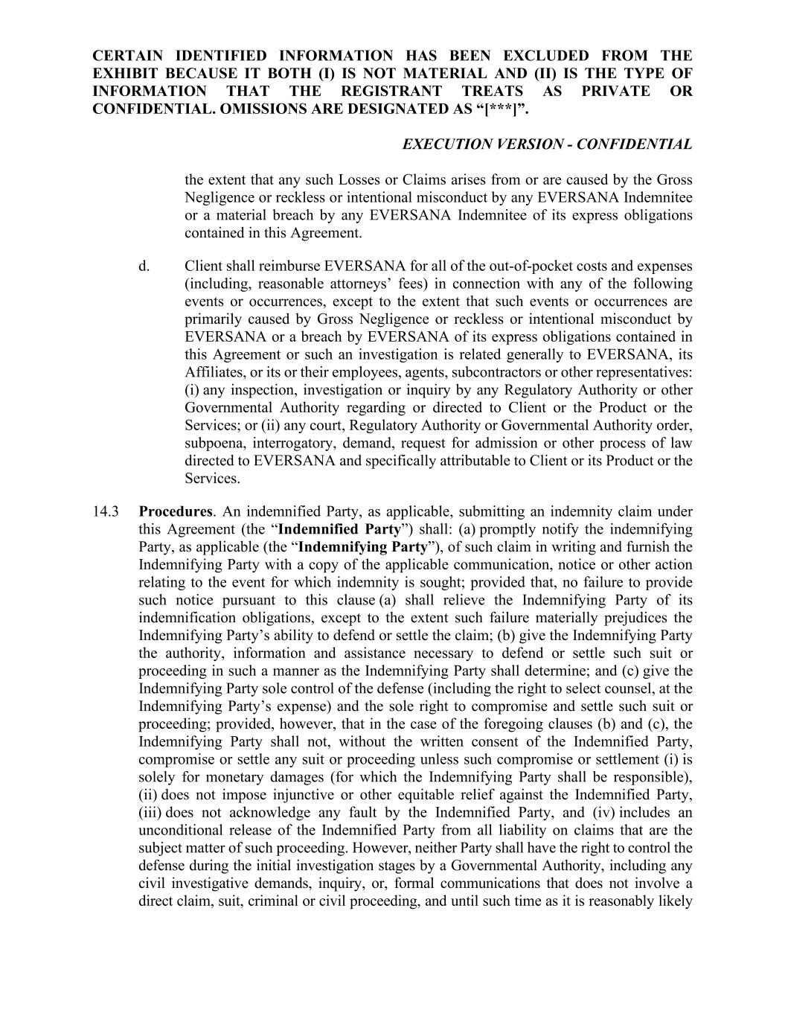
CERTAIN IDENTIFIED INFORMATION HAS BEEN EXCLUDED FROM THE EXHIBIT BECAUSE IT BOTH (I) IS NOT MATERIAL AND (II) IS THE TYPE OF INFORMATION THAT THE REGISTRANT TREATS AS PRIVATE OR CONFIDENTIAL. OMISSIONS ARE DESIGNATED AS “[***]”. EXECUTION VERSION - CONFIDENTIAL the extent that any such Losses or Claims arises from or are caused by the Gross Negligence or reckless or intentional misconduct by any EVERSANA Indemnitee or a material breach by any EVERSANA Indemnitee of its express obligations contained in this Agreement. d. Client shall reimburse EVERSANA for all of the out-of-pocket costs and expenses (including, reasonable attorneys’ fees) in connection with any of the following events or occurrences, except to the extent that such events or occurrences are primarily caused by Gross Negligence or reckless or intentional misconduct by EVERSANA or a breach by EVERSANA of its express obligations contained in this Agreement or such an investigation is related generally to EVERSANA, its Affiliates, or its or their employees, agents, subcontractors or other representatives: (i) any inspection, investigation or inquiry by any Regulatory Authority or other Governmental Authority regarding or directed to Client or the Product or the Services; or (ii) any court, Regulatory Authority or Governmental Authority order, subpoena, interrogatory, demand, request for admission or other process of law directed to EVERSANA and specifically attributable to Client or its Product or the Services. 14.3 Procedures. An indemnified Party, as applicable, submitting an indemnity claim under this Agreement (the “Indemnified Party”) shall: (a) promptly notify the indemnifying Party, as applicable (the “Indemnifying Party”), of such claim in writing and furnish the Indemnifying Party with a copy of the applicable communication, notice or other action relating to the event for which indemnity is sought; provided that, no failure to provide such notice pursuant to this clause (a) shall relieve the Indemnifying Party of its indemnification obligations, except to the extent such failure materially prejudices the Indemnifying Party’s ability to defend or settle the claim; (b) give the Indemnifying Party the authority, information and assistance necessary to defend or settle such suit or proceeding in such a manner as the Indemnifying Party shall determine; and (c) give the Indemnifying Party sole control of the defense (including the right to select counsel, at the Indemnifying Party’s expense) and the sole right to compromise and settle such suit or proceeding; provided, however, that in the case of the foregoing clauses (b) and (c), the Indemnifying Party shall not, without the written consent of the Indemnified Party, compromise or settle any suit or proceeding unless such compromise or settlement (i) is solely for monetary damages (for which the Indemnifying Party shall be responsible), (ii) does not impose injunctive or other equitable relief against the Indemnified Party, (iii) does not acknowledge any fault by the Indemnified Party, and (iv) includes an unconditional release of the Indemnified Party from all liability on claims that are the subject matter of such proceeding. However, neither Party shall have the right to control the defense during the initial investigation stages by a Governmental Authority, including any civil investigative demands, inquiry, or, formal communications that does not involve a direct claim, suit, criminal or civil proceeding, and until such time as it is reasonably likely

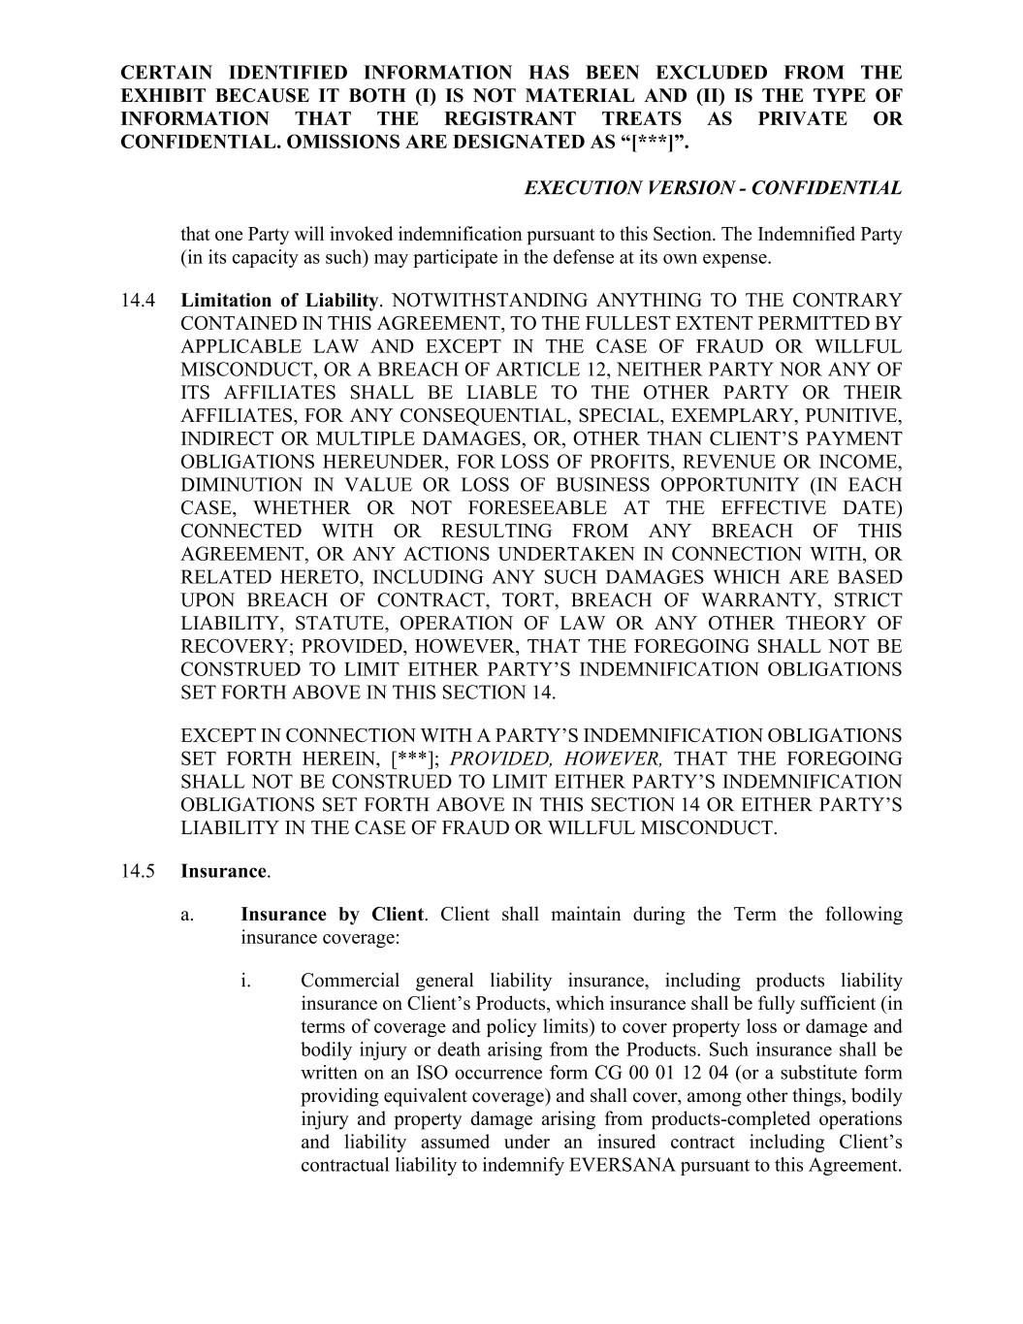
CERTAIN IDENTIFIED INFORMATION HAS BEEN EXCLUDED FROM THE EXHIBIT BECAUSE IT BOTH (I) IS NOT MATERIAL AND (II) IS THE TYPE OF INFORMATION THAT THE REGISTRANT TREATS AS PRIVATE OR CONFIDENTIAL. OMISSIONS ARE DESIGNATED AS “[***]”. EXECUTION VERSION - CONFIDENTIAL that one Party will invoked indemnification pursuant to this Section. The Indemnified Party (in its capacity as such) may participate in the defense at its own expense. 14.4 Limitation of Liability. NOTWITHSTANDING ANYTHING TO THE CONTRARY CONTAINED IN THIS AGREEMENT, TO THE FULLEST EXTENT PERMITTED BY APPLICABLE LAW AND EXCEPT IN THE CASE OF FRAUD OR WILLFUL MISCONDUCT, OR A BREACH OF ARTICLE 12, NEITHER PARTY NOR ANY OF ITS AFFILIATES SHALL BE LIABLE TO THE OTHER PARTY OR THEIR AFFILIATES, FOR ANY CONSEQUENTIAL, SPECIAL, EXEMPLARY, PUNITIVE, INDIRECT OR MULTIPLE DAMAGES, OR, OTHER THAN CLIENT’S PAYMENT OBLIGATIONS HEREUNDER, FOR LOSS OF PROFITS, REVENUE OR INCOME, DIMINUTION IN VALUE OR LOSS OF BUSINESS OPPORTUNITY (IN EACH CASE, WHETHER OR NOT FORESEEABLE AT THE EFFECTIVE DATE) CONNECTED WITH OR RESULTING FROM ANY BREACH OF THIS AGREEMENT, OR ANY ACTIONS UNDERTAKEN IN CONNECTION WITH, OR RELATED HERETO, INCLUDING ANY SUCH DAMAGES WHICH ARE BASED UPON BREACH OF CONTRACT, TORT, BREACH OF WARRANTY, STRICT LIABILITY, STATUTE, OPERATION OF LAW OR ANY OTHER THEORY OF RECOVERY; PROVIDED, HOWEVER, THAT THE FOREGOING SHALL NOT BE CONSTRUED TO LIMIT EITHER PARTY’S INDEMNIFICATION OBLIGATIONS SET FORTH ABOVE IN THIS SECTION 14. EXCEPT IN CONNECTION WITH A PARTY’S INDEMNIFICATION OBLIGATIONS SET FORTH HEREIN, [***]; PROVIDED, HOWEVER, THAT THE FOREGOING SHALL NOT BE CONSTRUED TO LIMIT EITHER PARTY’S INDEMNIFICATION OBLIGATIONS SET FORTH ABOVE IN THIS SECTION 14 OR EITHER PARTY’S LIABILITY IN THE CASE OF FRAUD OR WILLFUL MISCONDUCT. 14.5 Insurance. a. Insurance by Client. Client shall maintain during the Term the following insurance coverage: i. Commercial general liability insurance, including products liability insurance on Client’s Products, which insurance shall be fully sufficient (in terms of coverage and policy limits) to cover property loss or damage and bodily injury or death arising from the Products. Such insurance shall be written on an ISO occurrence form CG 00 01 12 04 (or a substitute form providing equivalent coverage) and shall cover, among other things, bodily injury and property damage arising from products-completed operations and liability assumed under an insured contract including Client’s contractual liability to indemnify EVERSANA pursuant to this Agreement.

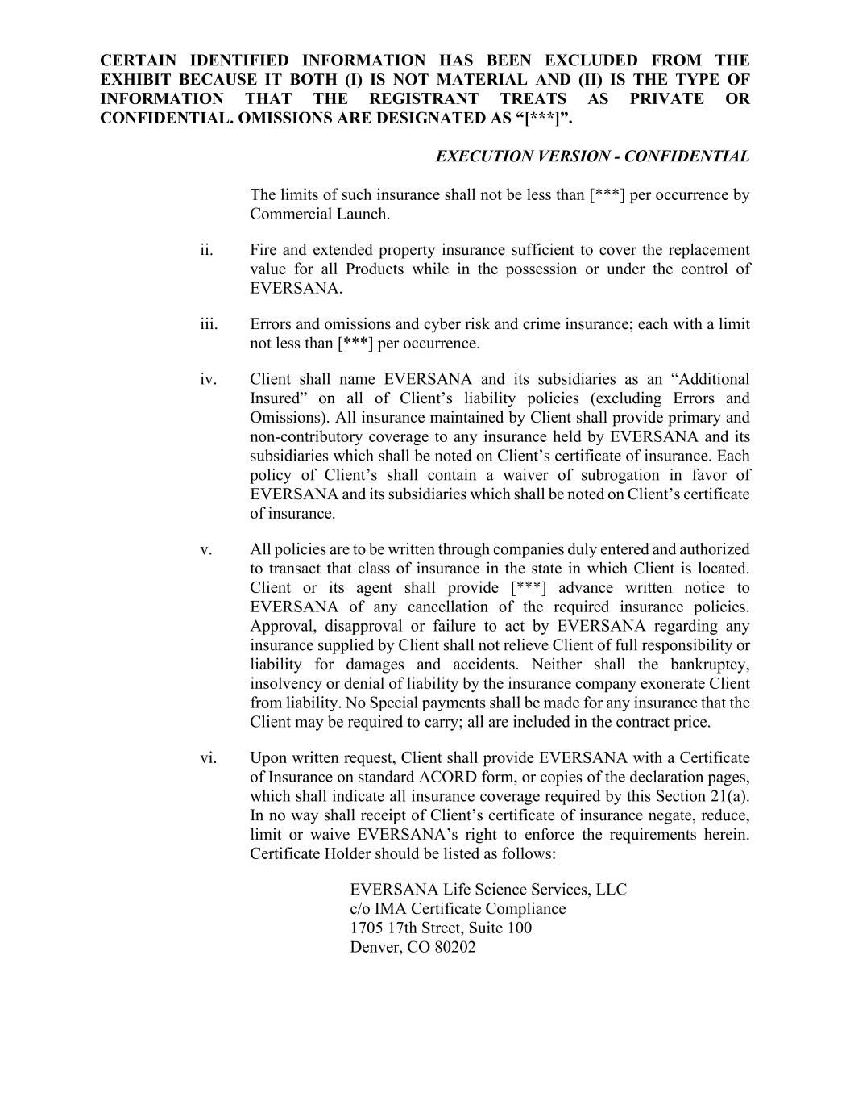
CERTAIN IDENTIFIED INFORMATION HAS BEEN EXCLUDED FROM THE EXHIBIT BECAUSE IT BOTH (I) IS NOT MATERIAL AND (II) IS THE TYPE OF INFORMATION THAT THE REGISTRANT TREATS AS PRIVATE OR CONFIDENTIAL. OMISSIONS ARE DESIGNATED AS “[***]”. EXECUTION VERSION - CONFIDENTIAL The limits of such insurance shall not be less than [***] per occurrence by Commercial Launch. ii. Fire and extended property insurance sufficient to cover the replacement value for all Products while in the possession or under the control of EVERSANA. iii. Errors and omissions and cyber risk and crime insurance; each with a limit not less than [***] per occurrence. iv. Client shall name EVERSANA and its subsidiaries as an “Additional Insured” on all of Client’s liability policies (excluding Errors and Omissions). All insurance maintained by Client shall provide primary and non-contributory coverage to any insurance held by EVERSANA and its subsidiaries which shall be noted on Client’s certificate of insurance. Each policy of Client’s shall contain a waiver of subrogation in favor of EVERSANA and its subsidiaries which shall be noted on Client’s certificate of insurance. v. All policies are to be written through companies duly entered and authorized to transact that class of insurance in the state in which Client is located. Client or its agent shall provide [***] advance written notice to EVERSANA of any cancellation of the required insurance policies. Approval, disapproval or failure to act by EVERSANA regarding any insurance supplied by Client shall not relieve Client of full responsibility or liability for damages and accidents. Neither shall the bankruptcy, insolvency or denial of liability by the insurance company exonerate Client from liability. No Special payments shall be made for any insurance that the Client may be required to carry; all are included in the contract price. vi. Upon written request, Client shall provide EVERSANA with a Certificate of Insurance on standard ACORD form, or copies of the declaration pages, which shall indicate all insurance coverage required by this Section 21(a). In no way shall receipt of Client’s certificate of insurance negate, reduce, limit or waive EVERSANA’s right to enforce the requirements herein. Certificate Holder should be listed as follows: EVERSANA Life Science Services, LLC c/o IMA Certificate Compliance 1705 17th Street, Suite 100 Denver, CO 80202

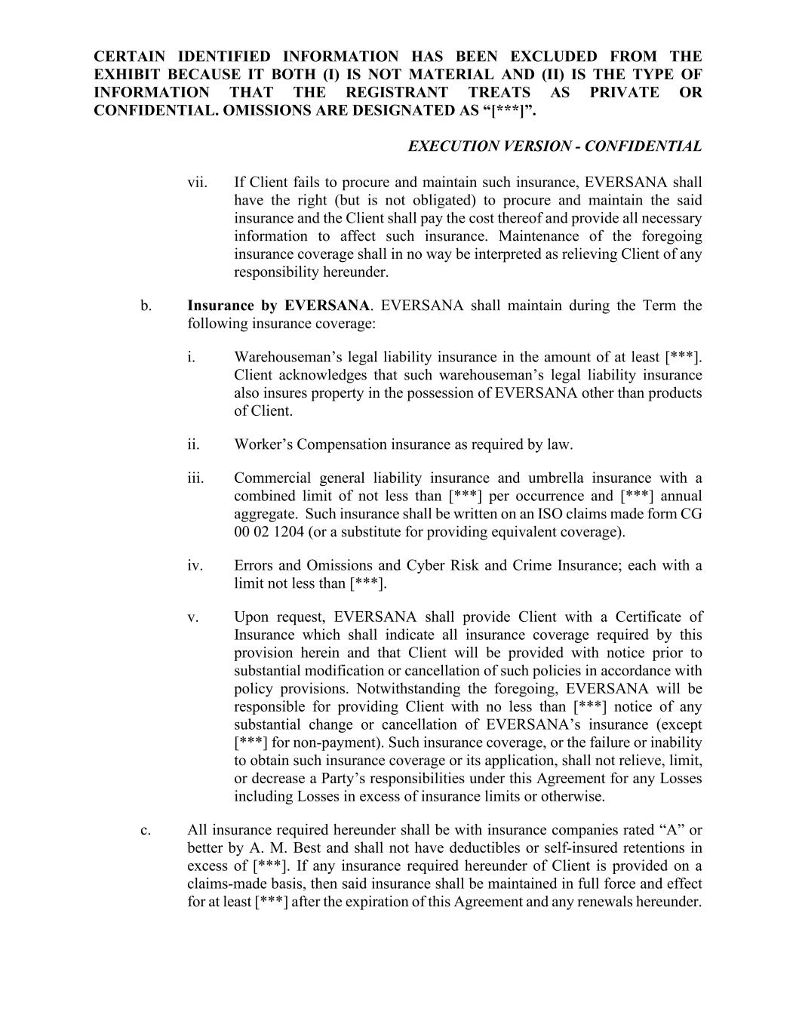
CERTAIN IDENTIFIED INFORMATION HAS BEEN EXCLUDED FROM THE EXHIBIT BECAUSE IT BOTH (I) IS NOT MATERIAL AND (II) IS THE TYPE OF INFORMATION THAT THE REGISTRANT TREATS AS PRIVATE OR CONFIDENTIAL. OMISSIONS ARE DESIGNATED AS “[***]”. EXECUTION VERSION - CONFIDENTIAL vii. If Client fails to procure and maintain such insurance, EVERSANA shall have the right (but is not obligated) to procure and maintain the said insurance and the Client shall pay the cost thereof and provide all necessary information to affect such insurance. Maintenance of the foregoing insurance coverage shall in no way be interpreted as relieving Client of any responsibility hereunder. b. Insurance by EVERSANA. EVERSANA shall maintain during the Term the following insurance coverage: i. Warehouseman’s legal liability insurance in the amount of at least [***]. Client acknowledges that such warehouseman’s legal liability insurance also insures property in the possession of EVERSANA other than products of Client. ii. Worker’s Compensation insurance as required by law. iii. Commercial general liability insurance and umbrella insurance with a combined limit of not less than [***] per occurrence and [***] annual aggregate. Such insurance shall be written on an ISO claims made form CG 00 02 1204 (or a substitute for providing equivalent coverage). iv. Errors and Omissions and Cyber Risk and Crime Insurance; each with a limit not less than [***]. v. Upon request, EVERSANA shall provide Client with a Certificate of Insurance which shall indicate all insurance coverage required by this provision herein and that Client will be provided with notice prior to substantial modification or cancellation of such policies in accordance with policy provisions. Notwithstanding the foregoing, EVERSANA will be responsible for providing Client with no less than [***] notice of any substantial change or cancellation of EVERSANA’s insurance (except [***] for non-payment). Such insurance coverage, or the failure or inability to obtain such insurance coverage or its application, shall not relieve, limit, or decrease a Party’s responsibilities under this Agreement for any Losses including Losses in excess of insurance limits or otherwise. c. All insurance required hereunder shall be with insurance companies rated “A” or better by A. M. Best and shall not have deductibles or self-insured retentions in excess of [***]. If any insurance required hereunder of Client is provided on a claims-made basis, then said insurance shall be maintained in full force and effect for at least [***] after the expiration of this Agreement and any renewals hereunder.

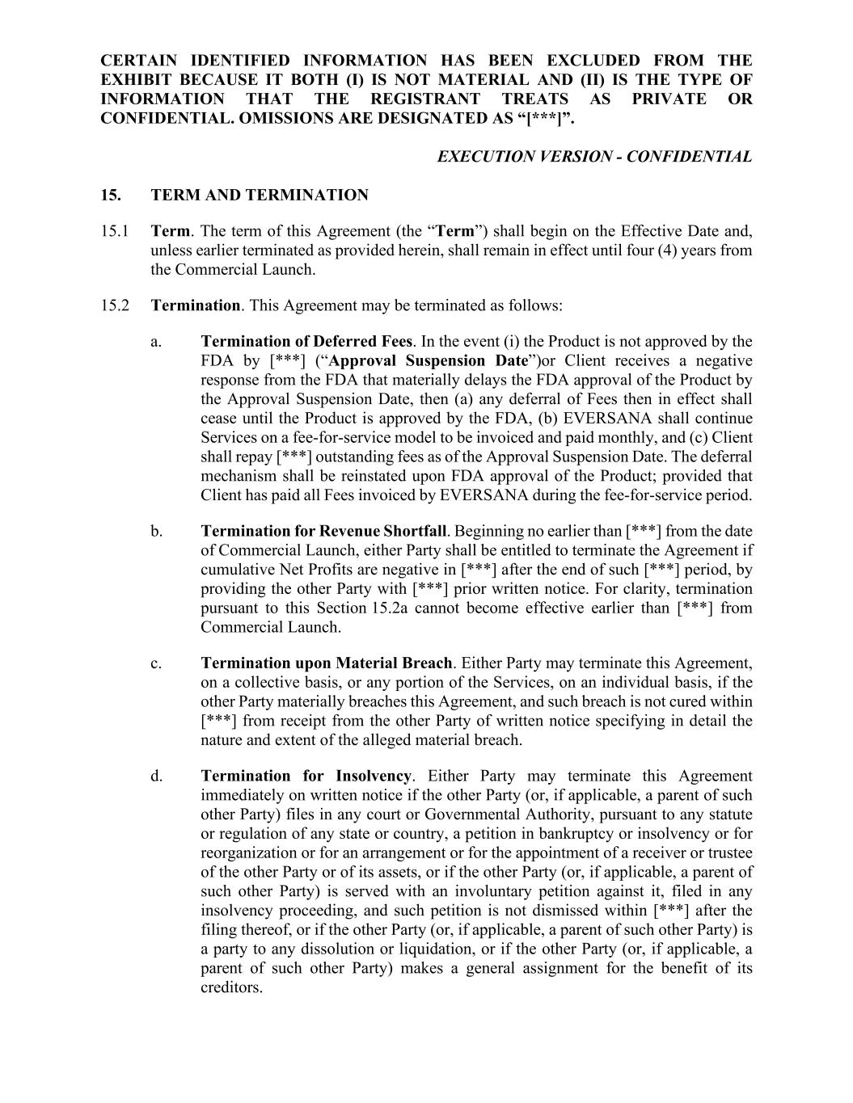
CERTAIN IDENTIFIED INFORMATION HAS BEEN EXCLUDED FROM THE EXHIBIT BECAUSE IT BOTH (I) IS NOT MATERIAL AND (II) IS THE TYPE OF INFORMATION THAT THE REGISTRANT TREATS AS PRIVATE OR CONFIDENTIAL. OMISSIONS ARE DESIGNATED AS “[***]”. EXECUTION VERSION - CONFIDENTIAL 15. TERM AND TERMINATION 15.1 Term. The term of this Agreement (the “Term”) shall begin on the Effective Date and, unless earlier terminated as provided herein, shall remain in effect until four (4) years from the Commercial Launch. 15.2 Termination. This Agreement may be terminated as follows: a. Termination of Deferred Fees. In the event (i) the Product is not approved by the FDA by [***] (“Approval Suspension Date”)or Client receives a negative response from the FDA that materially delays the FDA approval of the Product by the Approval Suspension Date, then (a) any deferral of Fees then in effect shall cease until the Product is approved by the FDA, (b) EVERSANA shall continue Services on a fee-for-service model to be invoiced and paid monthly, and (c) Client shall repay [***] outstanding fees as of the Approval Suspension Date. The deferral mechanism shall be reinstated upon FDA approval of the Product; provided that Client has paid all Fees invoiced by EVERSANA during the fee-for-service period. b. Termination for Revenue Shortfall. Beginning no earlier than [***] from the date of Commercial Launch, either Party shall be entitled to terminate the Agreement if cumulative Net Profits are negative in [***] after the end of such [***] period, by providing the other Party with [***] prior written notice. For clarity, termination pursuant to this Section 15.2a cannot become effective earlier than [***] from Commercial Launch. c. Termination upon Material Breach. Either Party may terminate this Agreement, on a collective basis, or any portion of the Services, on an individual basis, if the other Party materially breaches this Agreement, and such breach is not cured within [***] from receipt from the other Party of written notice specifying in detail the nature and extent of the alleged material breach. d. Termination for Insolvency. Either Party may terminate this Agreement immediately on written notice if the other Party (or, if applicable, a parent of such other Party) files in any court or Governmental Authority, pursuant to any statute or regulation of any state or country, a petition in bankruptcy or insolvency or for reorganization or for an arrangement or for the appointment of a receiver or trustee of the other Party or of its assets, or if the other Party (or, if applicable, a parent of such other Party) is served with an involuntary petition against it, filed in any insolvency proceeding, and such petition is not dismissed within [***] after the filing thereof, or if the other Party (or, if applicable, a parent of such other Party) is a party to any dissolution or liquidation, or if the other Party (or, if applicable, a parent of such other Party) makes a general assignment for the benefit of its creditors.

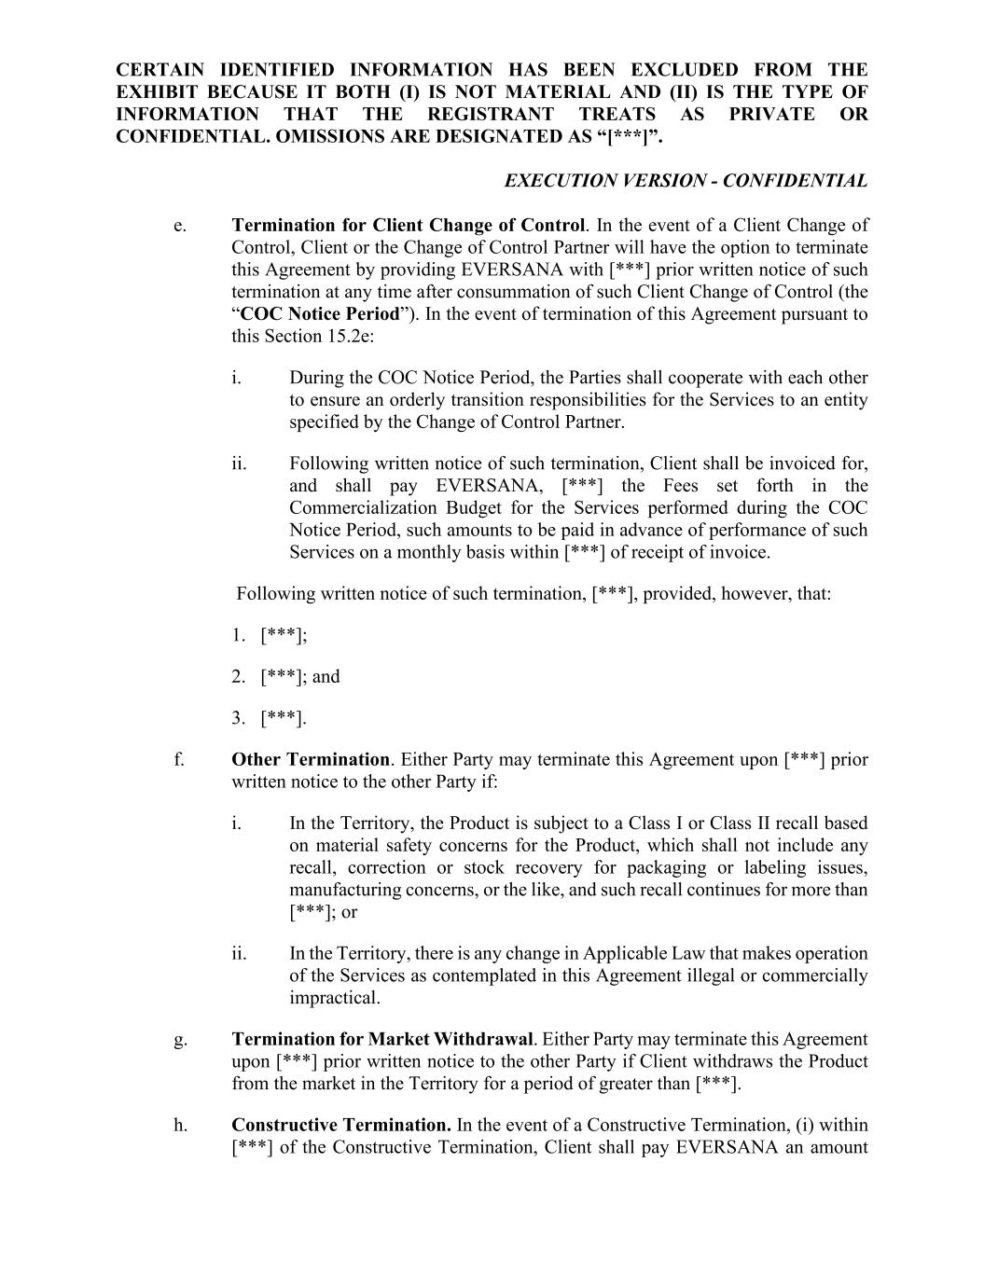
CERTAIN IDENTIFIED INFORMATION HAS BEEN EXCLUDED FROM THE EXHIBIT BECAUSE IT BOTH (I) IS NOT MATERIAL AND (II) IS THE TYPE OF INFORMATION THAT THE REGISTRANT TREATS AS PRIVATE OR CONFIDENTIAL. OMISSIONS ARE DESIGNATED AS “[***]”. EXECUTION VERSION - CONFIDENTIAL e. Termination for Client Change of Control. In the event of a Client Change of Control, Client or the Change of Control Partner will have the option to terminate this Agreement by providing EVERSANA with [***] prior written notice of such termination at any time after consummation of such Client Change of Control (the “COC Notice Period”). In the event of termination of this Agreement pursuant to this Section 15.2e: i. During the COC Notice Period, the Parties shall cooperate with each other to ensure an orderly transition responsibilities for the Services to an entity specified by the Change of Control Partner. ii. Following written notice of such termination, Client shall be invoiced for, and shall pay EVERSANA, [***] the Fees set forth in the Commercialization Budget for the Services performed during the COC Notice Period, such amounts to be paid in advance of performance of such Services on a monthly basis within [***] of receipt of invoice. Following written notice of such termination, [***], provided, however, that: 1. [***]; 2. [***]; and 3. [***]. f. Other Termination. Either Party may terminate this Agreement upon [***] prior written notice to the other Party if: i. In the Territory, the Product is subject to a Class I or Class II recall based on material safety concerns for the Product, which shall not include any recall, correction or stock recovery for packaging or labeling issues, manufacturing concerns, or the like, and such recall continues for more than [***]; or ii. In the Territory, there is any change in Applicable Law that makes operation of the Services as contemplated in this Agreement illegal or commercially impractical. g. Termination for Market Withdrawal. Either Party may terminate this Agreement upon [***] prior written notice to the other Party if Client withdraws the Product from the market in the Territory for a period of greater than [***]. h. Constructive Termination. In the event of a Constructive Termination, (i) within [***] of the Constructive Termination, Client shall pay EVERSANA an amount

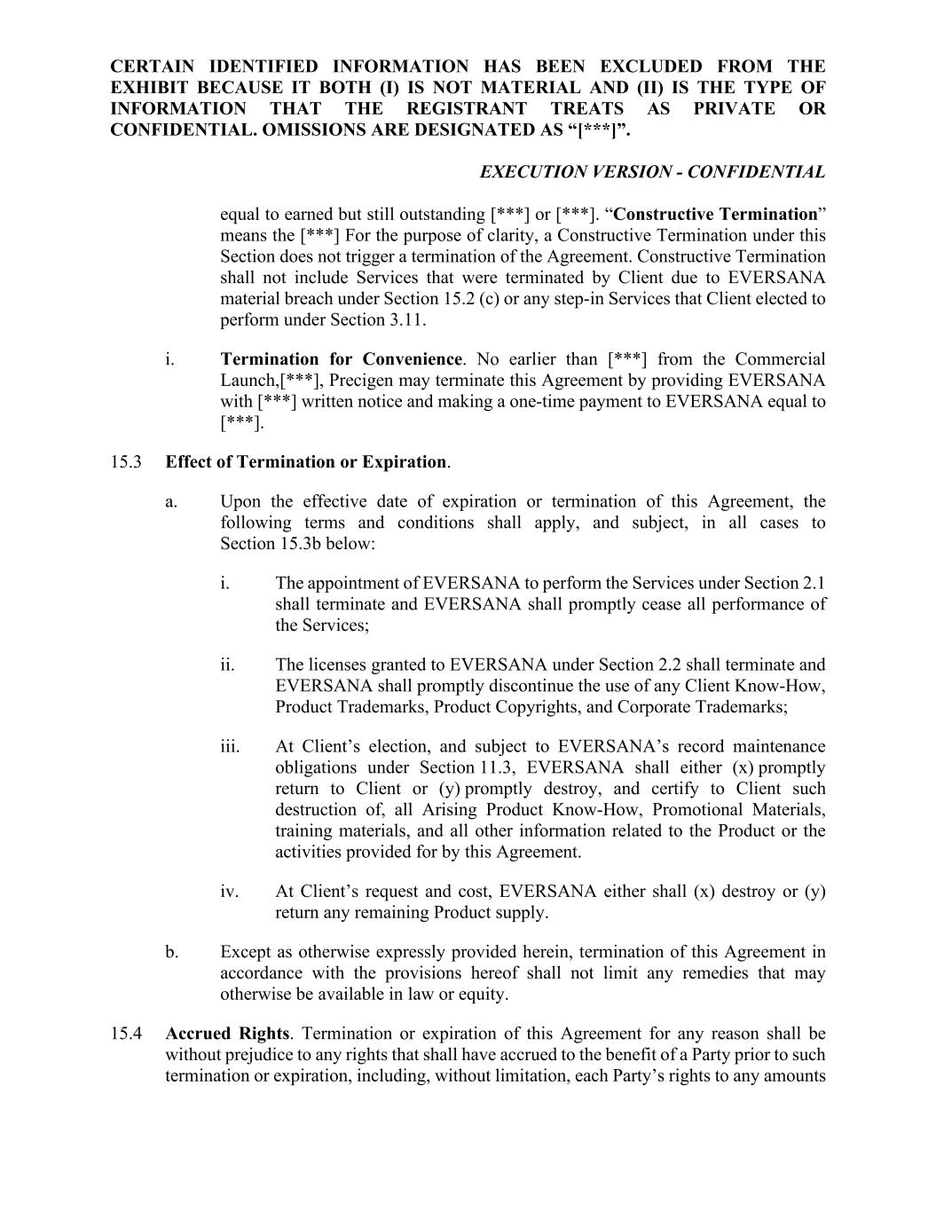
CERTAIN IDENTIFIED INFORMATION HAS BEEN EXCLUDED FROM THE EXHIBIT BECAUSE IT BOTH (I) IS NOT MATERIAL AND (II) IS THE TYPE OF INFORMATION THAT THE REGISTRANT TREATS AS PRIVATE OR CONFIDENTIAL. OMISSIONS ARE DESIGNATED AS “[***]”. EXECUTION VERSION - CONFIDENTIAL equal to earned but still outstanding [***] or [***]. “Constructive Termination” means the [***] For the purpose of clarity, a Constructive Termination under this Section does not trigger a termination of the Agreement. Constructive Termination shall not include Services that were terminated by Client due to EVERSANA material breach under Section 15.2 (c) or any step-in Services that Client elected to perform under Section 3.11. i. Termination for Convenience. No earlier than [***] from the Commercial Launch,[***], Precigen may terminate this Agreement by providing EVERSANA with [***] written notice and making a one-time payment to EVERSANA equal to [***]. 15.3 Effect of Termination or Expiration. a. Upon the effective date of expiration or termination of this Agreement, the following terms and conditions shall apply, and subject, in all cases to Section 15.3b below: i. The appointment of EVERSANA to perform the Services under Section 2.1 shall terminate and EVERSANA shall promptly cease all performance of the Services; ii. The licenses granted to EVERSANA under Section 2.2 shall terminate and EVERSANA shall promptly discontinue the use of any Client Know-How, Product Trademarks, Product Copyrights, and Corporate Trademarks; iii. At Client’s election, and subject to EVERSANA’s record maintenance obligations under Section 11.3, EVERSANA shall either (x) promptly return to Client or (y) promptly destroy, and certify to Client such destruction of, all Arising Product Know-How, Promotional Materials, training materials, and all other information related to the Product or the activities provided for by this Agreement. iv. At Client’s request and cost, EVERSANA either shall (x) destroy or (y) return any remaining Product supply. b. Except as otherwise expressly provided herein, termination of this Agreement in accordance with the provisions hereof shall not limit any remedies that may otherwise be available in law or equity. 15.4 Accrued Rights. Termination or expiration of this Agreement for any reason shall be without prejudice to any rights that shall have accrued to the benefit of a Party prior to such termination or expiration, including, without limitation, each Party’s rights to any amounts

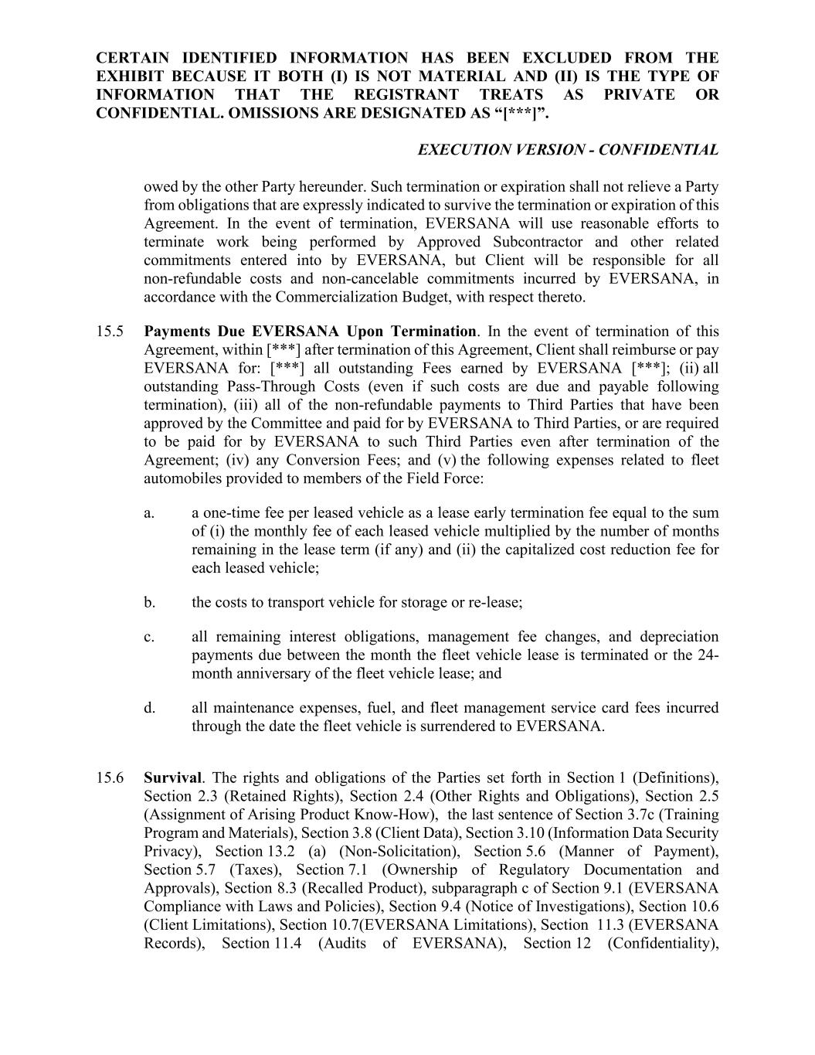
CERTAIN IDENTIFIED INFORMATION HAS BEEN EXCLUDED FROM THE EXHIBIT BECAUSE IT BOTH (I) IS NOT MATERIAL AND (II) IS THE TYPE OF INFORMATION THAT THE REGISTRANT TREATS AS PRIVATE OR CONFIDENTIAL. OMISSIONS ARE DESIGNATED AS “[***]”. EXECUTION VERSION - CONFIDENTIAL owed by the other Party hereunder. Such termination or expiration shall not relieve a Party from obligations that are expressly indicated to survive the termination or expiration of this Agreement. In the event of termination, EVERSANA will use reasonable efforts to terminate work being performed by Approved Subcontractor and other related commitments entered into by EVERSANA, but Client will be responsible for all non-refundable costs and non-cancelable commitments incurred by EVERSANA, in accordance with the Commercialization Budget, with respect thereto. 15.5 Payments Due EVERSANA Upon Termination. In the event of termination of this Agreement, within [***] after termination of this Agreement, Client shall reimburse or pay EVERSANA for: [***] all outstanding Fees earned by EVERSANA [***]; (ii) all outstanding Pass-Through Costs (even if such costs are due and payable following termination), (iii) all of the non-refundable payments to Third Parties that have been approved by the Committee and paid for by EVERSANA to Third Parties, or are required to be paid for by EVERSANA to such Third Parties even after termination of the Agreement; (iv) any Conversion Fees; and (v) the following expenses related to fleet automobiles provided to members of the Field Force: a. a one-time fee per leased vehicle as a lease early termination fee equal to the sum of (i) the monthly fee of each leased vehicle multiplied by the number of months remaining in the lease term (if any) and (ii) the capitalized cost reduction fee for each leased vehicle; b. the costs to transport vehicle for storage or re-lease; c. all remaining interest obligations, management fee changes, and depreciation payments due between the month the fleet vehicle lease is terminated or the 24- month anniversary of the fleet vehicle lease; and d. all maintenance expenses, fuel, and fleet management service card fees incurred through the date the fleet vehicle is surrendered to EVERSANA. 15.6 Survival. The rights and obligations of the Parties set forth in Section 1 (Definitions), Section 2.3 (Retained Rights), Section 2.4 (Other Rights and Obligations), Section 2.5 (Assignment of Arising Product Know-How), the last sentence of Section 3.7c (Training Program and Materials), Section 3.8 (Client Data), Section 3.10 (Information Data Security Privacy), Section 13.2 (a) (Non-Solicitation), Section 5.6 (Manner of Payment), Section 5.7 (Taxes), Section 7.1 (Ownership of Regulatory Documentation and Approvals), Section 8.3 (Recalled Product), subparagraph c of Section 9.1 (EVERSANA Compliance with Laws and Policies), Section 9.4 (Notice of Investigations), Section 10.6 (Client Limitations), Section 10.7(EVERSANA Limitations), Section 11.3 (EVERSANA Records), Section 11.4 (Audits of EVERSANA), Section 12 (Confidentiality),

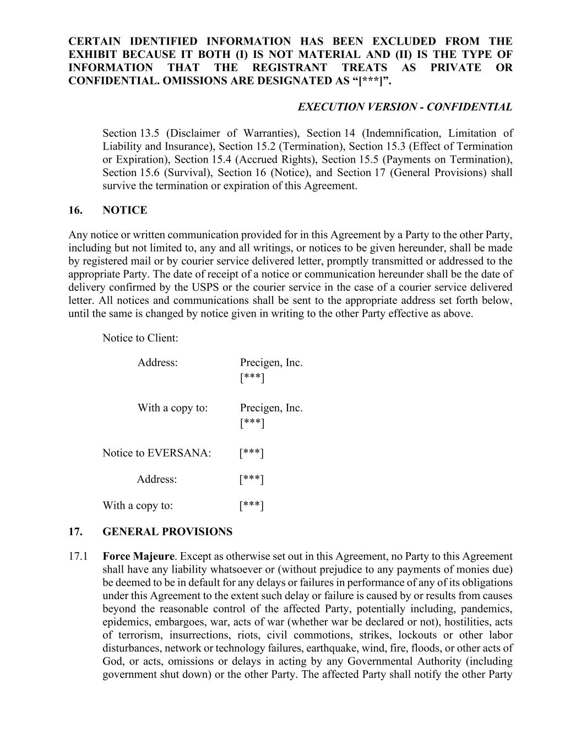
CERTAIN IDENTIFIED INFORMATION HAS BEEN EXCLUDED FROM THE EXHIBIT BECAUSE IT BOTH (I) IS NOT MATERIAL AND (II) IS THE TYPE OF INFORMATION THAT THE REGISTRANT TREATS AS PRIVATE OR CONFIDENTIAL. OMISSIONS ARE DESIGNATED AS “[***]”. EXECUTION VERSION - CONFIDENTIAL Section 13.5 (Disclaimer of Warranties), Section 14 (Indemnification, Limitation of Liability and Insurance), Section 15.2 (Termination), Section 15.3 (Effect of Termination or Expiration), Section 15.4 (Accrued Rights), Section 15.5 (Payments on Termination), Section 15.6 (Survival), Section 16 (Notice), and Section 17 (General Provisions) shall survive the termination or expiration of this Agreement. 16. NOTICE Any notice or written communication provided for in this Agreement by a Party to the other Party, including but not limited to, any and all writings, or notices to be given hereunder, shall be made by registered mail or by courier service delivered letter, promptly transmitted or addressed to the appropriate Party. The date of receipt of a notice or communication hereunder shall be the date of delivery confirmed by the USPS or the courier service in the case of a courier service delivered letter. All notices and communications shall be sent to the appropriate address set forth below, until the same is changed by notice given in writing to the other Party effective as above. Notice to Client: Address: Precigen, Inc. [***] With a copy to: Precigen, Inc. [***] Notice to EVERSANA: [***] Address: [***] With a copy to: [***] 17. GENERAL PROVISIONS 17.1 Force Majeure. Except as otherwise set out in this Agreement, no Party to this Agreement shall have any liability whatsoever or (without prejudice to any payments of monies due) be deemed to be in default for any delays or failures in performance of any of its obligations under this Agreement to the extent such delay or failure is caused by or results from causes beyond the reasonable control of the affected Party, potentially including, pandemics, epidemics, embargoes, war, acts of war (whether war be declared or not), hostilities, acts of terrorism, insurrections, riots, civil commotions, strikes, lockouts or other labor disturbances, network or technology failures, earthquake, wind, fire, floods, or other acts of God, or acts, omissions or delays in acting by any Governmental Authority (including government shut down) or the other Party. The affected Party shall notify the other Party

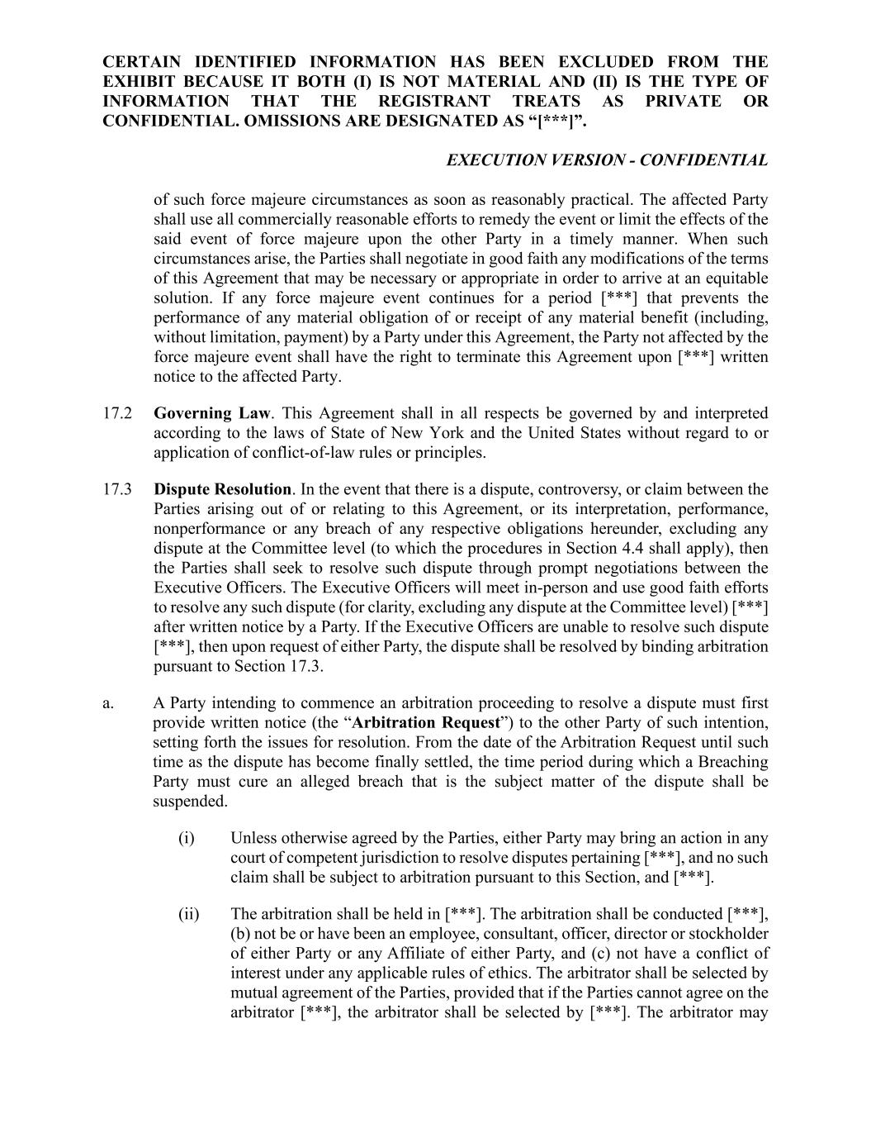
CERTAIN IDENTIFIED INFORMATION HAS BEEN EXCLUDED FROM THE EXHIBIT BECAUSE IT BOTH (I) IS NOT MATERIAL AND (II) IS THE TYPE OF INFORMATION THAT THE REGISTRANT TREATS AS PRIVATE OR CONFIDENTIAL. OMISSIONS ARE DESIGNATED AS “[***]”. EXECUTION VERSION - CONFIDENTIAL of such force majeure circumstances as soon as reasonably practical. The affected Party shall use all commercially reasonable efforts to remedy the event or limit the effects of the said event of force majeure upon the other Party in a timely manner. When such circumstances arise, the Parties shall negotiate in good faith any modifications of the terms of this Agreement that may be necessary or appropriate in order to arrive at an equitable solution. If any force majeure event continues for a period [***] that prevents the performance of any material obligation of or receipt of any material benefit (including, without limitation, payment) by a Party under this Agreement, the Party not affected by the force majeure event shall have the right to terminate this Agreement upon [***] written notice to the affected Party. 17.2 Governing Law. This Agreement shall in all respects be governed by and interpreted according to the laws of State of New York and the United States without regard to or application of conflict-of-law rules or principles. 17.3 Dispute Resolution. In the event that there is a dispute, controversy, or claim between the Parties arising out of or relating to this Agreement, or its interpretation, performance, nonperformance or any breach of any respective obligations hereunder, excluding any dispute at the Committee level (to which the procedures in Section 4.4 shall apply), then the Parties shall seek to resolve such dispute through prompt negotiations between the Executive Officers. The Executive Officers will meet in-person and use good faith efforts to resolve any such dispute (for clarity, excluding any dispute at the Committee level) [***] after written notice by a Party. If the Executive Officers are unable to resolve such dispute [***], then upon request of either Party, the dispute shall be resolved by binding arbitration pursuant to Section 17.3. a. A Party intending to commence an arbitration proceeding to resolve a dispute must first provide written notice (the “Arbitration Request”) to the other Party of such intention, setting forth the issues for resolution. From the date of the Arbitration Request until such time as the dispute has become finally settled, the time period during which a Breaching Party must cure an alleged breach that is the subject matter of the dispute shall be suspended. (i) Unless otherwise agreed by the Parties, either Party may bring an action in any court of competent jurisdiction to resolve disputes pertaining [***], and no such claim shall be subject to arbitration pursuant to this Section, and [***]. (ii) The arbitration shall be held in [***]. The arbitration shall be conducted [***], (b) not be or have been an employee, consultant, officer, director or stockholder of either Party or any Affiliate of either Party, and (c) not have a conflict of interest under any applicable rules of ethics. The arbitrator shall be selected by mutual agreement of the Parties, provided that if the Parties cannot agree on the arbitrator [***], the arbitrator shall be selected by [***]. The arbitrator may

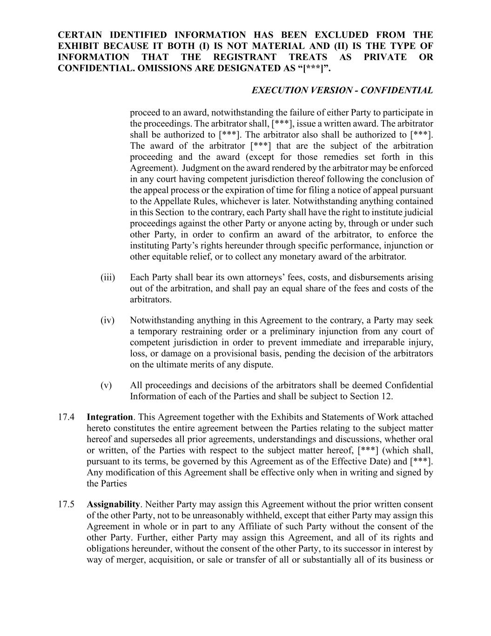
CERTAIN IDENTIFIED INFORMATION HAS BEEN EXCLUDED FROM THE EXHIBIT BECAUSE IT BOTH (I) IS NOT MATERIAL AND (II) IS THE TYPE OF INFORMATION THAT THE REGISTRANT TREATS AS PRIVATE OR CONFIDENTIAL. OMISSIONS ARE DESIGNATED AS “[***]”. EXECUTION VERSION - CONFIDENTIAL proceed to an award, notwithstanding the failure of either Party to participate in the proceedings. The arbitrator shall, [***], issue a written award. The arbitrator shall be authorized to [***]. The arbitrator also shall be authorized to [***]. The award of the arbitrator [***] that are the subject of the arbitration proceeding and the award (except for those remedies set forth in this Agreement). Judgment on the award rendered by the arbitrator may be enforced in any court having competent jurisdiction thereof following the conclusion of the appeal process or the expiration of time for filing a notice of appeal pursuant to the Appellate Rules, whichever is later. Notwithstanding anything contained in this Section to the contrary, each Party shall have the right to institute judicial proceedings against the other Party or anyone acting by, through or under such other Party, in order to confirm an award of the arbitrator, to enforce the instituting Party’s rights hereunder through specific performance, injunction or other equitable relief, or to collect any monetary award of the arbitrator. (iii) Each Party shall bear its own attorneys’ fees, costs, and disbursements arising out of the arbitration, and shall pay an equal share of the fees and costs of the arbitrators. (iv) Notwithstanding anything in this Agreement to the contrary, a Party may seek a temporary restraining order or a preliminary injunction from any court of competent jurisdiction in order to prevent immediate and irreparable injury, loss, or damage on a provisional basis, pending the decision of the arbitrators on the ultimate merits of any dispute. (v) All proceedings and decisions of the arbitrators shall be deemed Confidential Information of each of the Parties and shall be subject to Section 12. 17.4 Integration. This Agreement together with the Exhibits and Statements of Work attached hereto constitutes the entire agreement between the Parties relating to the subject matter hereof and supersedes all prior agreements, understandings and discussions, whether oral or written, of the Parties with respect to the subject matter hereof, [***] (which shall, pursuant to its terms, be governed by this Agreement as of the Effective Date) and [***]. Any modification of this Agreement shall be effective only when in writing and signed by the Parties 17.5 Assignability. Neither Party may assign this Agreement without the prior written consent of the other Party, not to be unreasonably withheld, except that either Party may assign this Agreement in whole or in part to any Affiliate of such Party without the consent of the other Party. Further, either Party may assign this Agreement, and all of its rights and obligations hereunder, without the consent of the other Party, to its successor in interest by way of merger, acquisition, or sale or transfer of all or substantially all of its business or

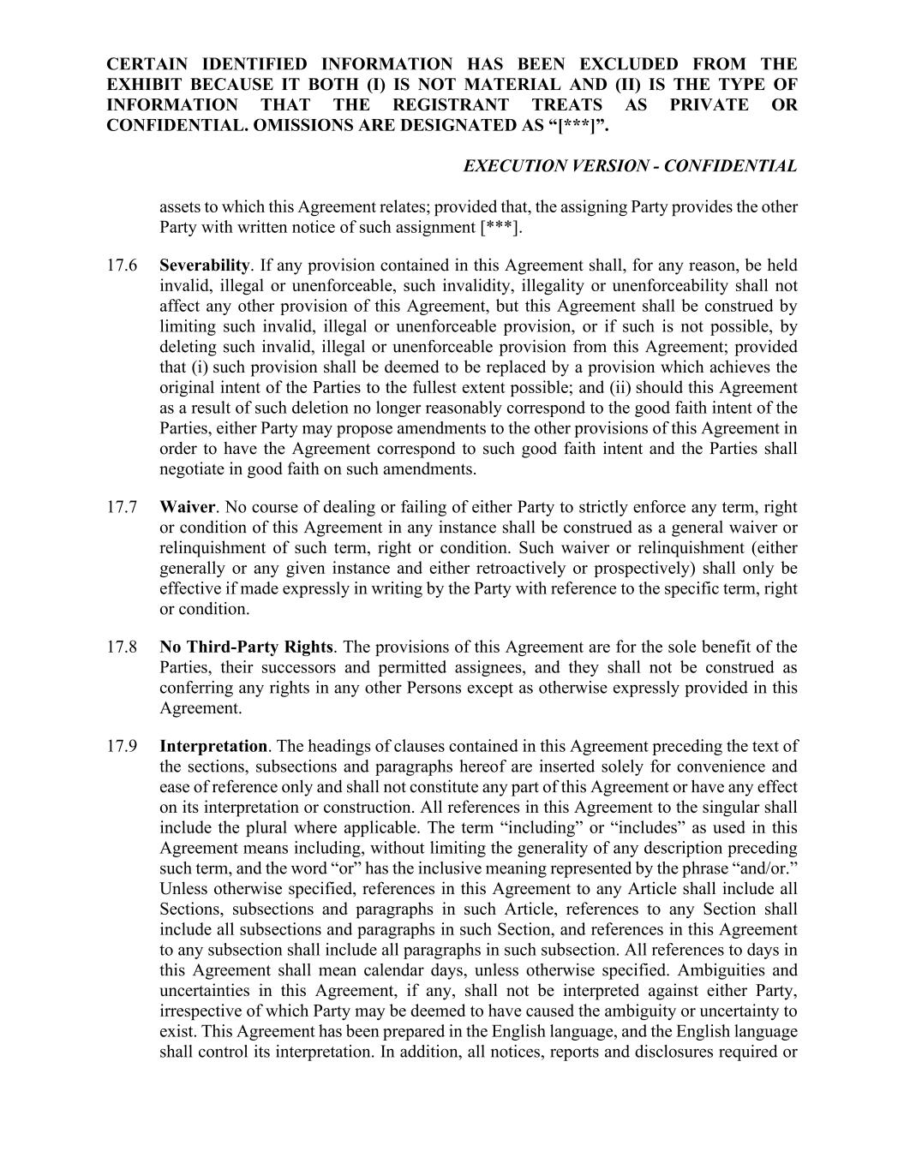
CERTAIN IDENTIFIED INFORMATION HAS BEEN EXCLUDED FROM THE EXHIBIT BECAUSE IT BOTH (I) IS NOT MATERIAL AND (II) IS THE TYPE OF INFORMATION THAT THE REGISTRANT TREATS AS PRIVATE OR CONFIDENTIAL. OMISSIONS ARE DESIGNATED AS “[***]”. EXECUTION VERSION - CONFIDENTIAL assets to which this Agreement relates; provided that, the assigning Party provides the other Party with written notice of such assignment [***]. 17.6 Severability. If any provision contained in this Agreement shall, for any reason, be held invalid, illegal or unenforceable, such invalidity, illegality or unenforceability shall not affect any other provision of this Agreement, but this Agreement shall be construed by limiting such invalid, illegal or unenforceable provision, or if such is not possible, by deleting such invalid, illegal or unenforceable provision from this Agreement; provided that (i) such provision shall be deemed to be replaced by a provision which achieves the original intent of the Parties to the fullest extent possible; and (ii) should this Agreement as a result of such deletion no longer reasonably correspond to the good faith intent of the Parties, either Party may propose amendments to the other provisions of this Agreement in order to have the Agreement correspond to such good faith intent and the Parties shall negotiate in good faith on such amendments. 17.7 Waiver. No course of dealing or failing of either Party to strictly enforce any term, right or condition of this Agreement in any instance shall be construed as a general waiver or relinquishment of such term, right or condition. Such waiver or relinquishment (either generally or any given instance and either retroactively or prospectively) shall only be effective if made expressly in writing by the Party with reference to the specific term, right or condition. 17.8 No Third-Party Rights. The provisions of this Agreement are for the sole benefit of the Parties, their successors and permitted assignees, and they shall not be construed as conferring any rights in any other Persons except as otherwise expressly provided in this Agreement. 17.9 Interpretation. The headings of clauses contained in this Agreement preceding the text of the sections, subsections and paragraphs hereof are inserted solely for convenience and ease of reference only and shall not constitute any part of this Agreement or have any effect on its interpretation or construction. All references in this Agreement to the singular shall include the plural where applicable. The term “including” or “includes” as used in this Agreement means including, without limiting the generality of any description preceding such term, and the word “or” has the inclusive meaning represented by the phrase “and/or.” Unless otherwise specified, references in this Agreement to any Article shall include all Sections, subsections and paragraphs in such Article, references to any Section shall include all subsections and paragraphs in such Section, and references in this Agreement to any subsection shall include all paragraphs in such subsection. All references to days in this Agreement shall mean calendar days, unless otherwise specified. Ambiguities and uncertainties in this Agreement, if any, shall not be interpreted against either Party, irrespective of which Party may be deemed to have caused the ambiguity or uncertainty to exist. This Agreement has been prepared in the English language, and the English language shall control its interpretation. In addition, all notices, reports and disclosures required or

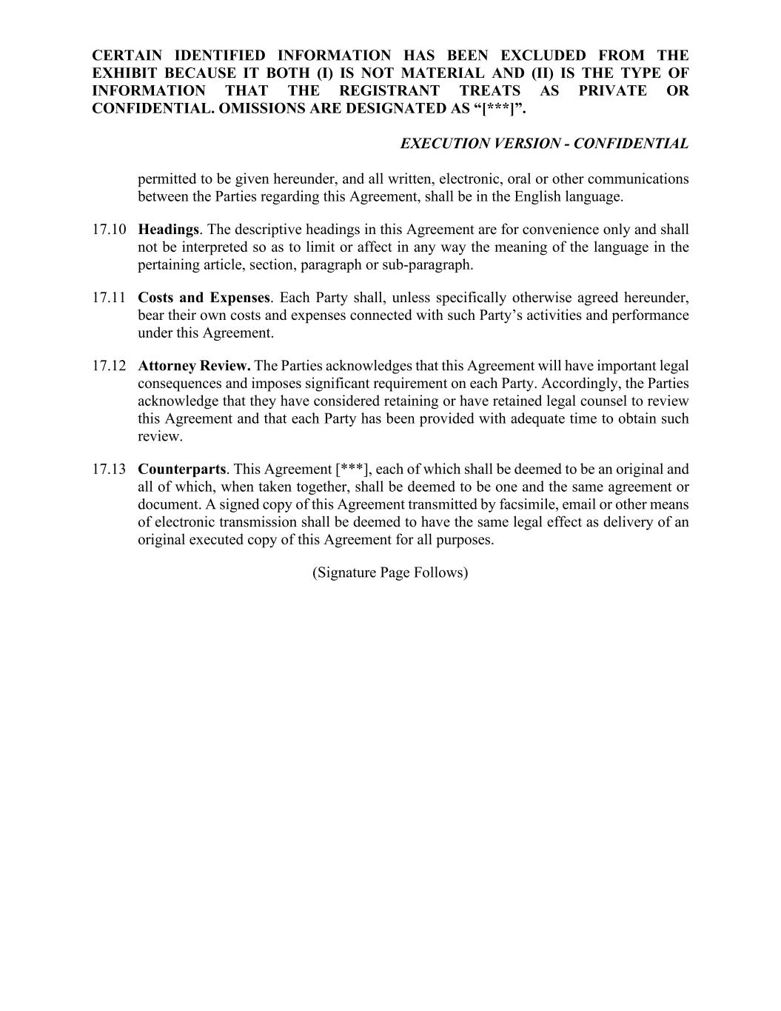
CERTAIN IDENTIFIED INFORMATION HAS BEEN EXCLUDED FROM THE EXHIBIT BECAUSE IT BOTH (I) IS NOT MATERIAL AND (II) IS THE TYPE OF INFORMATION THAT THE REGISTRANT TREATS AS PRIVATE OR CONFIDENTIAL. OMISSIONS ARE DESIGNATED AS “[***]”. EXECUTION VERSION - CONFIDENTIAL permitted to be given hereunder, and all written, electronic, oral or other communications between the Parties regarding this Agreement, shall be in the English language. 17.10 Headings. The descriptive headings in this Agreement are for convenience only and shall not be interpreted so as to limit or affect in any way the meaning of the language in the pertaining article, section, paragraph or sub-paragraph. 17.11 Costs and Expenses. Each Party shall, unless specifically otherwise agreed hereunder, bear their own costs and expenses connected with such Party’s activities and performance under this Agreement. 17.12 Attorney Review. The Parties acknowledges that this Agreement will have important legal consequences and imposes significant requirement on each Party. Accordingly, the Parties acknowledge that they have considered retaining or have retained legal counsel to review this Agreement and that each Party has been provided with adequate time to obtain such review. 17.13 Counterparts. This Agreement [***], each of which shall be deemed to be an original and all of which, when taken together, shall be deemed to be one and the same agreement or document. A signed copy of this Agreement transmitted by facsimile, email or other means of electronic transmission shall be deemed to have the same legal effect as delivery of an original executed copy of this Agreement for all purposes. (Signature Page Follows)

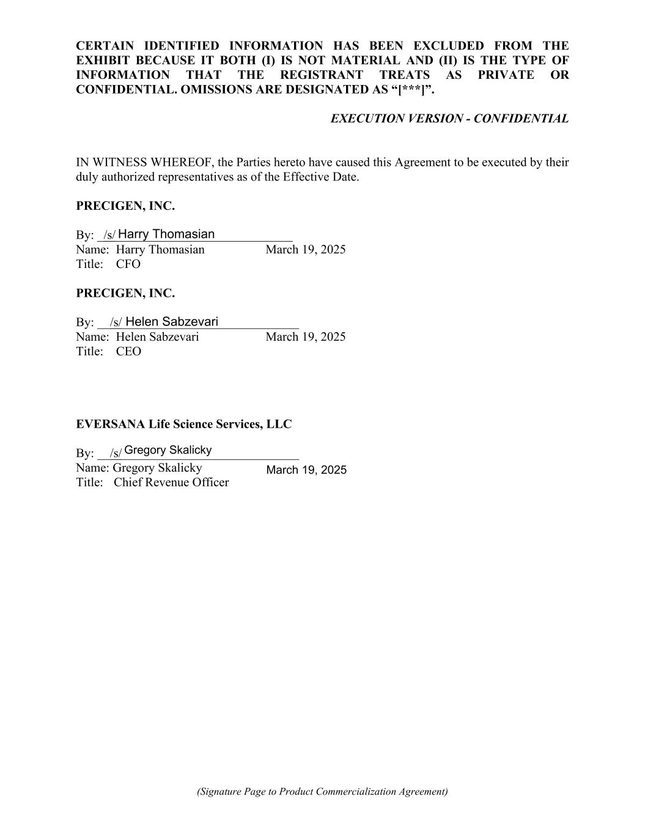
CERTAIN IDENTIFIED INFORMATION HAS BEEN EXCLUDED FROM THE EXHIBIT BECAUSE IT BOTH (I) IS NOT MATERIAL AND (II) IS THE TYPE OF INFORMATION THAT THE REGISTRANT TREATS AS PRIVATE OR CONFIDENTIAL. OMISSIONS ARE DESIGNATED AS “[***]”. EXECUTION VERSION - CONFIDENTIAL IN WITNESS WHEREOF, the Parties hereto have caused this Agreement to be executed by their duly authorized representatives as of the Effective Date. PRECIGEN, INC. By: _/s/____________________________ Name: Harry Thomasian March 19, 2025 Title: CFO PRECIGEN, INC. By: __/s/____________________________ Name: Helen Sabzevari March 19, 2025 Title: CEO EVERSANA Life Science Services, LLC By: __/s/____________________________ Name: Gregory Skalicky Title: Chief Revenue Officer (Signature Page to Product Commercialization Agreement) Harry Thomasian Helen Sabzevari Gregory Skalicky March 19, 2025


CERTAIN IDENTIFIED INFORMATION HAS BEEN EXCLUDED FROM THE EXHIBIT BECAUSE IT BOTH (I) IS NOT MATERIAL AND (II) IS THE TYPE OF INFORMATION THAT THE REGISTRANT TREATS AS PRIVATE OR CONFIDENTIAL. OMISSIONS ARE DESIGNATED AS “[***]”. EXECUTION VERSION - CONFIDENTIAL EXHIBIT A [***]


CERTAIN IDENTIFIED INFORMATION HAS BEEN EXCLUDED FROM THE EXHIBIT BECAUSE IT BOTH (I) IS NOT MATERIAL AND (II) IS THE TYPE OF INFORMATION THAT THE REGISTRANT TREATS AS PRIVATE OR CONFIDENTIAL. OMISSIONS ARE DESIGNATED AS “[***]”. EXECUTION VERSION - CONFIDENTIAL EXHIBIT B [***]


CERTAIN IDENTIFIED INFORMATION HAS BEEN EXCLUDED FROM THE EXHIBIT BECAUSE IT BOTH (I) IS NOT MATERIAL AND (II) IS THE TYPE OF INFORMATION THAT THE REGISTRANT TREATS AS PRIVATE OR CONFIDENTIAL. OMISSIONS ARE DESIGNATED AS “[***]”. EXECUTION VERSION - CONFIDENTIAL EXHIBIT C [***]


CERTAIN IDENTIFIED INFORMATION HAS BEEN EXCLUDED FROM THE EXHIBIT BECAUSE IT BOTH (I) IS NOT MATERIAL AND (II) IS THE TYPE OF INFORMATION THAT THE REGISTRANT TREATS AS PRIVATE OR CONFIDENTIAL. OMISSIONS ARE DESIGNATED AS “[***]”. EXECUTION VERSION - CONFIDENTIAL EXHIBIT D [***]


CERTAIN IDENTIFIED INFORMATION HAS BEEN EXCLUDED FROM THE EXHIBIT BECAUSE IT BOTH (I) IS NOT MATERIAL AND (II) IS THE TYPE OF INFORMATION THAT THE REGISTRANT TREATS AS PRIVATE OR CONFIDENTIAL. OMISSIONS ARE DESIGNATED AS “[***]”. EXECUTION VERSION - CONFIDENTIAL EXHIBIT E [***]


CERTAIN IDENTIFIED INFORMATION HAS BEEN EXCLUDED FROM THE EXHIBIT BECAUSE IT BOTH (I) IS NOT MATERIAL AND (II) IS THE TYPE OF INFORMATION THAT THE REGISTRANT TREATS AS PRIVATE OR CONFIDENTIAL. OMISSIONS ARE DESIGNATED AS “[***]”. EXECUTION VERSION - CONFIDENTIAL EXHIBIT F [***]


CERTAIN IDENTIFIED INFORMATION HAS BEEN EXCLUDED FROM THE EXHIBIT BECAUSE IT BOTH (I) IS NOT MATERIAL AND (II) IS THE TYPE OF INFORMATION THAT THE REGISTRANT TREATS AS PRIVATE OR CONFIDENTIAL. OMISSIONS ARE DESIGNATED AS “[***]”. EXECUTION VERSION - CONFIDENTIAL EXHIBIT G [***]

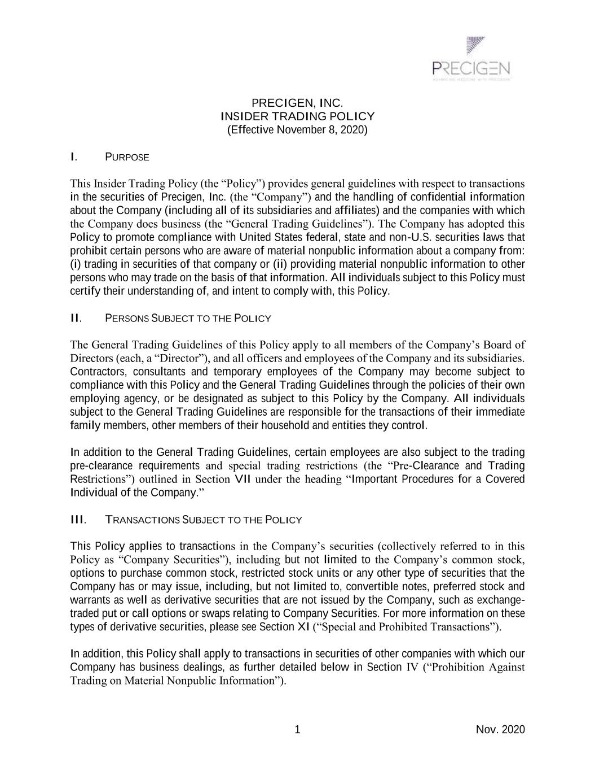
1 Nov. 2020 PRECIGEN, INC. INSIDER TRADING POLICY (Effective November 8, 2020) I. PURPOSE This Insider Trading Policy (the “Policy”) provides general guidelines with respect to transactions in the securities of Precigen, Inc. (the “Company”) and the handling of confidential information about the Company (including all of its subsidiaries and affiliates) and the companies with which the Company does business (the “General Trading Guidelines”). The Company has adopted this Policy to promote compliance with United States federal, state and non-U.S. securities laws that prohibit certain persons who are aware of material nonpublic information about a company from: (i) trading in securities of that company or (ii) providing material nonpublic information to other persons who may trade on the basis of that information. All individuals subject to this Policy must certify their understanding of, and intent to comply with, this Policy. II. PERSONS SUBJECT TO THE POLICY The General Trading Guidelines of this Policy apply to all members of the Company’s Board of Directors (each, a “Director”), and all officers and employees of the Company and its subsidiaries. Contractors, consultants and temporary employees of the Company may become subject to compliance with this Policy and the General Trading Guidelines through the policies of their own employing agency, or be designated as subject to this Policy by the Company. All individuals subject to the General Trading Guidelines are responsible for the transactions of their immediate family members, other members of their household and entities they control. In addition to the General Trading Guidelines, certain employees are also subject to the trading pre-clearance requirements and special trading restrictions (the “Pre-Clearance and Trading Restrictions”) outlined in Section VII under the heading “Important Procedures for a Covered Individual of the Company.” III. TRANSACTIONS SUBJECT TO THE POLICY This Policy applies to transactions in the Company’s securities (collectively referred to in this Policy as “Company Securities”), including but not limited to the Company’s common stock, options to purchase common stock, restricted stock units or any other type of securities that the Company has or may issue, including, but not limited to, convertible notes, preferred stock and warrants as well as derivative securities that are not issued by the Company, such as exchange- traded put or call options or swaps relating to Company Securities. For more information on these types of derivative securities, please see Section XI (“Special and Prohibited Transactions”). In addition, this Policy shall apply to transactions in securities of other companies with which our Company has business dealings, as further detailed below in Section IV (“Prohibition Against Trading on Material Nonpublic Information”).

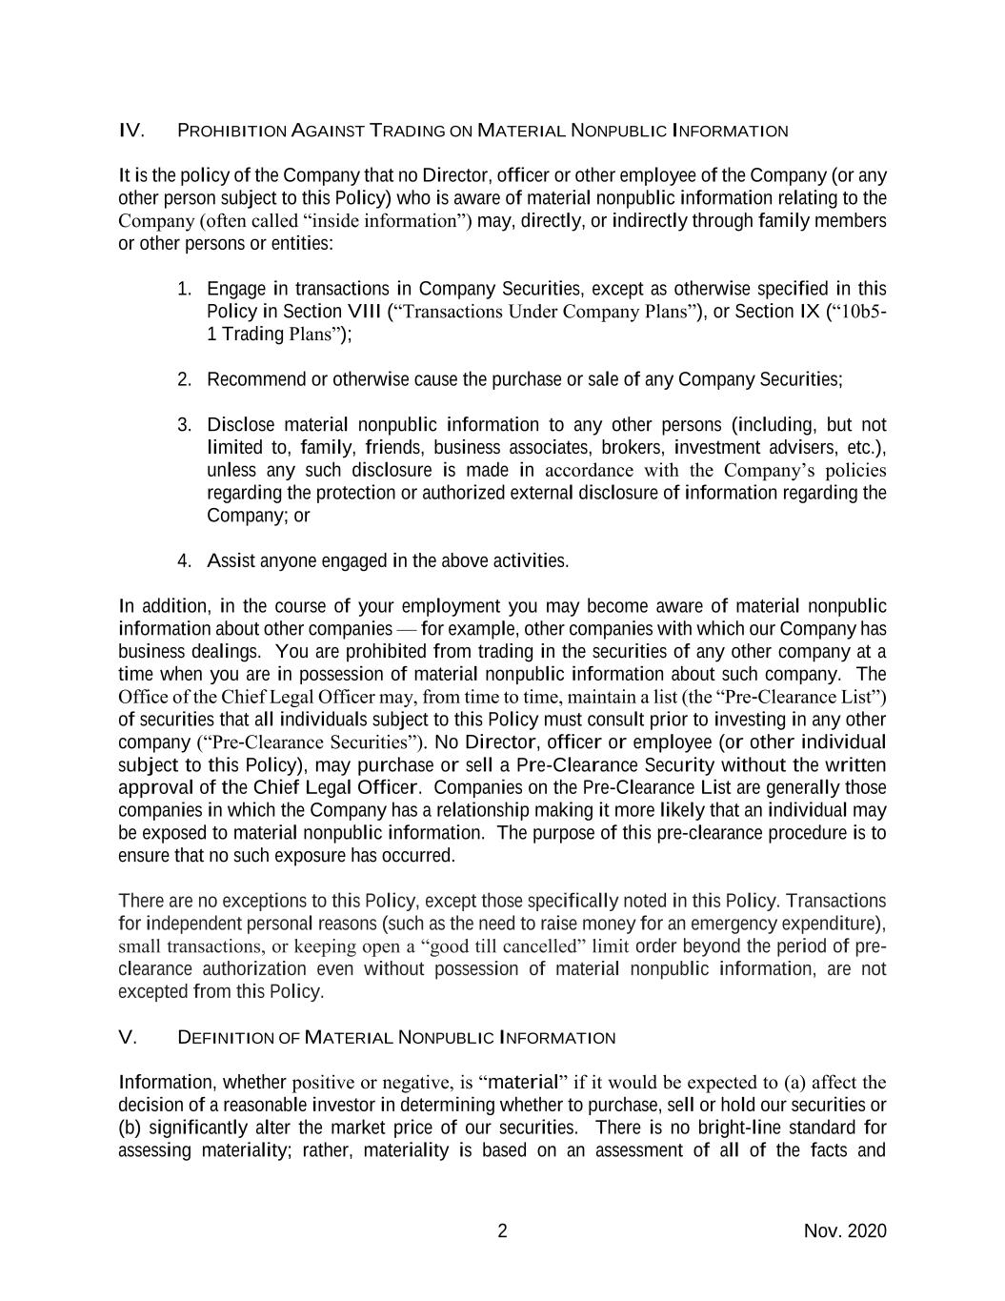
2 Nov. 2020 IV. PROHIBITION AGAINST TRADING ON MATERIAL NONPUBLIC INFORMATION It is the policy of the Company that no Director, officer or other employee of the Company (or any other person subject to this Policy) who is aware of material nonpublic information relating to the Company (often called “inside information”) may, directly, or indirectly through family members or other persons or entities: 1. Engage in transactions in Company Securities, except as otherwise specified in this Policy in Section VIII (“Transactions Under Company Plans”), or Section IX (“10b5- 1 Trading Plans”); 2. Recommend or otherwise cause the purchase or sale of any Company Securities; 3. Disclose material nonpublic information to any other persons (including, but not limited to, family, friends, business associates, brokers, investment advisers, etc.), unless any such disclosure is made in accordance with the Company’s policies regarding the protection or authorized external disclosure of information regarding the Company; or 4. Assist anyone engaged in the above activities. In addition, in the course of your employment you may become aware of material nonpublic information about other companies — for example, other companies with which our Company has business dealings. You are prohibited from trading in the securities of any other company at a time when you are in possession of material nonpublic information about such company. The Office of the Chief Legal Officer may, from time to time, maintain a list (the “Pre-Clearance List”) of securities that all individuals subject to this Policy must consult prior to investing in any other company (“Pre-Clearance Securities”). No Director, officer or employee (or other individual subject to this Policy), may purchase or sell a Pre-Clearance Security without the written approval of the Chief Legal Officer. Companies on the Pre-Clearance List are generally those companies in which the Company has a relationship making it more likely that an individual may be exposed to material nonpublic information. The purpose of this pre-clearance procedure is to ensure that no such exposure has occurred. There are no exceptions to this Policy, except those specifically noted in this Policy. Transactions for independent personal reasons (such as the need to raise money for an emergency expenditure), small transactions, or keeping open a “good till cancelled” limit order beyond the period of pre- clearance authorization even without possession of material nonpublic information, are not excepted from this Policy. V. DEFINITION OF MATERIAL NONPUBLIC INFORMATION Information, whether positive or negative, is “material” if it would be expected to (a) affect the decision of a reasonable investor in determining whether to purchase, sell or hold our securities or (b) significantly alter the market price of our securities. There is no bright-line standard for assessing materiality; rather, materiality is based on an assessment of all of the facts and

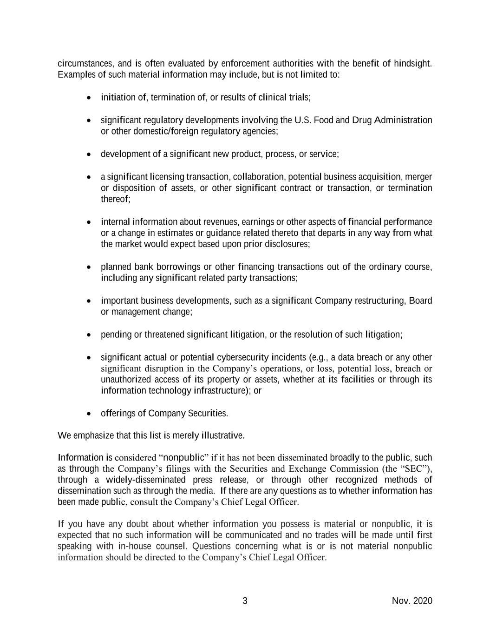
3 Nov. 2020 circumstances, and is often evaluated by enforcement authorities with the benefit of hindsight. Examples of such material information may include, but is not limited to: • initiation of, termination of, or results of clinical trials; • significant regulatory developments involving the U.S. Food and Drug Administration or other domestic/foreign regulatory agencies; • development of a significant new product, process, or service; • a significant licensing transaction, collaboration, potential business acquisition, merger or disposition of assets, or other significant contract or transaction, or termination thereof; • internal information about revenues, earnings or other aspects of financial performance or a change in estimates or guidance related thereto that departs in any way from what the market would expect based upon prior disclosures; • planned bank borrowings or other financing transactions out of the ordinary course, including any significant related party transactions; • important business developments, such as a significant Company restructuring, Board or management change; • pending or threatened significant litigation, or the resolution of such litigation; • significant actual or potential cybersecurity incidents (e.g., a data breach or any other significant disruption in the Company’s operations, or loss, potential loss, breach or unauthorized access of its property or assets, whether at its facilities or through its information technology infrastructure); or • offerings of Company Securities. We emphasize that this list is merely illustrative. Information is considered “nonpublic” if it has not been disseminated broadly to the public, such as through the Company’s filings with the Securities and Exchange Commission (the “SEC”), through a widely-disseminated press release, or through other recognized methods of dissemination such as through the media. If there are any questions as to whether information has been made public, consult the Company’s Chief Legal Officer. If you have any doubt about whether information you possess is material or nonpublic, it is expected that no such information will be communicated and no trades will be made until first speaking with in-house counsel. Questions concerning what is or is not material nonpublic information should be directed to the Company’s Chief Legal Officer.

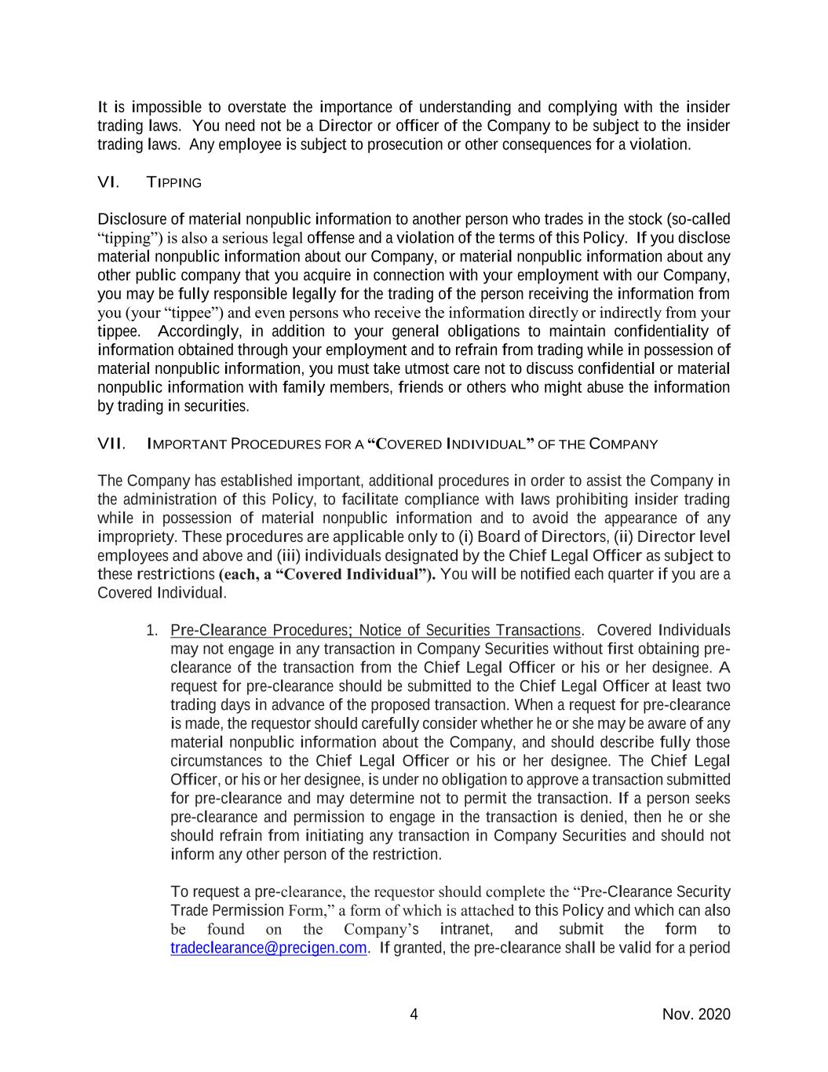
4 Nov. 2020 It is impossible to overstate the importance of understanding and complying with the insider trading laws. You need not be a Director or officer of the Company to be subject to the insider trading laws. Any employee is subject to prosecution or other consequences for a violation. VI. TIPPING Disclosure of material nonpublic information to another person who trades in the stock (so-called “tipping”) is also a serious legal offense and a violation of the terms of this Policy. If you disclose material nonpublic information about our Company, or material nonpublic information about any other public company that you acquire in connection with your employment with our Company, you may be fully responsible legally for the trading of the person receiving the information from you (your “tippee”) and even persons who receive the information directly or indirectly from your tippee. Accordingly, in addition to your general obligations to maintain confidentiality of information obtained through your employment and to refrain from trading while in possession of material nonpublic information, you must take utmost care not to discuss confidential or material nonpublic information with family members, friends or others who might abuse the information by trading in securities. VII. IMPORTANT PROCEDURES FOR A “COVERED INDIVIDUAL” OF THE COMPANY The Company has established important, additional procedures in order to assist the Company in the administration of this Policy, to facilitate compliance with laws prohibiting insider trading while in possession of material nonpublic information and to avoid the appearance of any impropriety. These procedures are applicable only to (i) Board of Directors, (ii) Director level employees and above and (iii) individuals designated by the Chief Legal Officer as subject to these restrictions (each, a “Covered Individual”). You will be notified each quarter if you are a Covered Individual. 1. Pre-Clearance Procedures; Notice of Securities Transactions. Covered Individuals may not engage in any transaction in Company Securities without first obtaining pre- clearance of the transaction from the Chief Legal Officer or his or her designee. A request for pre-clearance should be submitted to the Chief Legal Officer at least two trading days in advance of the proposed transaction. When a request for pre-clearance is made, the requestor should carefully consider whether he or she may be aware of any material nonpublic information about the Company, and should describe fully those circumstances to the Chief Legal Officer or his or her designee. The Chief Legal Officer, or his or her designee, is under no obligation to approve a transaction submitted for pre-clearance and may determine not to permit the transaction. If a person seeks pre-clearance and permission to engage in the transaction is denied, then he or she should refrain from initiating any transaction in Company Securities and should not inform any other person of the restriction. To request a pre-clearance, the requestor should complete the “Pre-Clearance Security Trade Permission Form,” a form of which is attached to this Policy and which can also be found on the Company’s intranet, and submit the form to tradeclearance@precigen.com. If granted, the pre-clearance shall be valid for a period

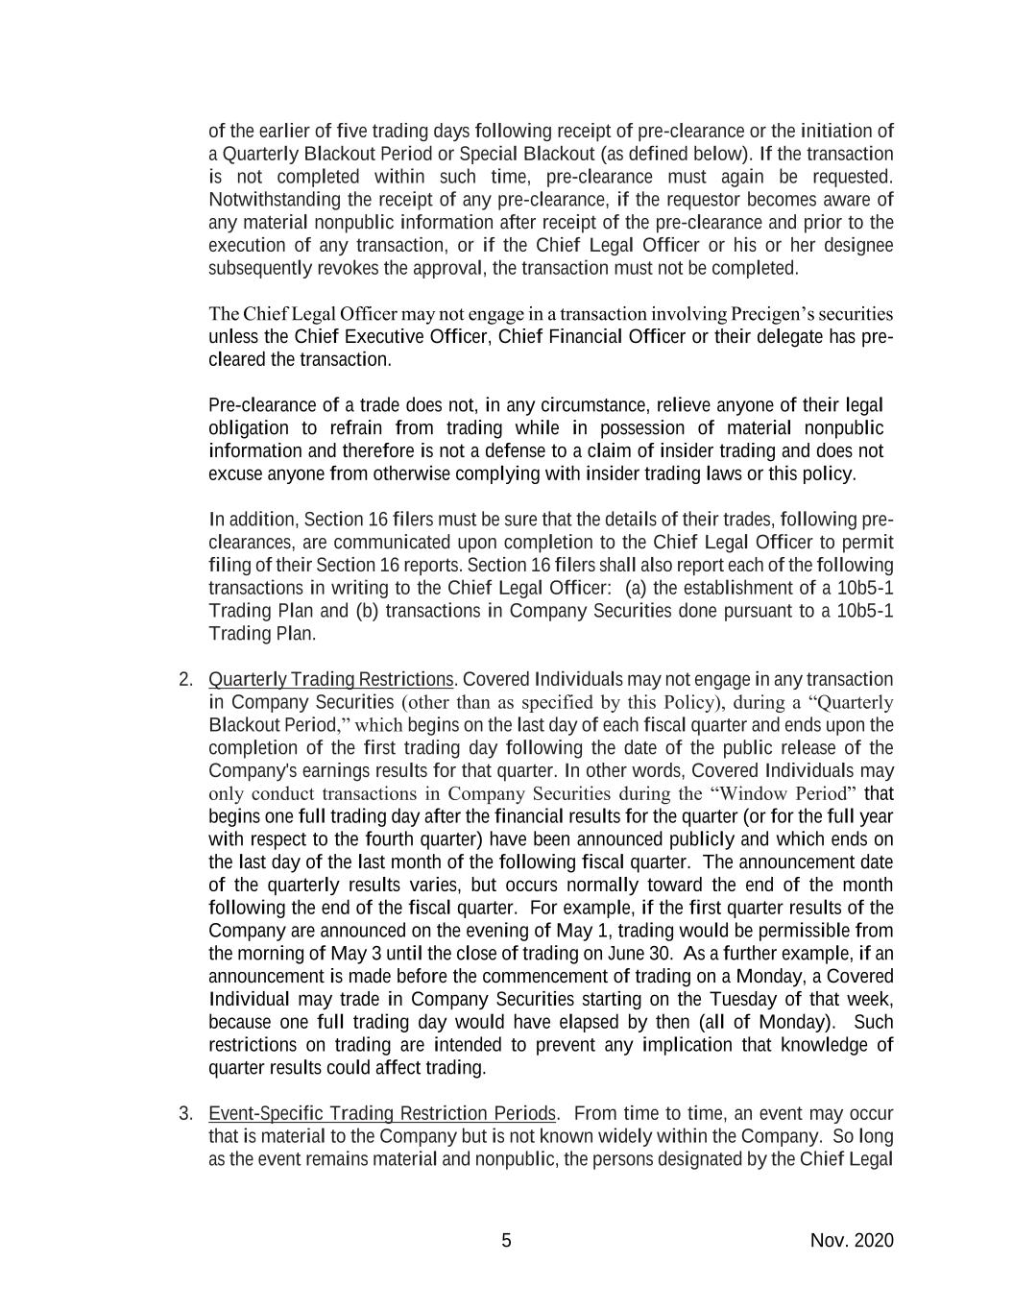
5 Nov. 2020 of the earlier of five trading days following receipt of pre-clearance or the initiation of a Quarterly Blackout Period or Special Blackout (as defined below). If the transaction is not completed within such time, pre-clearance must again be requested. Notwithstanding the receipt of any pre-clearance, if the requestor becomes aware of any material nonpublic information after receipt of the pre-clearance and prior to the execution of any transaction, or if the Chief Legal Officer or his or her designee subsequently revokes the approval, the transaction must not be completed. The Chief Legal Officer may not engage in a transaction involving Precigen’s securities unless the Chief Executive Officer, Chief Financial Officer or their delegate has pre- cleared the transaction. Pre-clearance of a trade does not, in any circumstance, relieve anyone of their legal obligation to refrain from trading while in possession of material nonpublic information and therefore is not a defense to a claim of insider trading and does not excuse anyone from otherwise complying with insider trading laws or this policy. In addition, Section 16 filers must be sure that the details of their trades, following pre- clearances, are communicated upon completion to the Chief Legal Officer to permit filing of their Section 16 reports. Section 16 filers shall also report each of the following transactions in writing to the Chief Legal Officer: (a) the establishment of a 10b5-1 Trading Plan and (b) transactions in Company Securities done pursuant to a 10b5-1 Trading Plan. 2. Quarterly Trading Restrictions. Covered Individuals may not engage in any transaction in Company Securities (other than as specified by this Policy), during a “Quarterly Blackout Period,” which begins on the last day of each fiscal quarter and ends upon the completion of the first trading day following the date of the public release of the Company's earnings results for that quarter. In other words, Covered Individuals may only conduct transactions in Company Securities during the “Window Period” that begins one full trading day after the financial results for the quarter (or for the full year with respect to the fourth quarter) have been announced publicly and which ends on the last day of the last month of the following fiscal quarter. The announcement date of the quarterly results varies, but occurs normally toward the end of the month following the end of the fiscal quarter. For example, if the first quarter results of the Company are announced on the evening of May 1, trading would be permissible from the morning of May 3 until the close of trading on June 30. As a further example, if an announcement is made before the commencement of trading on a Monday, a Covered Individual may trade in Company Securities starting on the Tuesday of that week, because one full trading day would have elapsed by then (all of Monday). Such restrictions on trading are intended to prevent any implication that knowledge of quarter results could affect trading. 3. Event-Specific Trading Restriction Periods. From time to time, an event may occur that is material to the Company but is not known widely within the Company. So long as the event remains material and nonpublic, the persons designated by the Chief Legal

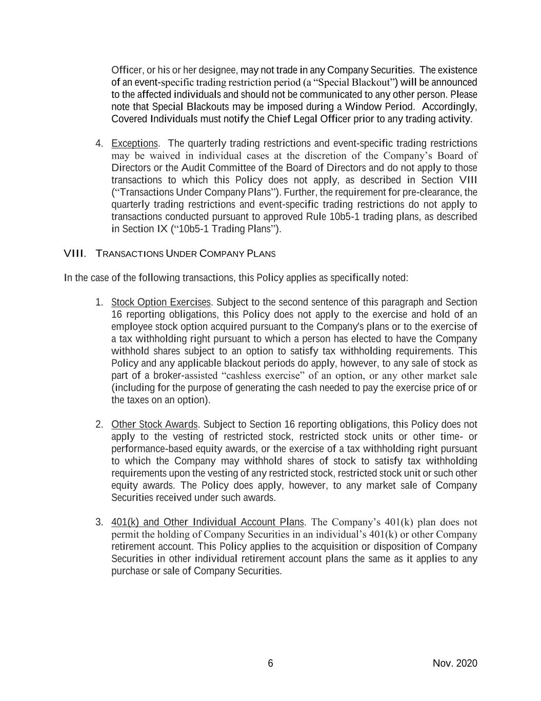
6 Nov. 2020 Officer, or his or her designee, may not trade in any Company Securities. The existence of an event-specific trading restriction period (a “Special Blackout”) will be announced to the affected individuals and should not be communicated to any other person. Please note that Special Blackouts may be imposed during a Window Period. Accordingly, Covered Individuals must notify the Chief Legal Officer prior to any trading activity. 4. Exceptions. The quarterly trading restrictions and event-specific trading restrictions may be waived in individual cases at the discretion of the Company’s Board of Directors or the Audit Committee of the Board of Directors and do not apply to those transactions to which this Policy does not apply, as described in Section VIII (“Transactions Under Company Plans”). Further, the requirement for pre-clearance, the quarterly trading restrictions and event-specific trading restrictions do not apply to transactions conducted pursuant to approved Rule 10b5-1 trading plans, as described in Section IX (“10b5-1 Trading Plans”). VIII. TRANSACTIONS UNDER COMPANY PLANS In the case of the following transactions, this Policy applies as specifically noted: 1. Stock Option Exercises. Subject to the second sentence of this paragraph and Section 16 reporting obligations, this Policy does not apply to the exercise and hold of an employee stock option acquired pursuant to the Company's plans or to the exercise of a tax withholding right pursuant to which a person has elected to have the Company withhold shares subject to an option to satisfy tax withholding requirements. This Policy and any applicable blackout periods do apply, however, to any sale of stock as part of a broker-assisted “cashless exercise” of an option, or any other market sale (including for the purpose of generating the cash needed to pay the exercise price of or the taxes on an option). 2. Other Stock Awards. Subject to Section 16 reporting obligations, this Policy does not apply to the vesting of restricted stock, restricted stock units or other time- or performance-based equity awards, or the exercise of a tax withholding right pursuant to which the Company may withhold shares of stock to satisfy tax withholding requirements upon the vesting of any restricted stock, restricted stock unit or such other equity awards. The Policy does apply, however, to any market sale of Company Securities received under such awards. 3. 401(k) and Other Individual Account Plans. The Company’s 401(k) plan does not permit the holding of Company Securities in an individual’s 401(k) or other Company retirement account. This Policy applies to the acquisition or disposition of Company Securities in other individual retirement account plans the same as it applies to any purchase or sale of Company Securities.

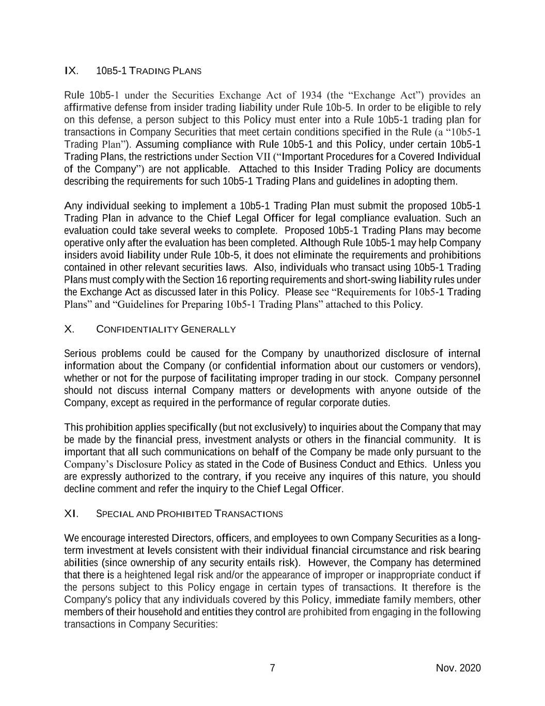
7 Nov. 2020 IX. 10B5-1 TRADING PLANS Rule 10b5-1 under the Securities Exchange Act of 1934 (the “Exchange Act”) provides an affirmative defense from insider trading liability under Rule 10b-5. In order to be eligible to rely on this defense, a person subject to this Policy must enter into a Rule 10b5-1 trading plan for transactions in Company Securities that meet certain conditions specified in the Rule (a “10b5-1 Trading Plan”). Assuming compliance with Rule 10b5-1 and this Policy, under certain 10b5-1 Trading Plans, the restrictions under Section VII (“Important Procedures for a Covered Individual of the Company”) are not applicable. Attached to this Insider Trading Policy are documents describing the requirements for such 10b5-1 Trading Plans and guidelines in adopting them. Any individual seeking to implement a 10b5-1 Trading Plan must submit the proposed 10b5-1 Trading Plan in advance to the Chief Legal Officer for legal compliance evaluation. Such an evaluation could take several weeks to complete. Proposed 10b5-1 Trading Plans may become operative only after the evaluation has been completed. Although Rule 10b5-1 may help Company insiders avoid liability under Rule 10b-5, it does not eliminate the requirements and prohibitions contained in other relevant securities laws. Also, individuals who transact using 10b5-1 Trading Plans must comply with the Section 16 reporting requirements and short-swing liability rules under the Exchange Act as discussed later in this Policy. Please see “Requirements for 10b5-1 Trading Plans” and “Guidelines for Preparing 10b5-1 Trading Plans” attached to this Policy. X. CONFIDENTIALITY GENERALLY Serious problems could be caused for the Company by unauthorized disclosure of internal information about the Company (or confidential information about our customers or vendors), whether or not for the purpose of facilitating improper trading in our stock. Company personnel should not discuss internal Company matters or developments with anyone outside of the Company, except as required in the performance of regular corporate duties. This prohibition applies specifically (but not exclusively) to inquiries about the Company that may be made by the financial press, investment analysts or others in the financial community. It is important that all such communications on behalf of the Company be made only pursuant to the Company’s Disclosure Policy as stated in the Code of Business Conduct and Ethics. Unless you are expressly authorized to the contrary, if you receive any inquires of this nature, you should decline comment and refer the inquiry to the Chief Legal Officer. XI. SPECIAL AND PROHIBITED TRANSACTIONS We encourage interested Directors, officers, and employees to own Company Securities as a long- term investment at levels consistent with their individual financial circumstance and risk bearing abilities (since ownership of any security entails risk). However, the Company has determined that there is a heightened legal risk and/or the appearance of improper or inappropriate conduct if the persons subject to this Policy engage in certain types of transactions. It therefore is the Company's policy that any individuals covered by this Policy, immediate family members, other members of their household and entities they control are prohibited from engaging in the following transactions in Company Securities:

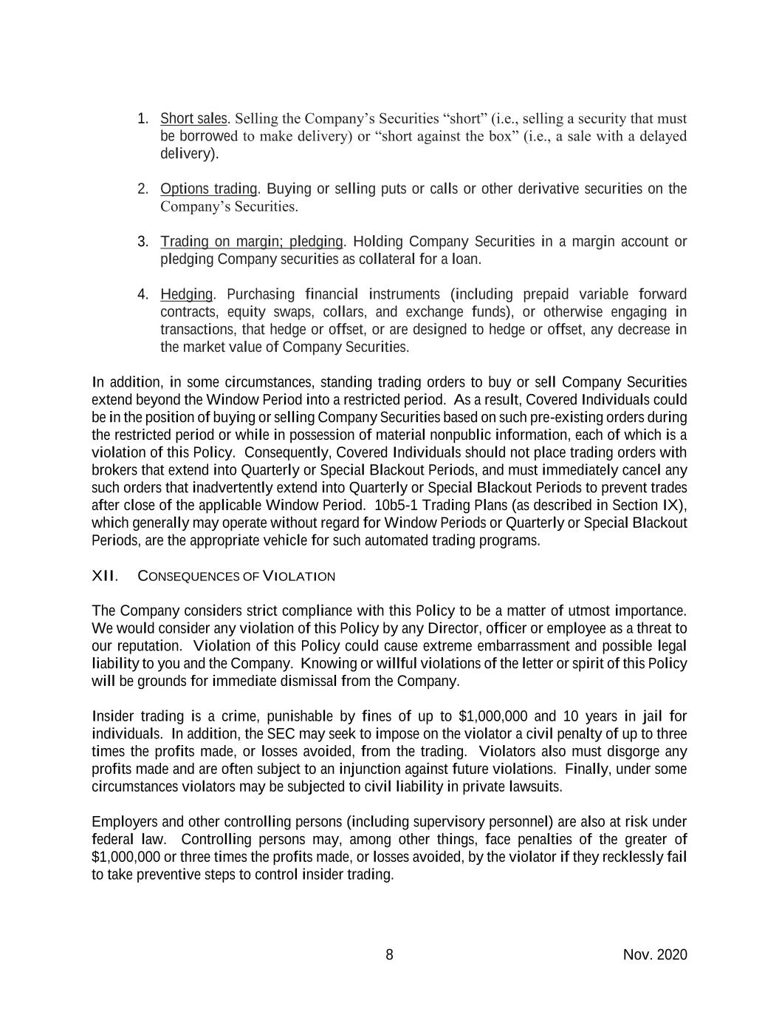
8 Nov. 2020 1. Short sales. Selling the Company’s Securities “short” (i.e., selling a security that must be borrowed to make delivery) or “short against the box” (i.e., a sale with a delayed delivery). 2. Options trading. Buying or selling puts or calls or other derivative securities on the Company’s Securities. 3. Trading on margin; pledging. Holding Company Securities in a margin account or pledging Company securities as collateral for a loan. 4. Hedging. Purchasing financial instruments (including prepaid variable forward contracts, equity swaps, collars, and exchange funds), or otherwise engaging in transactions, that hedge or offset, or are designed to hedge or offset, any decrease in the market value of Company Securities. In addition, in some circumstances, standing trading orders to buy or sell Company Securities extend beyond the Window Period into a restricted period. As a result, Covered Individuals could be in the position of buying or selling Company Securities based on such pre-existing orders during the restricted period or while in possession of material nonpublic information, each of which is a violation of this Policy. Consequently, Covered Individuals should not place trading orders with brokers that extend into Quarterly or Special Blackout Periods, and must immediately cancel any such orders that inadvertently extend into Quarterly or Special Blackout Periods to prevent trades after close of the applicable Window Period. 10b5-1 Trading Plans (as described in Section IX), which generally may operate without regard for Window Periods or Quarterly or Special Blackout Periods, are the appropriate vehicle for such automated trading programs. XII. CONSEQUENCES OF VIOLATION The Company considers strict compliance with this Policy to be a matter of utmost importance. We would consider any violation of this Policy by any Director, officer or employee as a threat to our reputation. Violation of this Policy could cause extreme embarrassment and possible legal liability to you and the Company. Knowing or willful violations of the letter or spirit of this Policy will be grounds for immediate dismissal from the Company. Insider trading is a crime, punishable by fines of up to $1,000,000 and 10 years in jail for individuals. In addition, the SEC may seek to impose on the violator a civil penalty of up to three times the profits made, or losses avoided, from the trading. Violators also must disgorge any profits made and are often subject to an injunction against future violations. Finally, under some circumstances violators may be subjected to civil liability in private lawsuits. Employers and other controlling persons (including supervisory personnel) are also at risk under federal law. Controlling persons may, among other things, face penalties of the greater of $1,000,000 or three times the profits made, or losses avoided, by the violator if they recklessly fail to take preventive steps to control insider trading.

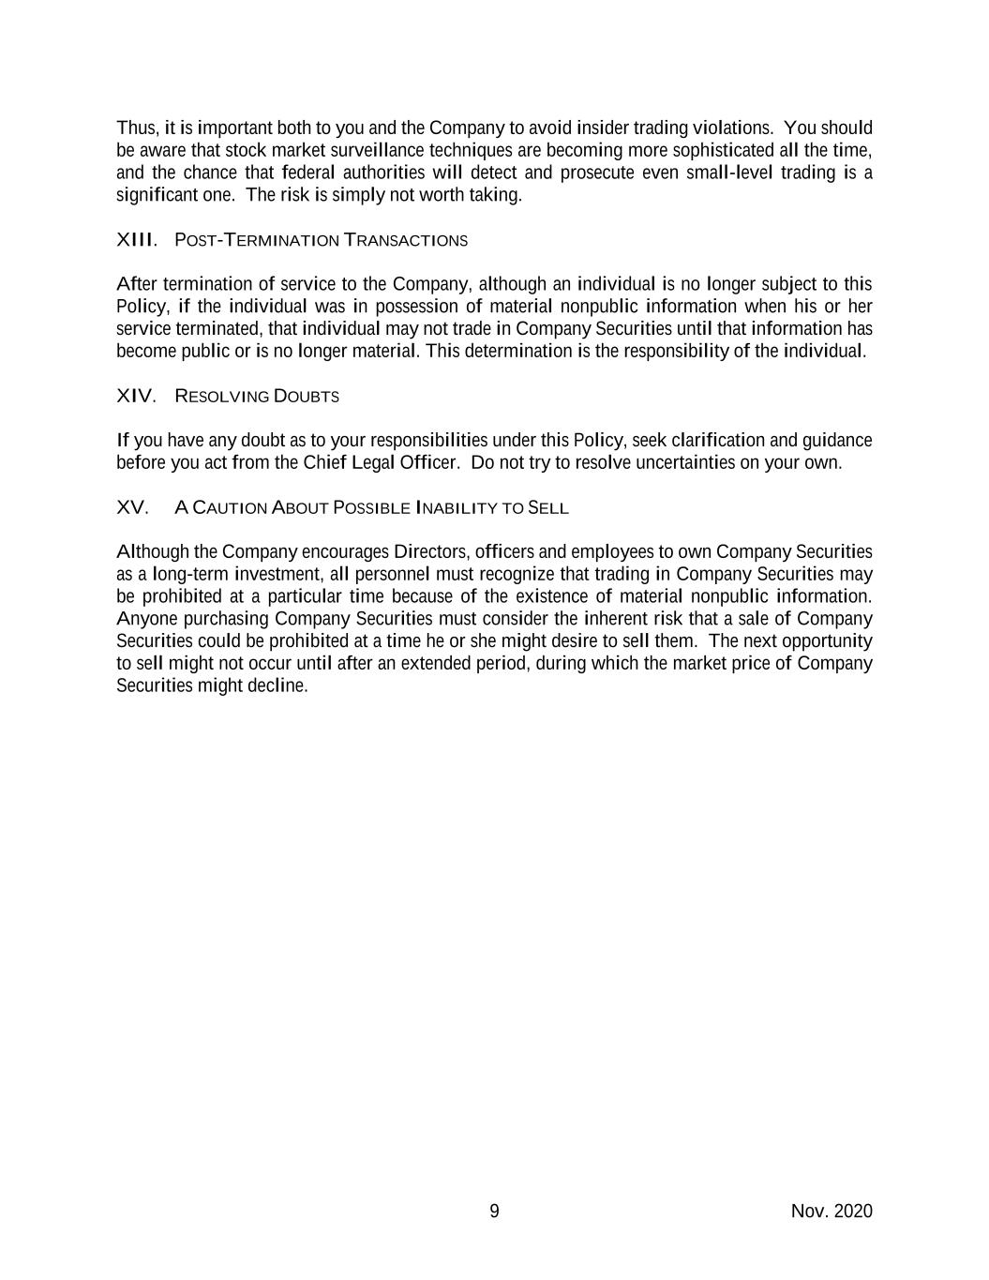
9 Nov. 2020 Thus, it is important both to you and the Company to avoid insider trading violations. You should be aware that stock market surveillance techniques are becoming more sophisticated all the time, and the chance that federal authorities will detect and prosecute even small-level trading is a significant one. The risk is simply not worth taking. XIII. POST-TERMINATION TRANSACTIONS After termination of service to the Company, although an individual is no longer subject to this Policy, if the individual was in possession of material nonpublic information when his or her service terminated, that individual may not trade in Company Securities until that information has become public or is no longer material. This determination is the responsibility of the individual. XIV. RESOLVING DOUBTS If you have any doubt as to your responsibilities under this Policy, seek clarification and guidance before you act from the Chief Legal Officer. Do not try to resolve uncertainties on your own. XV. A CAUTION ABOUT POSSIBLE INABILITY TO SELL Although the Company encourages Directors, officers and employees to own Company Securities as a long-term investment, all personnel must recognize that trading in Company Securities may be prohibited at a particular time because of the existence of material nonpublic information. Anyone purchasing Company Securities must consider the inherent risk that a sale of Company Securities could be prohibited at a time he or she might desire to sell them. The next opportunity to sell might not occur until after an extended period, during which the market price of Company Securities might decline.

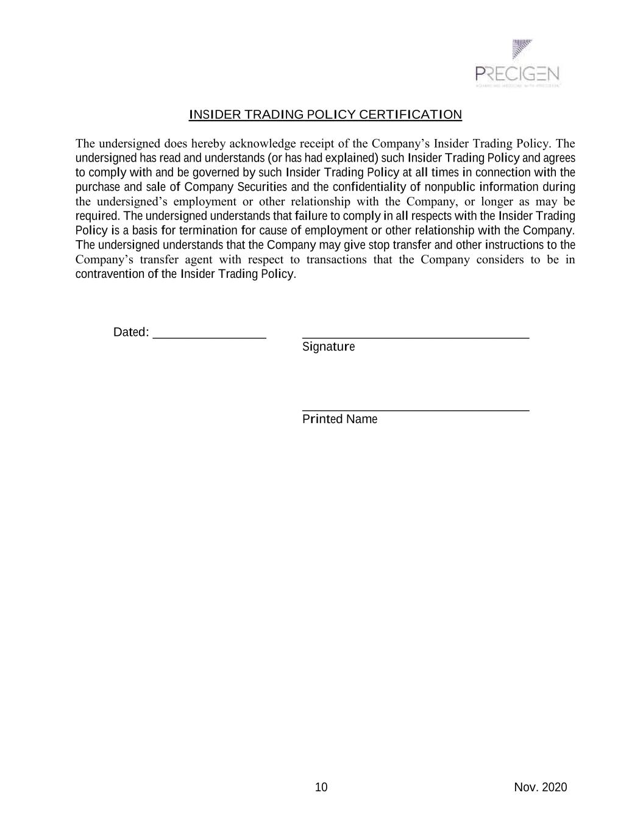
10 Nov. 2020 INSIDER TRADING POLICY CERTIFICATION The undersigned does hereby acknowledge receipt of the Company’s Insider Trading Policy. The undersigned has read and understands (or has had explained) such Insider Trading Policy and agrees to comply with and be governed by such Insider Trading Policy at all times in connection with the purchase and sale of Company Securities and the confidentiality of nonpublic information during the undersigned’s employment or other relationship with the Company, or longer as may be required. The undersigned understands that failure to comply in all respects with the Insider Trading Policy is a basis for termination for cause of employment or other relationship with the Company. The undersigned understands that the Company may give stop transfer and other instructions to the Company’s transfer agent with respect to transactions that the Company considers to be in contravention of the Insider Trading Policy. Dated: __________________ ____________________________________ Signature ____________________________________ Printed Name

Exhibit 21.1
List of Subsidiaries of Precigen, Inc.

Domestic
Exemplar Genetics, LLC |  |  | Iowa
Precigen ActoBio, Inc. |  |  | Delaware
Precigen ActoBio Holdings, Inc. |  |  | Delaware
International
ActoBio Laboratories Belgium BVBA (besloten vennootschap met beperkte aansprakelijkheid) |  |  | Belgium
Intrexon ActoBiotics NV (naamloze vennootschap) |  |  | Belgium

Exhibit 23.1
CONSENT OF INDEPENDENT REGISTERED PUBLIC ACCOUNTING FIRM
We consent to the incorporation by reference in Registration Statement No. 333-276337 on Form S-3 and Registration Statement Nos. 333-190614, 333-196840, 333-205642, 333-213065, 333-219874, 333-226821, 333-233209, 333-233211, 333-239367, and 333-273155 on Form S-8 of our report dated March 19, 2025, relating to the financial statements of Precigen, Inc. appearing in this Annual Report on Form 10-K for the year ended December 31, 2024.
/s/ Deloitte & Touche LLP
Baltimore, Maryland
March 19, 2025

Exhibit 31.1
CERTIFICATION OF PRINCIPAL EXECUTIVE OFFICER PURSUANT TO
SECTION 302 OF THE SARBANES-OXLEY ACT OF 2002
I, Helen Sabzevari, certify that:
1.I have reviewed this Annual Report on Form 10-K of Precigen, Inc.;
2.Based on my knowledge, this report does not contain any untrue statement of a material fact or omit to state a material fact necessary to make the statements made, in light of the circumstances under which such statements were made, not misleading with respect to the period covered by this report;
3.Based on my knowledge, the financial statements, and other financial information included in this report, fairly present in all material respects the financial condition, results of operations and cash flows of the registrant as of, and for, the periods presented in this report;
4.The registrant’s other certifying officer and I are responsible for establishing and maintaining disclosure controls and procedures (as defined in Exchange Act Rules 13a-15(e) and 15d-15(e)) and internal control over financial reporting (as defined in Exchange Act Rules 13a-15(f) and 15d-15(f)) for the registrant and have:
a.Designed such disclosure controls and procedures, or caused such disclosure controls and procedures to be designed under our supervision, to ensure that material information relating to the registrant, including its consolidated subsidiaries, is made known to us by others within those entities, particularly during the period in which this report is being prepared;
b.Designed such internal control over financial reporting, or caused such internal control over financial reporting to be designed under our supervision, to provide reasonable assurance regarding the reliability of financial reporting and the preparation of financial statements for external purposes in accordance with generally accepted accounting principles;
c.Evaluated the effectiveness of the registrant’s disclosure controls and procedures and presented in this report our conclusions about the effectiveness of the disclosure controls and procedures, as of the end of the period covered by this report based on such evaluation; and
d.Disclosed in this report any change in the registrant’s internal control over financial reporting that occurred during the registrant’s most recent fiscal quarter (the registrant’s fourth fiscal quarter in the case of an annual report) that has materially affected, or is reasonably likely to materially affect, the registrant’s internal control over financial reporting; and
5.The registrant’s other certifying officer and I have disclosed, based on our most recent evaluation of internal control over financial reporting, to the registrant’s auditors and the audit committee of the registrant’s board of directors (or persons performing the equivalent functions):
a.All significant deficiencies and material weaknesses in the design or operation of internal control over financial reporting which are reasonably likely to adversely affect the registrant’s ability to record, process, summarize and report financial information; and
b.Any fraud, whether or not material, that involves management or other employees who have a significant role in the registrant’s internal control over financial reporting.
Date: March 19, 2025

/s/ HELEN SABZEVARI
Helen Sabzevari
Chief Executive Officer and Director
(Principal Executive Officer)

Exhibit 31.2
CERTIFICATION OF PRINCIPAL FINANCIAL OFFICER PURSUANT TO
SECTION 302 OF THE SARBANES-OXLEY ACT OF 2002
I, Harry Thomasian Jr., certify that:
1.I have reviewed this Annual Report on Form 10-K of Precigen, Inc.;
2.Based on my knowledge, this report does not contain any untrue statement of a material fact or omit to state a material fact necessary to make the statements made, in light of the circumstances under which such statements were made, not misleading with respect to the period covered by this report;
3.Based on my knowledge, the financial statements, and other financial information included in this report, fairly present in all material respects the financial condition, results of operations and cash flows of the registrant as of, and for, the periods presented in this report;
4.The registrant’s other certifying officer and I are responsible for establishing and maintaining disclosure controls and procedures (as defined in Exchange Act Rules 13a-15(e) and 15d-15(e)) and internal control over financial reporting (as defined in Exchange Act Rules 13a-15(f) and 15d-15(f)) for the registrant and have:
a.Designed such disclosure controls and procedures, or caused such disclosure controls and procedures to be designed under our supervision, to ensure that material information relating to the registrant, including its consolidated subsidiaries, is made known to us by others within those entities, particularly during the period in which this report is being prepared;
b.Designed such internal control over financial reporting, or caused such internal control over financial reporting to be designed under our supervision, to provide reasonable assurance regarding the reliability of financial reporting and the preparation of financial statements for external purposes in accordance with generally accepted accounting principles;
c.Evaluated the effectiveness of the registrant’s disclosure controls and procedures and presented in this report our conclusions about the effectiveness of the disclosure controls and procedures, as of the end of the period covered by this report based on such evaluation; and
d.Disclosed in this report any change in the registrant’s internal control over financial reporting that occurred during the registrant’s most recent fiscal quarter (the registrant’s fourth fiscal quarter in the case of an annual report) that has materially affected, or is reasonably likely to materially affect, the registrant’s internal control over financial reporting; and
5.The registrant’s other certifying officer and I have disclosed, based on our most recent evaluation of internal control over financial reporting, to the registrant’s auditors and the audit committee of the registrant’s board of directors (or persons performing the equivalent functions):
a.All significant deficiencies and material weaknesses in the design or operation of internal control over financial reporting which are reasonably likely to adversely affect the registrant’s ability to record, process, summarize and report financial information; and
b.Any fraud, whether or not material, that involves management or other employees who have a significant role in the registrant’s internal control over financial reporting.
Date: March 19, 2025

/s/ HARRY THOMASIAN JR.
Harry Thomasian Jr.
Chief Financial Officer
(Principal Financial Officer)

Exhibit 32.1
CERTIFICATION PURSUANT TO
18 U.S.C. SECTION 1350
AS ADOPTED PURSUANT TO SECTION 906
OF THE SARBANES-OXLEY ACT OF 2002
I, Helen Sabzevari, Chief Executive Officer of Precigen, Inc. (the “Company”), do hereby certify, pursuant to 18 U.S.C. Section 1350, as adopted pursuant to Section 906 of the Sarbanes-Oxley Act of 2002, that to the best of my knowledge:

•the Annual Report on Form 10-K of the Company for the year ended December 31, 2024 (the “Report”) fully complies with the requirements of Section 13(a) or 15(d) of the Securities Exchange Act of 1934; and
•the information contained in the Report fairly presents, in all material respects, the financial condition and results of operations of the Company.
Date: March 19, 2025

/s/ HELEN SABZEVARI
Helen Sabzevari
Chief Executive Officer and Director
(Principal Executive Officer)
A signed original of this written statement required by Section 906, or other document authenticating, acknowledging or otherwise adopting the signature that appears in typed form within the electronic version of this written statement required by Section 906, has been provided to the Company and will be retained by the Company and furnished to the Securities and Exchange Commission or its staff upon request.
This certification accompanies the Form 10-K to which it relates, is not deemed filed with the Securities and Exchange Commission and is not to be incorporated by reference into any filing of the Registrant under the Securities Act of 1933 or the Securities Exchange Act of 1934 (whether made before or after the date of the Form 10-K), irrespective of any general incorporation language contained in such filing.

Exhibit 32.2
CERTIFICATION PURSUANT TO
18 U.S.C. SECTION 1350
AS ADOPTED PURSUANT TO SECTION 906
OF THE SARBANES-OXLEY ACT OF 2002
I, Harry Thomasian Jr., Chief Financial Officer of Precigen, Inc. (the “Company”), do hereby certify, pursuant to 18 U.S.C. Section 1350, as adopted pursuant to Section 906 of the Sarbanes-Oxley Act of 2002, that to the best of my knowledge:

•the Annual Report on Form 10-K of the Company for the year ended December 31, 2024 (the “Report”) fully complies with the requirements of Section 13(a) or 15(d) of the Securities Exchange Act of 1934; and
•the information contained in the Report fairly presents, in all material respects, the financial condition and results of operations of the Company.
Date: March 19, 2025

/s/ HARRY THOMASIAN JR.
Harry Thomasian Jr.
Chief Financial Officer
(Principal Financial Officer)
A signed original of this written statement required by Section 906, or other document authenticating, acknowledging or otherwise adopting the signature that appears in typed form within the electronic version of this written statement required by Section 906, has been provided to the Company and will be retained by the Company and furnished to the Securities and Exchange Commission or its staff upon request.
This certification accompanies the Form 10-K to which it relates, is not deemed filed with the Securities and Exchange Commission and is not to be incorporated by reference into any filing of the Registrant under the Securities Act of 1933 or the Securities Exchange Act of 1934 (whether made before or after the date of the Form 10-K), irrespective of any general incorporation language contained in such filing.

